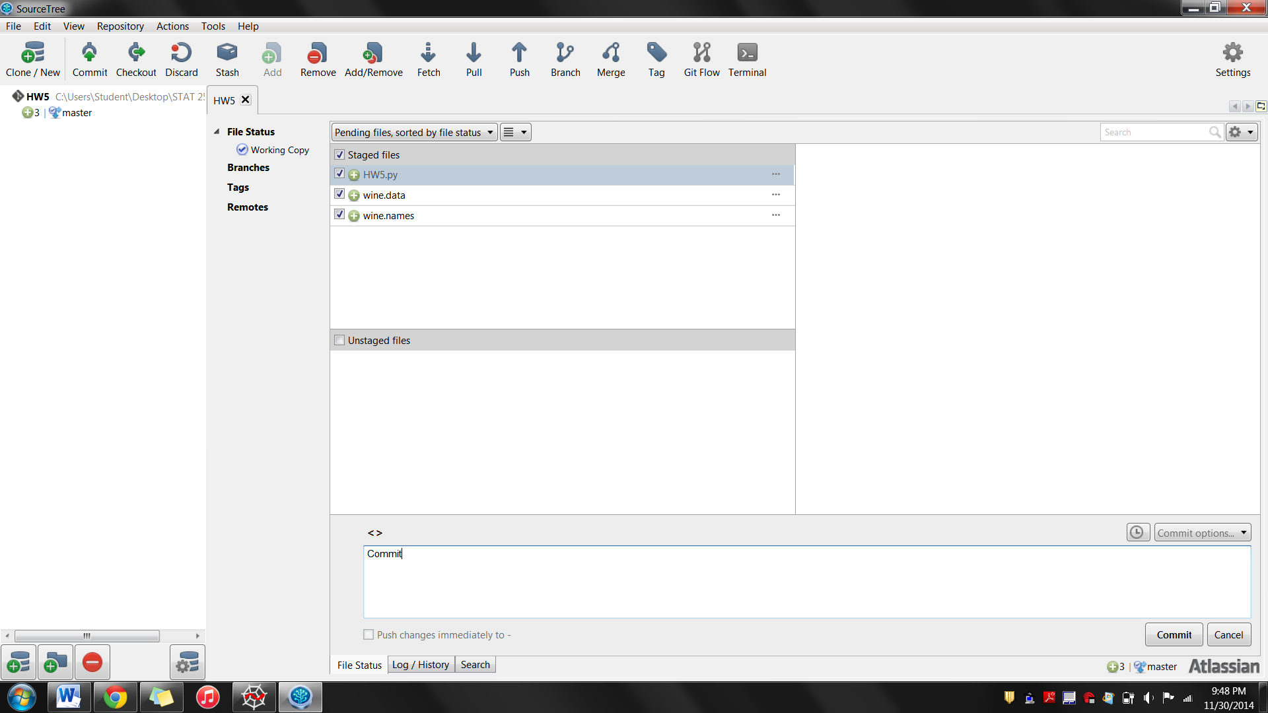

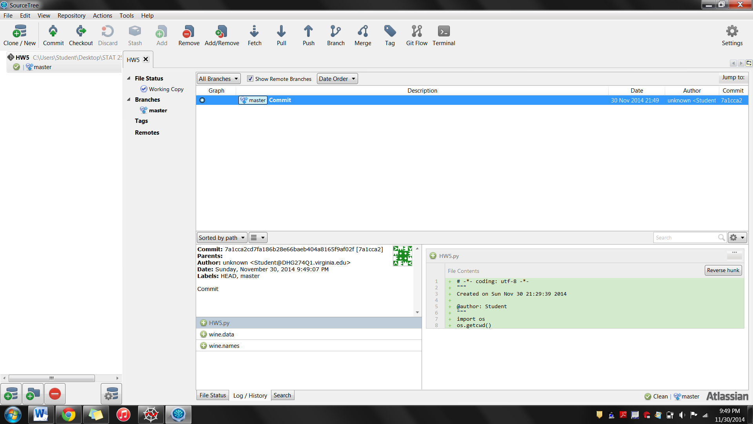

<http://nbviewer.ipython.org/urls/gist.github.com/fonnesbeck/5850375/raw/c18cfcd9580d382cb6d14e4708aab33a0916ff3e/1.+Introduction+to+Pandas.ipynb>

<http://stackoverflow.com/questions/11346283/renaming-columns-in-pandas>

<http://pandas.pydata.org/pandas-docs/dev/visualization.html#histograms>

<http://pandas.pydata.org/pandas-docs/dev/generated/pandas.DataFrame.values.html>

<http://wiki.scipy.org/Tentative_NumPy_Tutorial#head-d3f8e5fe9b903f3c3b2a5c0dfceb60d71602cf93>

<http://stackoverflow.com/questions/13042390/how-do-i-remove-rows-columns-from-this-matrix-using-python>

<http://stackoverflow.com/questions/13730468/from-2d-to-1d-arrays>

<http://scikit-learn.org/stable/modules/generated/sklearn.cross_validation.train_test_split.html>

<http://www.astroml.org/sklearn_tutorial/general_concepts.html>