Exploratory Data Analysis-Location

William Norfolk

10/9/2019

Load the required libraries for exploratory analysis.

library(readxl)  
library(dplyr)

##   
## Attaching package: 'dplyr'

## The following objects are masked from 'package:stats':  
##   
## filter, lag

## The following objects are masked from 'package:base':  
##   
## intersect, setdiff, setequal, union

library(tidyverse)

## -- Attaching packages ------------------------------------------------- tidyverse 1.2.1 --

## v ggplot2 3.2.1 v readr 1.3.1  
## v tibble 2.1.3 v purrr 0.3.2  
## v tidyr 0.8.3 v stringr 1.4.0  
## v ggplot2 3.2.1 v forcats 0.4.0

## -- Conflicts ---------------------------------------------------- tidyverse_conflicts() --  
## x dplyr::filter() masks stats::filter()  
## x dplyr::lag() masks stats::lag()

library(forcats)  
library(ggthemes)  
library(plotly)

##   
## Attaching package: 'plotly'

## The following object is masked from 'package:ggplot2':  
##   
## last_plot

## The following object is masked from 'package:stats':  
##   
## filter

## The following object is masked from 'package:graphics':  
##   
## layout

library(knitr)  
library(naniar)  
library(broom)  
library(gridExtra)

##   
## Attaching package: 'gridExtra'

## The following object is masked from 'package:dplyr':  
##   
## combine

library(zoo)

##   
## Attaching package: 'zoo'

## The following objects are masked from 'package:base':  
##   
## as.Date, as.Date.numeric

Load the processed data from the RDS. Then take a look!

WQ_clean_data <- readRDS("../../data/processed_data/processeddata.rds")  
  
glimpse(WQ_clean_data)

## Observations: 522  
## Variables: 15  
## $ Month <chr> "01", "02", "02", "02", "02", "02", "02", "02...  
## $ Day <chr> "08", "08", "08", "08", "09", "09", "09", "12...  
## $ Year <chr> "16", "16", "16", "16", "16", "16", "16", "16...  
## $ military_time <dbl> 1415, 1515, 1550, 1555, 1001, 1015, 1022, 103...  
## $ location <chr> "Boat Ramp", "Grecian Dry Rocks", "Grecian Dr...  
## $ instructor_name <chr> "Katy, Sarah, Driver", "Chelsea", "Katy, Tomm...  
## $ group_name <chr> "NA", "McLean High School", "McLean High Scho...  
## $ ph <dbl> 8.0, 8.4, 8.2, 8.4, 8.0, 8.0, 8.0, 8.0, 8.4, ...  
## $ ammonia <dbl> 0.00, 0.00, 0.00, 0.00, 0.25, 0.00, 0.00, 0.0...  
## $ dissolved_oxygen <dbl> 5.0, 4.0, 4.0, 6.0, 8.0, 4.0, 5.0, 6.0, 6.0, ...  
## $ water_temp <dbl> NA, 23.5, 21.0, 36.0, 18.0, 18.0, 18.0, 18.3,...  
## $ salinity <dbl> 36, 40, 44, 35, 33, 30, 33, 35, 40, 30, 35, 2...  
## $ equipment <chr> "kit", "kit", "kit", "kit", "kit", "kit", "ki...  
## $ island_side <chr> "ocean", "ocean", "ocean", "ocean", NA, "bay"...  
## $ site_type <chr> "Seagrass/Mangrove", "Coral Reef", "Coral Ree...

We will add soem filters to make life easy to deal with NAs in our variables of interest.

island_side_filter <- filter(WQ_clean_data, !is.na(island_side))  
  
site_type_filter <- filter(WQ_clean_data, !is.na(site_type))

Now we generate some plots to compare ocean vs bay.

Looks like pH is pretty consistent between the ocean and bayside in both mean and range. This is expected due to the limestone bedrock of the Florida Keys island chain.

island_side_filter %>% ggplot() +   
 geom_boxplot(aes(x = island_side, y = ph))

## Warning: Removed 6 rows containing non-finite values (stat_boxplot).

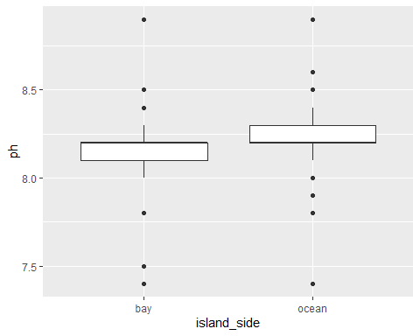

island_side_filter %>% ggplot() +   
 geom_jitter(aes(x = island_side, y = ph))

## Warning: Removed 6 rows containing missing values (geom_point).

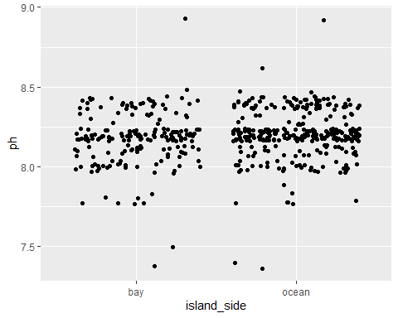

bay_v_ocean_ph <- ggplot(island_side_filter, aes(x = island_side, y = ph, color = island_side)) + geom_violin(width = 1) + geom_jitter(alpha = 0.25) + ggtitle("Bay vs. Ocean pH") + xlab("Island Side") + ylab("pH") + theme(legend.position = "none", axis.text.x = element_text(face = "bold"))  
  
bay_v_ocean_ph

## Warning: Removed 6 rows containing non-finite values (stat_ydensity).

## Warning: Removed 6 rows containing missing values (geom_point).

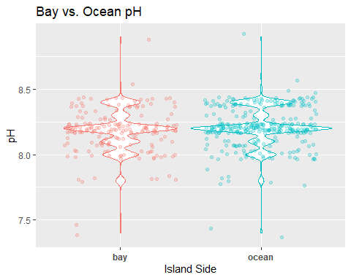

ggsave(filename = "../../results/bay_v_ocean_ph.png",plot = bay_v_ocean_ph)

## Saving 5 x 4 in image

## Warning: Removed 6 rows containing non-finite values (stat_ydensity).  
  
## Warning: Removed 6 rows containing missing values (geom_point).

We will save the violin + jitter plots we generate for use later.

Looks like salinity may be a little more interesting. Ocean side appears to have a narrower range of values compared to the bayside, this is likely due to the reduced size and depth range of the Florida Bay compared to the Atlantic Ocean.

island_side_filter %>% ggplot() +   
 geom_boxplot(aes(x = island_side, y = salinity))

## Warning: Removed 15 rows containing non-finite values (stat_boxplot).

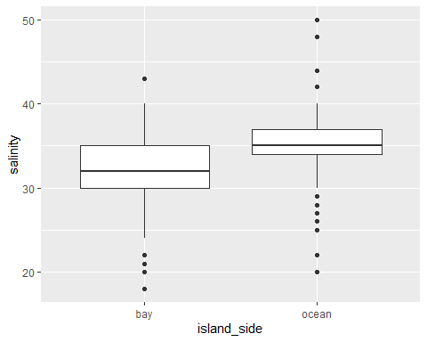

island_side_filter %>% ggplot() +   
 geom_jitter(aes(x = island_side, y = salinity))

## Warning: Removed 15 rows containing missing values (geom_point).

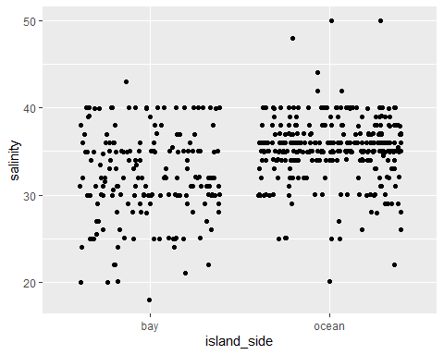

bay_v_ocean_salinity <- ggplot(island_side_filter, aes(x = island_side, y = salinity, color = island_side)) + geom_violin(width = 1) + geom_jitter(alpha = 0.25) + ggtitle("Bay vs. Ocean Salinity") + xlab("Island Side") + ylab("Salinity (ppt)") + theme(legend.position = "none", axis.text.x = element_text(face = "bold"))  
  
bay_v_ocean_salinity

## Warning: Removed 15 rows containing non-finite values (stat_ydensity).

## Warning: Removed 15 rows containing missing values (geom_point).

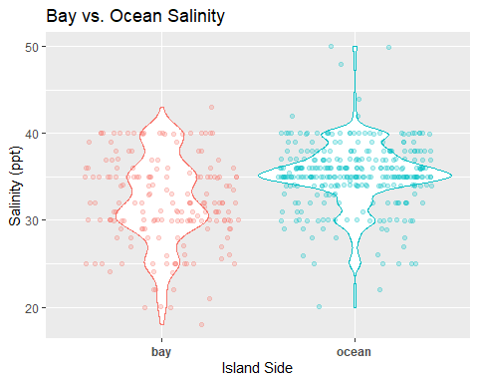

ggsave(filename = "../../results/bay_v_ocean_salinity.png",plot = bay_v_ocean_salinity)

## Saving 5 x 4 in image

## Warning: Removed 15 rows containing non-finite values (stat_ydensity).  
  
## Warning: Removed 15 rows containing missing values (geom_point).

The water temperature profiles look similar to the salinity profiles. The oceanside locations appear to have a narrower range compared to the bayside which can get quite cold and warm seasonally.

island_side_filter %>% ggplot() +   
 geom_boxplot(aes(x = island_side, y = water_temp))

## Warning: Removed 12 rows containing non-finite values (stat_boxplot).

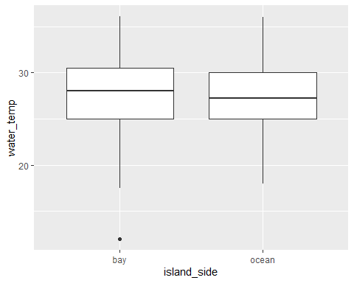

island_side_filter %>% ggplot() +   
 geom_jitter(aes(x = island_side, y = water_temp))

## Warning: Removed 12 rows containing missing values (geom_point).

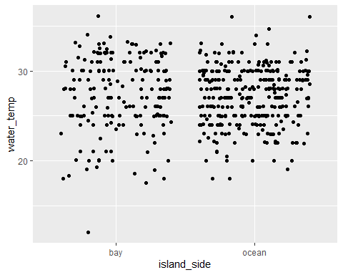

bay_v_ocean_water_temp <- ggplot(island_side_filter, aes(x = island_side, y = water_temp, color = island_side)) + geom_violin(width = 1) + geom_jitter(alpha = 0.25) + ggtitle("Bay vs. Ocean Water Temperature") + xlab("Island Side") + ylab("Water Temperature (C)") + theme(legend.position = "none", axis.text.x = element_text(face = "bold"))  
  
bay_v_ocean_water_temp

## Warning: Removed 12 rows containing non-finite values (stat_ydensity).

## Warning: Removed 12 rows containing missing values (geom_point).

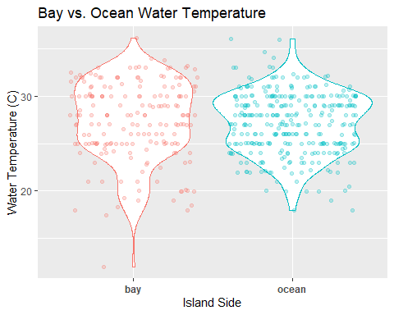

ggsave(filename = "../../results/bay_v_ocean_water_temp.png",plot = bay_v_ocean_water_temp)

## Saving 5 x 4 in image

## Warning: Removed 12 rows containing non-finite values (stat_ydensity).  
  
## Warning: Removed 12 rows containing missing values (geom_point).

Dissolved oxygen looks pretty similar across the ocean side and bayside on average. The distinct aggregations of jitter points is likely due to the fact that dissolved oxygen measures are recorded on a semiquantative scale using a colormetric comparison.

island_side_filter %>% ggplot() +   
 geom_boxplot(aes(x = island_side, y = dissolved_oxygen))

## Warning: Removed 4 rows containing non-finite values (stat_boxplot).

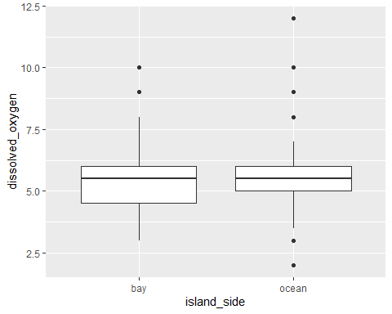

island_side_filter %>% ggplot() +   
 geom_jitter(aes(x = island_side, y = dissolved_oxygen))

## Warning: Removed 4 rows containing missing values (geom_point).

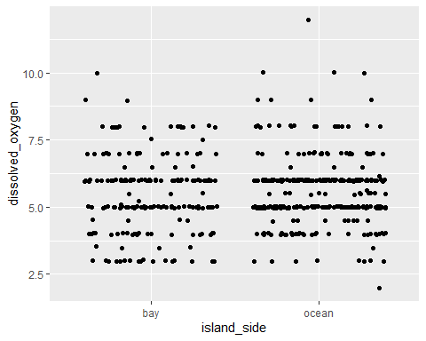

bay_v_ocean_dissolved_oxygen <- ggplot(island_side_filter, aes(x = island_side, y = dissolved_oxygen, color = island_side)) + geom_violin(width = 1) + geom_jitter(alpha = 0.25) + ggtitle("Bay vs. Ocean Dissolved Oxygen") + xlab("Island Side") + ylab("Dissolved Oxygen (mg/L)") + theme(legend.position = "none", axis.text.x = element_text(face = "bold"))  
  
bay_v_ocean_dissolved_oxygen

## Warning: Removed 4 rows containing non-finite values (stat_ydensity).

## Warning: Removed 4 rows containing missing values (geom_point).

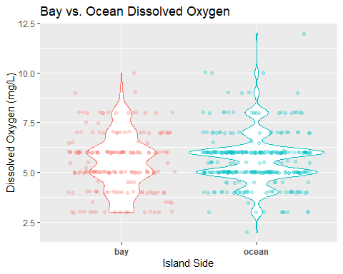

ggsave(filename = "../../results/bay_v_ocean_dissolved_oxygen.png",plot = bay_v_ocean_dissolved_oxygen)

## Saving 5 x 4 in image

## Warning: Removed 4 rows containing non-finite values (stat_ydensity).  
  
## Warning: Removed 4 rows containing missing values (geom_point).

Ammonia appears reasonably similar on average as well. Similar to dissolved oxygen, ammonia is also collected using a colormetric scale with semiquantative values which likely caused the grouping of observations seen. Most values appear to be zero or very close which is a healthy measurement of oceanic water typically. In depth analysis of this variable may be illuminating with respect to Hurrican Irma.

filter(WQ_clean_data, !is.na(island_side)) %>% ggplot() +   
 geom_boxplot(aes(x = island_side, y = ammonia))

## Warning: Removed 10 rows containing non-finite values (stat_boxplot).

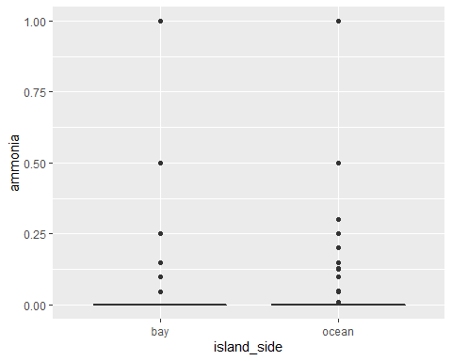

filter(WQ_clean_data, !is.na(island_side)) %>% ggplot() +   
 geom_jitter(aes(x = island_side, y = ammonia))

## Warning: Removed 10 rows containing missing values (geom_point).

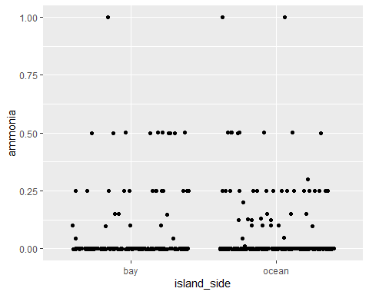

bay_v_ocean_ammonia <- ggplot(island_side_filter, aes(x = island_side, y = ammonia, color = island_side)) + geom_violin(width = 1) + geom_jitter(alpha = 0.25) + ggtitle("Bay vs. Ocean Ammonia") + xlab("Island Side") + ylab("Ammonia (mg/L)") + theme(legend.position = "none", axis.text.x = element_text(face = "bold"))  
  
bay_v_ocean_ammonia

## Warning: Removed 10 rows containing non-finite values (stat_ydensity).

## Warning: Removed 10 rows containing missing values (geom_point).

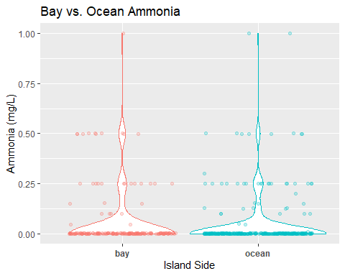

ggsave(filename = "../../results/bay_v_ocean_ammonia.png",plot = bay_v_ocean_ammonia)

## Saving 5 x 4 in image

## Warning: Removed 10 rows containing non-finite values (stat_ydensity).  
  
## Warning: Removed 10 rows containing missing values (geom_point).

Now we will consider site type. There are a number of sites that are located on the ocean side of the island that are actually mangrove/seagrass sites. Additionally, there is a biological difference between patch reefs/hardbottom sites and the formal reef line. We will compare individual variables as above.

Seperating the salinity data we can see that there is a much wider range for seagrass/mangrove site locations. Patch reefs/hardbottom sites appear similar to coral reefs in salinity, however it should be noted that patch reefs/hardbottom sites have fewer observations recorded.

site_type_filter %>% ggplot() +   
 geom_jitter(aes(x = site_type, y = salinity))

## Warning: Removed 15 rows containing missing values (geom_point).

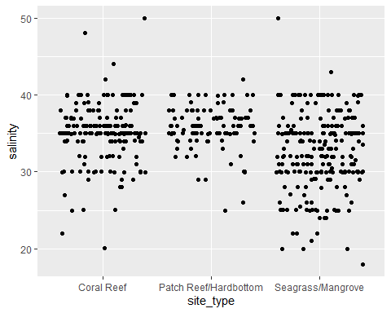

site_type_salinity <- ggplot(island_side_filter, aes(x = site_type, y = salinity, color = site_type)) + geom_violin(width = 1) + geom_jitter(alpha = 0.25) + ggtitle("Salinity by Site Type") + xlab("") + ylab("Salinity (ppt)") + theme(legend.position = "none", axis.text.x = element_text(face = "bold"))  
  
site_type_salinity

## Warning: Removed 15 rows containing non-finite values (stat_ydensity).  
  
## Warning: Removed 15 rows containing missing values (geom_point).

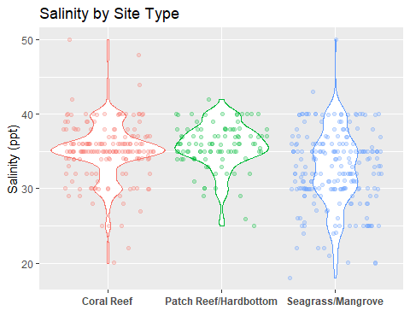

ggsave(filename = "../../results/site_type_salinity.png",plot = site_type_salinity)

## Saving 5 x 4 in image

## Warning: Removed 15 rows containing non-finite values (stat_ydensity).  
  
## Warning: Removed 15 rows containing missing values (geom_point).

Similar to salinity, we see a wide range of water temperature in seagrasss/mangrove site locations. Interestingly, it appears patch reefs/hardbottom has a higher average temperature compared to coral reefs. This may be due to the fact that patch reefs tend to be shallower in depth, however this parameter was not measured in this study.

site_type_filter %>% ggplot() +   
 geom_jitter(aes(x = site_type, y = water_temp))

## Warning: Removed 12 rows containing missing values (geom_point).

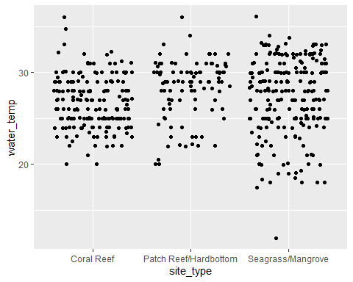

site_type_water_temp <- ggplot(island_side_filter, aes(x = site_type, y = water_temp, color = site_type)) + geom_violin(width = 1) + geom_jitter(alpha = 0.25) + ggtitle("Water Temperature by Site Type") + xlab("") + ylab("Water Temperature (C)") + theme(legend.position = "none", axis.text.x = element_text(face = "bold"))  
  
site_type_water_temp

## Warning: Removed 12 rows containing non-finite values (stat_ydensity).  
  
## Warning: Removed 12 rows containing missing values (geom_point).

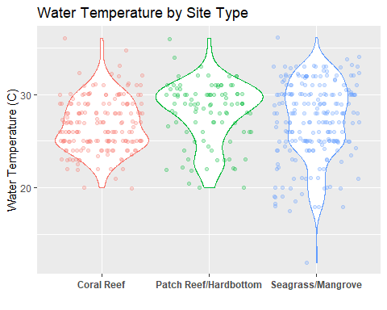

ggsave(filename = "../../results/site_type_water_temp.png",plot = site_type_water_temp)

## Saving 5 x 4 in image

## Warning: Removed 12 rows containing non-finite values (stat_ydensity).  
  
## Warning: Removed 12 rows containing missing values (geom_point).

Similar to the island side results, dissolved oxygen looks reasonably consistent across all three site types.

site_type_filter %>% ggplot() +   
 geom_jitter(aes(x = site_type, y = dissolved_oxygen))

## Warning: Removed 4 rows containing missing values (geom_point).

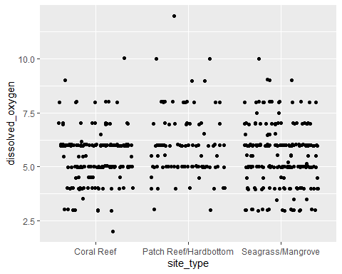

site_type_dissolved_oxygen <- ggplot(island_side_filter, aes(x = site_type, y = dissolved_oxygen, color = site_type)) + geom_violin(width = 1) + geom_jitter(alpha = 0.25) + ggtitle("Dissolved Oxygen by Site Type") + xlab("") + ylab("Dissolved Oxygen (mg/L)") + theme(legend.position = "none", axis.text.x = element_text(face = "bold"))  
  
site_type_dissolved_oxygen

## Warning: Removed 4 rows containing non-finite values (stat_ydensity).  
  
## Warning: Removed 4 rows containing missing values (geom_point).

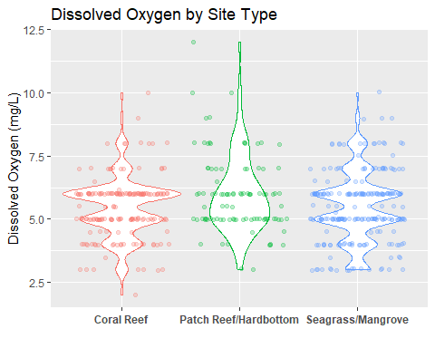

ggsave(filename = "../../results/site_type_dissolved_oxygen.png",plot = site_type_dissolved_oxygen)

## Saving 5 x 4 in image

## Warning: Removed 4 rows containing non-finite values (stat_ydensity).  
  
## Warning: Removed 4 rows containing missing values (geom_point).

Lastly, ammonia looks reasonably similar across all site types. There may be a slightly greater ammoina level in seagrass/mangrove sites judging by the distributions, however full analysis is needed to confirm.

site_type_filter %>% ggplot() +   
 geom_jitter(aes(x = site_type, y = ammonia))

## Warning: Removed 10 rows containing missing values (geom_point).

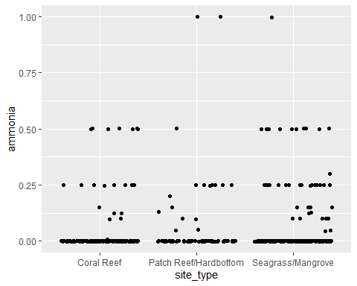

site_type_ammonia <- ggplot(island_side_filter, aes(x = site_type, y = ammonia, color = site_type)) + geom_violin(width = 1) + geom_jitter(alpha = 0.25) + ggtitle("Ammonia by Site Type") + xlab("") + ylab("Ammonia (mg/L)") + theme(legend.position = "none", axis.text.x = element_text(face = "bold"))  
  
site_type_ammonia

## Warning: Removed 10 rows containing non-finite values (stat_ydensity).  
  
## Warning: Removed 10 rows containing missing values (geom_point).

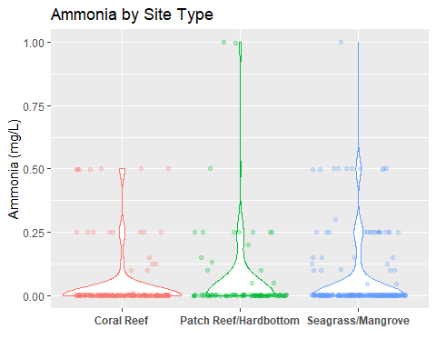

ggsave(filename = "../../results/site_type_ammonia.png",plot = site_type_ammonia)

## Saving 5 x 4 in image

## Warning: Removed 10 rows containing non-finite values (stat_ydensity).  
  
## Warning: Removed 10 rows containing missing values (geom_point).

Edit writing.

Basic R sript for realtime visualization analysis-Objective 4-may be more appropriate for final analysis section.