**Module 1 Critical Thinking Option 1**

Megan A. Babington

Colorado State University Global

CSC320: Programming 1

Professor Dr. Bindu George

July 21, 2024

**Pseudocode**

Read first name

Read last name

Read street address

Read city

Read zip code

Display the first name

Display the last name

Display the street address

Display the city

Display the zipcode

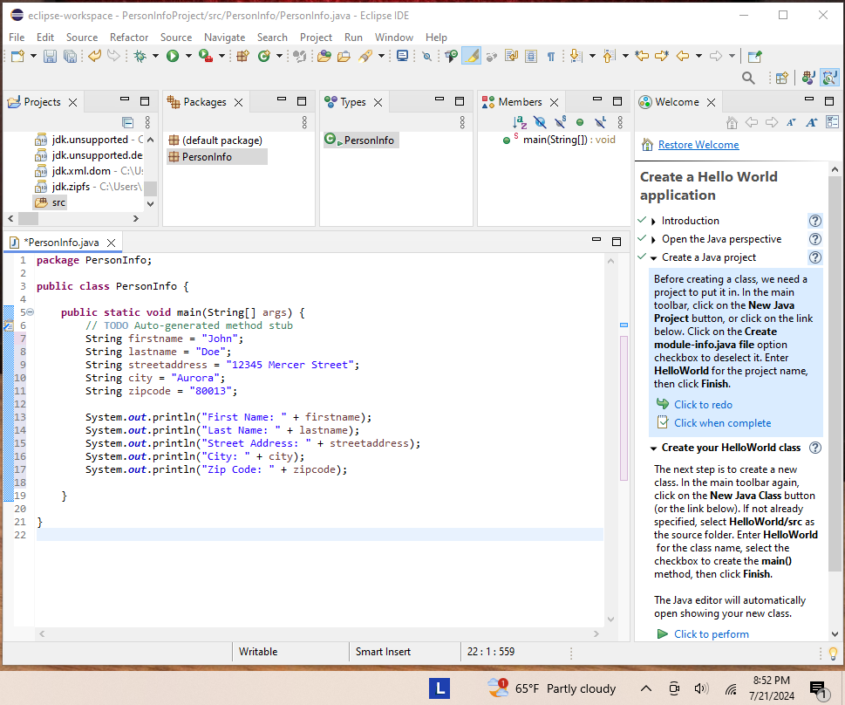

**Figure 1.1**

*This figure represents the source code for application.*

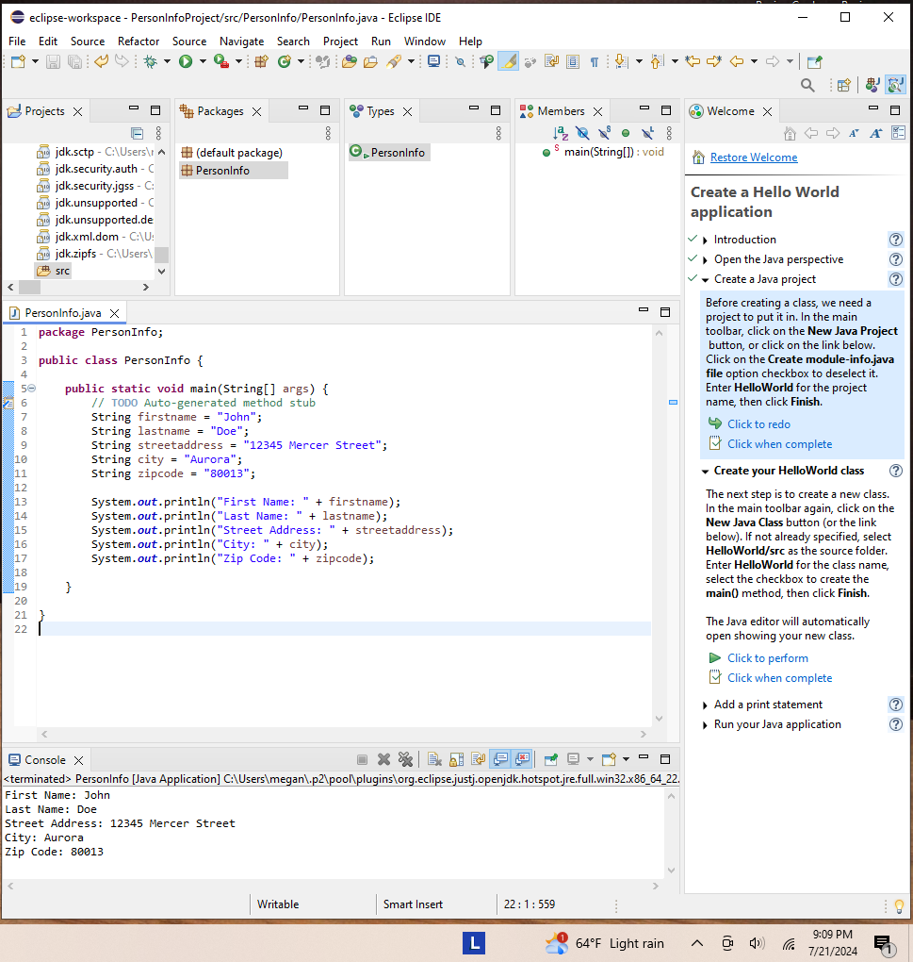

**Figure 1.2**

*This figure represents the executed code.*