**Module 4 Critical Thinking Option 1**

Megan A. Babington

Colorado State University Global

CSC320: Programming 1

Professor Dr. Bindu George

August 11, 2024

**Pseudocode**

Initialize variables for total, maximum, minimum, and a counter count.

Use a while loop that runs until count reaches 5.

Inside the loop:

Prompt the user to enter a floating-point value.

Add the value to the total.

Update the maximum and minimum if necessary.

Increment the counter.

After the loop:

Calculate the average by dividing the total by 5.

Calculate the interest on the total at 20%.

Print the results: total, average, maximum, minimum, and interest.

**Source Code**

package floatingpointproject;

import java.util.Scanner;

public class floatingpointproject {

public static void main(String[] args) {

// Initialize variables

double total = 0.0;

double maximum = Double.NEGATIVE_INFINITY;

double minimum = Double.POSITIVE_INFINITY;

int count = 0;

Scanner scanner = new Scanner(System.in);

// Use a while loop to read five floating-point values

while (count < 5) {

System.out.print("Enter floating-point value " + (count + 1) + ": ");

if (scanner.hasNextDouble()) {

double value = scanner.nextDouble();

// Update total

total += value;

// Update maximum

if (value > maximum) {

maximum = value;

}

// Update minimum

if (value < minimum) {

minimum = value;

}

// Increment counter

count++;

} else {

System.out.println("Please enter a valid floating-point number.");

scanner.next(); // Clear the invalid input

}

}

// Close the scanner

scanner.close();

// Calculate average

double average = total / 5;

// Calculate interest on total at 20%

double interest = total * 0.20;

// Print the results

System.out.println("Total: " + total);

System.out.println("Average: " + average);

System.out.println("Maximum: " + maximum);

System.out.println("Minimum: " + minimum);

System.out.println("Interest on total at 20%: " + interest);

}

}

**Output**

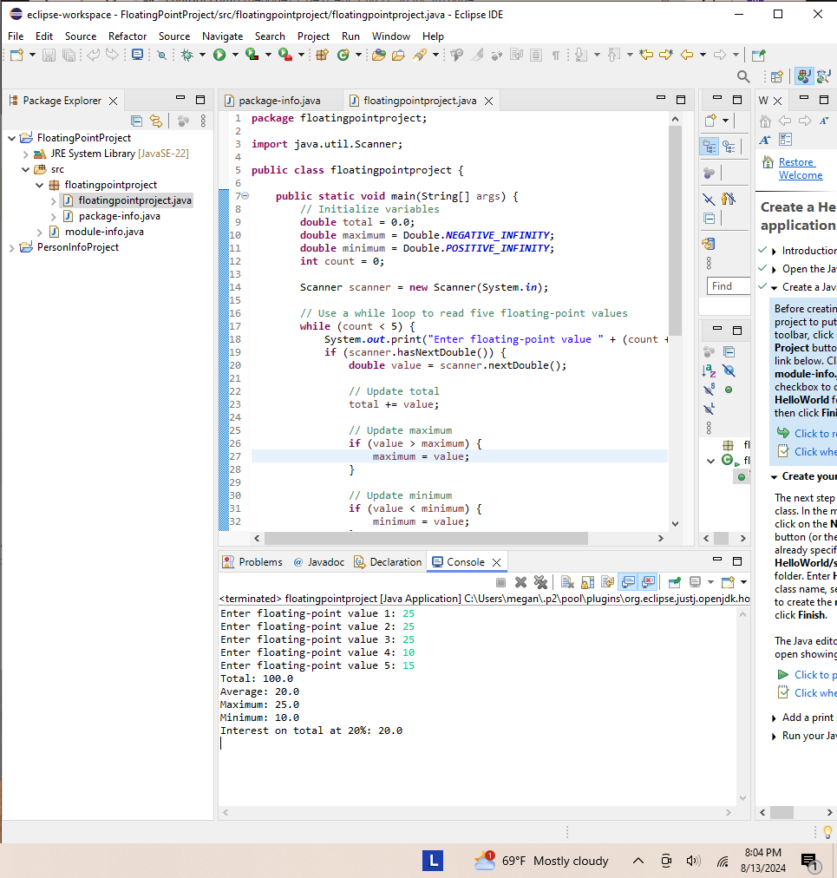

**Figure 1.1**

**GitHub Repository**

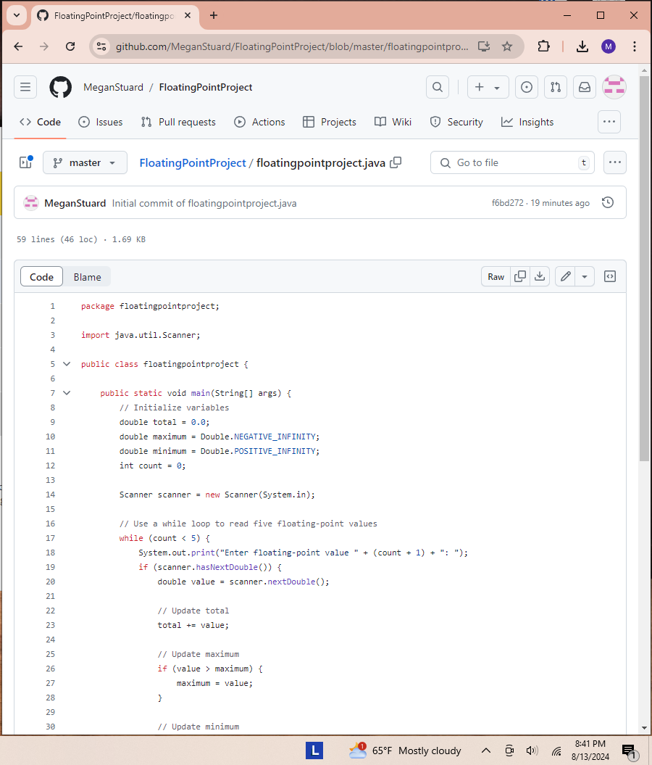

**Figure 1.2**