**Dataset:**

- Linked in GitHub due to file size: https://myuva-my.sharepoint.com/personal/vtf6hv_virginia_edu/_layouts/15/onedrive.aspx?id=%2Fpersonal%2Fvtf6hv%5Fvirginia%5Fedu%2FDocuments%2FCovid19%2DPneumonia%2DNormal%20Chest%20X%2DRay%20Images%20Dataset%2Ezip&parent=%2Fpersonal%2Fvtf6hv%5Fvirginia%5Fedu%2FDocuments&ga=1

- Unit of Observation: Each case is an x-ray image of the core of an individual

- The data file is split up by diagnosis. There are COVID, Normal, and Pneumonia folders, each of which contain data pertinent to the specific medical status.

- Type: .png image

- Example Values:

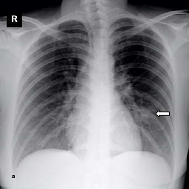

**Summary Statistics:**

**-** Total Entries: 5,228

- COVID images: 1,626

- Normal images: 1,802

- Pneumonia images: 1,800