Steps to Deploy Go Microservice for Chicago Business Intelligence on GCP

**Step1: Initial Setup for Google Cloud Platform**

* Install the [google cloud CLI](https://cloud.google.com/sdk/docs/install) on your local machine.
* Create a new project on your [google cloud console](https://console.cloud.google.com/projectcreate). Make a note of the project id and project Name.

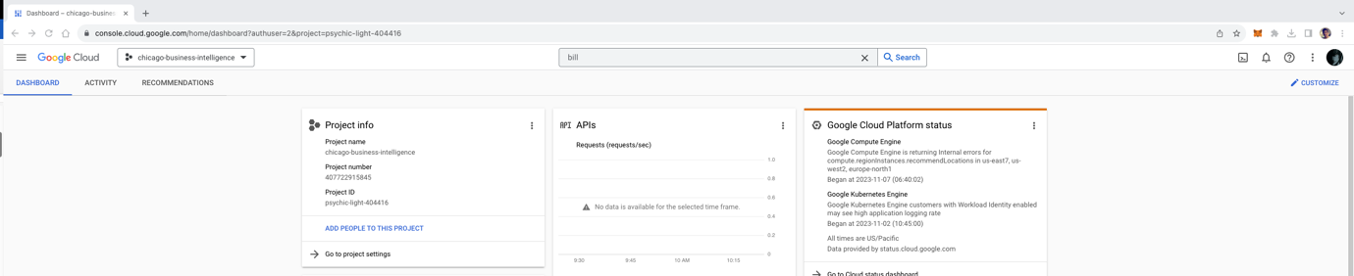

* After creating a project on Google Cloud Console execute “**gcloud init**” command on your local machine and select the project created above when prompted.

**Step 2: Postgres database Setup**

* Create database instance of postgres using the following command.

“**gcloud sql instances create mypostgres --database-version=POSTGRES_14 --cpu=2 --memory=7680MB --region=us-central**”

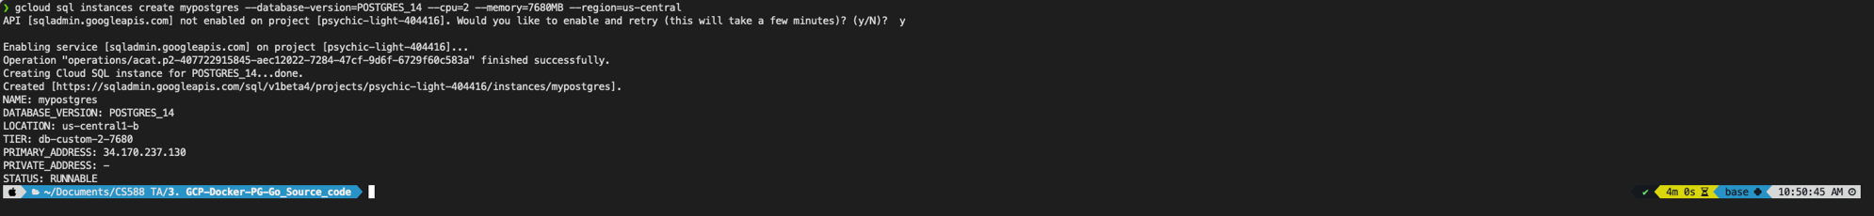

* Create sql users on the database instance using the following command.

“gcloud sql users set-password postgres --instance=mypostgres --password=root”



* Create a database for our microservice using the following command.

“gcloud sql databases create chicago_business_intelligence --instance=mypostgres”



* Open Google Cloud console, search for SQL and confirm that database instance is up and running

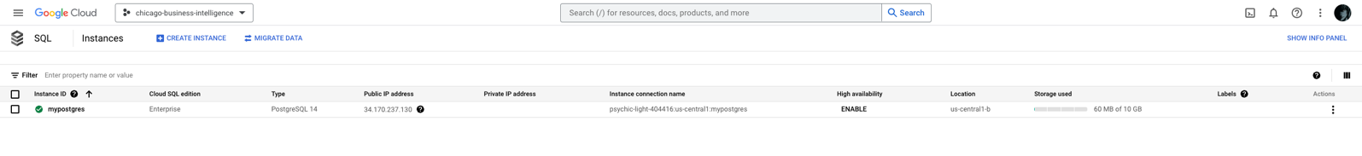

**Step 3: Setting up continuous deployment using cloud build.**

* Create a repository on GitHub to store the source code for our project.
* Open Google Cloud Console, Search for Cloud build API, and Enable it for your project

* After the API is enabled, click on the create trigger button.

* Fill the details for the trigger as shown in the below images.

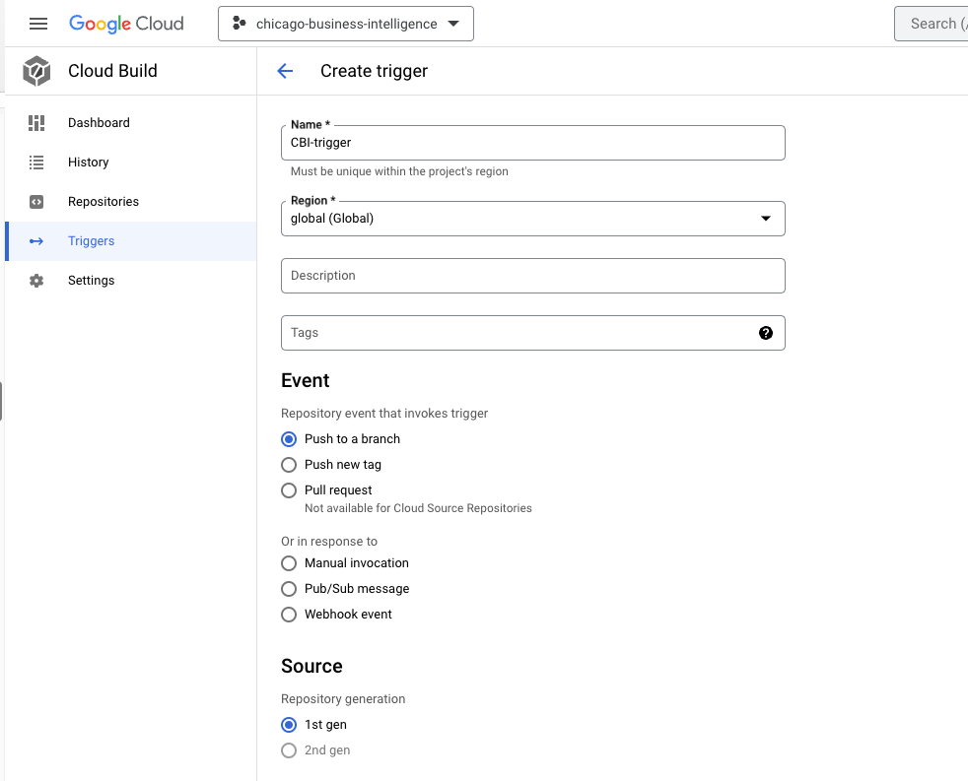

* Click on connect repository, select github and authenticate.

* After authentication select the repository created for Chicago business intelligence.

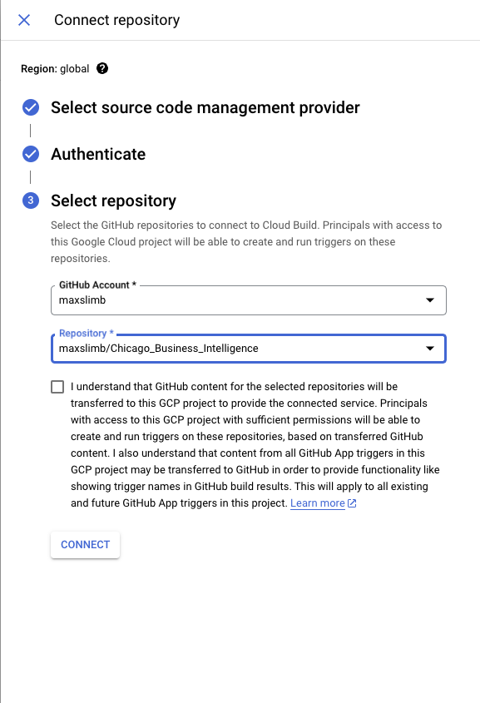

* Select the repository after connecting the project.

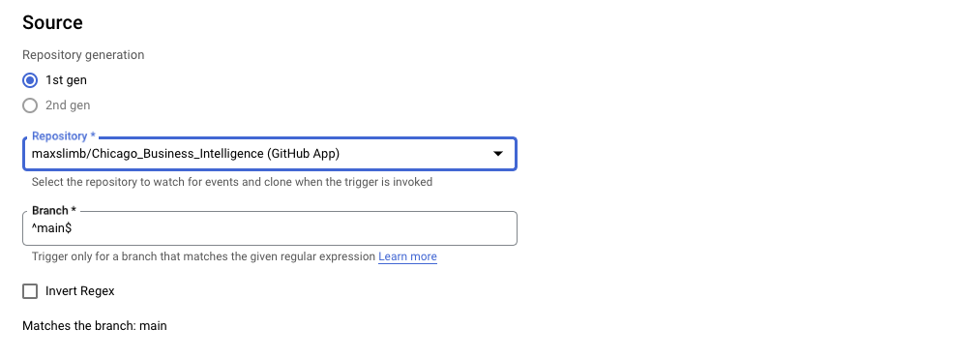

* Click on Create to create the trigger.

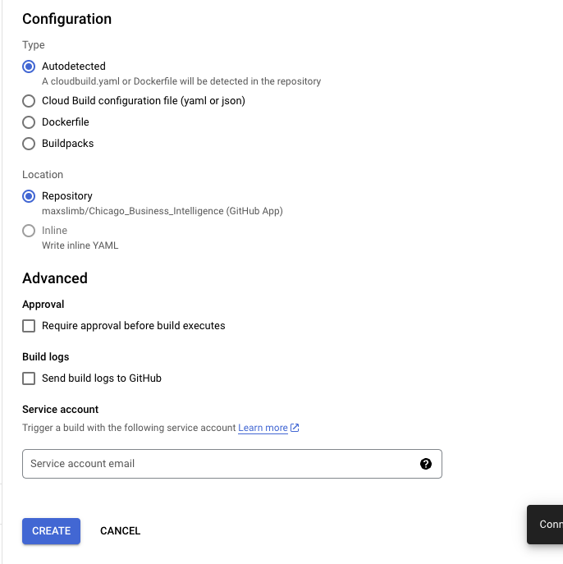

**Step 4: Setting up the containers for Go-microservice and Pgadmin**

* Enable Cloud Run API for your project.

* Go to IAM page and make sure all the required roles are enabled for the project.

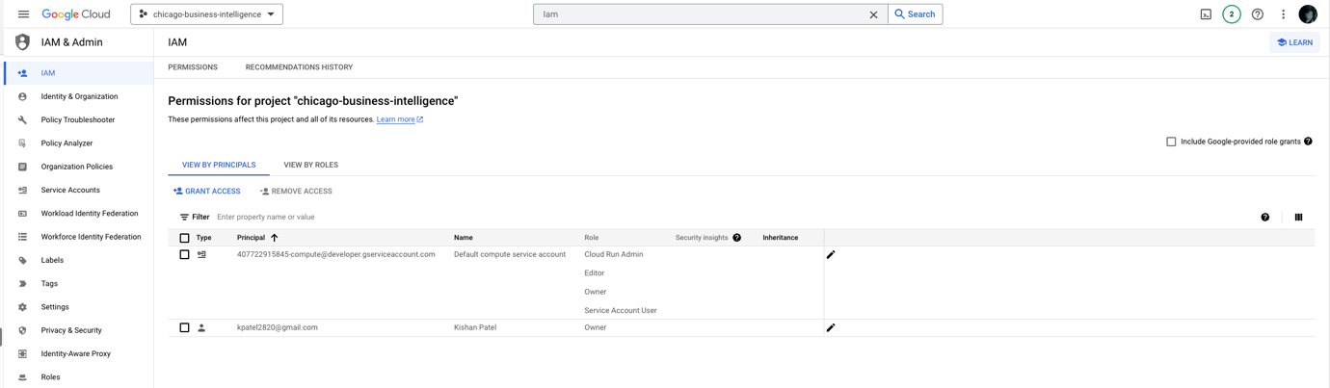

* The images for the go microservice and pgadmin are created with the help of cloudbuild.yaml file

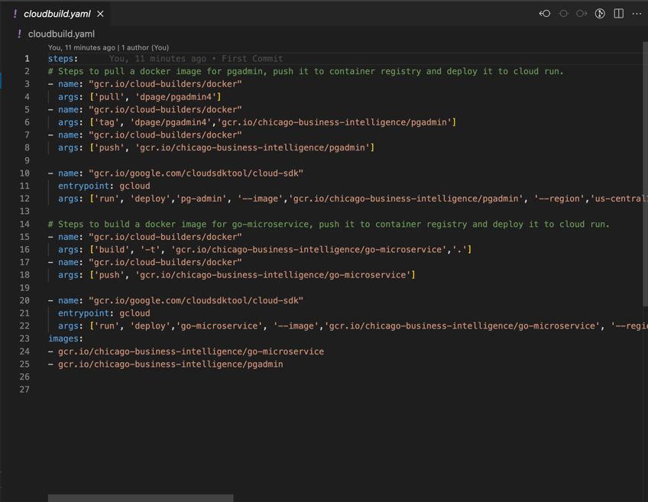

* Go to the postgres instance created in the previous steps and copy the instance connection name.

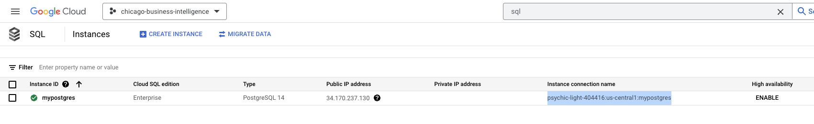

* Uncomment line 189 of your main.go source code file and update the connection string with your Instance connecton name as shown below.

"user=postgres dbname=chicago_business_intelligence password=root host=**/cloudsql/psychic-light-404416:us-central1:mypostgres** sslmode=disable port = 5432"

* Push the source code along with the cloudbuild.yaml file to the repository created in the above steps
* A build is triggered in cloud build immediately after pushing the code to the github.

* Wait for the build to be complete. Build logs can be viewed by clicking on the build id.

* Go to Cloud Run, click on pgadmin, copy the highlighted URLGraphical user interface, application

  Description automatically generated

Open the URL in a Browser and Login to pgadmin to validate that tables are created.