EXP.NO: 1 | Web Page Creation using HTML
DATE: 29/01/2025

AIM:
To create a web page that embeds a map with hotspots, frames, and links. The web page should be designed using HTML, incorporating embedded, external, and inline CSS for styling. This exercise aims to enhance understanding of integrating multimedia elements like maps, creating interactive hotspots, and organizing content using frames while applying different CSS techniques for styling.
ALGORITHM:
Create the HTML structure:
- Set up the basic HTML document with <!DOCTYPE html>, <html>, <head>, and <body> tags.
- In the <head>, link the external CSS file (<link> tag), define the title, and include any metadata.
- In the <body>, create the necessary elements:
  - Frames: Use the <frameset> tag to create a frame layout (for older browsers, use <iframe> instead).
  - Map: Use the <img> tag to display a map.
  - Hotspots: Create clickable regions using the <map> and <area> tags.
  - Links: Add hyperlinks (<a>) to navigate to different parts of the page or external sites.

Create CSS Styles:
- External CSS: In a separate file, define styles such as colors, fonts, and layout for the entire page.
- Inline CSS: Use the style attribute within specific tags to apply styles (e.g., in <div> or <p> tags).
- Embedded CSS: Inside the <style> tag in the <head>, define styles for specific elements like the map, frames, and text.
Map with Hotspots:
- Use the <map> tag to create an image map.
- Define the <area> tag for each hotspot, specifying the coordinates (e.g., coords="x,y,x2,y2") for clickable areas on the map.
Frames:
- Use the <iframe> tag for embedding external content like a map or another webpage, with attributes such as src for the URL, width, and height.
Add Links:
- Inside the <body>, use the <a> tag to create links for navigation (for example, to link to specific parts of the page or external sites).
Test the Page:
- Test the webpage to check the functionality of frames, hotspots, and links. Ensure that the map hotspots are clickable and the linked content displays correctly.
- Ensure that the styles are applied properly using inline, embedded, and external CSS.
CODE:
<!DOCTYPE html>
<html lang="en">
<head>
<meta charset="UTF-8">
<title>Course Details & Syllabus</title>
<link rel="stylesheet" href="style.css">
</head>
<body>

<!-- Navigation -->
<nav class="navbar">
<a href="index.html">Course</a>
<a href="location.html">Location</a>
</nav>

<!-- Header -->
<header>
<h1>Web Development Fundamentals</h1>
<p>Course Details & Syllabus Portal</p>
</header>

<!-- Course Info -->
<section class="course-info">
<div class="card">
<h2>Course Overview</h2>
<p>
This course introduces students to the fundamentals of web development,
including HTML, CSS, and responsive web design concepts.
</p>
</div>

<div class="card">
<h2>Course Details</h2>
<ul>
<li><strong>Instructor:</strong> John Doe</li>
<li><strong>Duration:</strong> 12 Weeks</li>
<li><strong>Credits:</strong> 3</li>
<li><strong>Level:</strong> Beginner</li>
</ul>
</div>
</section>

<!-- Syllabus -->
<section class="syllabus">
<h2>Course Syllabus</h2>

<div class="module">
<h3>Module 1: Introduction to Web</h3>
<ul>
<li>Internet Basics</li>
<li>Web Browsers & Servers</li>
<li>HTML Introduction</li>
</ul>
</div>

<div class="module">
<h3>Module 2: HTML</h3>
<ul>
<li>HTML Structure</li>
<li>Text Formatting</li>
<li>Links & Images</li>
<li>Forms</li>
</ul>
</div>

<div class="module">
<h3>Module 3: CSS</h3>
<ul>
<li>Selectors</li>
<li>Box Model</li>
<li>Flexbox</li>
<li>Layouts</li>
</ul>
</div>

<div class="module">
<h3>Module 4: Responsive Design</h3>
<ul>
<li>Media Queries</li>
<li>Mobile First Design</li>
</ul>
</div>
</section>

<!-- Footer -->
<footer>
<p>© 2026 Course Portal | HTML & CSS Only</p>
</footer>

</body>
</html>

<!DOCTYPE html>
<html lang="en">
<head>
<meta charset="UTF-8">
<title>Login | Course Portal</title>
<link rel="stylesheet" href="style.css">
</head>
<body>

<div class="login-container">
<h2>Student Login</h2>

<form action="home.html">
<label>Username</label>
<input type="text" placeholder="Enter username" required>

<label>Password</label>
<input type="password" placeholder="Enter password" required>

<button type="submit">Login</button>
</form>
</div>

</body>
</html>
<!DOCTYPE html>
<html lang="en">
<head>
<meta charset="UTF-8">
<title>Location | Course Portal</title>
<link rel="stylesheet" href="style.css">
</head>
<body>

<nav class="navbar">
<a href="index.html">Course</a>
<a href="location.html">Location</a>
</nav>

<section class="location">
<h2>Our Location</h2>
<p>Visit our campus at the location below.</p>

<div class="map-container">
<iframe
src="https://www.google.com/maps?q=New+York&output=embed"
allowfullscreen=""
loading="lazy">
</iframe>
</div>
</section>

</body>
</html>
CSS:
/* ---------- RESET ---------- */
* {
margin: 0;
padding: 0;
box-sizing: border-box;
font-family: Arial, Helvetica, sans-serif;
}

/* ---------- BODY ---------- */
body {
background-color: #f4f6f8;
color: #333;
line-height: 1.6;
}

/* ---------- NAVBAR ---------- */
.navbar {
background: #1f2a38;
padding: 15px;
text-align: center;
}

.navbar a {
color: #fff;
margin: 0 15px;
text-decoration: none;
font-weight: bold;
}

.navbar a:hover {
text-decoration: underline;
}

/* ---------- HEADER ---------- */
header {
background: #2c3e50;
color: #fff;
padding: 30px;
text-align: center;
}

/* ---------- COURSE INFO ---------- */
.course-info {
display: flex;
gap: 20px;
padding: 30px;
flex-wrap: wrap;
}

.card {
background: #fff;
padding: 20px;
flex: 1;
min-width: 280px;
border-radius: 8px;
box-shadow: 0 4px 8px rgba(0,0,0,0.1);
}

.card ul {
list-style: none;
}

.card li {
margin-bottom: 10px;
}

/* ---------- SYLLABUS ---------- */
.syllabus {
padding: 30px;
}

.syllabus h2 {
margin-bottom: 20px;
color: #2c3e50;
}

.module {
background: #fff;
margin-bottom: 15px;
padding: 20px;
border-left: 5px solid #3498db;
border-radius: 6px;
box-shadow: 0 3px 6px rgba(0,0,0,0.08);
}

.module h3 {
margin-bottom: 10px;
}

.module ul {
padding-left: 20px;
}

/* ---------- LOGIN PAGE ---------- */
.login-container {
max-width: 400px;
margin: 80px auto;
background: #fff;
padding: 30px;
border-radius: 8px;
box-shadow: 0 4px 10px rgba(0,0,0,0.1);
}

.login-container h2 {
text-align: center;
margin-bottom: 20px;
}

.login-container label {
display: block;
margin-top: 15px;
}

.login-container input {
width: 100%;
padding: 10px;
margin-top: 5px;
}

.login-container button {
width: 100%;
padding: 12px;
margin-top: 25px;
background: #3498db;
border: none;
color: #fff;
font-size: 16px;
cursor: pointer;
border-radius: 5px;
}

.login-container button:hover {
background: #2980b9;
}

/* ---------- LOCATION PAGE ---------- */
.location {
padding: 40px;
text-align: center;
}

.map-container {
margin-top: 20px;
}

.map-container iframe {
width: 100%;
max-width: 800px;
height: 400px;
border: none;
border-radius: 8px;
}

/* ---------- FOOTER ---------- */
footer {
text-align: center;
padding: 15px;
background: #2c3e50;
color: #fff;
margin-top: 30px;
}
OUTPUT:
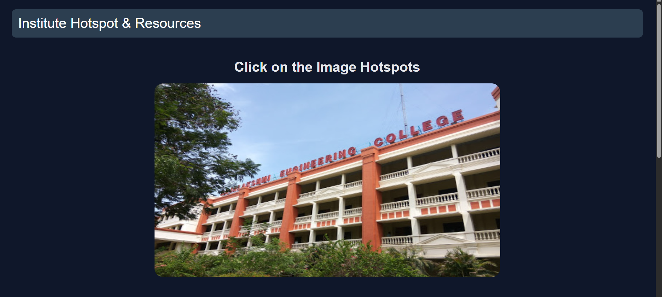

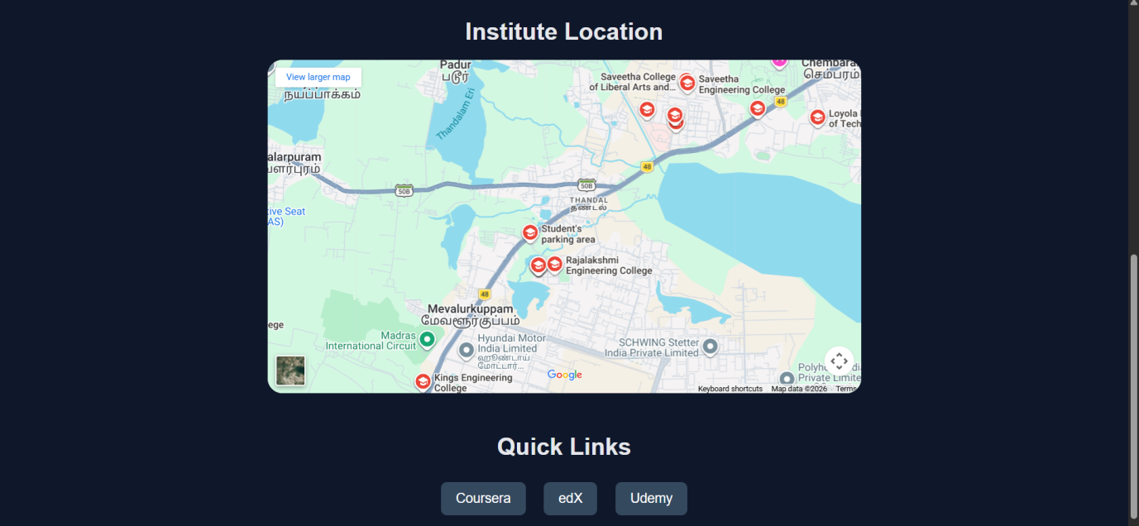

RESULT:
Html Page is created with embedded Chennai map along with hot spot, frames & links.

