EXP.NO: 2 | Write JavaScript Programme to validate the following fields of the HTML Registration page.
DATE: 06/02/2025

AIM:
To write JavaScript code to validate user input in a registration form. The validation will ensure that the data entered by the user meets specific criteria for each field. This will help in maintaining data integrity and prevent invalid submissions.
ALGORITHM:
1. Input:
- The user fills in the following fields: First Name, Password, E-mail, Mobile Number, Last Name, and Address.
2. Validation Steps:
- Validate First Name:
  - Check if the first name contains only alphabets.
  - Ensure the length of the First Name is at least 6 characters.
  - If any of these conditions fail, display an error message indicating the required input.
- Validate Password:
  - Check if the password is at least 6 characters long.
  - If it is less than 6 characters, display an error message.
- Validate E-mail:
  - Use a regular expression to check if the email follows the standard pattern: name@domain.com.
  - Ensure that the email contains no invalid characters and matches the required pattern.
  - If it doesn't match, display an error message indicating an invalid email format.
- Validate Mobile Number:
  - Check if the mobile number contains exactly 10 digits.
  - Ensure there are no alphabets or special characters.
  - If the number is invalid, display an error message indicating the correct format.
- Validate Last Name:
  - Ensure the Last Name field is not empty.
  - If it is empty, display an error message.
- Validate Address:
  - Ensure the Address field is not empty.
  - If it is empty, display an error message.
Code:
<!DOCTYPE html>
<html lang="en">
<head>
<meta charset="UTF-8">
<meta name="viewport" content="width=device-width, initial-scale=1.0">
<title>Login & Register</title>

<style>

body{
background:#151921;
font-family:Arial;
display:flex;
justify-content:center;
align-items:center;
height:100vh;
}

.container{
background:#30394a;
width:400px;
padding:30px;
border-radius:15px;
}

h2{
text-align:center;
color:white;
}

input, textarea{
width:100%;
padding:10px;
margin:8px 0;
border-radius:8px;
border:none;
}

button{
width:100%;
padding:10px;
margin-top:10px;
border:none;
border-radius:8px;
background:#151921;
color:white;
cursor:pointer;
}

button:hover{
background:#232a36;
}

.toggle{
text-align:center;
margin-top:15px;
color:white;
cursor:pointer;
}

.error{
color:red;
font-size:14px;
}

.hidden{
display:none;
}

</style>
</head>
<body>

<div class="container">

<!-- LOGIN FORM -->
<div id="loginForm">
<h2>Login</h2>
<input type="email" id="loginEmail" placeholder="Email">
<input type="password" id="loginPassword" placeholder="Password">
<div class="error" id="loginError"></div>
<button onclick="validateLogin()">Login</button>
<div class="toggle" onclick="showRegister()">Don't have account? Register</div>
</div>

<!-- REGISTER FORM -->
<div id="registerForm" class="hidden">
<h2>Register</h2>
<input type="text" id="firstname" placeholder="First Name">
<input type="text" id="lastname" placeholder="Last Name">
<input type="email" id="email" placeholder="Email">
<input type="text" id="mobile" placeholder="Mobile Number">
<input type="password" id="password" placeholder="Password">
<textarea id="address" placeholder="Address"></textarea>
<div class="error" id="registerError"></div>
<button onclick="validateRegister()">Register</button>
<div class="toggle" onclick="showLogin()">Already have account? Login</div>
</div>

</div>

<script>

function showRegister(){
document.getElementById("loginForm").classList.add("hidden");
document.getElementById("registerForm").classList.remove("hidden");
}

function showLogin(){
document.getElementById("registerForm").classList.add("hidden");
document.getElementById("loginForm").classList.remove("hidden");
}

function validateLogin(){

let email = document.getElementById("loginEmail").value.trim();
let password = document.getElementById("loginPassword").value.trim();
let error = document.getElementById("loginError");

if(email === "" || password === ""){
error.innerHTML = "All fields are required.";
return;
}

if(password.length < 6){
error.innerHTML = "Password must be at least 6 characters.";
return;
}

error.style.color = "lightgreen";
error.innerHTML = "Login Successful!";
}

function validateRegister(){

let firstname = document.getElementById("firstname").value.trim();
let lastname = document.getElementById("lastname").value.trim();
let email = document.getElementById("email").value.trim();
let mobile = document.getElementById("mobile").value.trim();
let password = document.getElementById("password").value.trim();
let address = document.getElementById("address").value.trim();
let error = document.getElementById("registerError");

let namePattern = /^[A-Za-z]+$/;
let emailPattern = /^[^ ]+@[^ ]+\.[a-z]{2,3}$/;
let mobilePattern = /^[0-9]{10}$/;

if(!namePattern.test(firstname) || firstname.length < 6){
error.innerHTML = "First Name must contain only alphabets & minimum 6 characters.";
return;
}

if(lastname === ""){
error.innerHTML = "Last Name cannot be empty.";
return;
}

if(!emailPattern.test(email)){
error.innerHTML = "Enter valid Email (name@domain.com).";
return;
}

if(!mobilePattern.test(mobile)){
error.innerHTML = "Mobile number must contain exactly 10 digits.";
return;
}

if(password.length < 6){
error.innerHTML = "Password must be at least 6 characters.";
return;
}

if(address === ""){
error.innerHTML = "Address cannot be empty.";
return;
}

error.style.color = "lightgreen";
error.innerHTML = "Registration Successful!";
}

</script>

</body>
</html>
Output:
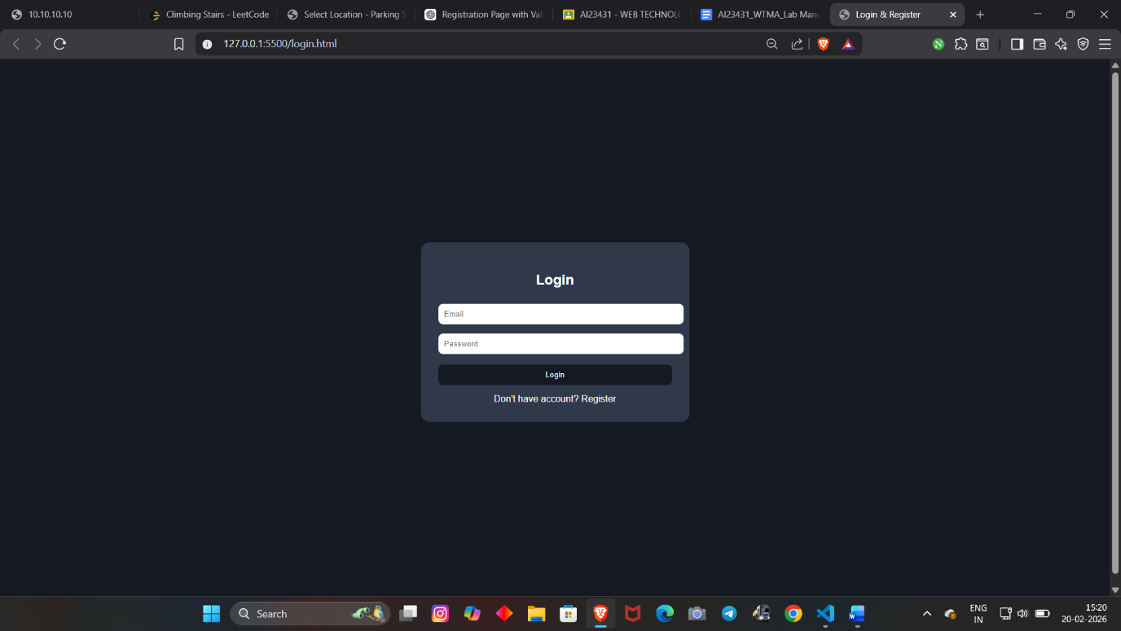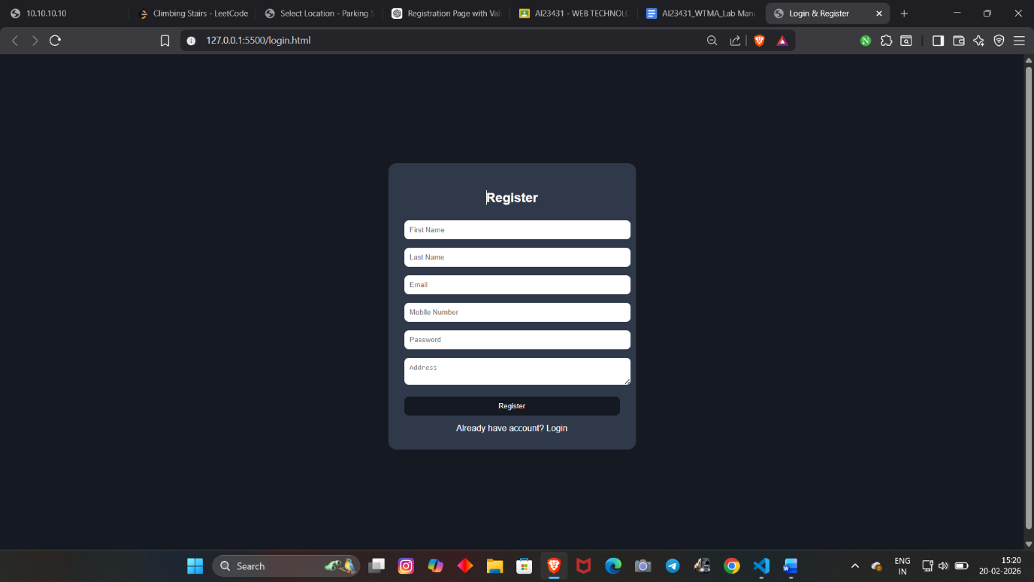
RESULT:
HTML page with Form is created and is validated using Javascript

