EXP.NO: 5 | Write a Servlet to demonstrate the difference between HTTP GET and POST methods by creating a form and handling requests accordingly.
DATE:05/03/2025

AIM:
To demonstrate the difference between the HTTP GET and POST methods by creating a form in an HTML page and handling the form submissions using two different HTTP methods in a Java Servlet.
ALGORITHM:
1. Input:
- The user fills out a web form with their name and email.
- The form will use both GET and POST methods for data submission.

2. Steps for Creating and Handling the HTTP GET and POST Requests:
- Create an HTML Form:
  - Design an HTML form with two input fields: one for the name and one for the email.
  - Create two buttons to allow the user to submit the form using GET or POST methods.
  - Use the action attribute to define the Servlet URL and specify the form method (either GET or POST).
- Create the Servlet to Handle GET and POST Requests:
  - Write a Java Servlet class that will handle both GET and POST requests.
  - The servlet will have two methods:
    - doGet() to handle the GET requests.
    - doPost() to handle the POST requests.
  - In both methods, retrieve the form data using request.getParameter().
  - In the doGet() method, process and display the data in the URL.
  - In the doPost() method, process and display the data in the HTTP request body.
- Handle GET Requests in the Servlet:
  - In the doGet() method, use request.getParameter() to retrieve the name and email submitted via GET.
  - Output the data as a response, including the name and email in the URL (visible to the user).
- Handle POST Requests in the Servlet:
  - In the doPost() method, use request.getParameter() to retrieve the name and email submitted via POST.
  - Output the data as a response, displaying the name and email without exposing them in the URL (more secure).
- Return the Output:
  - The Servlet should return an HTML page displaying the name and email entered by the user.
  - For the GET method, the output should be visible in the URL.
  - For the POST method, the output should be visible in the response body, not the URL.
- Deploy and Test the Servlet:
  - Compile the Servlet class and deploy it to a Servlet container (like Apache Tomcat).
  - Test the form using GET and POST methods to see the difference in data submission.
- Observe and Compare GET and POST Results:
  - Test the GET method: The form data is sent in the URL.
  - Test the POST method: The form data is sent in the HTTP request body, not visible in the URL.
Code:
ParkingServlet.java

package com.example;

import java.io.IOException;
import java.io.PrintWriter;
import javax.servlet.ServletException;
import javax.servlet.annotation.WebServlet;
import javax.servlet.http.HttpServlet;
import javax.servlet.http.HttpServletRequest;
import javax.servlet.http.HttpServletResponse;

@WebServlet("/ParkingServlet")
public class ParkingServlet extends HttpServlet {
private static final long serialVersionUID = 1L;

// common method for GET & POST
protected void processRequest(HttpServletRequest request, HttpServletResponse response, String method)
throws ServletException, IOException {

String name = request.getParameter("name");
String slot = request.getParameter("slot");
String hours = request.getParameter("hours");

response.setContentType("text/html");
PrintWriter out = response.getWriter();

out.println("<html><head><title>Parking Booking Confirmation</title>");
out.println("<style>");
out.println("body { font-family: 'Segoe UI', Tahoma, Geneva, Verdana, sans-serif; background-color: #121212; color: #f0f0f0; display:flex; justify-content:center; align-items:center; height:100vh; margin:0; }");
out.println(".container { background-color:#1f1f1f; padding:30px; border-radius:12px; box-shadow:0 0 15px rgba(0,0,0,0.5); text-align:center; width:400px; }");
out.println("h1 { color:#3399ff; margin-bottom:20px; }");
out.println("p { font-size:18px; margin:10px 0; }");
out.println("a { display:inline-block; margin-top:20px; text-decoration:none; color:#121212; background-color:#3399ff; padding:10px 20px; border-radius:8px; font-weight:bold; transition:0.3s; }");
out.println("a:hover { background-color:#2673cc; }");
out.println("</style></head><body>");
out.println("<div class='container'>");
out.println("<h1>Booking via " + method + "</h1>");
out.println("<p><strong>Name:</strong> " + (name != null ? name : "Not Provided") + "</p>");
out.println("<p><strong>Slot Number:</strong> " + (slot != null ? slot : "Not Provided") + "</p>");
out.println("<p><strong>Hours:</strong> " + (hours != null ? hours : "Not Provided") + "</p>");
out.println("<a href='bookingform.html'>Back to Booking Form</a>");
out.println("</div></body></html>");
}

protected void doGet(HttpServletRequest request, HttpServletResponse response)
throws ServletException, IOException {
processRequest(request, response, "GET");
}

protected void doPost(HttpServletRequest request, HttpServletResponse response)
throws ServletException, IOException {
processRequest(request, response, "POST");
}
}

Bookingform.html

<!DOCTYPE html>
<html>
<head>
<meta charset="UTF-8">
<title>Parking Slot Booking - GET vs POST</title>
<style>
body {
font-family: 'Segoe UI', Tahoma, Geneva, Verdana, sans-serif;
background-color: #121212;
color: #f0f0f0;
display: flex;
justify-content: center;
align-items: center;
height: 100vh;
margin: 0;
}
form {
background-color: #1f1f1f;
padding: 30px;
border-radius: 12px;
box-shadow: 0 0 15px rgba(0,0,0,0.5);
width: 400px;
}
h1 {
text-align: center;
color: #3399ff;
margin-bottom: 20px;
}
label {
display: block;
margin-top: 15px;
font-weight: bold;
color: #ddd;
}
input[type="text"], input[type="number"] {
width: 100%;
padding: 10px;
margin-top: 5px;
border-radius: 8px;
border: 1px solid #444;
background-color: #2a2a2a;
color: #f0f0f0;
}
input[type="submit"] {
margin-top: 20px;
width: 48%;
padding: 12px;
border: none;
border-radius: 8px;
background-color: #3399ff;
color: #121212;
font-weight: bold;
font-size: 16px;
cursor: pointer;
transition: 0.3s;
}
input[type="submit"]:hover {
background-color: #2673cc;
}
.buttons {
display: flex;
justify-content: space-between;
}
</style>
</head>
<body>
<form action="ParkingServlet" method="post">
<h1>Parking Slot Booking</h1>
<label for="name">Your Name:</label>
<input type="text" name="name" id="name" required>

<label for="slot">Slot Number:</label>
<input type="number" name="slot" id="slot" min="1" max="50" required>

<label for="hours">Hours to Book:</label>
<input type="number" name="hours" id="hours" min="1" required>

<div class="buttons">
<input type="submit" value="Book via POST">
<input type="submit" formaction="ParkingServlet" formmethod="get" value="Book via GET">
</div>
</form>
</body>
</html>

Output:
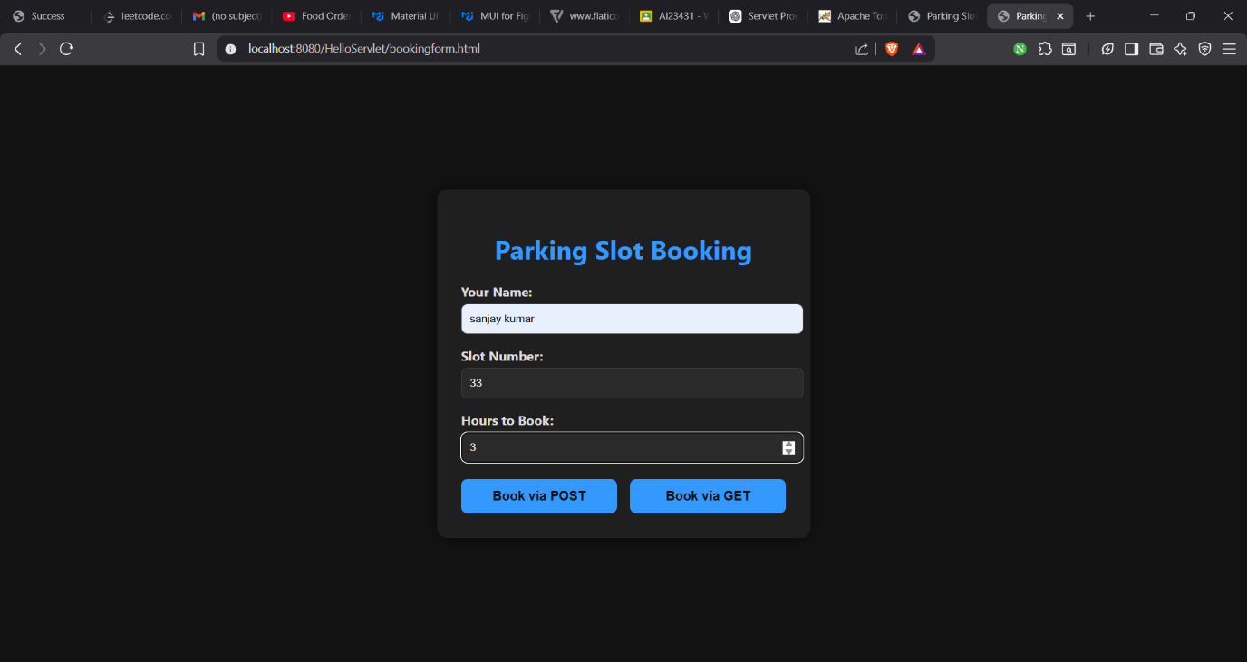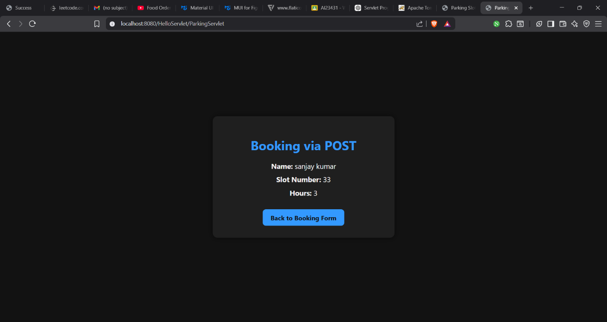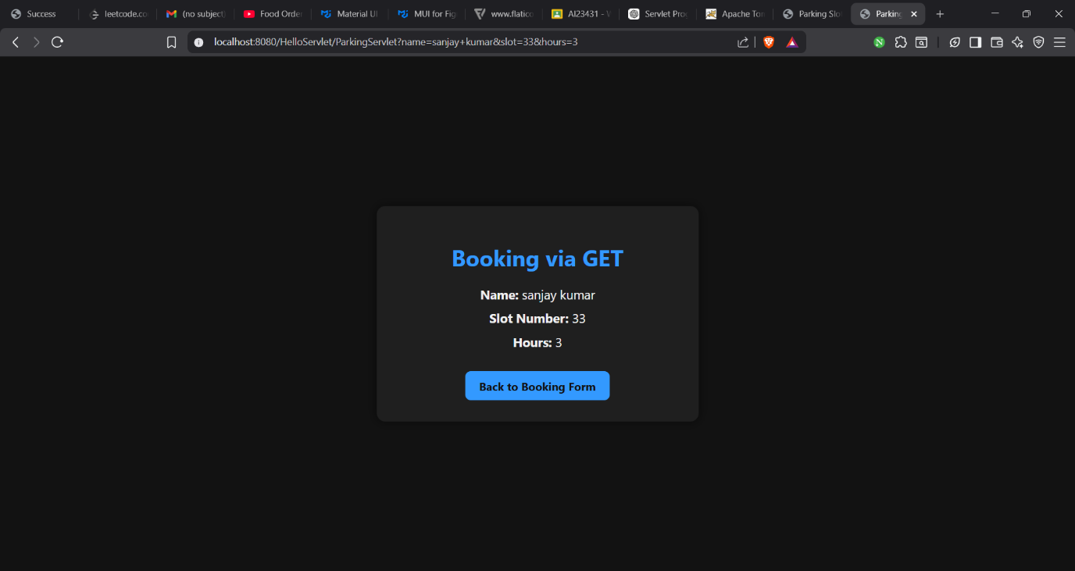
RESULT:
A Servlet is created to demonstrate the difference between HTTP GET and POST methods by creating a form and handling requests accordingly.

