EXP.NO: 6 | Write a Servlet to demonstrate session tracking using HttpSession.
DATE:26/03/2025

AIM:
To demonstrate session tracking using HttpSession in a Servlet-based web application. The exercise involves implementing a simple login system where a user can log in with their username and password, and their session will be tracked throughout their interaction with the web application.
ALGORITHM:
1. Input:
- The user will enter their username and password in a login form.
- The servlet will validate the credentials and create an HTTP session for the user if authentication is successful.

2. Steps for Implementing Session Tracking with HttpSession:
- Create the Login Form (HTML):
  - Create an HTML form with two input fields for username and password.
  - Provide a submit button to send the data to the servlet for authentication.
- Create the Login Servlet:
  - Write a Java servlet class to handle login requests.
  - The servlet will:
    - Retrieve the username and password from the form.
    - Authenticate the user by comparing the credentials to a stored value (e.g., hardcoded or from a database).
    - Create a new HTTP session for the user if the credentials are valid.
    - Set session attributes such as the user's username to track the session.
- Validate User Credentials:
  - In the servlet, check if the username and password match the expected values.
  - If valid, create a session and store the username in the session.
  - If invalid, redirect the user back to the login page with an error message.
- Create and Track User Session:
  - Upon successful login, use the HttpSession object to store the session data.
  - Use the session.setAttribute("username", username) method to save the username.
  - Optionally, set session timeout using session.setMaxInactiveInterval(time_in_seconds) to manage session expiration.
- Redirect to a Protected Page:
  - After a successful login, the user will be redirected to a protected page (e.g., a dashboard or home page).
  - The protected page should check if the user is authenticated by checking the session attribute.
- Logout and Session Invalidation:
  - Provide a logout feature that invalidates the session using session.invalidate() when the user logs out.
  - After logout, redirect the user back to the login page.
- Session Expiration:
  - If the session expires or the user manually logs out, the session will be invalidated, and the user will be redirected to the login page.
Code:
LoginServlet.java:
package com.example;

import java.io.IOException;
import javax.servlet.ServletException;
import javax.servlet.annotation.WebServlet;
import javax.servlet.http.*;

@WebServlet("/LoginServlet")
public class LoginServlet extends HttpServlet {

private static final long serialVersionUID = 1L;

protected void doPost(HttpServletRequest request, HttpServletResponse response)
throws ServletException, IOException {

String username = request.getParameter("username");
String password = request.getParameter("password");

if ("admin".equals(username) && "1234".equals(password)) {

HttpSession session = request.getSession();
session.setAttribute("username", username);

response.sendRedirect("home.jsp");

} else {
response.getWriter().println("Invalid login! <a href='login.html'>Try again</a>");
}
}
}
LogoutServlet.java:
package com.example;

import java.io.IOException;
import javax.servlet.ServletException;
import javax.servlet.annotation.WebServlet;
import javax.servlet.http.*;

@WebServlet("/LogoutServlet")
public class LogoutServlet extends HttpServlet {

private static final long serialVersionUID = 1L;

protected void doGet(HttpServletRequest request, HttpServletResponse response)
throws ServletException, IOException {

HttpSession session = request.getSession(false);

if (session != null) {
session.invalidate();
}

response.sendRedirect("login.html");
}
}
Login.html:
<!DOCTYPE html>
<html>
<head>
<title>Login</title>
<style>
body {
background-color: #0f172a;
font-family: Arial;
color: white;
display: flex;
justify-content: center;
align-items: center;
height: 100vh;
}

.container {
background-color: #020617;
padding: 30px;
border-radius: 8px;
text-align: center;
border: 1px solid #1e3a8a;
}

h2 {
color: #3b82f6;
margin-bottom: 20px;
}

input {
width: 85%;
padding: 10px;
margin: 10px 0;
border-radius: 5px;
border: 1px solid #1e3a8a;
background-color: #020617;
color: white;
}

input::placeholder {
color: #94a3b8;
}

input[type="submit"] {
background-color: #1d4ed8;
border: none;
cursor: pointer;
}

input[type="submit"]:hover {
background-color: #2563eb;
}
</style>
</head>
<body>

<div class="container">
<h2>Login</h2>
<form action="LoginServlet" method="post">
<input type="text" name="username" placeholder="Username"><br>
<input type="password" name="password" placeholder="Password"><br>
<input type="submit" value="Login">
</form>
</div>

</body>
</html>

Home.jsp:
<%
if (session.getAttribute("username") == null) {
response.sendRedirect("login.html");
return;
}

String user = (String) session.getAttribute("username");
%>

<!DOCTYPE html>
<html>
<head>
<title>Home</title>
<style>
body {
background-color: #0f172a;
font-family: Arial;
color: white;
display: flex;
justify-content: center;
align-items: center;
height: 100vh;
}

.container {
background-color: #020617;
padding: 30px;
border-radius: 8px;
text-align: center;
border: 1px solid #1e3a8a;
}

h2 {
color: #3b82f6;
}

a {
display: inline-block;
margin-top: 20px;
padding: 10px 20px;
background-color: #1d4ed8;
color: white;
text-decoration: none;
border-radius: 5px;
}

a:hover {
background-color: #2563eb;
}
</style>
</head>
<body>

<div class="container">
<h2>Welcome <%= user %></h2>
<a href="LogoutServlet">Logout</a>
</div>

</body>
</html>

Output:

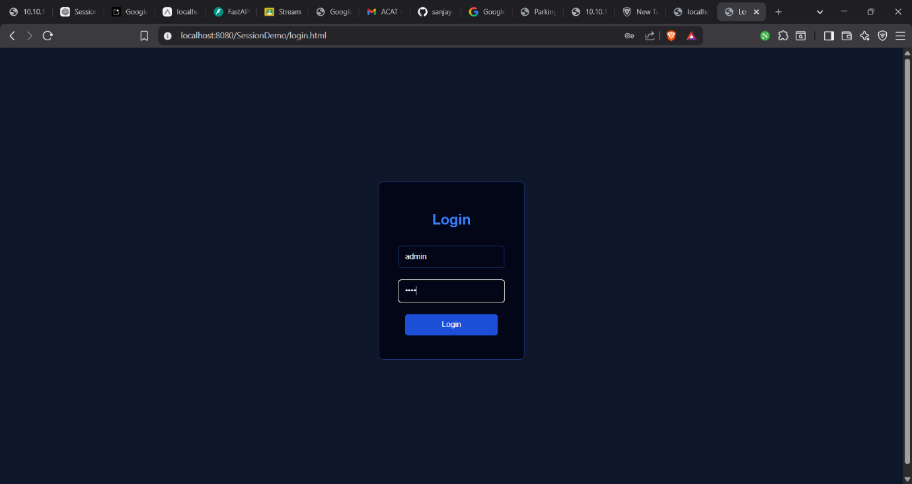

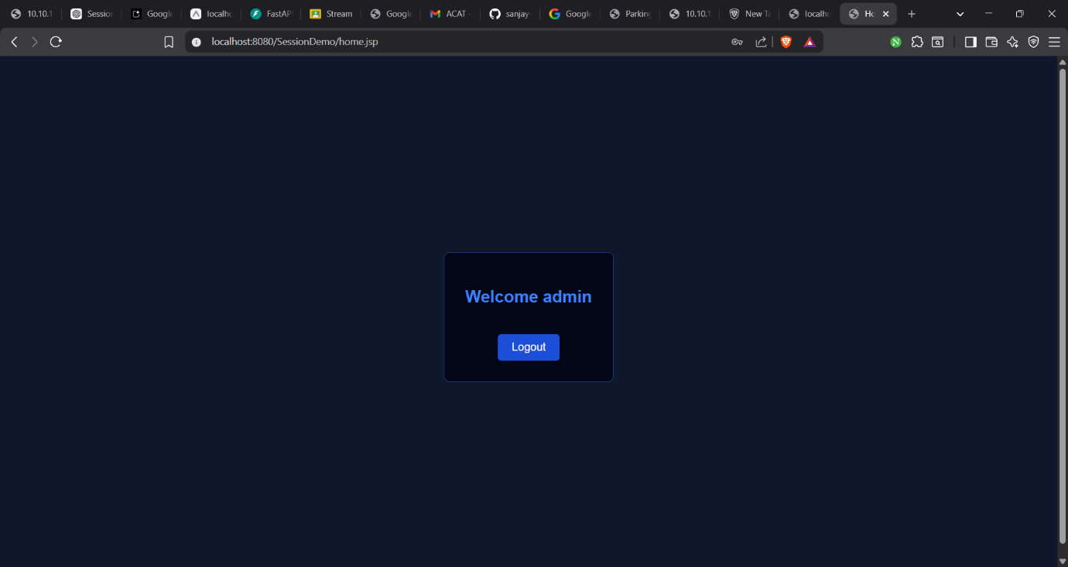

RESULT:
A simple login system is created where the user's session is tracked by a servlet to demonstrate session tracking using HttpSession.

