7. Write a Servlet program to store a user's preferences (like theme or language) using cookies. Retrieve and display these preferences on
subsequent visits.

AIM
To develop a Java Servlet-based web application that stores user preferences (such as theme and language) using cookies and retrieves them on subsequent visits to personalize the weather information webpage.

ALGORITHM
- Create a Dynamic Web Project in Eclipse or any IDE.
- Add Servlet API library (Apache Tomcat server).
- Create an HTML form to accept user preferences: Theme (Light/Dark)
Language (English/Tamil/etc.)
- Develop a Servlet (PreferenceServlet): Read user inputs from the form.
Store preferences using cookies.
- Develop another Servlet (DisplayServlet): Retrieve cookies.
Display saved preferences along with weather info.
- Configure web.xml (if not using annotations).
- Run the project on server (Tomcat).
- Test in browser:
First visit → set preferences.
Next visit → preferences auto-loaded.

SOURCE CODE

HTML Page (index.html)
<!DOCTYPE html>
<html>
<head>
<title>Parking Booking</title>
<style>
body {
background-color: #0f172a;
font-family: Arial;
color: white;
display: flex;
justify-content: center;
align-items: center;
height: 100vh;
}

.container {
background-color: #020617;
padding: 30px;
border-radius: 8px;
border: 1px solid #1e3a8a;
width: 300px;
text-align: center;
}

h2 {
color: #3b82f6;
margin-bottom: 20px;
}

select {
width: 100%;
padding: 10px;
margin: 10px 0;
background-color: #020617;
color: white;
border: 1px solid #1e3a8a;
border-radius: 5px;
}

input[type="submit"] {
width: 100%;
padding: 10px;
background-color: #1d4ed8;
border: none;
color: white;
border-radius: 5px;
cursor: pointer;
}

input[type="submit"]:hover {
background-color: #2563eb;
}
</style>
</head>
<body>

<div class="container">
<h2>Parking Booking</h2>

<form action="ParkingServlet" method="post">

<label>Select Slot</label>
<select name="slot">
<option value="A1">A1</option>
<option value="A2">A2</option>
<option value="B1">B1</option>
</select>

<label>Vehicle Type</label>
<select name="vehicle">
<option value="Car">Car</option>
<option value="Bike">Bike</option>
</select>

<input type="submit" value="Book Slot">

</form>
</div>

</body>
</html>

PreferenceServlet.java
package com.example;

import java.io.IOException;
import javax.servlet.ServletException;
import javax.servlet.annotation.WebServlet;
import javax.servlet.http.*;

@WebServlet("/ParkingServlet")
public class ParkingServlet extends HttpServlet {

private static final long serialVersionUID = 1L;

// SAVE BOOKING
protected void doPost(HttpServletRequest request, HttpServletResponse response)
throws ServletException, IOException {

String slot = request.getParameter("slot");
String vehicle = request.getParameter("vehicle");

// Create cookies
Cookie slotCookie = new Cookie("slot", slot);
Cookie vehicleCookie = new Cookie("vehicle", vehicle);

slotCookie.setMaxAge(24 * 60 * 60);
vehicleCookie.setMaxAge(24 * 60 * 60);

response.addCookie(slotCookie);
response.addCookie(vehicleCookie);

response.setContentType("text/html");

response.getWriter().println(
"<html><head><style>" +
"body{background:#0f172a;color:white;font-family:Arial;text-align:center;padding-top:100px;}" +
".box{background:#020617;padding:30px;border-radius:8px;border:1px solid #1e3a8a;display:inline-block;}" +
"h2{color:#3b82f6;}" +
"a{display:inline-block;margin-top:15px;padding:10px 20px;background:#1d4ed8;color:white;text-decoration:none;border-radius:5px;}" +
"a:hover{background:#2563eb;}" +
"</style></head><body>" +

"<div class='box'>" +
"<h2>Slot Booked Successfully!</h2>" +
"Slot: " + slot + "<br><br>" +
"Vehicle: " + vehicle + "<br>" +
"<a href='ParkingServlet'>View Booking</a>" +
"</div>" +

"</body></html>"
);
}

// VIEW BOOKING
protected void doGet(HttpServletRequest request, HttpServletResponse response)
throws ServletException, IOException {

Cookie[] cookies = request.getCookies();

String slot = "Not booked";
String vehicle = "Not selected";

if (cookies != null) {
for (Cookie c : cookies) {
if (c.getName().equals("slot")) {
slot = c.getValue();
}
if (c.getName().equals("vehicle")) {
vehicle = c.getValue();
}
}
}

response.setContentType("text/html");

response.getWriter().println(
"<html><head><style>" +
"body{background:#0f172a;color:white;font-family:Arial;text-align:center;padding-top:100px;}" +
".box{background:#020617;padding:30px;border-radius:8px;border:1px solid #1e3a8a;display:inline-block;}" +
"h2{color:#3b82f6;}" +
"a{display:inline-block;margin-top:15px;padding:10px 20px;background:#1d4ed8;color:white;text-decoration:none;border-radius:5px;}" +
"a:hover{background:#2563eb;}" +
"</style></head><body>" +

"<div class='box'>" +
"<h2>Your Parking Details</h2>" +
"Slot: " + slot + "<br><br>" +
"Vehicle: " + vehicle + "<br>" +
"<a href='index.html'>Book Again</a>" +
"</div>" +

"</body></html>"
);
}
}

OUTPUT :
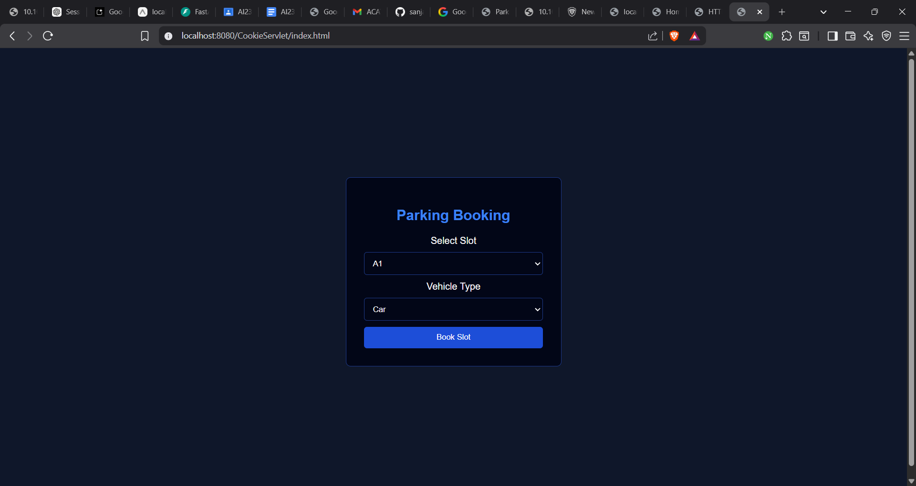

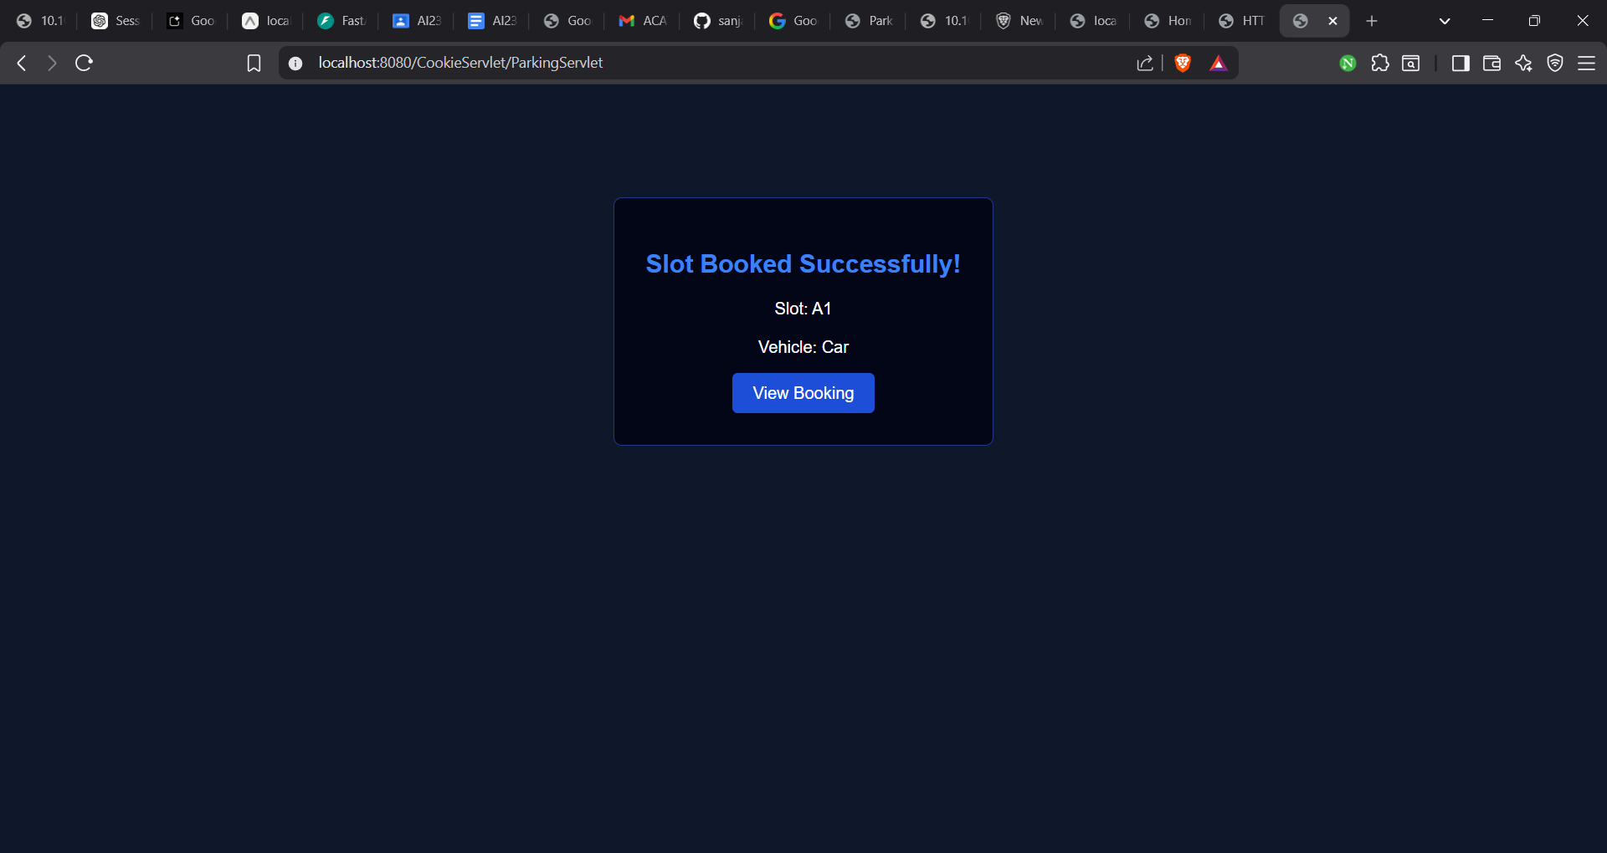

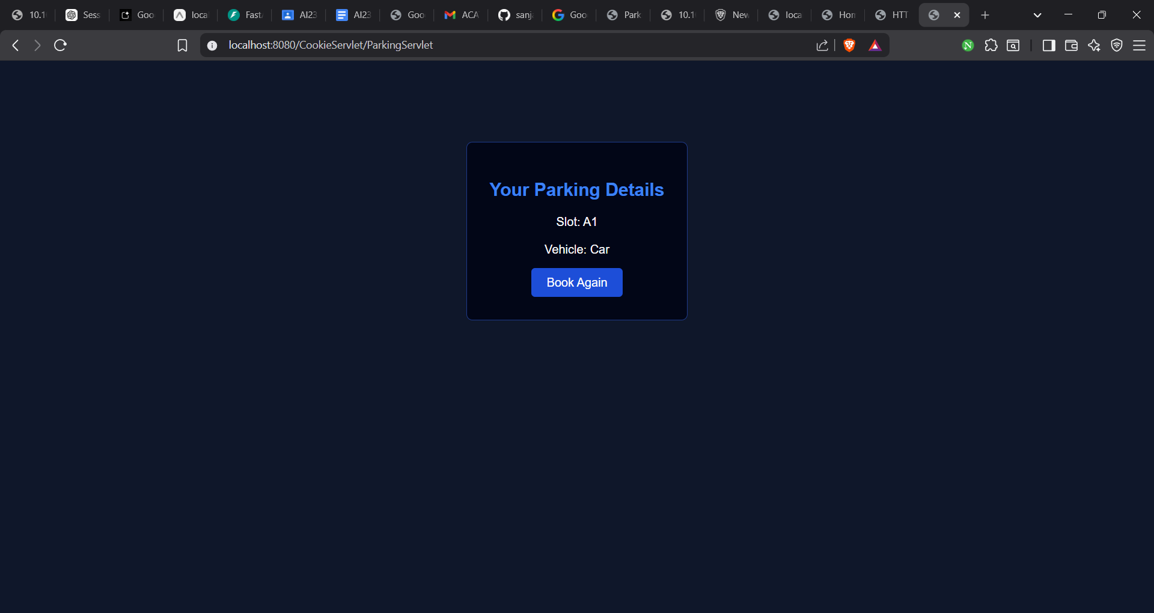
Result:
The experiment was successfully completed.User preferences (theme and language) were stored using cookies and retrieved on subsequent visits, allowing the weather webpage to provide a personalized user experience.

