Consider a Library Management System. Develop a JavaScript program that will validate the controls in the forms you have created for the application. State the assumptions you make (business logic you are taking into consideration).

Aim:
To develop a web-based Library Management System that validates user inputs using JavaScript and connects to a database using Servlets and JSP, while also demonstrating a simple Weather Information Webpage UI.

Procedure:
  - Create an HTML webpage for Library Management System.
  - Design a form to add books/users.
  - Apply JavaScript validation for all fields.
  - Create a JSP page to display data.
  - Develop a Servlet to handle form submission.
  - Connect the application to a MySQL database.
  - Insert validated data into the database.
  - Run the project on a server (e.g., Apache Tomcat).
  - Display success or error messages.

Code:
- Booking.html
<!DOCTYPE html>
<html>
<head>
<title>Parking Booking</title>

<style>
body {
background:#0f172a;
color:white;
font-family:Arial;
display:flex;
justify-content:center;
align-items:center;
height:100vh;
}

.box {
background:#020617;
padding:30px;
border-radius:8px;
border:1px solid #1e3a8a;
width:300px;
text-align:center;
}

h2 {
color:#3b82f6;
}

input, select {
width:100%;
padding:10px;
margin:10px 0;
background:#020617;
color:white;
border:1px solid #1e3a8a;
border-radius:5px;
}

button {
width:100%;
padding:10px;
background:#1d4ed8;
color:white;
border:none;
border-radius:5px;
cursor:pointer;
}

button:hover {
background:#2563eb;
}
</style>

<script>
function validateForm() {

let name = document.forms["form"]["name"].value;
let vehicle = document.forms["form"]["vehicleNo"].value;

let pattern = /^[A-Z]{2}-\d{2}-[A-Z]{2}-\d{4}$/;

if (name.trim() === "") {
alert("Name is required");
return false;
}

if (!pattern.test(vehicle)) {
alert("Invalid Vehicle Number (Ex: TN-01-AB-1234)");
return false;
}

return true;
}
</script>

</head>
<body>

<div class="box">
<h2>Parking Booking</h2>

<form name="form" action="BookingServlet" method="post" onsubmit="return validateForm()">

<input type="text" name="name" placeholder="Enter Name" required>

<input type="text" name="vehicleNo" placeholder="TN-01-AB-1234" required>

<select name="slot">
<option value="A1">A1</option>
<option value="A2">A2</option>
<option value="B1">B1</option>
</select>

<select name="type">
<option value="Car">Car</option>
<option value="Bike">Bike</option>
</select>

<button type="submit">Book Slot</button>

</form>
</div>

</body>
</html>

2. BookingServlet.java
package com.example;

import java.io.*;
import javax.servlet.*;
import javax.servlet.annotation.WebServlet;
import javax.servlet.http.*;
import java.sql.*;

@WebServlet("/BookingServlet")
public class BookingServlet extends HttpServlet {

private static final long serialVersionUID = 1L;

protected void doPost(HttpServletRequest request, HttpServletResponse response)
throws ServletException, IOException {

String name = request.getParameter("name");
String vehicle = request.getParameter("vehicleNo");
String slot = request.getParameter("slot");
String type = request.getParameter("type");

try {
Class.forName("com.mysql.cj.jdbc.Driver");

Connection con = DriverManager.getConnection(
"jdbc:mysql://localhost:3306/parking", "root", "YOUR_PASSWORD");

PreparedStatement ps = con.prepareStatement(
"insert into booking values(?,?,?,?)");

ps.setString(1, name);
ps.setString(2, vehicle);
ps.setString(3, slot);
ps.setString(4, type);

ps.executeUpdate();

// SEND DATA TO JSP
request.setAttribute("name", name);
request.setAttribute("vehicle", vehicle);
request.setAttribute("slot", slot);
request.setAttribute("type", type);

RequestDispatcher rd = request.getRequestDispatcher("result.jsp");
rd.forward(request, response);

} catch (Exception e) {
e.printStackTrace();
}
}
}

3. result.jsp

<%@ page language="java" contentType="text/html; charset=UTF-8" %>
<!DOCTYPE html>
<html>
<head>
<title>Booking Result</title>

<style>
body{
background:#0f172a;
color:white;
font-family:Arial;
text-align:center;
padding-top:100px;
}

.box{
background:#020617;
padding:30px;
border-radius:8px;
border:1px solid #1e3a8a;
display:inline-block;
}

h2{
color:#3b82f6;
}

p{
margin:10px 0;
}

a{
display:inline-block;
margin-top:15px;
padding:10px 20px;
background:#1d4ed8;
color:white;
text-decoration:none;
border-radius:5px;
}

a:hover{
background:#2563eb;
}
</style>

</head>
<body>

<div class="box">
<h2>Booking Successful</h2>

<p><b>Name:</b> ${name}</p>
<p><b>Vehicle No:</b> ${vehicle}</p>
<p><b>Slot:</b> ${slot}</p>
<p><b>Type:</b> ${type}</p>

<a href="booking.html">Book Again</a>

</div>

</body>
</html

Output

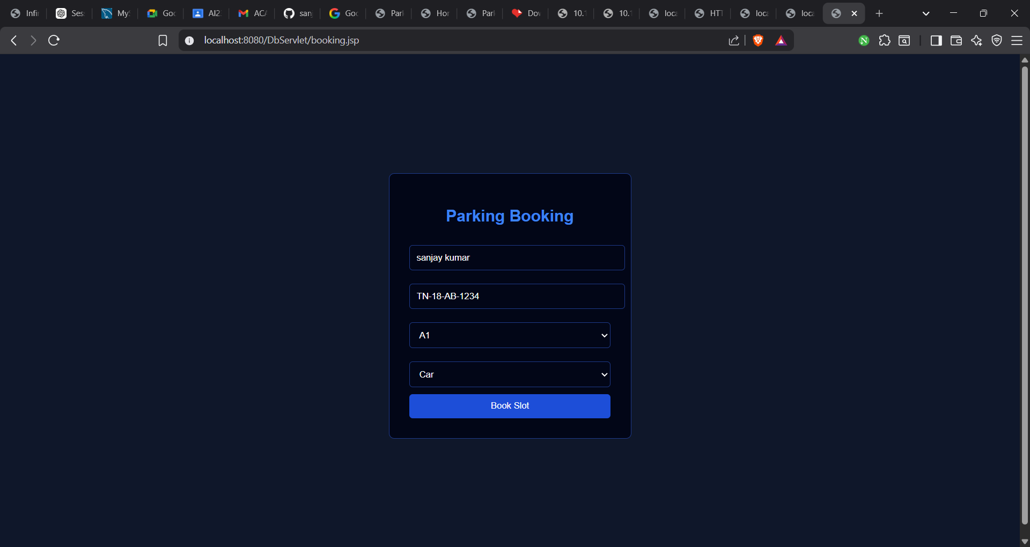

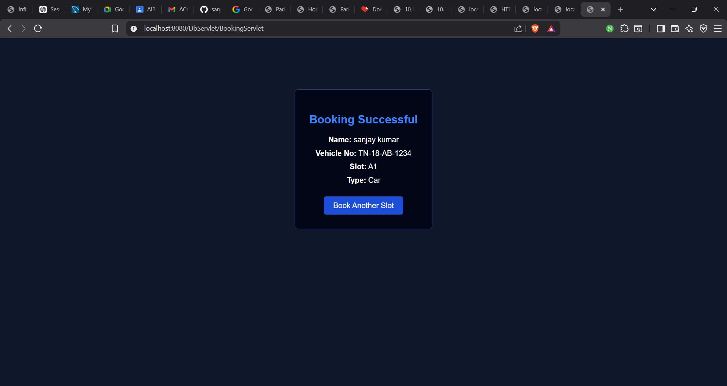

Result:
Thus, the Library Management System with JavaScript validation and database connectivity using Servlet and JSP was successfully developed and executed.

