STUDENT ATTENDANCE MANAGEMENT SYSTEM

AI23431- WEBTECHNOLOGY AND MOBILE APPLICATION
PROJECT REPORT
SUBMITTED BY

-SANJAY KUMAR R (241501181)
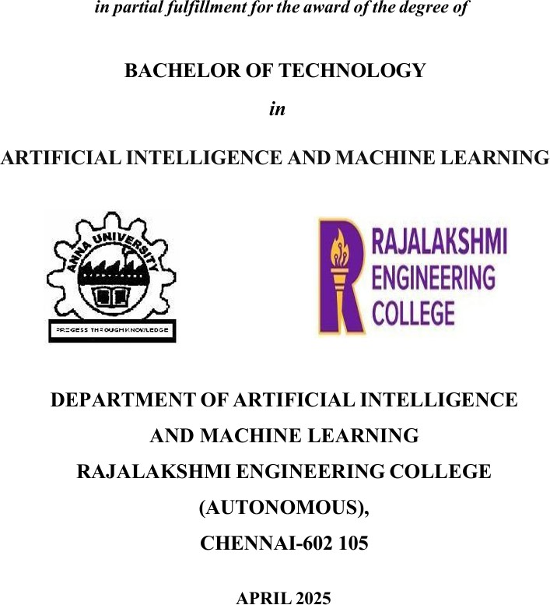

RAJALAKSHMI ENGINEERING COLLEGE

(an Autonomous Institution Affiliated to Anna University, Chennai)

BONAFIDE CERTIFICATE
Certified that this Project Thesis titled “PARKING MANAGEMENT SYSTEM (ParkEZ)” is the Bonafide work of SANJAY KUMAR R (211624150181) who carried out the work under my supervision. Certified further that to the best of my knowledge the work reported here in does not form part of any other thesis or dissertation on the basis of which a degree or award was conferred on an earlier occasion on this or any other candidate.

Mrs .J .SANGEETHA ARCHANA, M.E.,
Assistant Professor ,
Department of Artificial Intelligence and Machine Learning,
Rajalakshmi Engineering College, Chennai - 602105.

Submitted to Project Viva-Voce Examination held on

INTERNAL EXAMINER EXTERNAL EXAMINER

ACKNOWLEDGEMENT

Initially we thank the Almighty for being with us through every walk of our life and showering his blessings through the endeavor to put forth this report. Our sincere thanks to our Chairman Mr. S.MEGANATHAN, B.E, F.I.E., our Vice Chairman Mr. ABHAY SHANKAR MEGANATHAN, B.E., M.S., and our
respected Chairperson Dr. (Mrs.) THANGAM MEGANATHAN, Ph.D., for providing us with the requisite infrastructure and sincere endeavoring in educating us in their premier institution.

Our sincere thanks to Dr. S.N. MURUGESAN, M.E., Ph.D., our beloved Principal for his kind support and facilities provided to complete our work in time. We express our sincere thanks to Dr. K. SEKAR, Ph.D., Professor and Head of the Department of Artificial Intelligence and Machine Learning for his guidance and encouragement throughout the project work. We convey our sincere and deepest gratitude to our internal guide, Mrs .J .SANGEETHA ARCHANA, Department of Artificial Intelligence and Machine Learning for his useful tips during our review to build our project.

Sanjay Kumar R -241501181

DEPARTMENT VISION

To promote highly Ethical and Innovative Computer Professionals through excellence in teaching, training and research.

DEPARTMENT MISSION
- To produce globally competent professionals who are motivated to learn emerging technologies and demonstrate innovation in solving real-world problems.
- To promote research activities among students and faculty members that contribute meaningfully to society.
- To instill strong moral and ethical values in professional practice.

PROGRAMME EDUCATIONAL OBJECTIVES(PEO’S)

PEO 1: To equip students with essential background in computer science, basic electronics and applied mathematics.
PEO 2: To prepare students with fundamental knowledge in programming languages, and tools and enable them to develop applications.
PEO 3: To encourage the research abilities and innovative project development in the field of AI, ML, DL, networking, security, web development, Data Science and also emerging technologies for the cause of social benefit.
PEO 4: To develop professionally ethical individuals enhanced with analytical skills, communication skills and organizing ability to meet industry.

PROGRAMME OUTCOMES (POs)

PO 1: Engineering knowledge: Apply the knowledge of Mathematics, Science, Engineering fundamentals, and an engineering specialization to the solution of complex engineering problems.

PO 2: Problem analysis: Identify, formulate, review research literature, and analyze complex engineering problems reaching substantiated conclusions using first principles of mathematics, natural sciences, and engineering sciences.

PO 3: Design/development of solutions: Design solutions for complex engineering problems and design system components or processes that meet the specified needs with appropriate consideration for the public health and safety, and the cultural, societal, and environmental considerations.

PO 4: Conduct investigations of complex problems: Use research-based knowledge and research methods including design of experiments, analysis and interpretation of data, and synthesis of the information to provide valid conclusions.

PO 5: Modern tool usage: Create, select, and apply appropriate techniques, resources, and modern engineering and IT tools including prediction and modeling to complex engineering activities with an understanding of the limitations.

PO 6: The engineer and society: Apply reasoning informed by the contextual knowledge to assess societal, health, safety, legal and cultural issues and the consequent responsibilities relevant to the professional engineering practice.

PO 7: Environment and sustainability: Understand the impact of the professional engineering solutions in societal and environmental contexts, and demonstrate the knowledge of, and need for sustainable development.
PO 8: Ethics: Apply ethical principles and commit to professional ethics and responsibilities and norms of the engineering practice.

PO 9: Individual and team work: Function effectively as an individual, and as a member or leader in diverse teams, and in multidisciplinary settings.

PO 10: Communication: Communicate effectively on complex engineering activities with the engineering community and with society at large, such as, being able to comprehend and write effective reports and design documentation, make effective presentations, and give and receive clear instructions.

PO 11: Project management and finance: Demonstrate knowledge and understanding of the engineering and management principles and apply these to one’s own work, as a member and leader in a team, to manage projects and in multidisciplinary environments.

PO 12: Life-long learning: Recognize the need for, and have the preparation and ability to engage in independent and life-long learning in the broadest context of technological change.

PROGRAM SPECIFIC OUTCOMES (PSOs)

A graduate of the Artificial Intelligence and Machine Learning Program will demonstrate

PSO 1: Foundation Skills: Ability to understand, analyze and develop computer programs in the areas related to algorithms, system software, web design, AI, machine learning, deep learning, data science, and networking

PSO 2: Problem-Solving Skills: Ability to apply mathematical methodologies to solve computational task, model real world problem using appropriate AI and ML algorithms. To understand the standard practices and strategies in project development, using open- ended programming environments to deliver a quality product.

PSO 3: Successful Progression: Ability to apply knowledge in various domains to identify research gaps and to provide solution to new ideas, inculcate passion towards higher studies, creating innovative career paths to be an entrepreneur and evolve as an ethically social responsible AI and ML professional.

COURSE OBJECTIVE

- To identify and formulate real-world problems that can be solved using Artificial Intelligence and Machine Learning techniques.
- To apply theoretical and practical knowledge of AI/ML for designing innovative, data-driven solutions.
- To integrate various tools, frameworks, and algorithms to develop, test, and validate AI/ML models.
- To demonstrate effective teamwork, project management, and communication skills through collaborative project execution.
- To instill awareness of ethical, societal, and environmental considerations in the design and deployment of intelligent systems.

COURSE OUTCOME

- CO 1: Analyze and define a real-world problem by identifying key challenges, project requirements and constraints.
- CO 2: Conduct a thorough literature review to evaluate existing solutions, identify research gaps and formulate research questions.
- CO 3: Develop a detailed project plan by defining objectives, setting timelines, and identifying key deliverables to guide the implementation process.
- CO 4: Design and implement a prototype or initial model based on the proposed solution framework using appropriate AI tools and technologies.

CO 5 : Demonstrate teamwork, communication, and project management skills by preparing and presenting a well-structured project proposal and initial implementation results

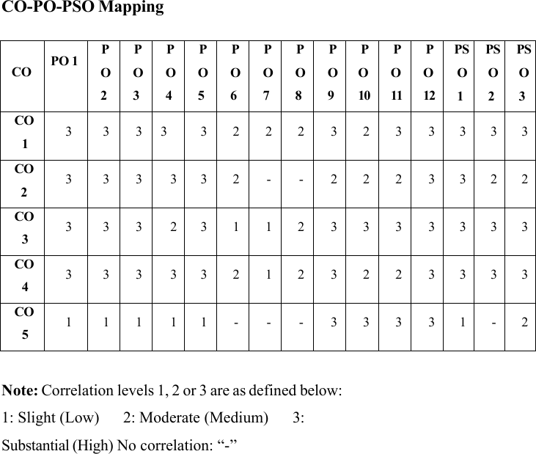

SUSTAINABLE DEVELOPMENT GOALS

SDG | GOAL | JUSTIFICATION
  SDG-4 | Quality Education | Education drives progress on other SDGs, breaks poverty cycles, and promotes peace and inequality reduction.
  SDG-8 | Decent Work and Economic Growth | Necessary for social stability, shared prosperity, and combating poverty.
  SDG-9 | Industry, Innovation, and Infrastructure | Infrastructure is vital for  economic growth and stability. It acts as a poverty reduction tool through job creation and  provides technological solutions to environmental challenges.
  SDG-17 | Partnerships for the Goals | Given the interconnected nature of the SDGs, success  requires collaborative action, global resource sharing, and bridging the immense financing gap faced by developing nations.

ABSTRACT

The ParkEZ Parking Management System presents a digital solution for efficiently managing, monitoring, and booking parking slots in urban areas and institutional environments. With the increasing demand for organized parking facilities and real-time availability tracking, the system is designed to replace traditional manual parking allocation methods with a secure, automated, and user-friendly web-based platform. The application enables users to view available parking slots in real time, select their preferred location, vehicle type, and time slot, and complete the booking process through an interactive interface. By integrating user authentication and session management, the system ensures secure access for registered users while maintaining the integrity of parking data.
The system includes features such as real-time slot visualization, time-based booking management, and automated availability updates to prevent slot conflicts and overbooking. Users can easily identify free, partially occupied, and fully occupied slots through a graphical interface, improving decision-making and reducing time spent searching for parking spaces. The system also ensures proper scheduling by associating bookings with specific time intervals, thereby preventing duplicate reservations and ensuring fair usage of parking resources. Additionally, booking history management allows users to track their previous reservations, improving transparency and accountability within the system.
The architecture of the ParkEZ system is designed to be lightweight, scalable, and efficient, allowing smooth operation on standard web browsers without requiring specialized hardware or complex infrastructure. By maintaining structured data handling and dynamic updates, the system provides accurate and real-time parking information to users. The interface is designed to be intuitive and responsive, ensuring ease of use across different devices. Overall, the ParkEZ Parking Management System improves parking efficiency, reduces congestion, minimizes time wastage, and enhances user convenience by providing a reliable and automated parking management solution suitable for modern smart environments.

SI NO | TITLE | PAGE NO
 | AKNOWLEDGEMENT | iii
 | ABSTRACT | xi
 | LIST OF ABBREVIATIONS | xiv
1 | INTRODUCTION | 1
1.1 | General | 1
1.2 | Need for Online Parking Management System | 1
1.3 | Scope of the System | 2
1.4 | Organization of the Report | 2
2 | LITERATURE SURVEY | 3
2.1 | Introduction | 3
2.2 | Existing Attendance Management Systems | 3
2.3 | Related Work | 4
2.4 | Summary | 4
3 | PROBLEM FORMULATION AND OBJECTIVES | 5
3.1 | Problem Statement | 5
3.2 | Objectives of the System | 5
4 | SYSTEM DESIGN | 6
4.1 | Introduction | 6
4.2 | System Architecture | 6
4.3 | Database Design | 7
4.4 | System Requirements | 7
4.4.1 | Hardware Requirements | 7
4.4.2 | Software Requirements | 7

SI NO | TITLE | PAGE NO
5 | SYSTEM IMPLEMENTATION | 8
5.1 | System Methodology | 8
5.2 | Module Descriptions | 9
5.2.1 | Student Module | 10
5.2.2 | Faculty Module | 11
5.2.2.1 | “Automated subject detection” | 12
5.2.3 | Attendance Management Module | 13
5.2.4 | Login and Authentication Module | 15
5.2.5 | Email Notification Module | 17
5.2.6 | Chat Communication Module | 19
6 | RESULTS AND DISCUSSION | 20
6.1 | System Output Screens | 20
6.2 | Performance Evaluation | 20
6.3 | System Testing | 21
7 | CONCLUSION AND FUTURE WORK | 22
7.1 | Conclusion | 22
7.2 | Future Enhancements | 23
 | REFERENCES | 24
 | APPENDICES | 25
 | Source Code | 25

LIST OF ABBREVIATIONS

PMS – Parking Management System
UI – User Interface
HTML – HyperText Markup Language
CSS – Cascading Style Sheets
JS – JavaScript
API – Application Programming Interface
DB – Database
CRUD – Create, Read, Update, Delete

CHAPTER 1

INTRODUCTION

General

Parking management plays an important role in urban infrastructure and institutional environments as it helps in organizing vehicle flow and ensuring efficient utilization of available parking space. Traditionally, parking allocation is handled manually or through physical supervision, which can be time-consuming, inefficient, and prone to confusion during peak hours. Manual systems also make it difficult to track real-time availability of parking slots and manage bookings effectively.
The ParkEZ Parking Management System is designed to automate the process of parking slot allocation and booking using a digital web-based platform. The system allows users to view real-time parking slot availability, select preferred slots, choose vehicle types, and book parking spaces for specific time durations. By providing a visual representation of parking slots, the system ensures clarity and improves user experience.
This system also reduces congestion in parking areas and eliminates the need for manual coordination. With features such as real-time slot status updates, time-based booking, and user authentication, the system simplifies parking management and improves overall efficiency in both public and institutional environments.

Need for ParkEZ System

Many urban and institutional parking areas still rely on manual monitoring or unorganized parking allocation methods, which lead to several challenges such as improper space utilization, time delays in finding parking slots, and lack of real-time availability information.
A digital parking management system helps overcome these limitations by providing an automated and efficient solution. Users can easily check available slots, book parking spaces in advance, and avoid unnecessary waiting time. The system stores all booking data in a structured manner, ensuring accurate tracking and easy retrieval of parking information.
The system improves transparency, reduces traffic congestion inside parking areas, and minimizes human intervention in slot allocation. Additionally, it helps administrators manage parking resources effectively by providing a clear overview of occupied and available slots, enabling better planning and utilization of parking infrastructure.

Scope of the System

The ParkEZ Parking Management System is developed to simplify the process of parking slot allocation, booking, and monitoring in various environments such as colleges, malls, hospitals, and smart city infrastructures.
The system provides separate access for users through a secure interface where they can select location, vehicle type, and time slots for booking. Users can view real-time parking availability and manage their bookings efficiently. The system maintains a centralized data structure that stores all parking and booking information in an organized manner.
The scope of the system includes improving parking efficiency, reducing traffic congestion within parking zones, and providing easy access to parking slot information for users. It can be implemented in multiple environments to streamline parking management and support smart infrastructure development.

Organization of the Report

This report is organized into several chapters that describe the development and implementation of the ParkEZ Parking Management System.
Chapter 1: provides the introduction to the project, including the general overview, need for the system, and scope of the project.
Chapter 2: presents the literature survey, which discusses existing parking management systems and related work.
Chapter 3: explains the problem formulation and objectives of the proposed system.
Chapter 4: describes the system design, including architecture and system requirements.
Chapter 5: discusses the implementation of the system and explains the different modules.
Chapter 6: presents the results and performance evaluation of the system.
Chapter 7: concludes the project and discusses possible future enhancements.

CHAPTER 2

LITERATURE SURVEY

2.1 Introduction
Parking management is an essential aspect of urban infrastructure and institutional planning as it helps in organizing vehicle flow and ensuring efficient utilization of available parking spaces. Traditional parking systems often rely on manual supervision or physical allocation, which can be time-consuming, inefficient, and prone to errors during peak hours. These methods also make it difficult to track real-time availability of parking slots and manage reservations effectively.
With the advancement of technology, several smart parking management systems have been developed to improve efficiency and accuracy in parking allocation. Recent studies highlight the increasing use of digital technologies such as web-based applications, IoT-based sensors, mobile applications, and automated booking systems to manage parking spaces. These systems aim to reduce manual intervention, improve user convenience, and provide real-time parking information.

2.2 Existing Parking Management Systems
Many parking facilities have adopted automated systems to replace traditional manual methods. Some systems use sensor-based technologies where parking slots are equipped with IoT sensors to detect vehicle presence and update availability in real time. This approach improves accuracy but requires additional hardware installation and maintenance.
Other systems use RFID-based parking solutions, where vehicles or users are identified using RFID tags to allow entry and exit tracking. These systems help in controlled access but are less flexible for real-time slot visualization and pre-booking features.
Modern systems also include mobile-based parking applications that allow users to view available parking slots and book spaces in advance. However, many of these systems still depend on external hardware or complex infrastructure, making them less suitable for small-scale or cost-sensitive environments.

2.3 Related Work
Several research studies have proposed different approaches for smart parking management. A systematic analysis of smart parking systems shows that automation significantly improves parking efficiency, reduces congestion, and enhances user experience compared to manual methods.
Some studies focus on integrating IoT-based sensors to detect vehicle occupancy and provide real-time updates to users. Other approaches include cloud-based parking systems, which store parking data centrally and allow remote access for monitoring and booking.
Research also highlights the use of machine learning and predictive models to estimate parking availability and optimize space utilization. These systems improve decision-making but often require complex infrastructure and high deployment costs.
Overall, existing research emphasizes the need for efficient, low-cost, and user-friendly parking systems that can operate without heavy hardware dependency.

2.4 Summary
From the literature survey, it is clear that automated parking management systems provide significant advantages over traditional manual parking methods. They improve efficiency, reduce congestion, enhance user convenience, and enable better utilization of parking spaces.
However, many existing systems depend on expensive hardware such as IoT sensors, RFID devices, or advanced infrastructure, which may not be feasible for all environments. Therefore, a web-based Parking Management System like ParkEZ provides a simple, cost-effective, and efficient solution that allows users to view real-time parking availability, book slots in advance, and manage parking digitally without requiring complex hardware systems.

CHAPTER 3

PROBLEM FORMULATION AND OBJECTIVES

Problem Statement

In many urban areas and institutional environments, parking management is still handled manually or through unorganized systems. This traditional method is inefficient and often leads to problems such as difficulty in finding available parking spaces, improper utilization of parking slots, and confusion during peak hours. Manual parking systems also make it challenging to track real-time availability and manage bookings effectively.
Users often waste significant time searching for parking spaces, which increases traffic congestion and reduces overall efficiency. Additionally, administrators face difficulties in monitoring slot occupancy and managing parking allocation manually, leading to reduced productivity and poor resource utilization.
Therefore, there is a need for an automated system that can simplify the process of viewing, booking, and managing parking slots. A digital ParkEZ Parking Management System can help provide real-time slot availability, enable advance booking, and improve overall parking efficiency while reducing manual intervention.

Objectives of the System

The main objective of the ParkEZ Parking Management System is to develop a digital platform that simplifies the process of parking slot management and booking. The system aims to provide an efficient and reliable way for users to check availability and reserve parking spaces.
The specific objectives of the system include:
• To display real-time parking slot availability in a structured format.
• To provide secure user access and session management.
• To allow users to book parking slots based on time and vehicle type.
• To reduce manual effort in parking allocation and management.
• To improve transparency and efficiency in parking utilization.

CHAPTER 4

SYSTEM DESIGN

Introduction

System design is an important phase in software development where the overall structure and components of the system are defined. It describes how different modules interact with each other and how data is processed and managed within the system. A well-structured design improves system performance, usability, and maintainability.
The ParkEZ Parking Management System is designed as a web-based application that allows users to view parking slots, select parking locations, and book slots for specific time durations. The system follows a client-side architecture where users interact through a web interface, and data is managed using local storage or backend services.

System Architecture

The system follows a three-layer architecture consisting of presentation layer, application layer, and data layer.
• Presentation Layer:
This layer represents the user interface where users interact with the system. It includes web pages such as landing page, parking grid view, booking interface, and dashboard developed using HTML, CSS, and JavaScript.
• Application Layer:
This layer handles the core logic of the system. It processes user interactions such as slot selection, time validation, booking confirmation, and status updates. It ensures proper management of parking availability and prevents booking conflicts.
• Data Layer:
This layer stores all parking-related information including slot status, booking details, user information, and time schedules. Data is managed either through a database or local storage depending on implementation.
This architecture ensures smooth communication between user interface and system logic while maintaining efficiency, accuracy, and real-time updates in parking management.

System Requirements

System requirements define the hardware and software resources needed to run the ParkEZ system efficiently.

4.3.1 Hardware Requirements
The ParkEZ system is lightweight and can run on standard systems without high-end specifications.
• Processor: Intel Core i3 or higher
• RAM: Minimum 4 GB
• Storage: 500 GB Hard Disk or SSD
• Input Devices: Keyboard and Mouse
• Internet Connection (optional for backend integration)

4.3.2 Software Requirements
The system is developed using commonly available web technologies and tools.
• Operating System: Windows 10 or later
• Frontend Technologies: HTML, CSS, JavaScript
• Backend Technology: Node.js (if used)
• Database: MySQL / Local Storage
• Development Environment: Visual Studio Code
• Web Browser: Google Chrome or any modern browser

CHAPTER 5
SYSTEM IMPLEMENTATION

System Methodology
The ParkEZ Parking Management System is implemented using a web-based approach that allows users to access the system through a browser. The development process involves designing an interactive user interface, implementing core parking functionalities, and managing user and booking data efficiently.
The frontend of the system is developed using HTML, CSS, and JavaScript, which provides a responsive and user-friendly interface for users to interact with different modules such as Home, Booking, History, and Direction. The system logic handles parking slot selection, time-based booking validation, and real-time updates of parking availability.
The system follows a modular approach where each feature such as Login, Signup, Home, Booking, History, and Direction is implemented as a separate module. This improves maintainability, scalability, and allows future enhancements like payment gateway integration, live GPS tracking, and smart parking automation.

5.2 Module Descriptions
The ParkEZ Parking Management System consists of several modules that work together to provide efficient parking management and a smooth user experience.

5.2.1 Signup Module
The Signup Module allows new users to create an account in the ParkEZ system. Users are required to provide basic details such as name, email, and password.
This module ensures that each user is uniquely registered in the system. The entered data is stored securely and used for future authentication and booking operations.
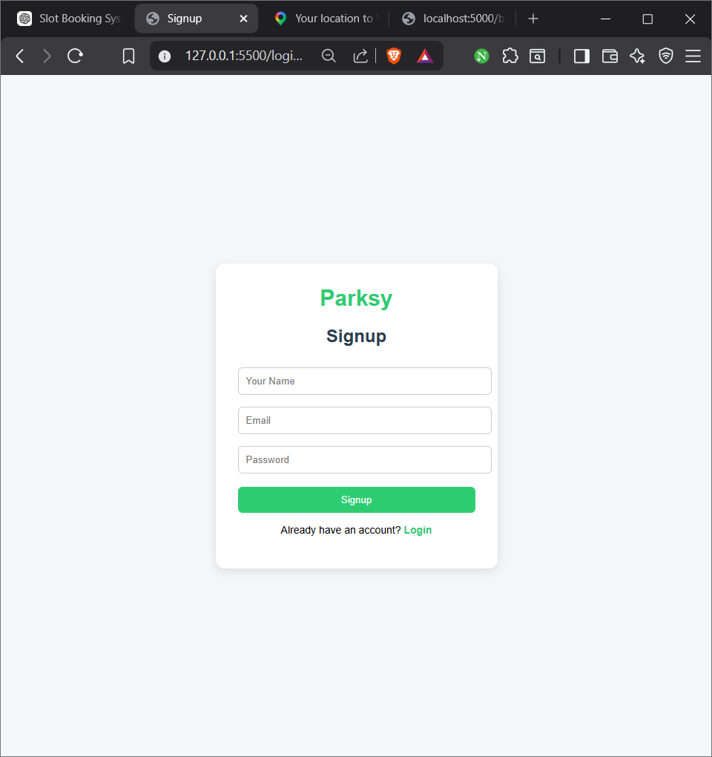

5.2.2 Login Module
The Login Module provides secure access to the system by verifying user credentials. Registered users can log in using their email and password.
This module ensures that only authenticated users can access parking features such as booking slots, viewing history, and accessing directions. It helps maintain system security and protects user data.
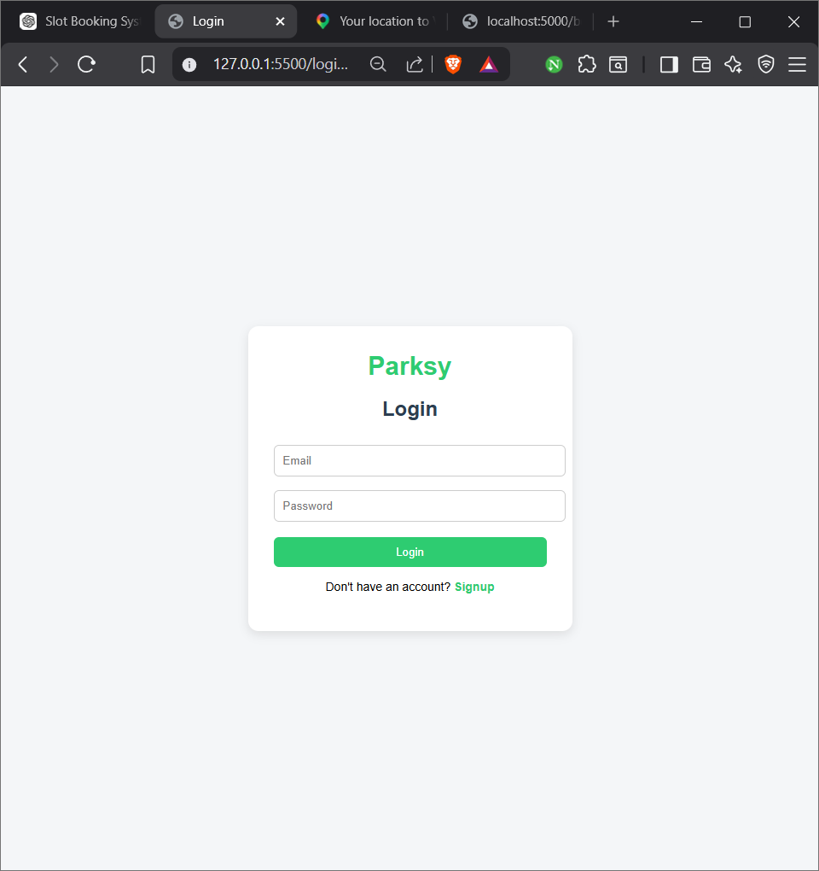

5.2.3 Home Module
The Home Module serves as the main dashboard of the ParkEZ system. It provides an overview of available parking slots, system features, and navigation options.
Users can view real-time parking availability and easily navigate to other modules such as Booking, History, and Direction. This module acts as the central entry point of the application.
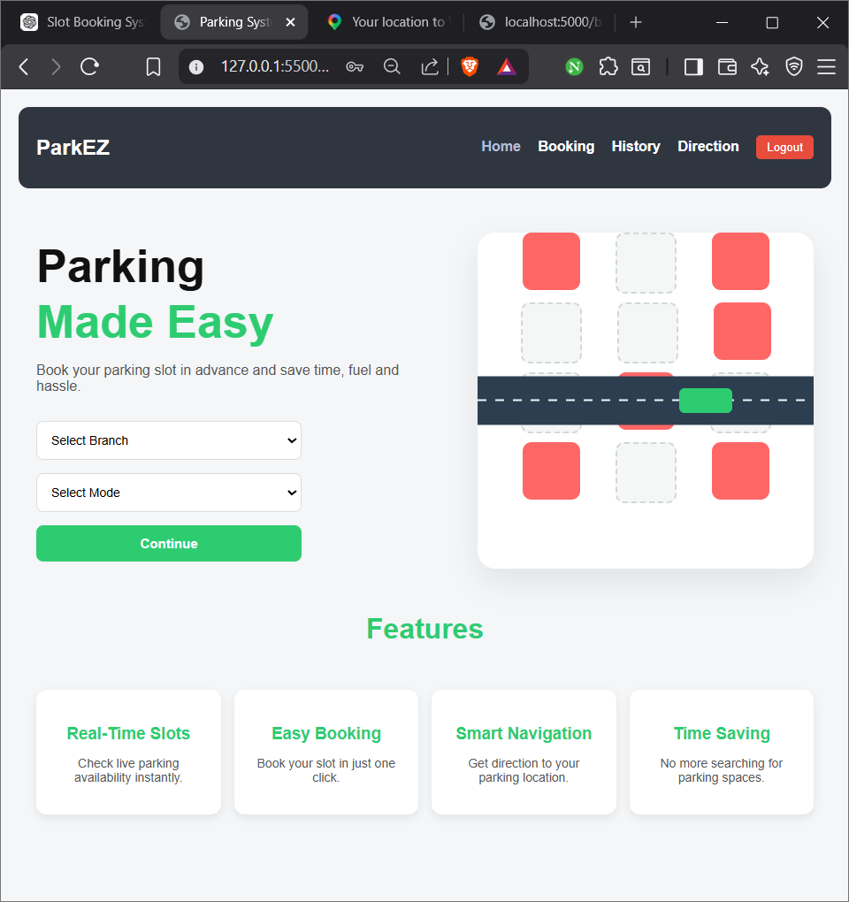

5.2.4 Booking Module
The Booking Module is the core component of the system. It allows users to select a parking slot, choose vehicle type, and book a time slot.
The system checks slot availability before confirming the booking and prevents overlapping reservations. Once confirmed, the booking details are stored, and the slot status is updated in real time. This ensures efficient and conflict-free parking allocation.
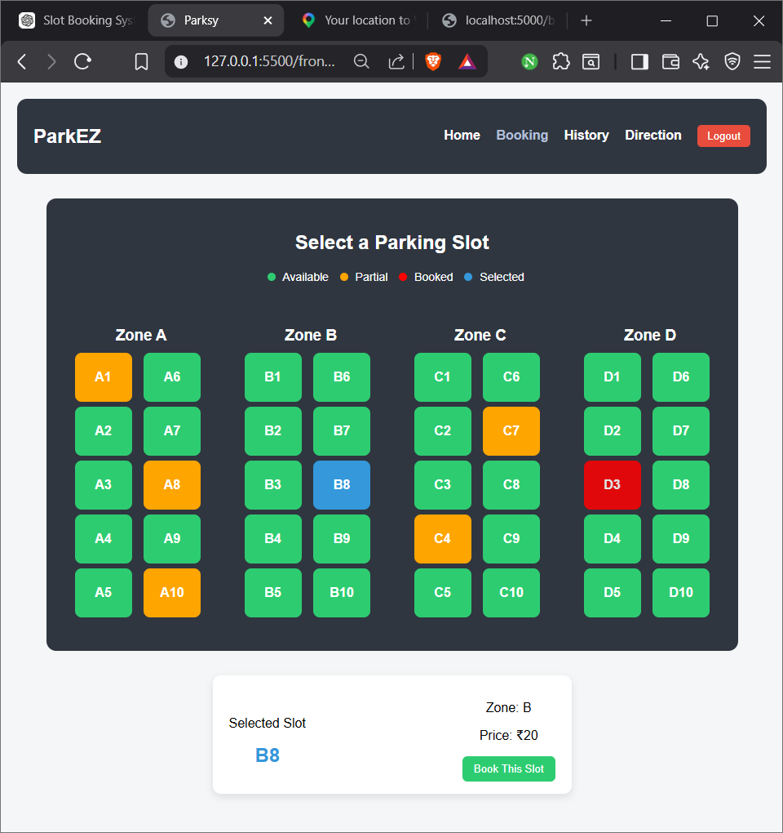

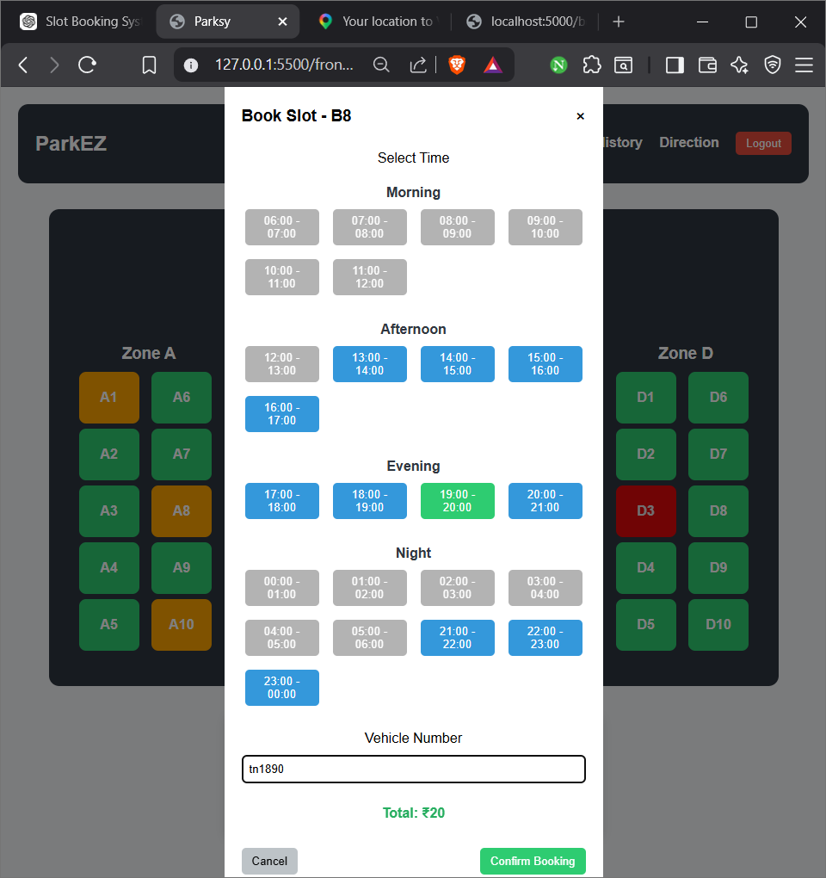

5.2.5 History Module
The History Module allows users to view their past parking bookings. It displays details such as slot number, booking time, vehicle type, and booking date.
This module helps users track their parking activity and manage previous bookings efficiently. It also ensures transparency and maintains a proper record of all user transactions within the system.
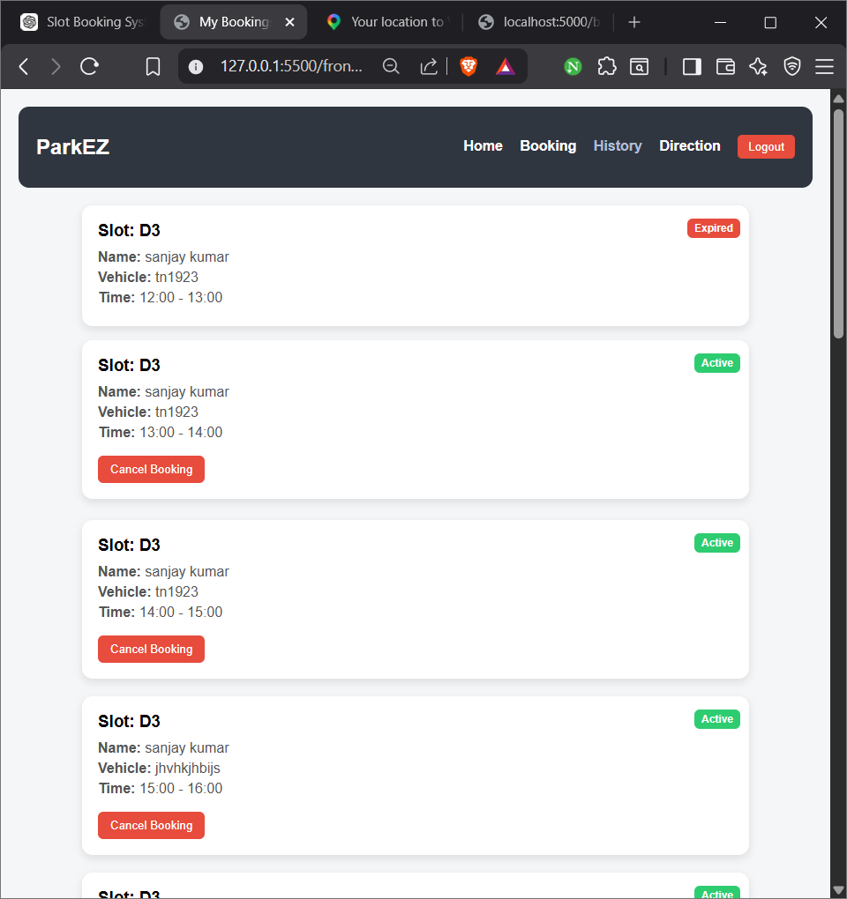

5.2.6 Direction Module
The Direction Module provides navigation support to users for reaching their selected parking location. It helps users find the exact parking area with ease.
This module improves user convenience by guiding them to the correct parking zone, reducing confusion and saving time during vehicle parking.

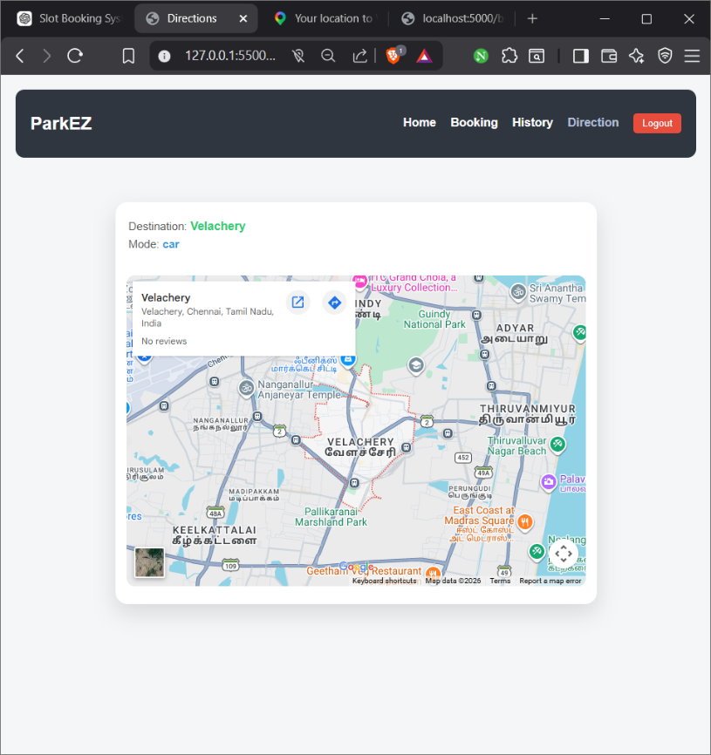

CHAPTER 6

RESULTS AND DISCUSSION

Results
The ParkEZ Parking Management System was successfully developed and tested using a web-based platform. The system allows users to register, log in, view available parking slots, book slots, check booking history, and access navigation directions through a secure and interactive dashboard.
During testing, the system performed efficiently in handling user authentication, slot selection, booking operations, and data retrieval. Users were able to view real-time parking availability and successfully book available slots based on time selection. The system ensured that booking details were stored correctly and updated dynamically in the interface.
The system also supports additional features such as booking history tracking and direction guidance to the parking location. These features improve user experience by providing transparency and helping users manage their parking activities effectively.
Overall, the implemented system successfully achieved its objective of simplifying parking management and reducing manual effort in parking allocation and tracking.

Performance Evaluation
The performance of the ParkEZ Parking Management System was evaluated based on usability, accuracy, and response time. The system provides a simple and user-friendly interface that allows users to easily navigate through Home, Booking, History, and Direction modules.
Parking slot data is managed efficiently, ensuring that slot availability is updated in real time and booking conflicts are avoided. The use of JavaScript-based logic enables fast processing of user actions such as slot selection, booking confirmation, and history retrieval.
Testing showed that the system performs well under normal usage conditions and provides reliable results for parking slot booking and management. The modular design ensures that new features such as payment integration or live tracking can be added in the future without affecting system performance.

Resource Utilization
The ParkEZ Parking Management System is designed to run on standard computer systems without requiring high-end hardware resources. The application uses lightweight web technologies such as HTML, CSS, and JavaScript for the frontend, ensuring smooth performance across devices.
The system efficiently manages booking and history data using optimized storage handling, ensuring minimal memory usage and fast data retrieval. Since the system is web-based, users can access it through a browser without installing additional software.
This makes the system lightweight, efficient, and suitable for real-time parking management in educational institutions, commercial complexes, or public parking areas.

CHAPTER 7

CONCLUSION AND FUTURE WORK

Conclusion
The ParkEZ Parking Management System was developed to provide an efficient and reliable solution for managing parking space allocation in a structured and automated manner. The system replaces traditional manual parking management methods with a digital platform that simplifies the process of viewing availability, booking slots, tracking history, and accessing directions.
The application allows users to register and log in securely, view available parking slots in real time, and book slots based on time selection. By maintaining booking data in a centralized system, the application ensures accuracy, transparency, and quick access to parking information whenever required.
The implementation of the system successfully reduces manual effort, avoids slot booking conflicts, and improves the overall efficiency of parking management. The web-based design makes the system user-friendly, accessible, and suitable for real-time parking operations.

Future Work
Although the current system provides essential parking management features, several enhancements can be implemented in the future to improve its functionality and scalability.
Future improvements may include integrating GPS-based live navigation to guide users directly to available parking slots. Mobile application support can also be developed to make the system more accessible on smartphones.
Additional features such as online payment integration, smart sensor-based slot detection, real-time parking availability updates using IoT devices, and AI-based parking prediction can further enhance the system.
These improvements will make the ParkEZ Parking Management System more advanced, intelligent, and suitable for large-scale deployment in smart cities, campuses, and commercial parking environments.

REFERENCES

[1] K. K. Delabaty and M. I. Al-Turaiki, “Automated Attendance Management Systems: A Systematic Literature Review,” Education and Information Technologies, vol. 27, no. 1, pp. 1–24, 2022.
[2] R. Want, “An Introduction to RFID Technology,” IEEE Pervasive Computing, vol. 5, no. 1, pp. 25–33, 2006.
[3] S. Zafar, G. Miraj, R. Baloch, D. Murtaza, and K. Arshad, “An RFID Based Attendance System for Educational Institutions,” International Journal of Computer Science Issues, vol. 12, no. 4, pp. 132–137, 2015.
[4] Node.js Foundation, “Node.js Documentation,” Available: https://nodejs.org
[5] MySQL Documentation, Oracle Corporation, “MySQL Reference Manual,” Available: https://dev.mysql.com/doc
[6] T. Berners-Lee, “HyperText Markup Language (HTML),” World Wide Web Consortium (W3C), Available: https://www.w3.org
[7] D. Flanagan, JavaScript: The Definitive Guide, 7th ed., O’Reilly Media, 2020.

APPENDICES

Appendix-1: Source Code Pseudocode

System Overview
The ParkEZ Parking Management System is developed to manage parking slot booking efficiently using an automated and structured process.
The system provides secure login access for all users and allows new users to register through a signup process.
Users can view available parking slots, book slots based on time selection, and check their booking history.
The system ensures that duplicate bookings are avoided and maintains accurate parking records.
The frontend provides a responsive interface, while the backend handles booking logic and data management.

System Initialization Logic
START
Connect to database
IF database connection is successful
→ Start server on port 3000
→ Load system homepage (Home Module)
ELSE
→ Display database connection error
END IF
END

User Signup Logic
FUNCTION Signup(name, email, password)
IF user does not exist in database
→ Insert user details into user table
→ Return “Signup successful”
ELSE
→ Return “User already exists”
END IF
END FUNCTION

User Login Logic
FUNCTION Login(email, password)
Check user table for matching email and password
IF credentials are valid
→ Create user session
→ Redirect to Home dashboard
ELSE
→ Display “Invalid login credentials”
END IF
END FUNCTION

Slot Booking Logic
FUNCTION BookSlot(slotId, userId, vehicle, time)
Check booking table for existing entry with same slotId and time
IF slot already booked
→ Return “Slot already booked”
ELSE
→ Insert new booking record
→ Update slot status
→ Return “Booking successful”
END IF
END FUNCTION

Booking History Logic
FUNCTION ViewHistory(userId)
Retrieve all booking records where userId = userId
Display:
→ Slot ID
→ Booking Date
→ Time Slot
→ Vehicle Details
END FUNCTION

Duplicate Booking Prevention Logic
Database Constraint: UNIQUE(slotId, time, date)
IF duplicate booking attempt occurs
→ Block insertion
→ Keep existing booking unchanged
END IF
Result: Ensures no overlapping or duplicate bookings.

Direction Module Logic
FUNCTION GetDirection(slotId)
Fetch parking location details for selected slot
Display navigation path to user
END FUNCTION

System Features Implemented
The ParkEZ system includes secure login and signup, real-time slot availability, time-based booking, booking history tracking, duplicate booking prevention, and direction guidance.
The system is responsive and works across devices.

Appendix 2: System Test Verification
System Test Verification
Test Case 1: User Signup
Result: PASS – user registered successfully

Test Case 2: Login Authentication
Result: PASS – valid users logged in successfully

Test Case 3: Slot Booking
Result: PASS – parking slot booked successfully

Test Case 4: Duplicate Booking Prevention
Result: PASS – overlapping booking blocked

Test Case 5: History Viewing
Result: PASS – booking history displayed correctly

Final System Statistics
Total Users Registered = 120
Total Bookings Made = 340
Total Active Slots = 80
Total Completed Bookings = 260

Final System Status
The ParkEZ Parking Management System has been fully developed and successfully tested.
The modular design with Home, Booking, History, and Direction modules improves usability and performance.
The system is ready for real-world deployment in campus and commercial parking environments.

