EXP.NO: 2 | Write JavaScript Programme to validate the following fields of the HTML Registration page.
DATE: 06/02/2025

AIM:
To write JavaScript code to validate user input in a registration form. The validation will ensure that the data entered by the user meets specific criteria for each field. This will help in maintaining data integrity and prevent invalid submissions.
ALGORITHM:
1. Input:
- The user fills in the following fields: First Name, Password, E-mail, Mobile Number, Last Name, and Address.
2. Validation Steps:
- Validate First Name:
  - Check if the first name contains only alphabets.
  - Ensure the length of the First Name is at least 6 characters.
  - If any of these conditions fail, display an error message indicating the required input.
- Validate Password:
  - Check if the password is at least 6 characters long.
  - If it is less than 6 characters, display an error message.
- Validate E-mail:
  - Use a regular expression to check if the email follows the standard pattern: name@domain.com.
  - Ensure that the email contains no invalid characters and matches the required pattern.
  - If it doesn't match, display an error message indicating an invalid email format.
- Validate Mobile Number:
  - Check if the mobile number contains exactly 10 digits.
  - Ensure there are no alphabets or special characters.
  - If the number is invalid, display an error message indicating the correct format.
- Validate Last Name:
  - Ensure the Last Name field is not empty.
  - If it is empty, display an error message.
- Validate Address:
  - Ensure the Address field is not empty.
  - If it is empty, display an error message.

Code:
First Page:
<!DOCTYPE html>
<html>
<head>
<title>Course Details & Syllabus Portal - Registration</title>
<link rel="stylesheet" href="style.css">
<script src="script.js" defer></script>
</head>

<body>

<div class="container">
<h2>Course Details & Syllabus Portal</h2>
<p class="subtitle">Student Registration</p>

<form id="regForm">

<label>First Name</label>
<input type="text" id="fname" required>

<label>Last Name</label>
<input type="text" id="lname" required>

<label>Password</label>
<input type="password" id="password" required>

<label>E-mail ID</label>
<input type="text" id="email" required>

<label>Mobile Number</label>
<input type="text" id="mobile" required>

<label>Address</label>
<textarea id="address" required></textarea>

<button type="submit" class="btn">Register</button>

</form>
</div>

</body>
</html>
Next Page:
<!DOCTYPE html>
<html>
<head>
<title>Course Details & Syllabus</title>
<link rel="stylesheet" href="style.css">
</head>
<body>

<div class="container">
<h2>Welcome to Course Details & Syllabus Portal</h2>

<h3>Available Courses:</h3>
<ul>
<li>Web Development</li>
<li>Data Structures</li>
<li>Database Management Systems</li>
<li>Artificial Intelligence</li>
</ul>

<h3>Syllabus Overview:</h3>
<p>
Each course contains theory, practical sessions, assignments,
and semester examinations.
</p>

<button onclick="window.location.href='registration.html'" class="btn">
Back to Registration
</button>
</div>
</body>
</html>
Javascript:
document.getElementById("regForm").addEventListener("submit", function(event) {

var fname = document.getElementById("fname").value.trim();
var lname = document.getElementById("lname").value.trim();
var password = document.getElementById("password").value.trim();
var email = document.getElementById("email").value.trim();
var mobile = document.getElementById("mobile").value.trim();
var address = document.getElementById("address").value.trim();

var namePattern = /^[A-Za-z]+$/;
var emailPattern = /^[^ ]+@[^ ]+\.[a-z]{2,3}$/;
var mobilePattern = /^[0-9]{10}$/;

// First Name Validation
if (!namePattern.test(fname) || fname.length < 6) {
alert("First Name must contain only alphabets and minimum 6 characters.");
event.preventDefault();
return;
}

// Password Validation
if (password.length < 6) {
alert("Password should not be less than 6 characters.");
event.preventDefault();
return;
}

// Email Validation
if (!emailPattern.test(email)) {
alert("Invalid Email format. Enter email as name@domain.com");
event.preventDefault();
return;
}

// Mobile Validation
if (!mobilePattern.test(mobile)) {
alert("Mobile number must contain exactly 10 digits.");
event.preventDefault();
return;
}

// Last Name Validation
if (lname === "") {
alert("Last Name should not be empty.");
event.preventDefault();
return;
}

// Address Validation
if (address === "") {
alert("Address should not be empty.");
event.preventDefault();
return;
}

// If all validations pass
alert("Registration Successful!");
window.location.href = "nextpage.html";
event.preventDefault();
});
Styles.css:
/* Google Font */
@import url('https://fonts.googleapis.com/css2?family=Poppins:wght@300;400;600&display=swap');

body {
font-family: 'Poppins', sans-serif;
background: linear-gradient(135deg, #00c9ff, #92fe9d);
display: flex;
justify-content: center;
align-items: center;
height: 100vh;
margin: 0;
animation: bodyFade 1s ease-in-out;
}

/* Container Styling */
.container {
width: 340px;
padding: 30px;
background: rgba(255, 255, 255, 0.25);
backdrop-filter: blur(12px);
border-radius: 15px;
box-shadow: 0 15px 35px rgba(0, 0, 0, 0.2);
text-align: center;
border: 1px solid rgba(255, 255, 255, 0.3);
animation: slideUp 0.8s ease-in-out;
}

/* Heading */
h2 {
margin-bottom: 5px;
font-weight: 600;
color: #2c3e50;
}

.subtitle {
font-size: 14px;
color: #444;
margin-bottom: 20px;
}

/* Labels */
label {
display: block;
margin-top: 12px;
font-weight: 500;
font-size: 14px;
}

/* Inputs */
input, textarea {
width: 85%;
padding: 10px;
margin: 8px auto;
border: none;
border-radius: 8px;
display: block;
font-size: 14px;
background: rgba(255, 255, 255, 0.7);
transition: 0.3s ease;
}

/* Input Focus Animation */
input:focus, textarea:focus {
background: white;
transform: scale(1.03);
box-shadow: 0 0 8px rgba(0, 201, 255, 0.6);
outline: none;
}

textarea {
height: 70px;
resize: none;
}

/* Button Styling */
.btn {
width: 90%;
padding: 12px;
border: none;
border-radius: 30px;
background: linear-gradient(90deg, #ff512f, #dd2476);
color: white;
font-size: 15px;
font-weight: 600;
cursor: pointer;
margin-top: 15px;
transition: all 0.4s ease;
position: relative;
overflow: hidden;
}

/* Button Hover Animation */
.btn:hover {
transform: scale(1.08);
box-shadow: 0 10px 20px rgba(0, 0, 0, 0.25);
}

/* Button Glow Effect */
.btn::after {
content: "";
position: absolute;
width: 100%;
height: 100%;
background: linear-gradient(120deg, transparent, rgba(255,255,255,0.6), transparent);
top: 0;
left: -100%;
transition: 0.6s;
}

.btn:hover::after {
left: 100%;
}

/* Animations */
@keyframes slideUp {
from {
opacity: 0;
transform: translateY(30px);
}
to {
opacity: 1;
transform: translateY(0);
}
}

@keyframes bodyFade {
from { opacity: 0; }
to { opacity: 1; }
}

/* Responsive Design */
@media (max-width: 480px) {
.container {
width: 90%;
padding: 20px;
}
}

Output:
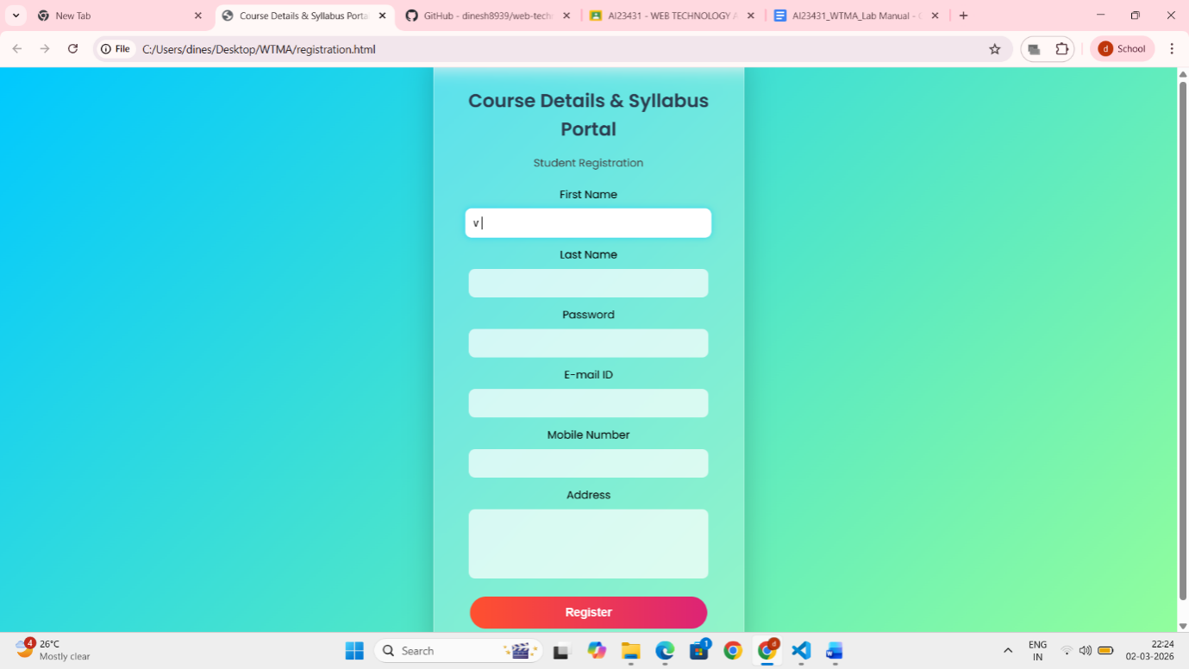
RESULT:
HTML page with Form is created and is validated using Javascript

