EXP.NO: 3 | Write a Servlet program that prints "Hello, World!" when accessed through a browser.
DATE:10/02/2026

AIM:
To write a basic Servlet program that demonstrates the use of Java Servlets by printing "Hello, World!" when accessed through a browser.

ALGORITHM:

Input:
  - The user makes an HTTP request (usually by entering a URL) through a browser.

Servlet Program Flow:
- Create a Servlet Class:
  - Define a Java class that extends the HttpServlet class.
  - Override the doGet() method, which handles HTTP GET requests from the client (browser).

Handle HTTP Request:
  - In the doGet() method:
    - Get the PrintWriter object to write the response to the browser.
    - Set the response content type to text/html.

    - Write the "Hello, World!" message to the response.

Compile the Servlet Class:
  - Compile the Java Servlet file using the javac command to generate a .class file.

Deploy the Servlet:
  - Place the compiled servlet class file in the appropriate directory of the web application (typically in the /WEB-INF/classes folder).
  - Configure the servlet in the web.xml file of the web application or use annotations.

Access the Servlet via Browser:
  - Start the Apache Tomcat or another servlet container.
  - Access the servlet by entering the appropriate URL (e.g., http://localhost:8080/your-webapp/hello).

Code:

import java.io.*;
import javax.servlet.*;
import javax.servlet.http.*;

public class HelloServlet extends HttpServlet {

public void doGet(HttpServletRequest request, HttpServletResponse response)
throws ServletException, IOException {

response.setContentType("text/html");
PrintWriter out = response.getWriter();

out.println("<html>");
out.println("<head><title>Hello Servlet</title></head>");
out.println("<body>");
out.println("<h1>Hello, World!</h1>");
out.println("</body>");
out.println("</html>");
}
}

OUTPUT:

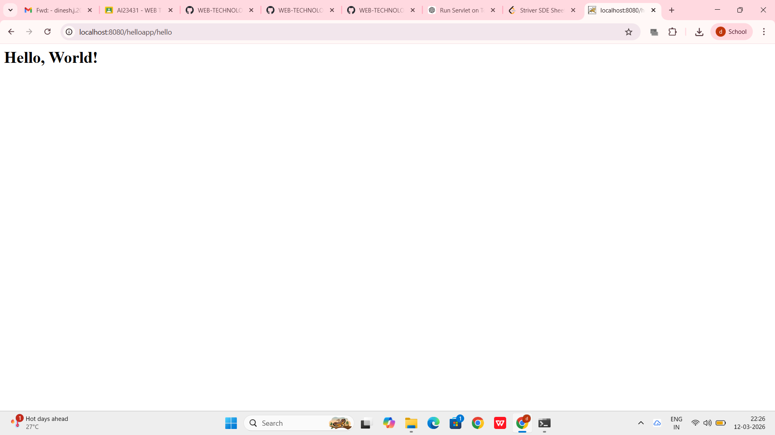

RESULT:
The browser will display the message "Hello, World!" returned by the Servlet.

