

Create a web form that accepts a user's name and age. EXP.NO: 4 Write a Servlet to process the form data and display it
back on the browser.

AIM:

To create a simple web application that includes a form to accept a user's name and age, and then use a Servlet to process the submitted data. The Servlet will retrieve the form data, process it, and display the values back on the browser.

ALGORITHM:

1. Input:

• The user fills out a web form with their name and age and submits it.

2. Form Handling and Servlet Processing:

1. Create the Web Form:

o Create an HTML form with two input fields: one for the user's name and one for the user's age.

o Add a submit button to the form.

o Set the form's action attribute to the URL of the Servlet and the method to POST (or GET).

2. Create the Servlet Class:

o Write a Servlet that processes the form data submitted by the user.

o The Servlet will override the doPost() (or doGet() depending on the form method) to handle form submissions.

o The Servlet will retrieve the name and age parameters from the request object using request.getParameter("name") and request.getParameter("age").

3. Process the Data in the Servlet:

o Extract the name and age values submitted from the form.

o Validate the input (e.g., check if the age is a valid number).

o Prepare a response that will display the user's name and age back on the browser.

4. Send Response to the Browser:

o The Servlet will send a response to the browser containing a message like:
      ▪ "Hello, [name]! You are [age] years old."

o The response will be displayed to the user in the browser.

5. Deploy the Servlet:

o Compile the Servlet and deploy it to a Servlet container (likeApache Tomcat).

o Ensure the web.xml file or Servlet annotations are used to map the Servlet to the URL defined in the form's action attribute.

6. Test the Application:

o Open the web browser, fill in the form with the name and age, and submit it.

o The Servlet will process the data and display the message back to the user in the browser.

HTML File ( index.html ):
<html>
<head>
<title>Course Portal</title>
<style>
body {
font-family: Arial;
background: linear-gradient(to right, #28a745, #e9f7ef);
margin: 0;
}
.container {
width: 400px;
margin: 100px auto;
padding: 30px;
background: white;
border-radius: 12px;
box-shadow: 0 0 15px rgba(0,0,0,0.2);
text-align: center;
}
h2 {
color: #28a745;
}
input {
width: 90%;
padding: 10px;
margin: 10px 0;
border-radius: 6px;
border: 1px solid #ccc;
}
button {
padding: 10px 20px;
background: #28a745;
border: none;
color: white;
border-radius: 6px;
cursor: pointer;
}
button:hover {
background: #218838;
}
</style>
</head>
<body>
<div class="container">
<h2>Course Details Portal</h2>
<form action="course" method="post">
<input type="text" name="name" placeholder="Enter Your Name" required>
<input type="number" name="age" placeholder="Enter Your Age" required>
<br>
<button type="submit">View Course Details</button>
</form>
</div>
</body>
</html>

Java File ( UserServlet.java ) :

import java.io.*;
import javax.servlet.*;
import javax.servlet.http.*;
import javax.servlet.annotation.WebServlet;
@WebServlet("/course")
public class CourseServlet extends HttpServlet {
private static final long serialVersionUID = 1L;
protected void doPost(HttpServletRequest request, HttpServletResponse response)
throws ServletException, IOException {
response.setContentType("text/html");
PrintWriter out = response.getWriter();
String name = request.getParameter("name");
String ageStr = request.getParameter("age");
int age = 0;
try {
age = Integer.parseInt(ageStr);
} catch (Exception e) {
age = 0;
}
out.println("<html><body style='font-family:Arial;background:#e9f7ef;'>");
out.println("<div style='width:450px;margin:100px auto;padding:30px;background:white;border-radius:12px;box-shadow:0 0 15px rgba(0,0,0,0.2);text-align:center;'>");
out.println("<h2 style='color:#28a745;'>Course Details</h2>");
out.println("<p>Hello, <b>" + name + "</b>!</p>");
out.println("<p>You are <b>" + age + "</b> years old.</p>");
out.println("<hr>");
out.println("<h3>Course: Web Development</h3>");
out.println("<p>Syllabus:</p>");
out.println("<ul style='text-align:left;'>");
out.println("<li>HTML & CSS Basics</li>");
out.println("<li>JavaScript Fundamentals</li>");
out.println("<li>Servlets & JSP</li>");
out.println("<li>Database Integration</li>");
out.println("</ul>");
out.println("<br><a href='index.html'>");
out.println("<button style='padding:10px 20px;background:#28a745;color:white;border:none;border-radius:6px;'>Go Back</button>");
out.println("</a>");
out.println("</div></body></html>");
}
}

File ( web.xml) :

<web-app> <servlet>
<servlet-name>UserServlet</servlet-name> <servlet-class>UserServlet</servlet-class>
</servlet>

<servlet-mapping>
<servlet-name>UserServlet</servlet-name> <url-pattern>/UserServlet</url-pattern>
</servlet-mapping> </web-app>

OUTPUT:

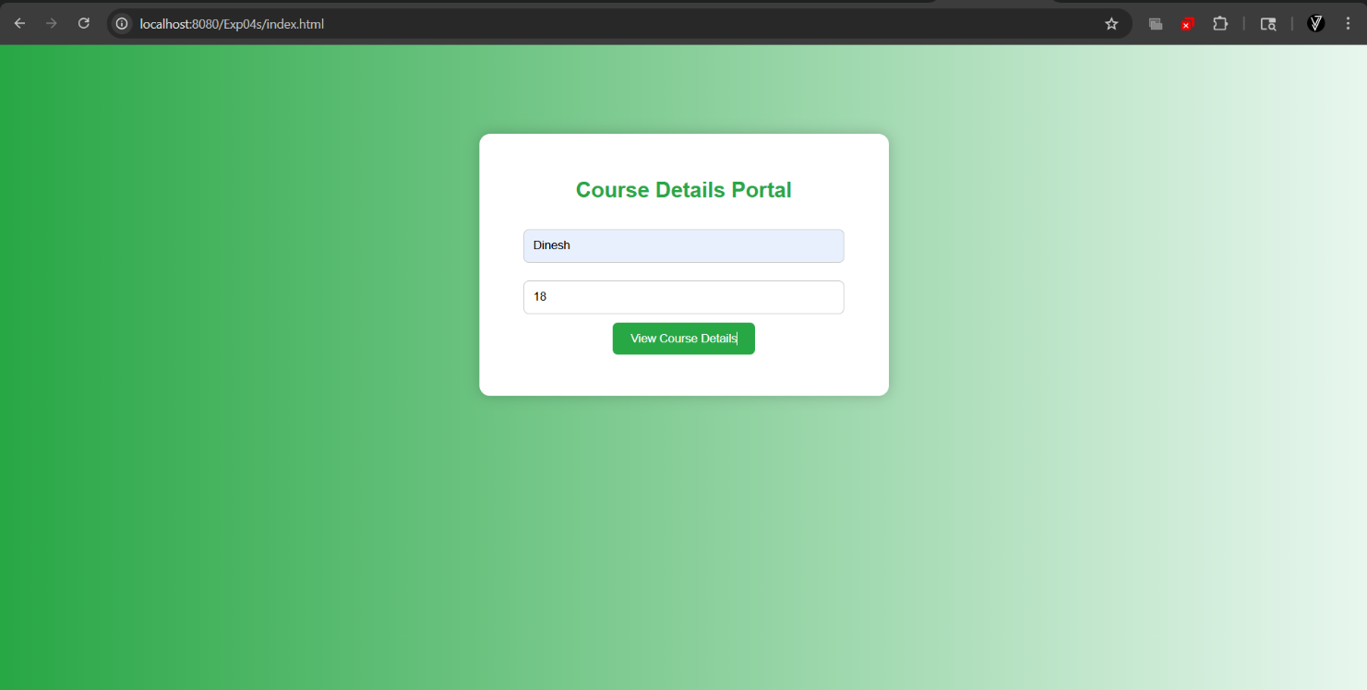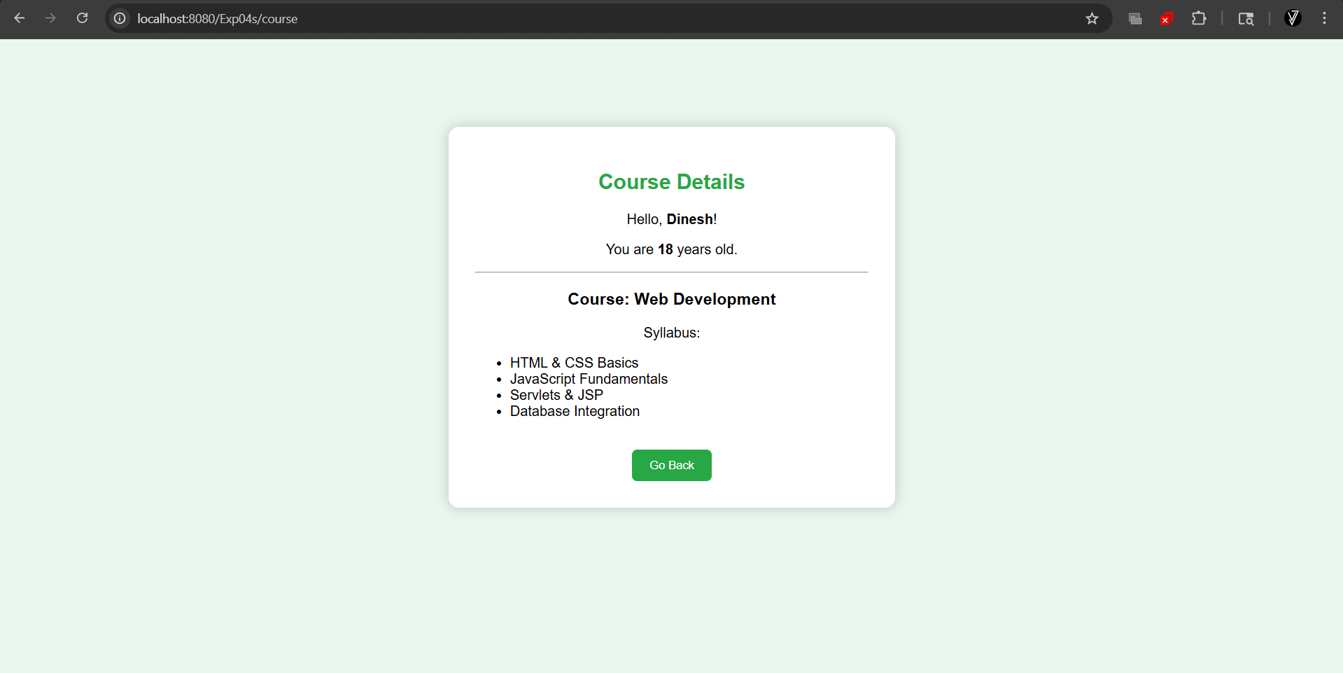

RESULT:

Thus A Servlet was created to process the HTML form data and display it back on the browser

