Write a Servlet to demonstrate the difference between HTTP GET and POST
methods by creating a form and handling requests accordingly.

AIM
To create a web application demonstrating the difference between HTTP GET and POST methods. The application includes a secure login gateway leading to a weather dashboard where users can search for city data and submit weather reports.

ALGORITHM
- Input: User provides login credentials; once authenticated, they input city names for searching or weather feedback for submission.

Form Handling:
  - Create index.html using a POST form for secure login.
  - Create a dashboard with a GET form for city searches and a POST form for reporting conditions.

Servlet Processing:
  - LoginServlet: Authenticates credentials and redirects the user upon success.
  - WeatherServlet: Overrides doGet() to process searches via URL parameters and doPost()
to process report submissions via the request body.
- Deployment: Compile the Servlets and deploy to a container like Apache Tomcat. Use
@WebServlet annotations or web.xml for URL mapping.
- Output: Display processed results (City search result or submission confirmation) back to the browser.

SOURCE CODE

User Interface (index.html)
<head>
<title>Course Portal - GET vs POST</title>
<style>
body {
font-family: Arial;
background: linear-gradient(to right, #28a745, #e9f7ef);
margin: 0;
}
.container {
width: 420px;
margin: 100px auto;
padding: 30px;
background: white;
border-radius: 12px;
box-shadow: 0 0 15px rgba(0,0,0,0.2);
text-align: center;
}
h2 {
color: #28a745;
}
input {
width: 90%;
padding: 10px;
margin: 10px 0;
border-radius: 6px;
border: 1px solid #ccc;
}
button {
width: 95%;
padding: 10px;
margin-top: 10px;
border: none;
border-radius: 6px;
background: #28a745;
color: white;
cursor: pointer;
}
button:hover {
background: #218838;
}
</style>
</head>
<body>
<div class="container">
<h2>Course Portal</h2>
<!-- GET FORM -->
<form action="course" method="get">
<input type="text" name="name" placeholder="Enter Name" required>
<input type="email" name="email" placeholder="Enter Email" required>
<button type="submit">View via GET</button>
</form>
<br>
<!-- POST FORM -->
<form action="course" method="post">
<input type="text" name="name" placeholder="Enter Name" required>
<input type="email" name="email" placeholder="Enter Email" required>
<button type="submit">View via POST</button>
</form>
</div>
</body>
</html>

Controller Servlet (LoginServlet.java)
import java.io.*;
import javax.servlet.*;
import javax.servlet.http.*;
import javax.servlet.annotation.WebServlet;
@WebServlet("/course")
public class CourseServlet extends HttpServlet {
private static final long serialVersionUID = 1L;
// GET METHOD
protected void doGet(HttpServletRequest request, HttpServletResponse response)
throws ServletException, IOException {
response.setContentType("text/html");
PrintWriter out = response.getWriter();
String name = request.getParameter("name");
String email = request.getParameter("email");
out.println("<html><body style='font-family:Arial;background:#e9f7ef;'>");
out.println("<div style='width:450px;margin:100px auto;padding:30px;background:white;border-radius:12px;text-align:center;'>");
out.println("<h2 style='color:#28a745;'>GET Method Used</h2>");
out.println("<p>Name: <b>" + name + "</b></p>");
out.println("<p>Email: <b>" + email + "</b></p>");
out.println("<p style='color:red;'>Data visible in URL</p>");
// COURSE DETAILS
out.println("<h3>Course: Web Development</h3>");
out.println("<ul style='text-align:left;'>");
out.println("<li>HTML & CSS</li>");
out.println("<li>JavaScript</li>");
out.println("<li>Servlets & JSP</li>");
out.println("</ul>");
out.println("<br><a href='index.html'><button>Go Back</button></a>");
out.println("</div></body></html>");
}
// POST METHOD
protected void doPost(HttpServletRequest request, HttpServletResponse response)
throws ServletException, IOException {
response.setContentType("text/html");
PrintWriter out = response.getWriter();
String name = request.getParameter("name");
String email = request.getParameter("email");
out.println("<html><body style='font-family:Arial;background:#e9f7ef;'>");
out.println("<div style='width:450px;margin:100px auto;padding:30px;background:white;border-radius:12px;text-align:center;'>");
out.println("<h2 style='color:#28a745;'>POST Method Used</h2>");
out.println("<p>Name: <b>" + name + "</b></p>");
out.println("<p>Email: <b>" + email + "</b></p>");
out.println("<p style='color:green;'>Data NOT visible in URL</p>");
// COURSE DETAILS
out.println("<h3>Course: Web Development</h3>");
out.println("<ul style='text-align:left;'>");
out.println("<li>HTML & CSS</li>");
out.println("<li>JavaScript</li>");
out.println("<li>Servlets & JSP</li>");
out.println("</ul>");
out.println("<br><a href='index.html'><button>Go Back</button></a>");
out.println("</div></body></html>");
}
}

Web.xml
<web-app>
<!-- Welcome file (VERY IMPORTANT) -->
<welcome-file-list>
<welcome-file>index.html</welcome-file>
</welcome-file-list>
</web-app>

OUTPUT :

Get Method:

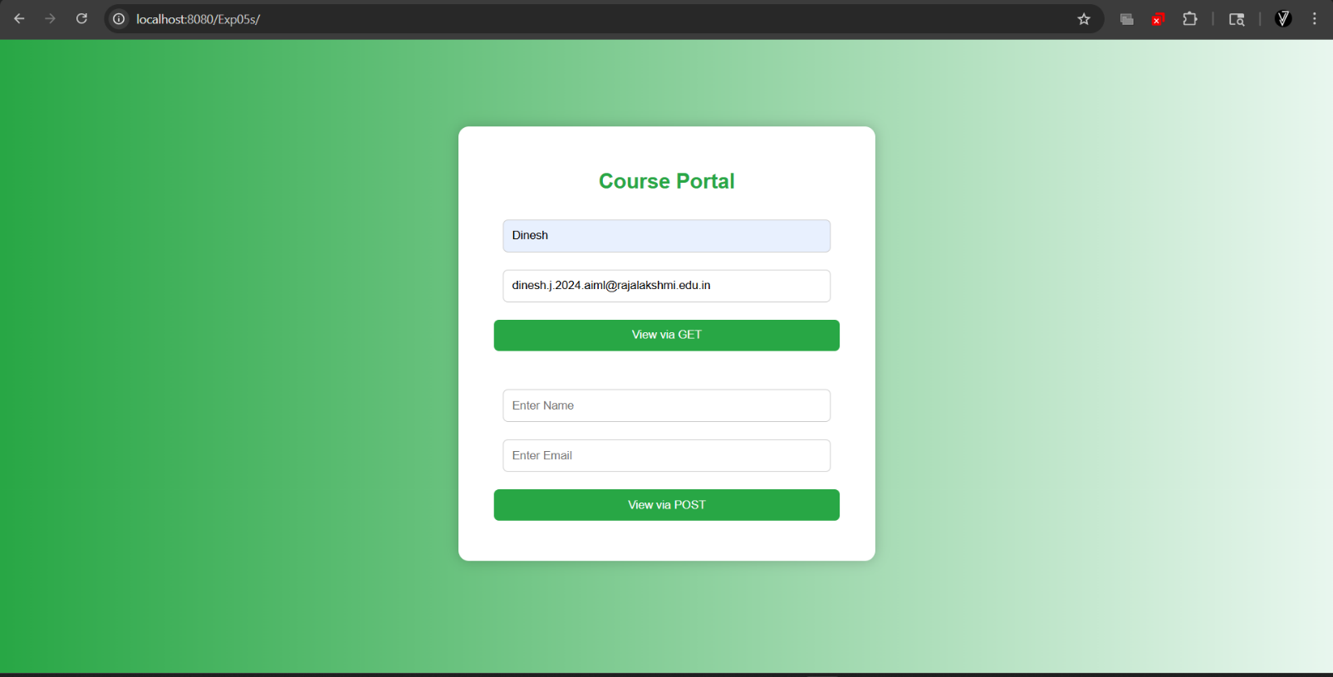
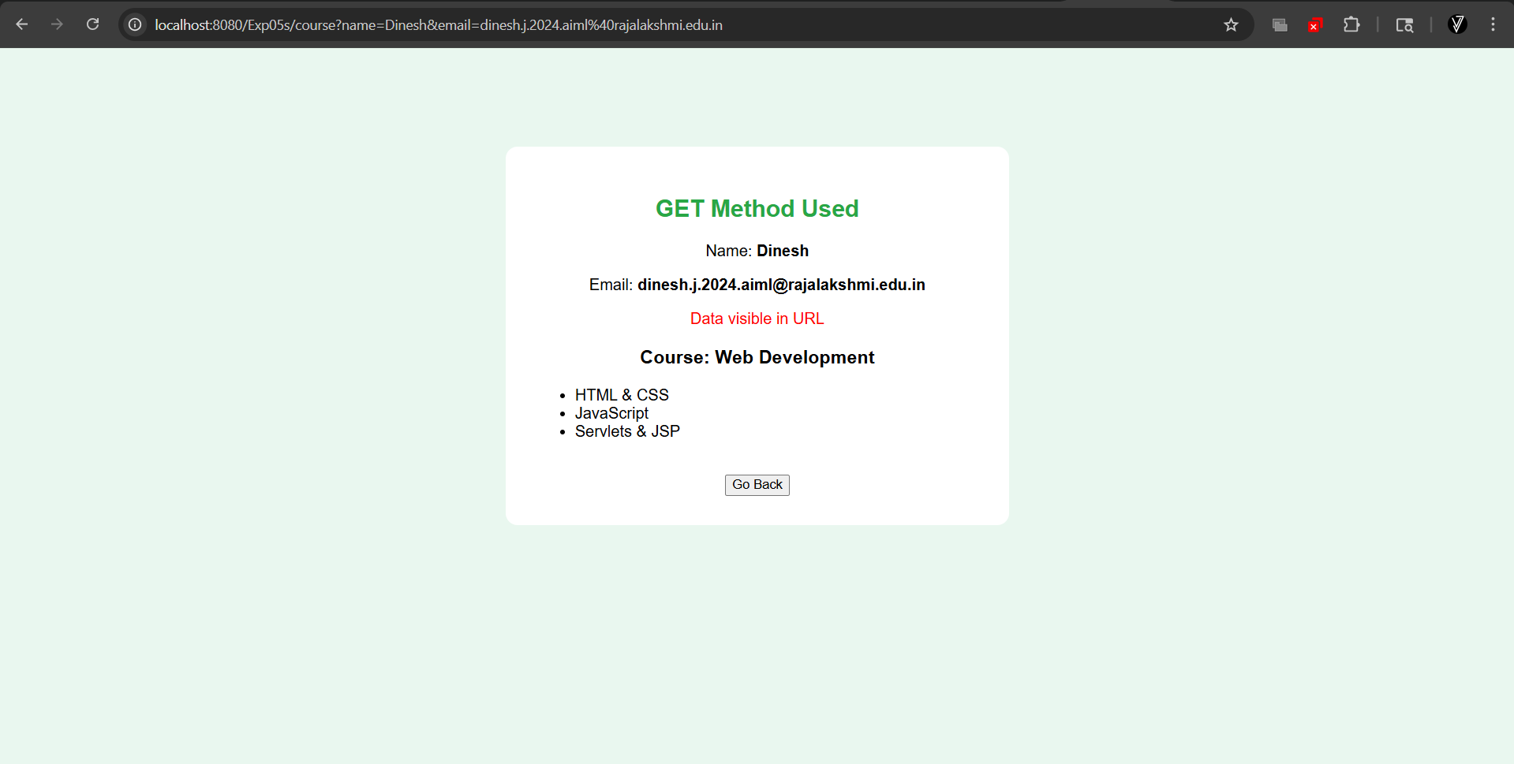

Post Method:
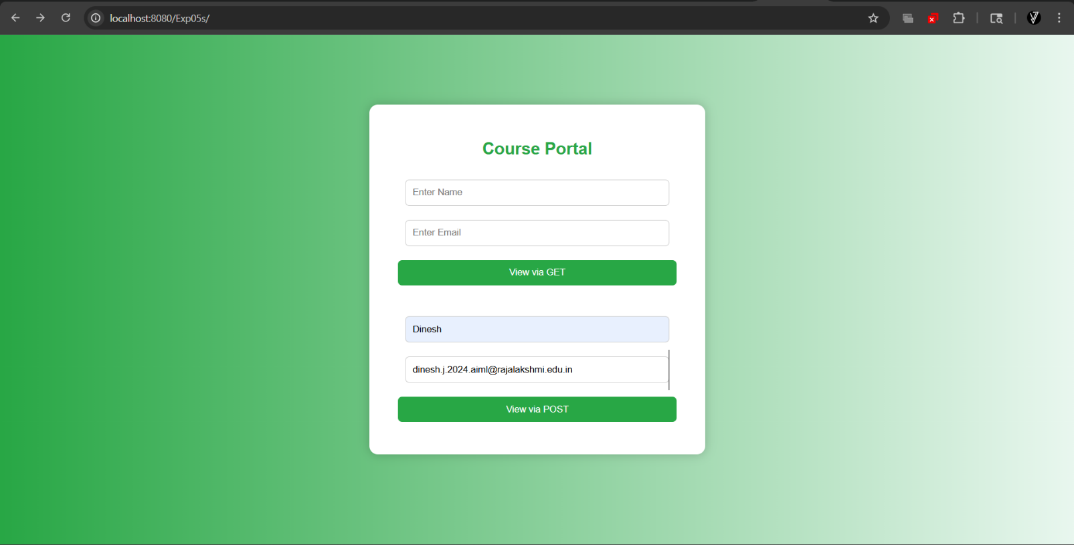
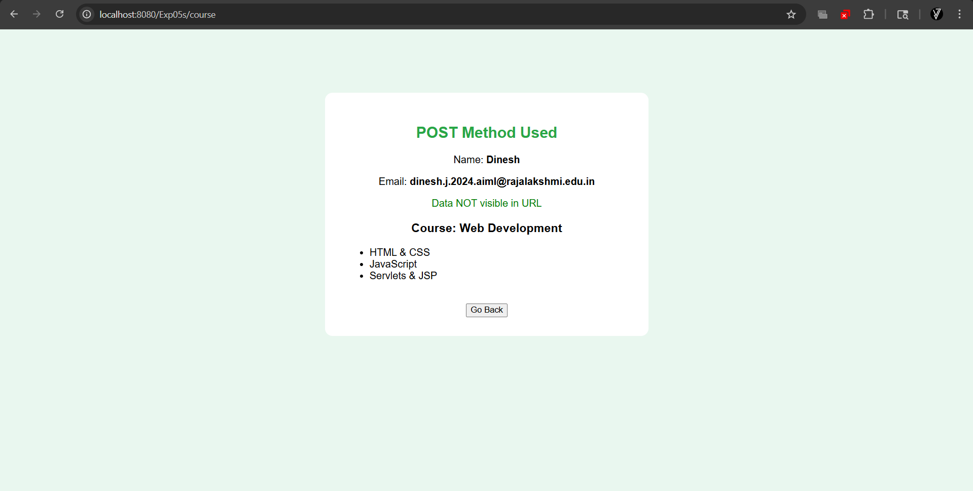

RESULT:
A Servlet-based weather application was successfully created to demonstrate the differences between HTTP GET and POST methods. The GET method was utilized for data retrieval, while POST ensured secure data transmission for authentication and user reports.

