EXP.NO: 6 | Write a Servlet to demonstrate session tracking using HttpSession.
DATE:26/03/2025

AIM:
To demonstrate session tracking using HttpSession in a Servlet-based web application. The exercise involves implementing a simple login system where a user can log in with their username and password, and their session will be tracked throughout their interaction with the web application.
ALGORITHM:
1. Input:
- The user will enter their username and password in a login form.
- The servlet will validate the credentials and create an HTTP session for the user if authentication is successful.

2. Steps for Implementing Session Tracking with HttpSession:
- Create the Login Form (HTML):
  - Create an HTML form with two input fields for username and password.
  - Provide a submit button to send the data to the servlet for authentication.
- Create the Login Servlet:
  - Write a Java servlet class to handle login requests.
  - The servlet will:
    - Retrieve the username and password from the form.
    - Authenticate the user by comparing the credentials to a stored value (e.g., hardcoded or from a database).
    - Create a new HTTP session for the user if the credentials are valid.
    - Set session attributes such as the user's username to track the session.
- Validate User Credentials:
  - In the servlet, check if the username and password match the expected values.
  - If valid, create a session and store the username in the session.
  - If invalid, redirect the user back to the login page with an error message.
- Create and Track User Session:
  - Upon successful login, use the HttpSession object to store the session data.
  - Use the session.setAttribute("username", username) method to save the username.
  - Optionally, set session timeout using session.setMaxInactiveInterval(time_in_seconds) to manage session expiration.
- Redirect to a Protected Page:
  - After a successful login, the user will be redirected to a protected page (e.g., a dashboard or home page).
  - The protected page should check if the user is authenticated by checking the session attribute.
- Logout and Session Invalidation:
  - Provide a logout feature that invalidates the session using session.invalidate() when the user logs out.
  - After logout, redirect the user back to the login page.
- Session Expiration:
  - If the session expires or the user manually logs out, the session will be invalidated, and the user will be redirected to the login page.
Code:
1.index.html (Login Page)
<html>
<head>
<style>
body{
margin:0;
font-family:Arial;
background:linear-gradient(135deg,#1db954,#191414);
display:flex;
justify-content:center;
align-items:center;
height:100vh;
color:white;
}
.box{
background:#121212;
padding:30px;
border-radius:12px;
text-align:center;
width:300px;
}
input,button{
width:90%;
padding:10px;
margin:10px;
border:none;
border-radius:5px;
}
button{
background:#1db954;
color:white;
font-weight:bold;
}
button:hover{background:#1ed760;}
</style>
</head>
<body>
<div class="box">
<h2>Course Portal Login</h2>
<form action="login" method="post">
<input name="username" placeholder="Username" required><br>
<input type="password" name="password" placeholder="Password" required><br>
<button>Login</button>
</form>
</div>
</body>
</html>
2. LoginServlet.java
import java.io.*;
import javax.servlet.http.*;
public class LoginServlet extends HttpServlet {
private static final long serialVersionUID = 1L;
protected void doPost(HttpServletRequest r,HttpServletResponse s)
throws IOException {
s.setContentType("text/html");
String u=r.getParameter("username");
String p=r.getParameter("password");
if(u.equals("student") && p.equals("123")){
HttpSession ss=r.getSession();
ss.setAttribute("user",u);
s.sendRedirect("home");
} else {
PrintWriter out = s.getWriter();
out.println("<html><body style='margin:0;font-family:Arial;background:linear-gradient(135deg,#1db954,#191414);display:flex;justify-content:center;align-items:center;height:100vh;color:white;'>");
out.println("<div style='background:#121212;padding:30px;border-radius:12px;text-align:center;'>");
out.println("<h2 style='color:red;'>Invalid Login</h2>");
out.println("<p>Check username and password</p>");
out.println("<a href='index.html'>");
out.println("<button style='padding:10px;background:#1db954;border:none;color:white;border-radius:5px;'>Try Again</button>");
out.println("</a>");
out.println("</div></body></html>");
}
}
}

3. HomeServlet.java
import java.io.*;
import javax.servlet.http.*;
public class HomeServlet extends HttpServlet {
private static final long serialVersionUID = 1L;
protected void doGet(HttpServletRequest r,HttpServletResponse s)
throws IOException {
HttpSession ss=r.getSession(false);
if(ss==null || ss.getAttribute("user")==null){
s.sendRedirect("index.html");
return;
}
String user=(String)ss.getAttribute("user");
PrintWriter out=s.getWriter();
out.println("<html><body style='margin:0;font-family:Arial;background:linear-gradient(135deg,#1db954,#191414);color:white;'>");
out.println("<div style='width:350px;margin:120px auto;background:#121212;padding:30px;border-radius:12px;text-align:center;'>");
out.println("<h2>Welcome "+user+"</h2>");
out.println("<h3>Course Details</h3>");
out.println("<p>Subject: Web Technology</p>");
out.println("<p>Syllabus: HTML, CSS, JS, Servlet</p>");
out.println("<a href='logout'><button style='padding:10px;background:#1db954;border:none;color:white;border-radius:5px;'>Logout</button></a>");
out.println("</div></body></html>");
}
}

4. LogoutServlet.java
import java.io.*;
import javax.servlet.http.*;
public class LogoutServlet extends HttpServlet {
private static final long serialVersionUID = 1L;
protected void doGet(HttpServletRequest r,HttpServletResponse s)
throws IOException {
HttpSession ss=r.getSession(false);
if(ss!=null) ss.invalidate();
s.sendRedirect("index.html");
}
}

5. web.xml
<web-app>
<welcome-file-list>
<welcome-file>index.html</welcome-file>
</welcome-file-list>
<servlet>
<servlet-name>LoginServlet</servlet-name>
<servlet-class>LoginServlet</servlet-class>
</servlet>
<servlet-mapping>
<servlet-name>LoginServlet</servlet-name>
<url-pattern>/login</url-pattern>
</servlet-mapping>
<servlet>
<servlet-name>HomeServlet</servlet-name>
<servlet-class>HomeServlet</servlet-class>
</servlet>
<servlet-mapping>
<servlet-name>HomeServlet</servlet-name>
<url-pattern>/home</url-pattern>
</servlet-mapping>
<servlet>
<servlet-name>LogoutServlet</servlet-name>
<servlet-class>LogoutServlet</servlet-class>
</servlet>
<servlet-mapping>
<servlet-name>LogoutServlet</servlet-name>
<url-pattern>/logout</url-pattern>
</servlet-mapping>
</web-app>

Output:
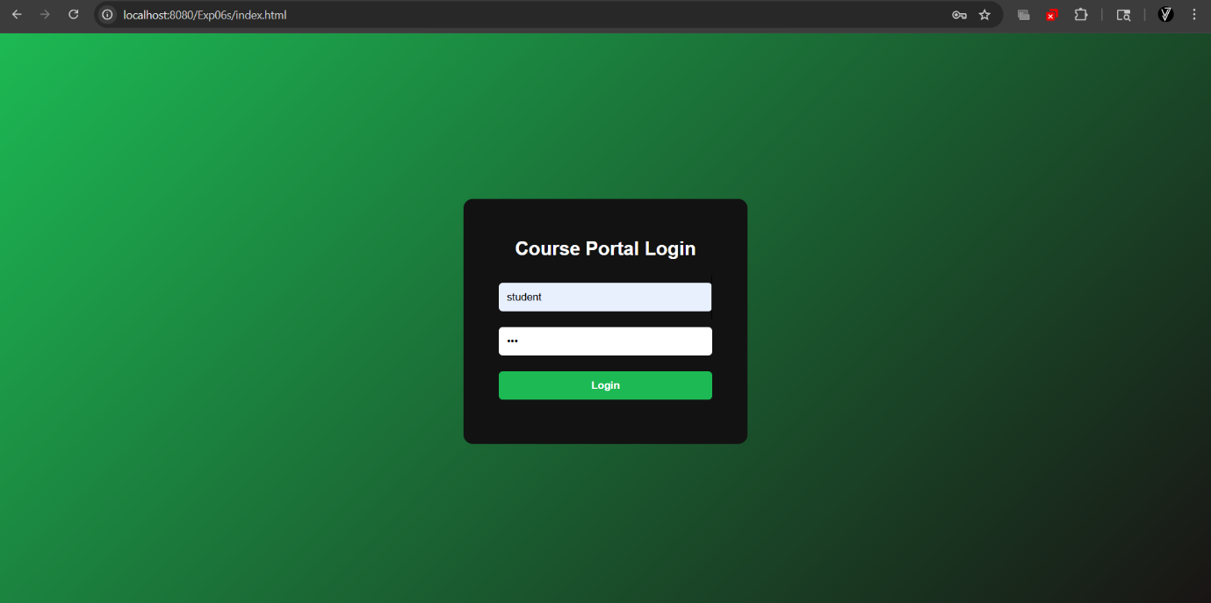

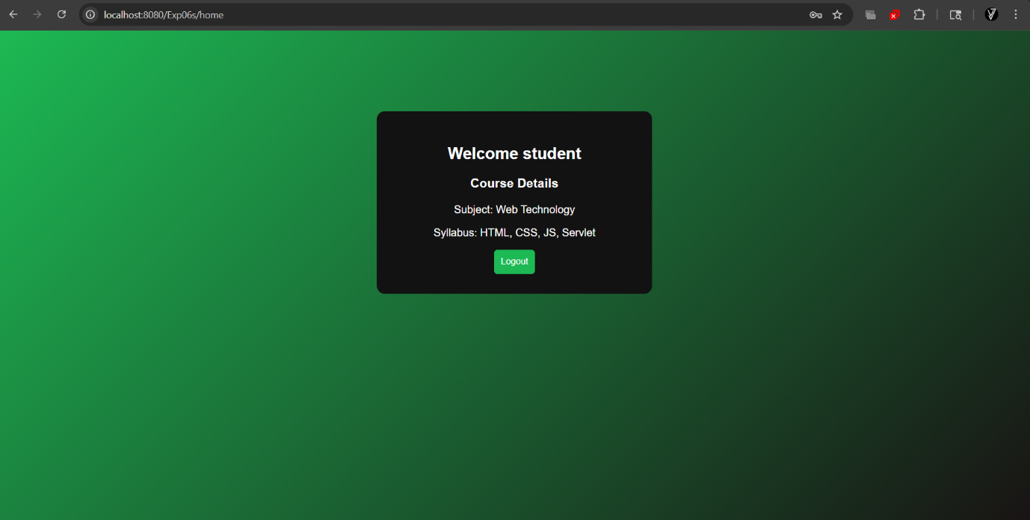

RESULT:
A simple login system is created where the user's session is tracked by a servlet to demonstrate session tracking using HttpSession.

