7. Write a Servlet program to store a user's preferences (like theme or language) using cookies. Retrieve and display these preferences on
subsequent visits.

AIM
To develop a Java Servlet-based web application that stores user preferences (such as theme and language) using cookies and retrieves them on subsequent visits to personalize the weather information webpage.

ALGORITHM
- Create a Dynamic Web Project in Eclipse or any IDE.
- Add Servlet API library (Apache Tomcat server).
- Create an HTML form to accept user preferences: Theme (Light/Dark)
Language (English/Tamil/etc.)
- Develop a Servlet (PreferenceServlet): Read user inputs from the form.
Store preferences using cookies.
- Develop another Servlet (DisplayServlet): Retrieve cookies.
Display saved preferences along with weather info.
- Configure web.xml (if not using annotations).
- Run the project on server (Tomcat).
- Test in browser:
First visit → set preferences.
Next visit → preferences auto-loaded.

Code:

index.html
<html>
<head>
<style>
body{
font-family:Arial;
text-align:center;
background:linear-gradient(135deg,#1db954,#191414);
color:white;
}
.box{
margin-top:100px;
}
select,button{
padding:10px;
margin:10px;
border:none;
border-radius:5px;
}
button{
background:#1db954;
color:white;
}
</style>
</head>
<body>
<div class="box">
<h2>Course Preferences</h2>
<form action="PreferenceServlet" method="post">
Theme:
<select name="theme">
<option>Light</option>
<option>Dark</option>
</select><br>
Language:
<select name="language">
<option>English</option>
<option>Tamil</option>
</select><br>
<button>Save Preferences</button>
</form>
<br>
<a href="DisplayServlet">Go to Course Portal</a>
</div>
</body>
</html>

2. PreferenceServlet.java
import java.io.*;
import javax.servlet.*;
import javax.servlet.http.*;
public class PreferenceServlet extends HttpServlet {
protected void doPost(HttpServletRequest req,HttpServletResponse res)
throws IOException {
String theme=req.getParameter("theme");
String lang=req.getParameter("language");
Cookie c1=new Cookie("theme",theme);
Cookie c2=new Cookie("lang",lang);
c1.setMaxAge(86400);
c2.setMaxAge(86400);
res.addCookie(c1);
res.addCookie(c2);
PrintWriter out=res.getWriter();
out.println("<body style='font-family:Arial;text-align:center;background:#191414;color:white;'>");
out.println("<h2>Preferences Saved</h2>");
out.println("<a href='DisplayServlet'><button style='padding:10px;background:#1db954;border:none;color:white;'>Go to Portal</button></a>");
out.println("</body>");
}
}

3. DisplayServlet.java
import java.io.*;
import javax.servlet.*;
import javax.servlet.http.*;
public class DisplayServlet extends HttpServlet {
protected void doGet(HttpServletRequest req,HttpServletResponse res)
throws IOException {
Cookie c[]=req.getCookies();
String theme="Light",lang="English";
if(c!=null){
for(Cookie x:c){
if(x.getName().equals("theme")) theme=x.getValue();
if(x.getName().equals("lang")) lang=x.getValue();
}
}
PrintWriter out=res.getWriter();
out.println("<html><body style='font-family:Arial;text-align:center;'>");
if(theme.equals("Dark"))
out.println("<body style='background:black;color:white;'>");
out.println("<h2>Course Dashboard</h2>");
out.println("<p>Theme: "+theme+"</p>");
out.println("<p>Language: "+lang+"</p>");
out.println("<h3>Course Details</h3>");
out.println("<p>Subject: Web Technology</p>");
out.println("<p>Syllabus: HTML, CSS, JS, Servlet</p>");
out.println("<a href='index.html'>Change Preferences</a>");
out.println("</body></html>");
}
}

4. web.xml
<web-app>
<welcome-file-list>
<welcome-file>index.html</welcome-file>
</welcome-file-list>
<servlet>
<servlet-name>PreferenceServlet</servlet-name>
<servlet-class>PreferenceServlet</servlet-class>
</servlet>
<servlet-mapping>
<servlet-name>PreferenceServlet</servlet-name>
<url-pattern>/PreferenceServlet</url-pattern>
</servlet-mapping>
<servlet>
<servlet-name>DisplayServlet</servlet-name>
<servlet-class>DisplayServlet</servlet-class>
</servlet>
<servlet-mapping>
<servlet-name>DisplayServlet</servlet-name>
<url-pattern>/DisplayServlet</url-pattern>
</servlet-mapping>
</web-app>

OUTPUT :
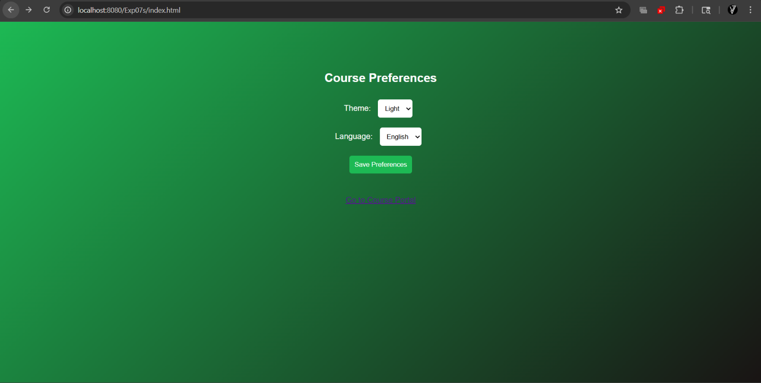
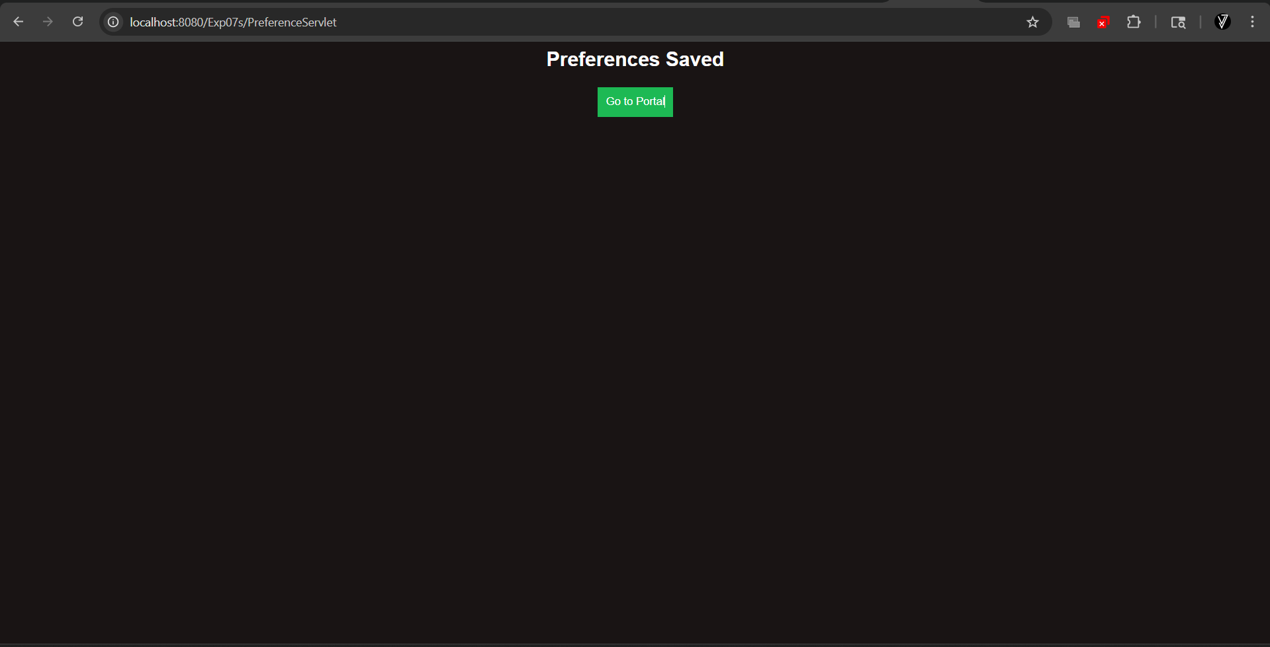
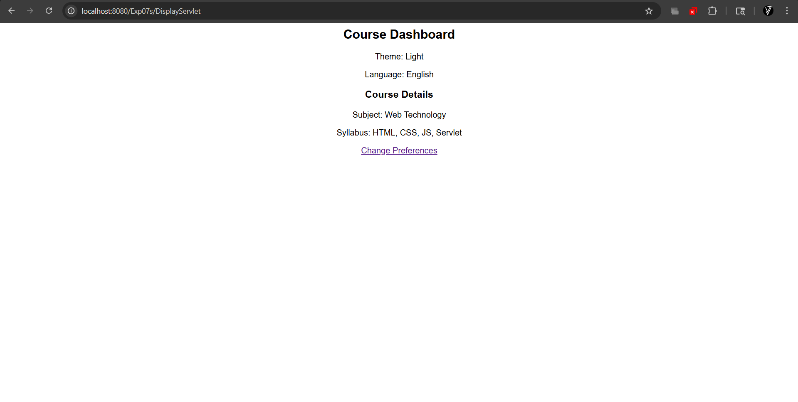

Result:
The experiment was successfully completed.User preferences (theme and language) were stored using cookies and retrieved on subsequent visits, allowing the weather webpage to provide a personalized user experience.

