Consider a Library Management System. Develop a JavaScript program that will validate the controls in the forms you have created for the application. State the assumptions you make (business logic you are taking into consideration).

Aim:
To develop a web-based Library Management System that validates user inputs using JavaScript and connects to a database using Servlets and JSP, while also demonstrating a simple Weather Information Webpage UI.

Procedure:
  - Create an HTML webpage for Library Management System.
  - Design a form to add books/users.
  - Apply JavaScript validation for all fields.
  - Create a JSP page to display data.
  - Develop a Servlet to handle form submission.
  - Connect the application to a MySQL database.
  - Insert validated data into the database.
  - Run the project on a server (e.g., Apache Tomcat).
  - Display success or error messages.

Code:
index.html <!DOCTYPE html>
<html>
<head>
<title>Course Portal</title>

<script>
function validateForm() {

let name=document.forms["f"]["name"].value;
let email=document.forms["f"]["email"].value;
let phone=document.forms["f"]["phone"].value;
let course=document.forms["f"]["course"].value;

let nameP=/^[A-Za-z ]+$/;
let emailP=/^[^ ]+@[^ ]+\.[a-z]{2,3}$/;

if(name==""||email==""||phone==""||course==""){
alert("Fill all fields"); return false;
}

if(!name.match(nameP)){
alert("Invalid Name"); return false;
}

if(!email.match(emailP)){
alert("Invalid Email"); return false;
}

if(phone.length!=10 || isNaN(phone)){
alert("Phone must be 10 digits"); return false;
}

return true;
}
</script>

<style>
body{
font-family:Arial;
background:linear-gradient(135deg,#1db954,#191414);
color:white;
text-align:center;
}
form{
margin-top:100px;
}
input,button{
padding:10px; margin:10px;
border:none; border-radius:5px;
}
button{background:#1db954;color:white;}
</style>

</head>

<body>

<h2>Course Registration</h2>

<form name="f" action="CourseServlet" method="post" onsubmit="return validateForm()">

<input name="name" placeholder="Name"><br>
<input name="email" placeholder="Email"><br>
<input name="phone" placeholder="Phone"><br>
<input name="course" placeholder="Course"><br>

<button>Submit</button>

</form>

<br>
<a href="display.jsp">View Records</a>

</body>
</html> CourseServlet.java import java.io.*;
import javax.servlet.*;
import javax.servlet.http.*;
import java.sql.*;
public class CourseServlet extends HttpServlet {
private static final long serialVersionUID = 1L;
protected void doPost(HttpServletRequest req, HttpServletResponse res)
throws IOException {
String name = req.getParameter("name");
String email = req.getParameter("email");
String phone = req.getParameter("phone");
String course = req.getParameter("course");
res.setContentType("text/html");
PrintWriter out = res.getWriter();
try {
// Load Driver
Class.forName("com.mysql.cj.jdbc.Driver");
// Connect DB
Connection con = DriverManager.getConnection(
"jdbc:mysql://localhost:3306/musicdb", "root", "Vishagan@2007");
// FIXED QUERY
PreparedStatement ps = con.prepareStatement(
"INSERT INTO users(name,email,phone,course) VALUES(?,?,?,?)");
ps.setString(1, name);
ps.setString(2, email);
ps.setString(3, phone);
ps.setString(4, course);
int i = ps.executeUpdate();
// STYLED OUTPUT PAGE
out.println("<!DOCTYPE html>");
out.println("<html><head><title>Success</title>");
out.println("<style>");
out.println("body{margin:0;font-family:Arial;background:linear-gradient(135deg,#1db954,#191414);display:flex;justify-content:center;align-items:center;height:100vh;color:white;}");
out.println(".card{background:#121212;padding:30px;border-radius:12px;text-align:center;box-shadow:0 0 15px rgba(0,0,0,0.6);width:320px;}");
out.println("h2{color:#1db954;}");
out.println("button{padding:10px 20px;margin:10px;border:none;border-radius:25px;background:#1db954;color:white;cursor:pointer;}");
out.println("button:hover{background:#1ed760;transform:scale(1.05);}");
out.println("a{text-decoration:none;}");
out.println("</style>");
out.println("</head><body>");
out.println("<div class='card'>");
if (i > 0) {
out.println("<h2>Data Inserted</h2>");
out.println("<p>Course registered successfully</p>");
// CORRECT LINK (no 404)
out.println("<a href='" + req.getContextPath() + "/display.jsp'>");
out.println("<button>View Records</button>");
out.println("</a>");
} else {
out.println("<h2>Error</h2>");
out.println("<p>Failed to insert data</p>");
}
out.println("<a href='index.html'>");
out.println("<button>Back</button>");
out.println("</a>");
out.println("</div>");
out.println("</body></html>");
con.close();
} catch (Exception e) {
out.println("<h3 style='color:red;text-align:center;'>Error: " + e + "</h3>");
}
}
} display.jsp
<%@ page import="java.sql.*" %>
<!DOCTYPE html>
<html>
<head>
<title>Music Records</title>

<style>
body{
margin:0;
font-family:Arial;
background:linear-gradient(135deg,#1db954,#191414);
color:white;
text-align:center;
}

.container{
width:80%;
margin:50px auto;
background:#121212;
padding:20px;
border-radius:12px;
box-shadow:0 0 15px rgba(0,0,0,0.6);
}

h2{
color:#1db954;
}

table{
width:100%;
border-collapse:collapse;
margin-top:20px;
}

th, td{
padding:12px;
border-bottom:1px solid #333;
}

th{
background:#1db954;
color:white;
}

tr:hover{
background:#222;
}

button{
margin-top:20px;
padding:10px 20px;
border:none;
border-radius:25px;
background:#1db954;
color:white;
cursor:pointer;
}

button:hover{
background:#1ed760;
}
</style>

</head>

<body>

<div class="container">

<h2>Music Records</h2>

<table>
<tr>
<th>Name</th>
<th>Email</th>
<th>Phone</th>
<th>Course</th>
</tr>

<%
try{
Class.forName("com.mysql.cj.jdbc.Driver");

Connection con = DriverManager.getConnection(
"jdbc:mysql://localhost:3306/musicdb","root","Vishagan@2007");

Statement st = con.createStatement();
ResultSet rs = st.executeQuery("SELECT * FROM users");

while(rs.next()){
%>

<tr>
<td><%= rs.getString("name") %></td>
<td><%= rs.getString("email") %></td>
<td><%= rs.getString("phone") %></td>
<td><%= rs.getString("course") %></td>
</tr>

<%
}
con.close();
}catch(Exception e){
%>
<tr>
<td colspan="4"><%= e %></td>
</tr>
<%
}
%>

</table>

<br>

<a href="index.html">
<button>Back</button>
</a>

</div>

</body>
</html>

Output

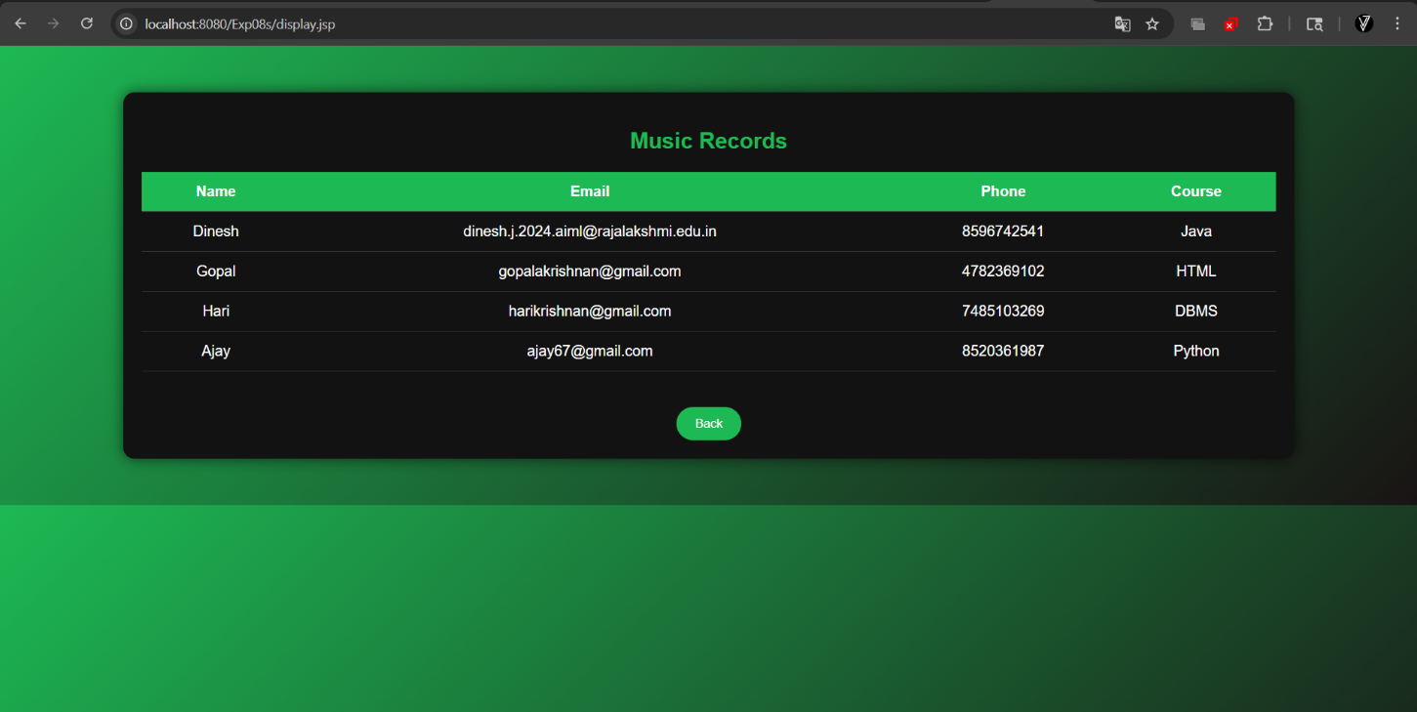

Result:
Thus, the Library Management System with JavaScript validation and database connectivity using Servlet and JSP was successfully developed and executed.

