9. Develop an Android application using controls like Button, TextView, EditText for designing a calculator having basic functionality like Addition, Subtraction, multiplication, and

Division

AIM:
To design and develop a functional Android application that utilizes UI controls such as Button, TextView, and EditText to perform basic arithmetic operations.

ALGORITHM:

UI Design:
  - Open activity_main.xml. o Add two EditText fields to accept numerical input from the user.
  - Add four Button controls for Addition (+), Subtraction (-), Multiplication (*), and Division (/).
  - Add a TextView to display the final calculated result.

Logic Implementation
  - In MainActivity.java, declare variables for the UI components.
  - Initialize these components using findViewById().
  - Create OnClickListener events for each button.

Data Processing:
  - Retrieve the input strings from the EditText fields using getText().toString().
  - Convert the strings to numeric types (e.g., Double).
  - Perform the arithmetic operation corresponding to the button clicked.

Output:
  - Set the calculated value as the text of the TextView using setText().

Deployment:
Run the application on an Android Emulator or a physical device to test functionality.

CODE:

- XML :

<?xml version="1.0" encoding="utf-8"?>
<LinearLayout xmlns:android="http://schemas.android.com/apk/res/android" android:orientation="vertical"
android:padding="20dp" android:layout_width="match_parent" android:layout_height="match_parent">

<EditText android:id="@+id/num1"
android:hint="Enter first number" android:inputType="numberDecimal" android:layout_width="match_parent" android:layout_height="wrap_content"/>

<EditText android:id="@+id/num2"
android:hint="Enter second number" android:inputType="numberDecimal" android:layout_width="match_parent" android:layout_height="wrap_content"/>

<TextView android:id="@+id/result" android:text="Result" android:textSize="24sp"
android:layout_marginTop="20dp" android:layout_width="wrap_content" android:layout_height="wrap_content"/>

<LinearLayout android:orientation="horizontal" android:layout_marginTop="20dp" android:layout_width="match_parent" android:layout_height="wrap_content">

<Button
android:id="@+id/add" android:text="+"

android:layout_weight="1" android:layout_width="0dp" android:layout_height="wrap_content"/>

<Button
android:id="@+id/sub" android:text="-" android:layout_weight="1" android:layout_width="0dp"
android:layout_height="wrap_content"/>

<Button
android:id="@+id/mul" android:text="*" android:layout_weight="1" android:layout_width="0dp" android:layout_height="wrap_content"/>

<Button
android:id="@+id/div" android:text="/" android:layout_weight="1" android:layout_width="0dp"
android:layout_height="wrap_content"/>
</LinearLayout>

</LinearLayout>

Java Code:

package com.example.calculator;

import android.os.Bundle; import android.view.View; import android.widget.Button; import android.widget.EditText; import android.widget.TextView;
import androidx.appcompat.app.AppCompatActivity; public class MainActivity extends AppCompatActivity {

EditText num1, num2;
TextView result;
Button add, sub, mul, div;

@Override
protected void onCreate(Bundle savedInstanceState) { super.onCreate(savedInstanceState); setContentView(R.layout.activity_main);

num1 = findViewById(R.id.num1); num2 = findViewById(R.id.num2); result = findViewById(R.id.result);

add = findViewById(R.id.add); sub = findViewById(R.id.sub); mul = findViewById(R.id.mul); div = findViewById(R.id.div);

add.setOnClickListener(v -> calculate('+')); sub.setOnClickListener(v -> calculate('-')); mul.setOnClickListener(v -> calculate('*')); div.setOnClickListener(v -> calculate('/'));
}

private void calculate(char operator) {
double n1 = Double.parseDouble(num1.getText().toString()); double n2 = Double.parseDouble(num2.getText().toString()); double res = 0;

switch (operator) {
case '+': res = n1 + n2; break; case '-': res = n1 - n2; break; case '*': res = n1 * n2; break; case '/':
if (n2 != 0)
res = n1 / n2; else {
result.setText("Cannot divide by zero"); return;

}
break;
}

result.setText("Result: " + res);
}
}

Output:

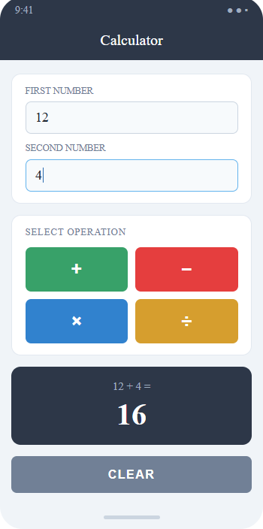

Result:

Thus, an Android calculator application was successfully developed using Button, TextView, and EditText controls to perform basic arithmetic operations.

