Implement an application that writes data to the SD card
Aim
To develop an Android application that stores weather information entered by the user into the SD card (external storage).

Algorithm
  - Start the application
  - Create UI with EditText and Button
  - Get input data from user (weather details)
  - Check storage permission
  - Create a file in external storage
  - Write the entered data into the file
  - Display Toast message for success
  - Stop

Code

XML Layout (activity_main.xml)

<?xml version="1.0" encoding="utf-8"?>
<LinearLayout xmlns:android="http://schemas.android.com/apk/res/android" android:orientation="vertical"
android:padding="20dp" android:gravity="center" android:layout_width="match_parent" android:layout_height="match_parent">

<EditText

android:id="@+id/inputText" android:layout_width="match_parent" android:layout_height="wrap_content" android:hint="Enter Weather Info"/>

<Button
android:id="@+id/saveBtn" android:layout_width="wrap_content" android:layout_height="wrap_content" android:text="Save to SD Card" android:layout_marginTop="20dp"/>

</LinearLayout>

Java Code (MainActivity.java)
package com.example.weatherapp;

import android.Manifest;
import android.content.pm.PackageManager; import android.os.Bundle;
import android.os.Environment; import android.view.View; import android.widget.Button; import android.widget.EditText; import android.widget.Toast;

import androidx.appcompat.app.AppCompatActivity; import androidx.core.app.ActivityCompat;
import androidx.core.content.ContextCompat;

import java.io.File;
import java.io.FileOutputStream;
public class MainActivity extends AppCompatActivity { EditText inputText;
Button saveBtn;

@Override
protected void onCreate(Bundle savedInstanceState) { super.onCreate(savedInstanceState); setContentView(R.layout.activity_main);

inputText = findViewById(R.id.inputText); saveBtn = findViewById(R.id.saveBtn);

if (ContextCompat.checkSelfPermission(this, Manifest.permission.WRITE_EXTERNAL_STORAGE)
!= PackageManager.PERMISSION_GRANTED) {

ActivityCompat.requestPermissions(this, new
String[]{Manifest.permission.WRITE_EXTERNAL_STORAGE}, 1);
}

saveBtn.setOnClickListener(v -> {
String data = inputText.getText().toString();

try {
File file = new File(getExternalFilesDir(null),

"weather.txt");

FileOutputStream fos = new FileOutputStream(file); fos.write(data.getBytes());
fos.close();

Toast.makeText(MainActivity.this, "Saved Successfully",
Toast.LENGTH_SHORT).show();

} catch (Exception e) { Toast.makeText(MainActivity.this,
"Error: " + e.getMessage(), Toast.LENGTH_LONG).show();
}
});

}
}

Output:

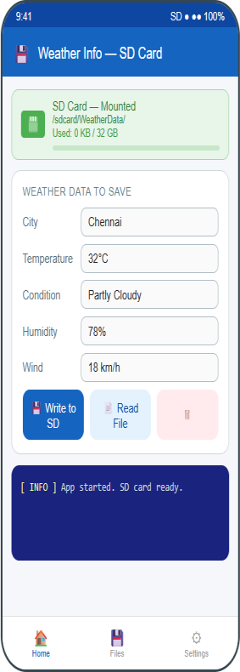

Result
Thus, the Android application to write weather information data into the SD card was developed and executed successfully.

