12.Develop a mobile application to send an email.

AIM:
To develop a mobile application that enables the user to send an email through the app. The application will provide an interface to input the recipientC#39;s email address, subject, message content, and optionally attach files. It will use AndroidC#39;s built-in email capabilities to send the email,

ALGORITHM:
Initialize the Android Application:

Set up a new Android project in Android Studio.

Create a MainActivity for the UI where the user will input email details (recipient
address, subject, message, and attachment if any).

Design the User Interface (UI):

In the XML layout file, create the following UI components:

EditText fields for entering:



RecipientC#39;s email address. Subject of the email.
Message content.
- Button to trigger the email sending process.
- Optional: Button to select file attachments (if required).
- TextView or Toast for displaying feedback to the user (e.g., success or failure).

Declare Variables:

Declare variables for EditText fields (for email address, subject, and message).

Declare a Button for sending the email and another Button for attachment (optional).

Declare a String variable to hold the recipient email, subject, and message content.

Set OnClickListener for Send Button:

Set an OnClickListener for the Send Email Button.

Inside the onClick() method, retrieve the values entered by the user:
- Get the email recipient, subject, and message using getText().toString() for the EditText fields.

Validate User Input:

Ensure that the email address is in a valid format (e.g., name@domain.com).

Check if all necessary fields (email, subject, message) are not empty.

If any validation fails, show an error message (Toast) and do not proceed.

Create an Intent to Send the Email:

Use an Intent to trigger the email client (e.g., Gmail, Outlook, etc.).
- Set the action to Intent.ACTION_SENDTO.
- Use mailto: URI scheme to trigger the email client and set the recipient, subject, and message as parameters.
- Example: mailto:recipient@example.com?subject=SubjectCamp;body=Message

Set the email fields (recipient, subject, message) in the intent.

Optional: Attach Files (if applicable):

If attachments are required, use Intent.EXTRA_STREAM to attach a file (e.g., an
image or document).

Use a file picker to allow the user to select the attachment, then add the file URI to the
intent.

Send the Email:

Call startActivity(intent) to invoke the email client and send the email.

If the email client is installed, it will open with the email details prefilled, and the user can press the send button.

If the email client is not installed or an error occurs, display an appropriate Toast message informing the user.

Display Feedback:

If the email was successfully sent, show a Toast or update the UI with a success message.

If there was an error (e.g., invalid email, missing email client), display an error Toast or show an error message in the TextView.

End the Operation:

After the email has been sent or if there was an error, the operation is complete. The
user can send another email or exit the app.

Code:

XML Layout (activity_main.xml)

<?xml version="1.0" encoding="utf-8"?>
<LinearLayout xmlns:android="http://schemas.android.com/apk/res/android" android:orientation="vertical"
android:padding="20dp" android:layout_width="match_parent" android:layout_height="match_parent">

<EditText android:id="@+id/emailTo"
android:layout_width="match_parent" android:layout_height="wrap_content" android:hint="Enter Email Address"/>

<EditText android:id="@+id/emailSubject" android:layout_width="match_parent" android:layout_height="wrap_content" android:hint="Enter Subject"/>

<EditText

android:id="@+id/emailMessage" android:layout_width="match_parent" android:layout_height="wrap_content" android:hint="Enter Weather Info" android:lines="4"/>

<Button android:id="@+id/sendBtn"
android:layout_width="wrap_content" android:layout_height="wrap_content" android:text="Send Email" android:layout_marginTop="20dp"/>

</LinearLayout>

Java Code (MainActivity.java)
package com.example.weatherapp;

import android.content.Intent; import android.os.Bundle; import android.view.View; import android.widget.Button; import android.widget.EditText;

import androidx.appcompat.app.AppCompatActivity;

public class MainActivity extends AppCompatActivity {

EditText emailTo, emailSubject, emailMessage; Button sendBtn;

@Override
protected void onCreate(Bundle savedInstanceState) { super.onCreate(savedInstanceState); setContentView(R.layout.activity_main);

emailTo = findViewById(R.id.emailTo); emailSubject = findViewById(R.id.emailSubject); emailMessage = findViewById(R.id.emailMessage); sendBtn = findViewById(R.id.sendBtn);

sendBtn.setOnClickListener(v -> {

String to = emailTo.getText().toString();
String subject = emailSubject.getText().toString(); String message = emailMessage.getText().toString();

Intent intent = new Intent(Intent.ACTION_SEND); intent.setType("message/rfc822");

intent.putExtra(Intent.EXTRA_EMAIL, new String[]{to}); intent.putExtra(Intent.EXTRA_SUBJECT, subject); intent.putExtra(Intent.EXTRA_TEXT, message);

startActivity(Intent.createChooser(intent, "Send Email"));
});
}
}

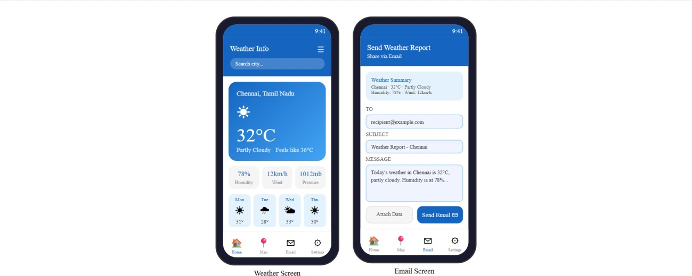
Output:

RESULT:
A mobile application is developed to send an email.

