PRODUCT SALES ANALYTICS

What Is Sales Analysis?
It's pretty simple: sales analysis is what happens when sales professionals monitor sales data, in order to evaluate sales team performance. Doing so can uncover insights about:
- Top-performing products/services
- Underperforming products/services
- Customer behavior and retention
- New sales and market opportunities
- The future outlook of your sales team

What is Included in a Sales Analysis?
- Sales activity volume
- Ratio of new leads to qualified leads
- Information about your pricing structure
- Data on your social media campaigns
- Current sales trends
- Revenue and costs for a specific period

How to Perform Sales Analysis: A 4-Step Process

Step 1: Choose the Right Sales Analysis Method
- Sales trend analysis: This type of sales analysis looks for patterns in sales data. Use it to track your team's progress towards its sales goals, while simultaneously understanding sales patterns in specific products, customers, and/or geographies.
- Sales performance analysis: Sales performance analysis is crucial for effective sales performance analysis . This type of analysis will help you gauge your sales team's performance and evaluate the overall effectiveness of your sales strategy. Utilize it to compare actual results to expected outcomes, and then make necessary adjustments. Implementing these changes can lead to faster closing times, increased win rates, and a significant boost in revenue growth.
- Predictive sales analysis: This type of sales analysis is designed to help you predict future risks and opportunities. Use it to create accurate sales forecasts.
- Sales pipeline analysis: This type of sales analysis will help you discover common sales activities prospects go through before they convert. As such, it will give your sales team the context it needs to shorten sales cycles and close more deals.

- Product sales analysis: This type of sales analysis is perfect for large companies and/or companies with extensive product offerings. Why? Because it helps them determine which products actually affect their bottom lines. Use it to better understand your company's demographics, pinpoint popular products, and the like.
- Prescriptive analysis: This type of sales analysis will empower your sales reps with knowledge, helping them determine which opportunities to pursue and which to dump like radioactive waste. Use it to increase rep success and team-wide win rates.
- Market research: This type of sales analysis may seem old-fashioned, but it's never gone out of style. To use this technique, simply survey your customers, research your competitors through web scraping using curl proxy for greater efficiency and reliability, and read general sales statistics. Once you do, you'll have a much better understanding of your customer’s needs, thereby improving your sales effectiveness.

Step 2: Identify the Specific Information You Need
You've chosen the perfect sales analysis method. It just seems to get you and the sales goals you want to achieve. Congratulations! But your work is far from over…
Now you need to identify the specific bits of information that you need. For example, you might want to measure the impact of your sales training efforts. Or find the top-selling product from a recent marketing campaign. Or determine similarities between repeat customers.
When you know what information you need, you can choose metrics and KPIs that will help you acquire, track, and measure it. We'll talk about this a bit more in the next section.
Before we get there, though, we need to talk about timing—as in, what time frames should you collect data for? The answer to that question will depend on the metrics you're tracking, but weekly, monthly, quarterly, and yearly time periods are pretty common.
Just remember, consistency is essential, regardless of which metrics you decide to monitor. With that in mind, plan to conduct analysis more frequently during special promotions.

Step 3: Choose a Sales Analysis Tool and Analyse Your Data
Your sales analysis efforts are going strong! To keep them that way, invest in an analytics tool to help you get the most out of every metric you decide to track. Here are a few ideas:
- Spreadsheets: You got a love the classics, right? A spreadsheet tool like Microsoft excel can help you analyse and interpret your sales data. Just make sure that you have sufficient quantity and quality of data before you get started. If you don't, you won't be able to make informed decisions that propel your company forward.
- CRM software: Every sales organization needs a CRM. How else will you store contact information, automate email sequences, and view sales pipelines from one sales dashboard? Newsflash: your CRM tool can also be used for sales analysis. If you use close, for example, you can easily generate reports for any metric or KPI, including detailed pipeline and funnel reports, which will help you with sales forecasting.
- Sales analytics apps: Some tools are completely dedicated to sales analysis Chrous.ai, for example, will help you analyse sales calls and pinpoint areas of improvement. Gong.io will help you report on customer interactions and forecast future sales. And Seismic will help you calculate the effect of your sales enablement efforts.
At the end of the day, choose the sales analysis tool to help you accomplish your goals. Look for substance, not style. We all know you'll make better business decisions with the right data analytics tools in your toolbox.

Step 4: Share Your Results with Relevant Stakeholders
Last but not least, you need to present your sales data analysis to key stakeholders.
Unless you’re asked to share the process by which you arrived at your results, only show the main findings. You can use graphs and visuals to help your audience interpret the data. Additionally, employing tools like the revenue growth calculator can be instrumental in visualizing and comprehending complex sales data effectively.
For example: If you lead a sales team and want to share information regarding sales team performance with your CEO, you might want to include charts around your sales goals, your best-selling products, and the revenue and expenses of your team.
Overall, your sales analysis presentations should share actionable insights and be easy to understand. End with recommendations to help accomplish this goal.

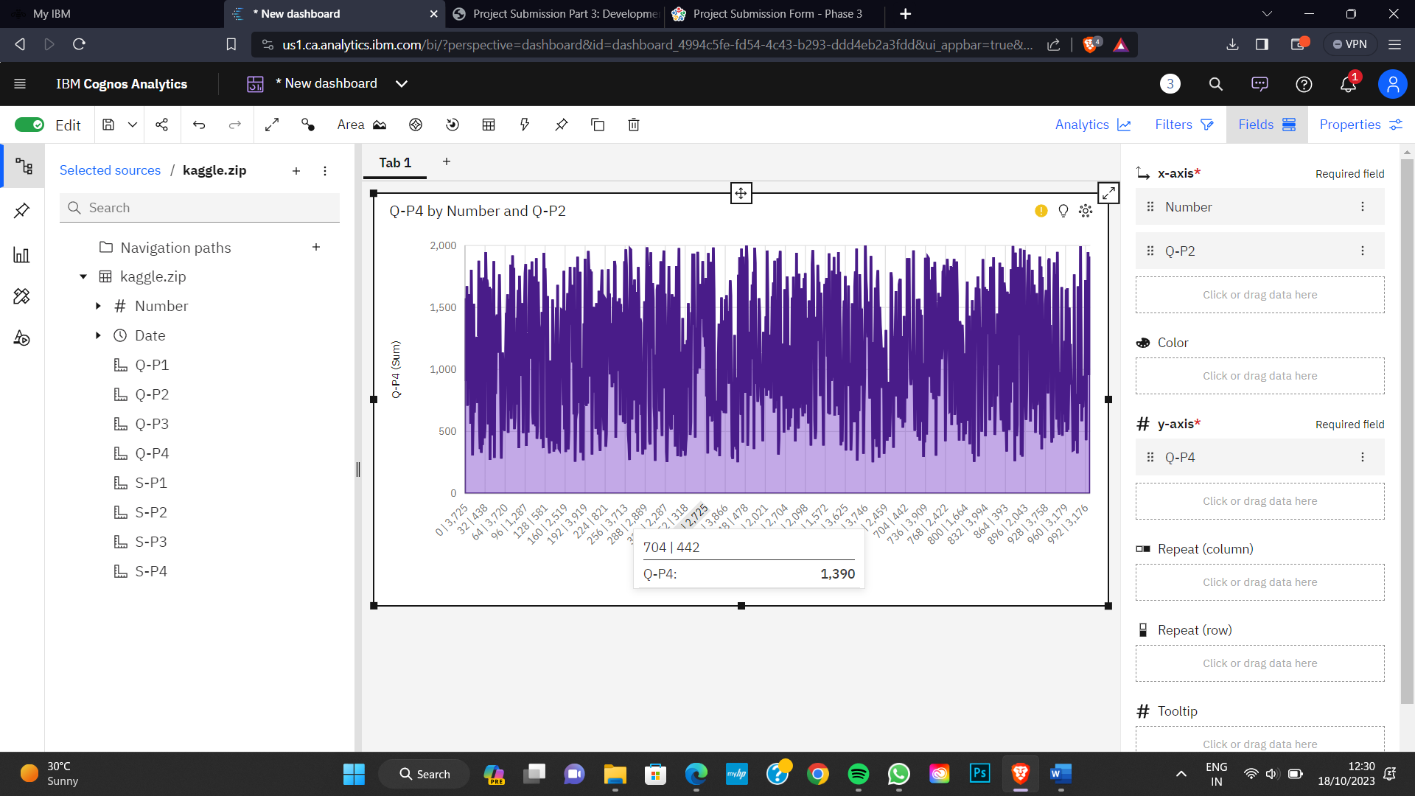

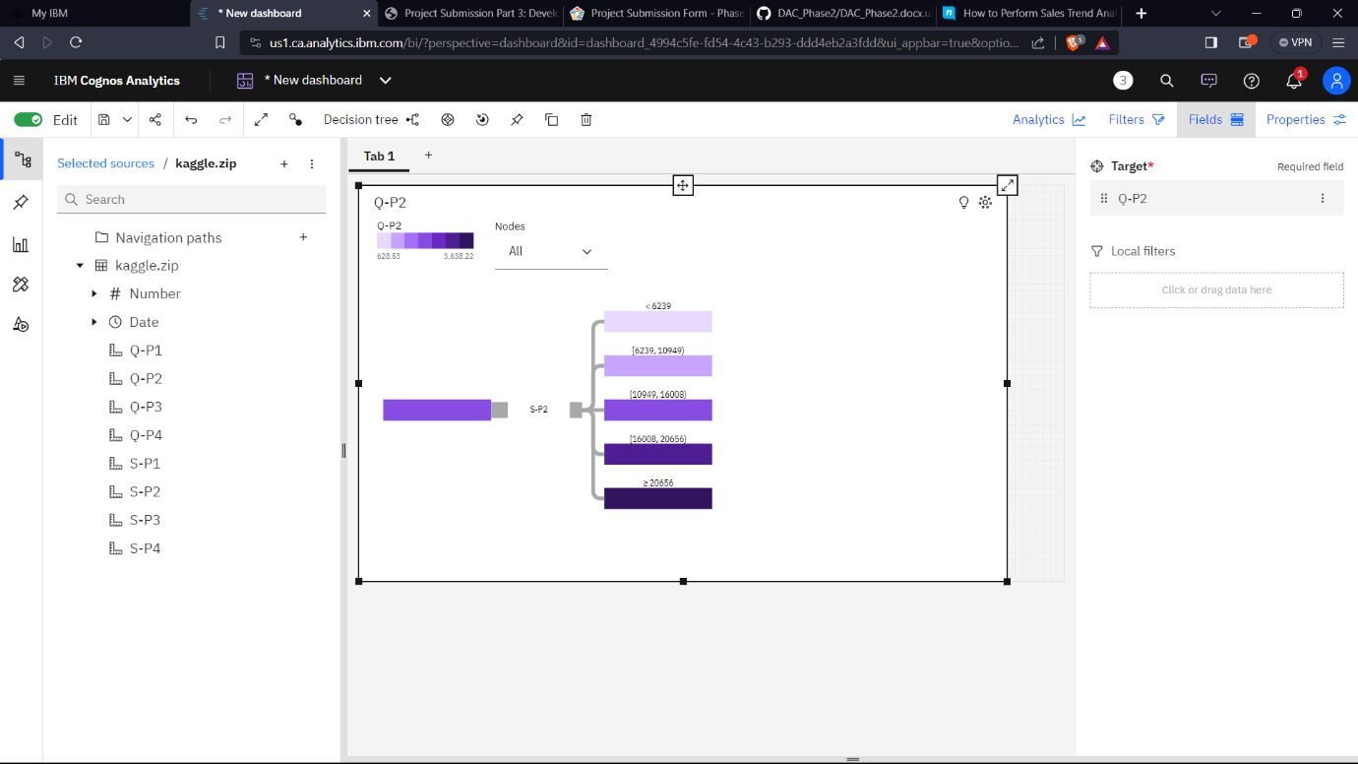

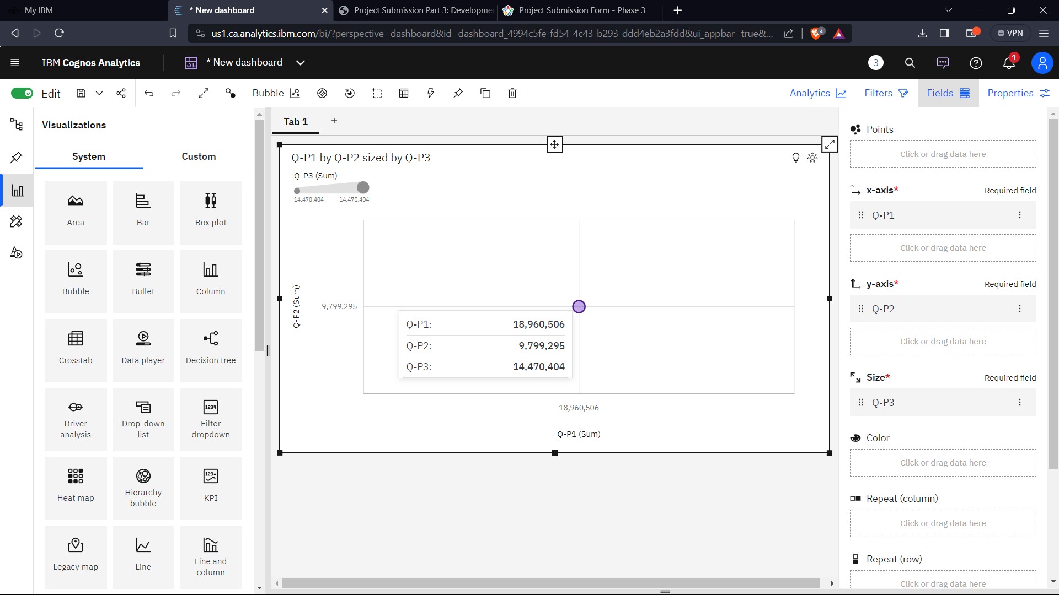
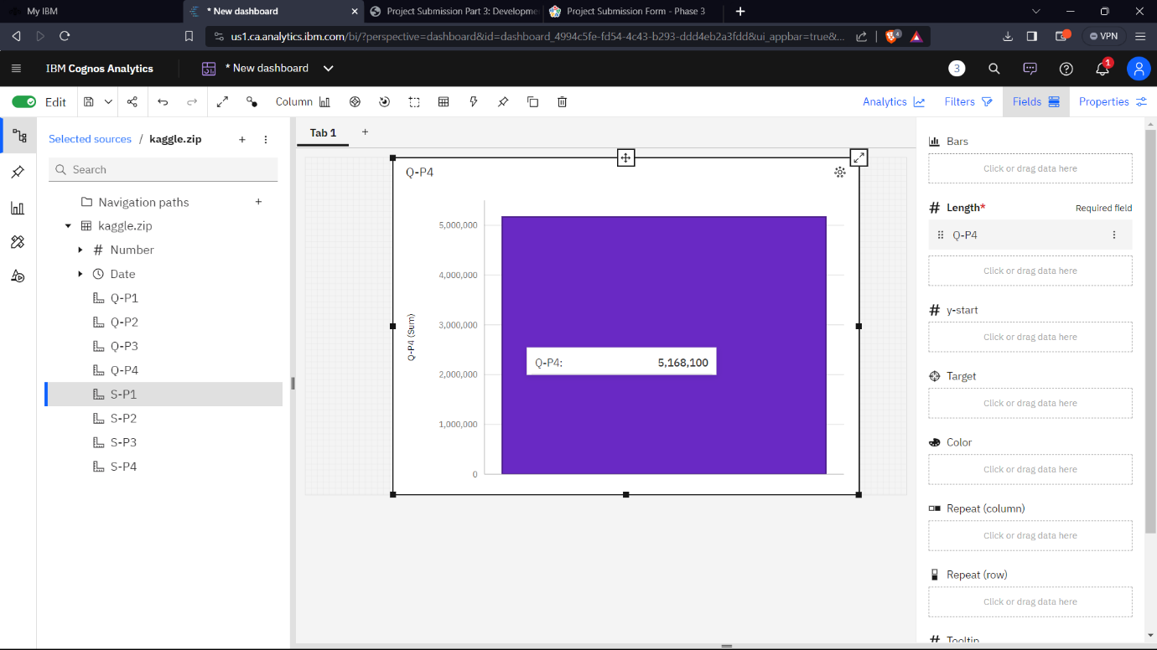
CONCLUSION :
Sales analysis reports create accountability, reveal insights about one’s customer base, the specific traits top-performing sales reps have. Honestly, they have the power to revolutionize your entire sales and decision-making processes, which is why they deserve your unending love and devotion.

