**PROJECT TITLE : PRODUCT SALES ANALYSIS**

**PRODUCT SALES ANALYSIS :**

**Building phase of the project:**

Product sales analysis is a judgment on the market performance of a product. For each product sold by your business, it is recommended that you perform a product sales analysis to compare the profit contribution of different products. If certain products do not perform well in generating profits, you can consider whether to stop or reduce the investment in that product.

**Product sales analysis using IBM cognos visualization:**

* Identifying the most suitable machine learning technique for prediction to perform on product sales analysis.
* Preparing a machine learning model that could make accurate prediction on product sales analysis patterns.
* Identifying the feature that affects the prediction of product and sales analysis.

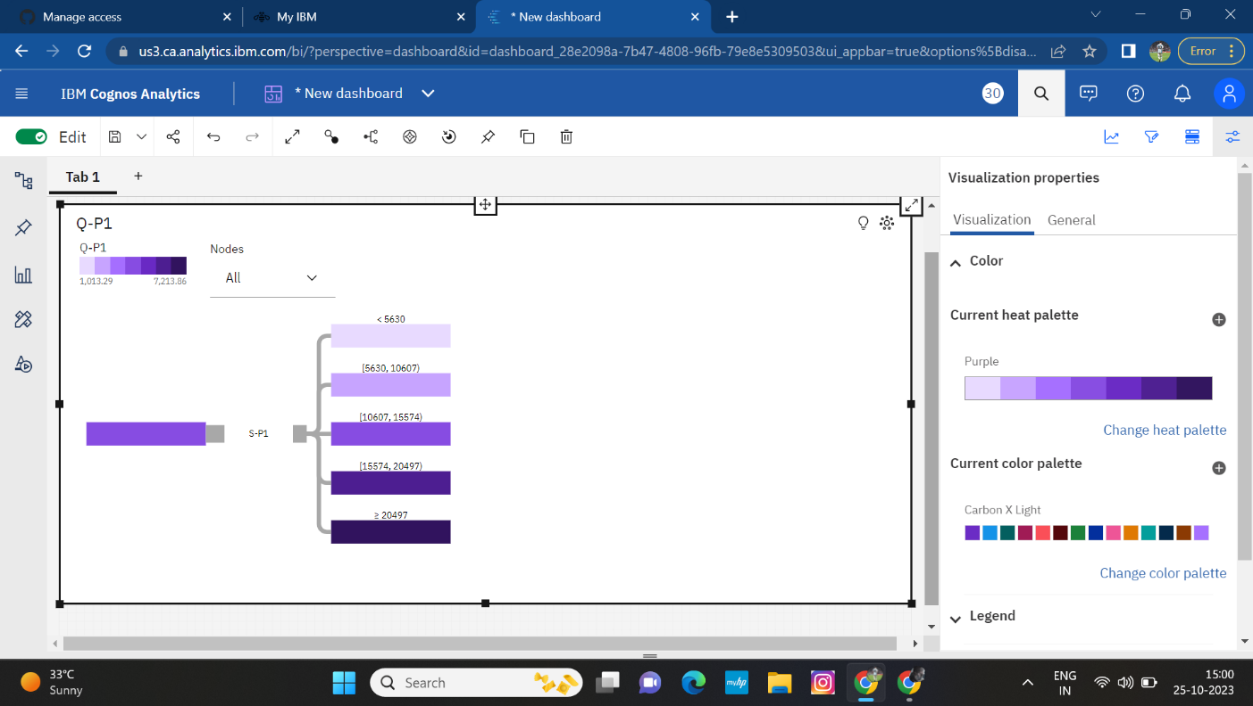

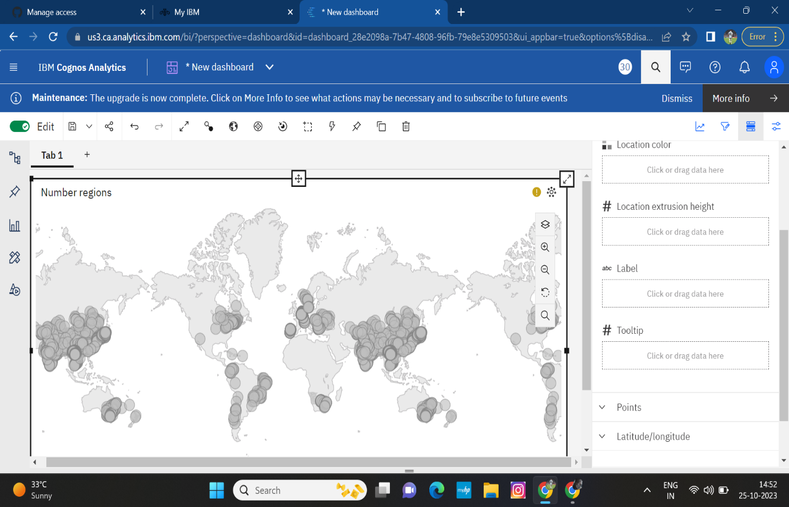

**Deriving insights from data :**

* Product insights refer to valuable information and data-driven findings about a product that helps businesses make informed decisions. These insights can be used to enhance product development, marketing, sales, and customer support strategies.
* Product insights can help product teams identify areas where their product is excelling and areas where there is room for improvement.
* Leveraging product insights allows companies to anticipate customer needs, identify potential problems, and adjust their approach as needed.

**Types :**

1. Behavioral insights
2. Performance insights
3. Market insights
4. Operational insights

**Insights from the data :**

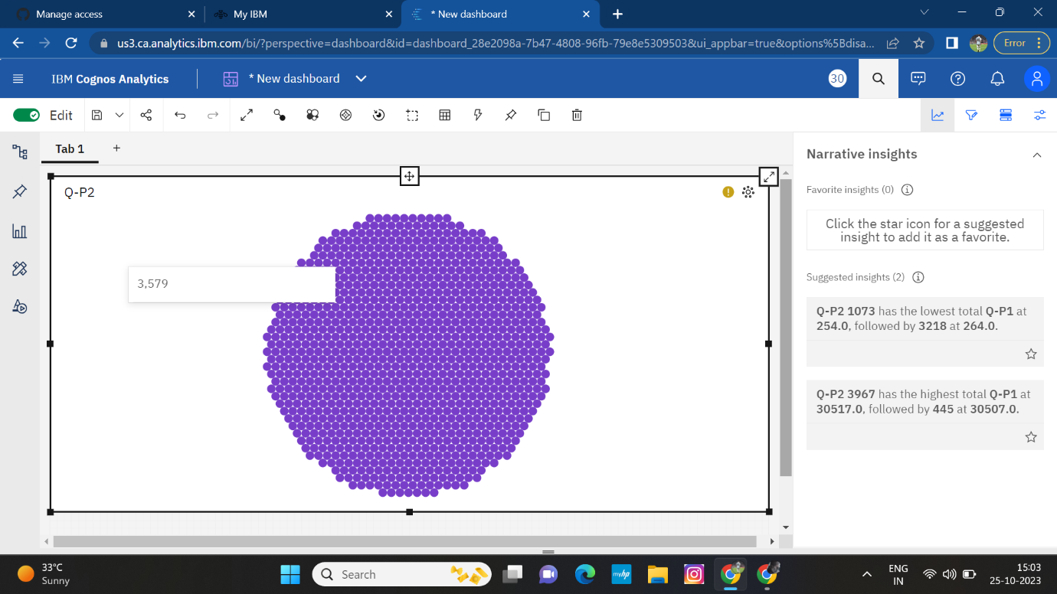

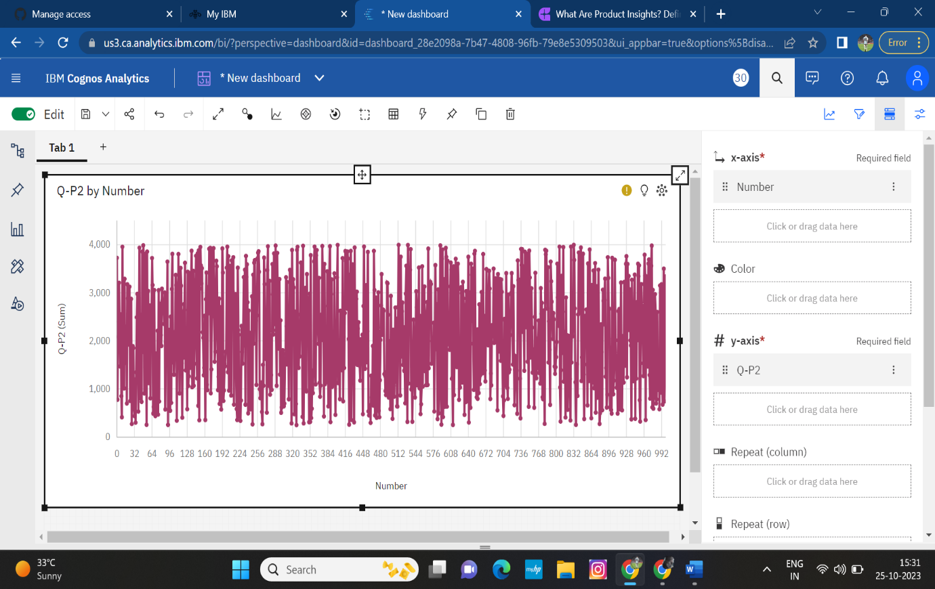

**Analyze the visualizations to identify trends,highest sales,peak sales,customer preference:**

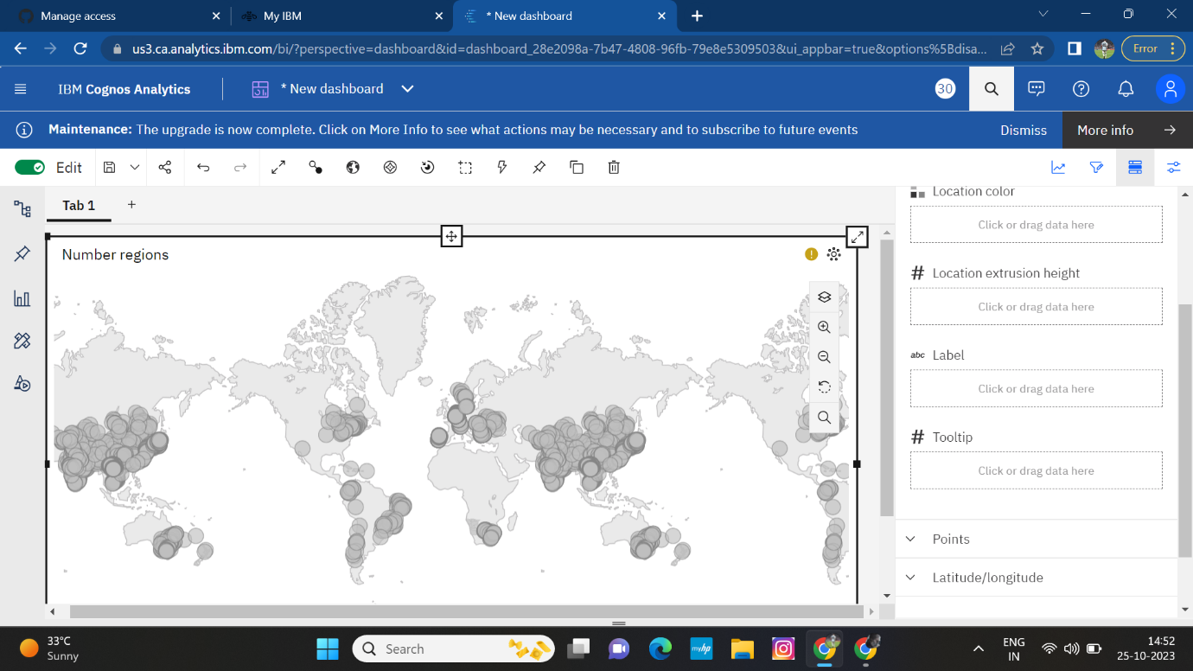

**DATASET LINK:**

[**https://www.kaggle.com/datasets/ksabishek/product-sales-data**](https://www.kaggle.com/datasets/ksabishek/product-sales-data)

**CONCLUSION:**

Product insights play a vital role in helping businesses make informed decisions about product development, marketing, sales, and customer support. By gathering and analyzing data from different sources, product teams can gain valuable information about how their product is being used and what improvements can be made to better meet customers' needs. By understanding the four main types of product insights - behavioral insights, performance insights, market insights, and operational insights - teams can create a comprehensive view of their product's performance and customer interactions.