PRODUCT SALES ANALYSIS

# Objectives:

The product sales analysis provides insight into how well a product is matched to prospective customer needs. It can also indicate which products are the most successful, when and why certain products are most likely to be purchased, and which types of consumers are likely to buy a specific product or service.

Sales management objectives

A sales manager’s responsibility is to set long-term goals and objectives for their team. By understanding how sales objectives fit into the organization, you’ll better understand the big picture and can communicate better with senior management. Some of the main objectives of sales management include:

* Revenue generation
* Increased sales volume
* Sustained profits
* Sales department growth
* Market leadership
* Prospect conversions
* Motivating the sales force

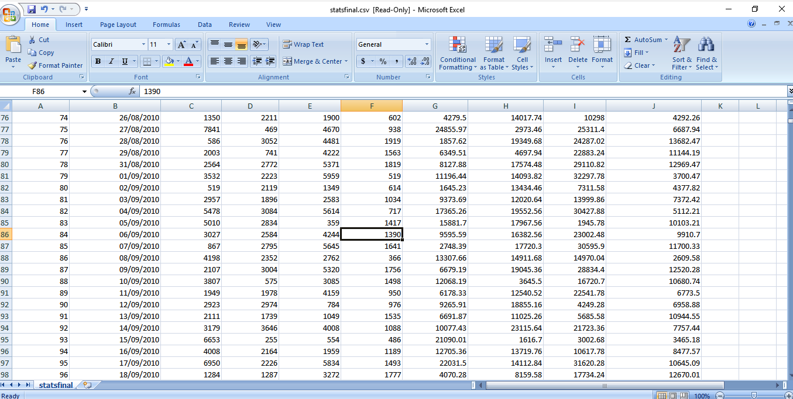

# DESIGNING THINKING PROCESS:

* Design Thinking identifies and solves problems creatively and iteratively, with a focus on the human need being addressed.
* Design Thinking process has been associated with innovation and product development, but it turns out that it is also highly applicable in a sales context.
* A Design Thinking approach to selling – in essence, empathising with the customer’s need and then jointly designing sustainable solutions – can create superior outcomes to more traditional sales approaches, as it places both the buyer and the seller firmly on the same side of the table.
* This highly interactive programme develops lasting consultative selling skills through a comprehensive set of application and real-life exercises, tools and reinforcement techniques within Imparta’s continuous improvement
* It forms part of Imparta’s 3D Curriculum, which helps sales professionals to create, differentiate, protect, capture, deliver and expand value around the whole customer Buying Cycle.
* It is based on more than 20 years of quantitative, qualitative and field-based sales research. Completing this course will help participants know when and how to use the powerful tools in Design Thinking for Sales.

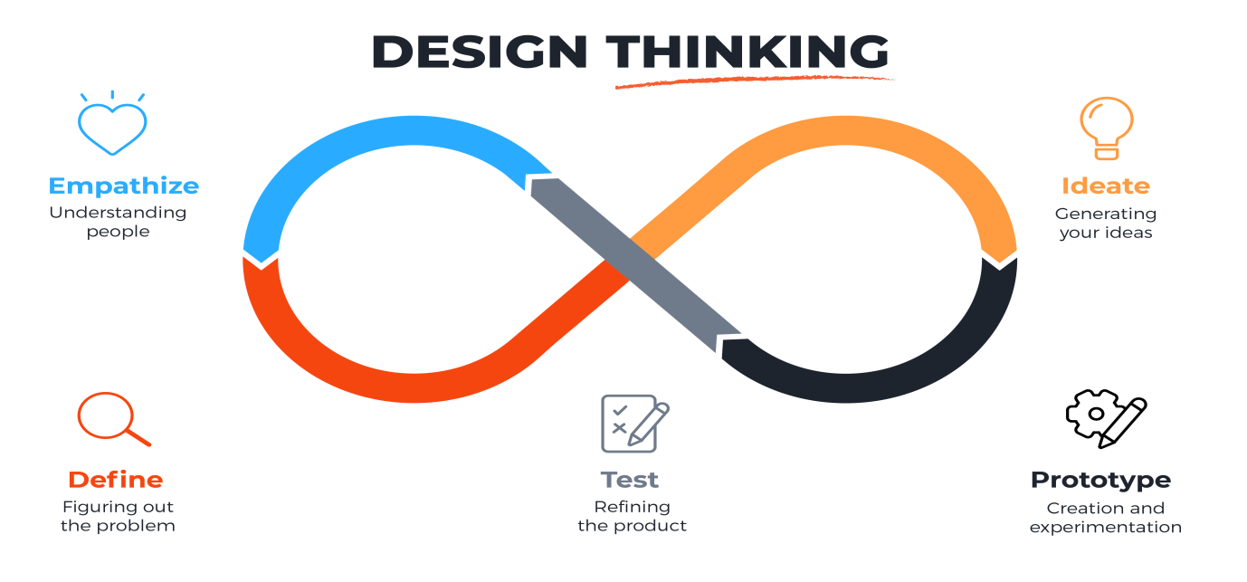

# DEVELOPMENT PHASE:

Product development is the process of building a new product, from ideation all the way through launch. Product development begins with those initial brainstorming sessions, when you’re just discussing a budding idea. From there, the process is creative but strategic, and you may have seen it done in a million different ways. But without clear organization, it can be hard to mesh creativity and strategy effectively. Where the product development process comes in—a six step framework to help you standardize and define your work.

The 6 stages of product development

1. Idea generation (Ideation)

2. Product definition

3. Prototyping

4. Initial design

5. Validation and testing

6. Commercialization

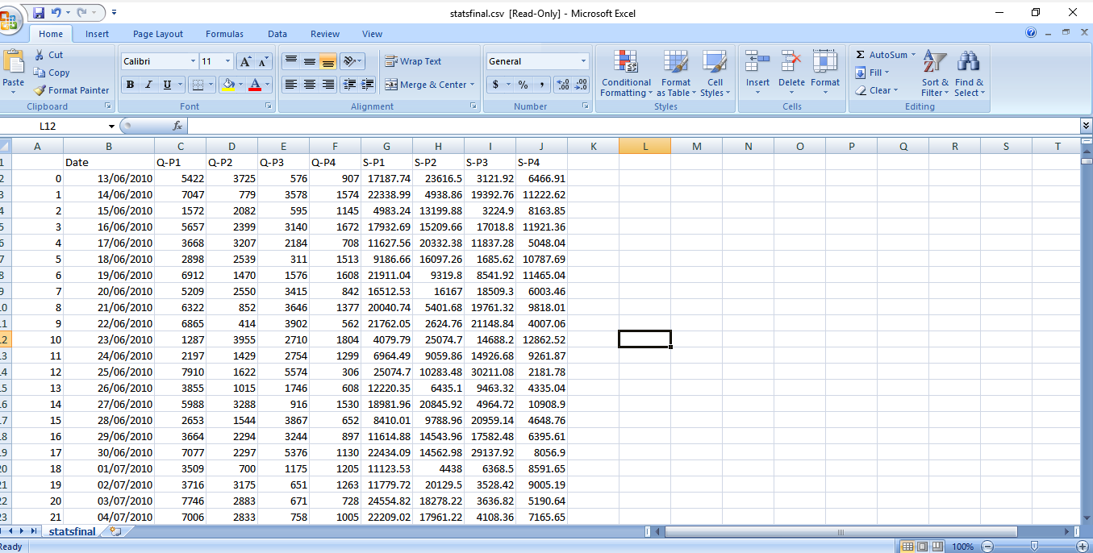

# ANALYSIS OF DATA COLLECTION,DATA VISUALIZATION PROCESS:

## DATA COLLECTION PROCESS:

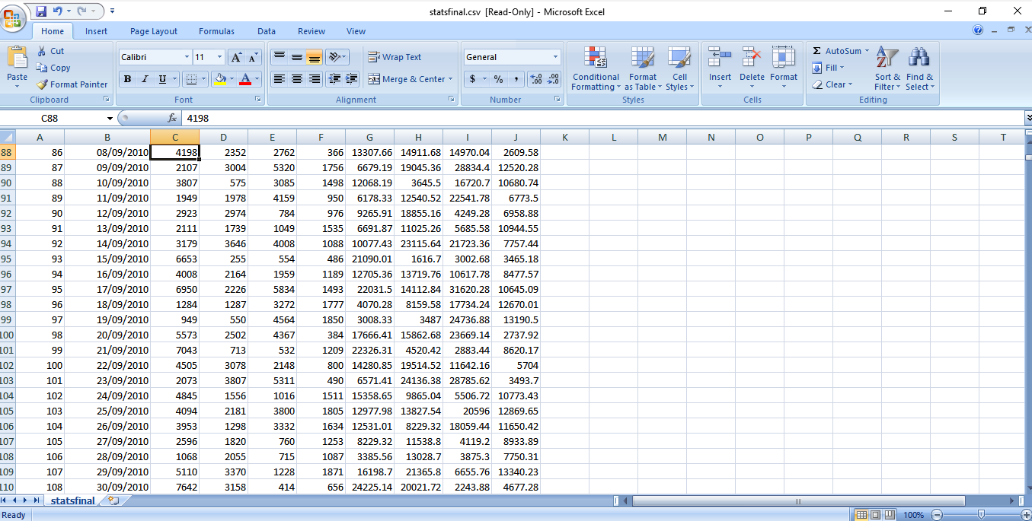

# DATA VISUALIZATION USING IBM COGNOS:

* Identifying the most suitable machine learning technique for prediction, to perform on product sales analysis.
* Preparing a machine learning model that could make accurate predictions of product sales analysis.
* Identifying the features that affects the prediction of product sales analysis.

VISUALIZATION:

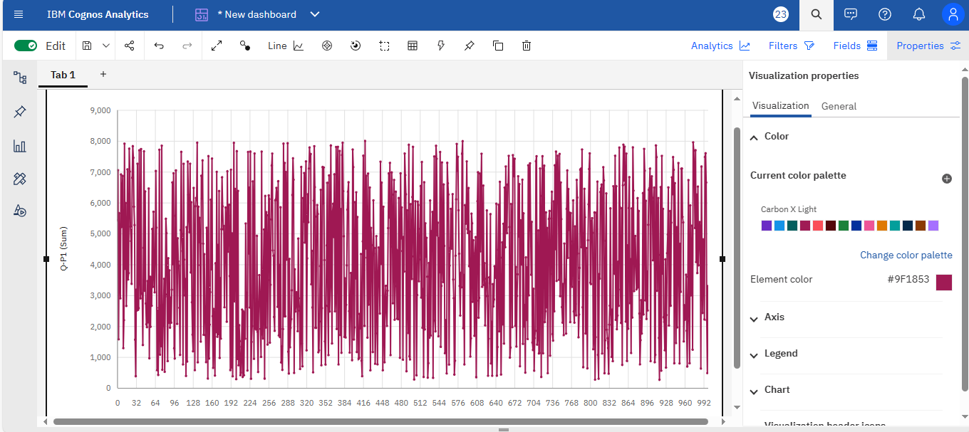

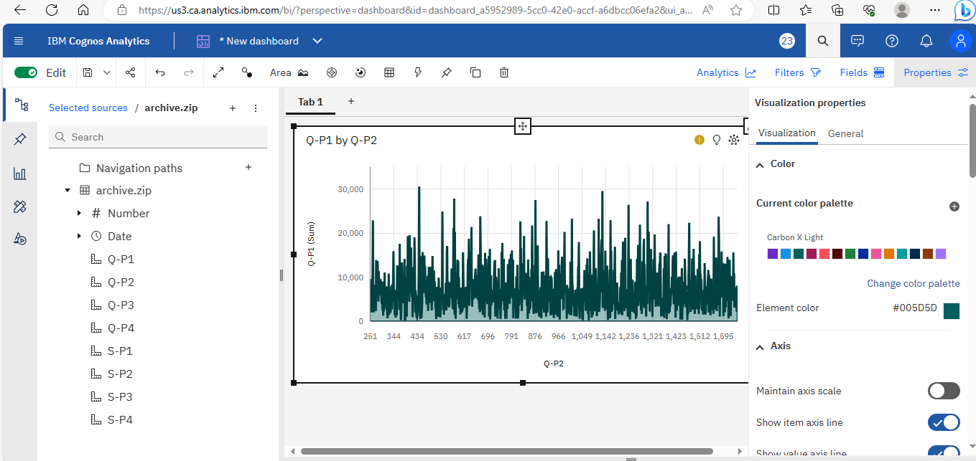

**PYTHON CODE:**

import pandas as pd

# Load the sales data from a CSV file

sales_data = pd.read_csv('sales_data.csv')

# Calculate total sales for each product

product_sales = sales_data.groupby('Product')['Quantity'].sum()

# Calculate total revenue for each product

sales_data['Revenue'] = sales_data['Quantity'] * sales_data['Price']

product_revenue = sales_data.groupby('Product')['Revenue'].sum()

# Calculate average price for each product

product_avg_price = product_revenue / product_sales

# Calculate total sales and revenue for each month

sales_data['Month'] = pd.to_datetime(sales_data['Date']).dt.month

monthly_sales = sales_data.groupby('Month')['Quantity'].sum()

monthly_revenue = sales_data.groupby('Month')['Revenue'].sum()

# Print the results

print("Total Sales by Product:")

print(product_sales)

print("\nTotal Revenue by Product:")

print(product_revenue)

print("\nAverage Price by Product:")

print(product_avg_price)

print("\nTotal Sales by Month:")

print(monthly_sales)

print("\nTotal Revenue by Month:")

print(monthly_revenue)

**OUTPUT:**

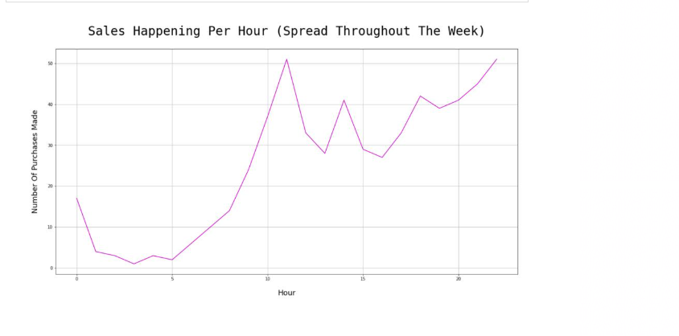

**INSIGHTS FROM THE ANALYSIS:**

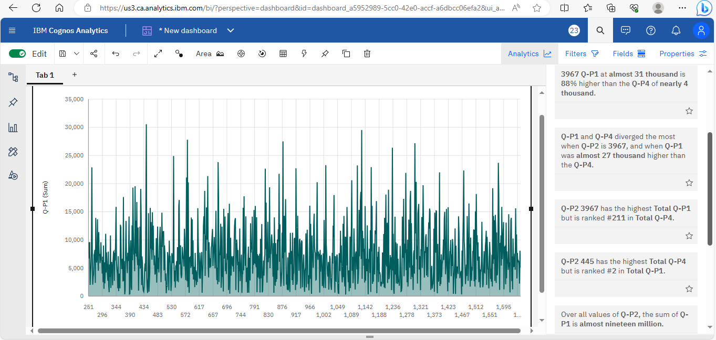

**DATASET LINK:**

[**https://www.kaggle.com/datasets/ksabishek/product-sales-data**](https://www.kaggle.com/datasets/ksabishek/product-sales-data)

**CONCLUSION:**

A sales analysis tool shows both sides of the coin: On the one hand, you get to know the best-performing sales agents, segment hot leads, set up your sales goal, and identify the campaigns that bring in customers in hordes

On the other hand, you can weed out cold leads, train struggling agents, and tweak or improve failed products or campaigns.

There are a few great CRM software in the market today. For small businesses that need a comprehensive yet affordable sales analysis software, EngageBay is an excellent choice.