Name: Magnathan A

Tittle : Global Economic and Demographic Trends Analysis  
Course: Data Science & Data Analytics  
Tool Used: Power BI, Excel, SQL, Statistics

# Abstract

This project analyzes global datasets representing population, GDP, demographics, and health-related indicators. Data from SQL and Excel were cleaned, transformed, and integrated into Power BI. Descriptive statistics and DAX calculations were applied to derive insights, and findings were visualized in an interactive Power BI dashboard. The analysis highlights key global economic and demographic trends, providing actionable insights for decision-making.

# Introduction

The project explores how global population and economic changes have shaped development trends over decades. Using SQL, Excel, and Power BI, the analysis focuses on population growth, GDP per capita, literacy rates, and infant mortality. The aim is to create a clear, interactive dashboard to better understand disparities across regions.

# Objectives

- Connect and integrate SQL and Excel datasets.  
- Perform data cleaning and transformation.  
- Apply descriptive statistical analysis.  
- Use DAX to calculate growth rates, GDP per capita, and correlations.  
- Design an interactive dashboard with visual storytelling.

# Data Sources

1. SQL Dataset – CountriesWorld

- Population, Area, Density, GDP per capita, Literacy, Infant Mortality, etc.

2. Excel Datasets

- PopulationPerCountry (1960–2017)  
 - MetaData (Region, Income Group)  
 - GDP by Country (1960–2016)

# Methodology

1. Data Cleaning & Transformation:  
- Removed duplicates and missing values.  
- Standardized country codes.  
- Converted data types and merged datasets.  
  
2. Descriptive Statistical Analysis:  
- Population: Mean, Median, Standard Deviation.  
- GDP: Average per capita, min and max countries.  
- Infant Mortality: Range and distribution.  
- Literacy: Regional averages.  
  
3. DAX Calculations:  
- Population Growth Rate.  
- GDP Growth Rate.  
- GDP per Capita (calculated column).  
- Aggregations and correlations.  
  
4. Dashboard Design:  
- Line, Bar, Pie, Area charts, Maps.  
- Filters and slicers for interactivity.

# Screenshots

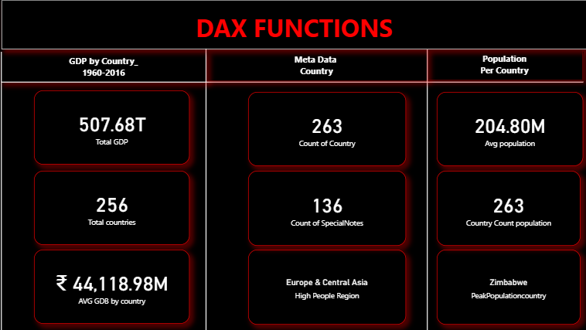 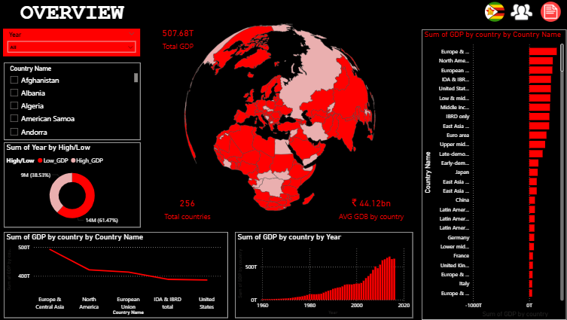

# Detailed Analysis & Findings

1. Population Trends: Rapid growth in Asia and Africa, stabilization in Europe and North America.  
2. GDP Analysis: Developed countries lead in GDP per capita; developing regions lag behind.  
3. Literacy vs GDP: High literacy rates correlate strongly with GDP.  
4. Infant Mortality: Significant decline globally, but disparities remain.  
5. Population Density: High-density nations face economic and social challenges.

# Insights & Recommendations

- Invest in education to boost GDP growth.  
- Improve healthcare systems to reduce infant mortality.  
- Support balanced development across agriculture, industry, and services.  
- Use BI dashboards for dynamic policy evaluation.

# Conclusion

The project demonstrates the importance of integrating SQL and Excel data sources into Power BI to derive actionable insights. It highlights the relationships between population growth, GDP, literacy, and health indicators. The interactive dashboard empowers decision-makers with data-driven knowledge for global development policies.

# Future Scope

- Predictive modeling for GDP and population forecasting.  
- Including environmental factors like climate change.  
- Expanding with advanced DAX and AI-powered visuals.