Contents

Setup PyCharm to integrate with GitHub 2

Upload the flask project from PyCharm to GitHub 4

Push the changes from PyCharm (local on your PC) to GitHub 6

Download a flask project from GitHub to PyCharm 8

Resource: <https://www.jetbrains.com/help/pycharm/using-git-integration.html>

# Setup PyCharm to integrate with GitHub

1. Install Git

Download Git from <https://git-scm.com/downloads>

Install Git using the downloaded executable.

1. Configure PyCharm
   1. Go to File -> Settings

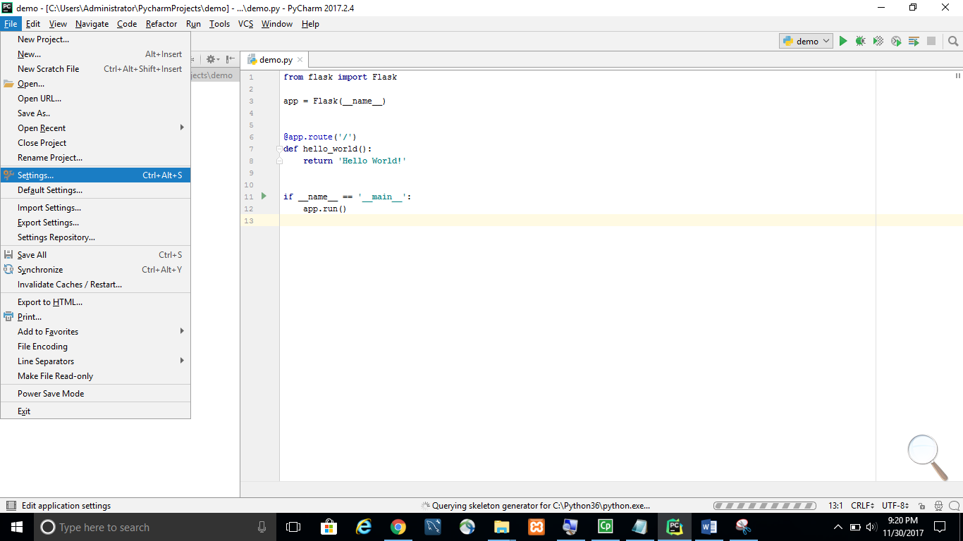

* 1. Go to Version Control -> Git and set the Path to Git executable. The path depends on where the Git is installed from the previous step.

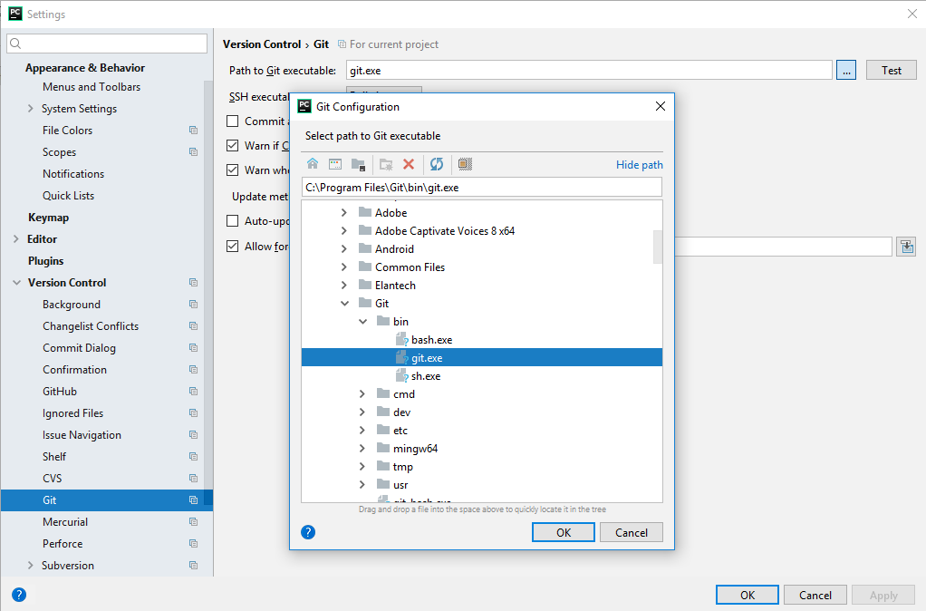

* 1. Click on the **Test** button to ensure Git can be executed successfully.

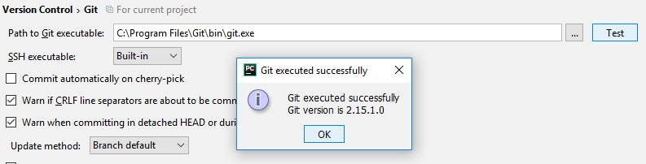

* 1. Go to **Version Control -> GitHub**. Enter your Github’s username and password. Click on **Test** to ensure the connection is successful.

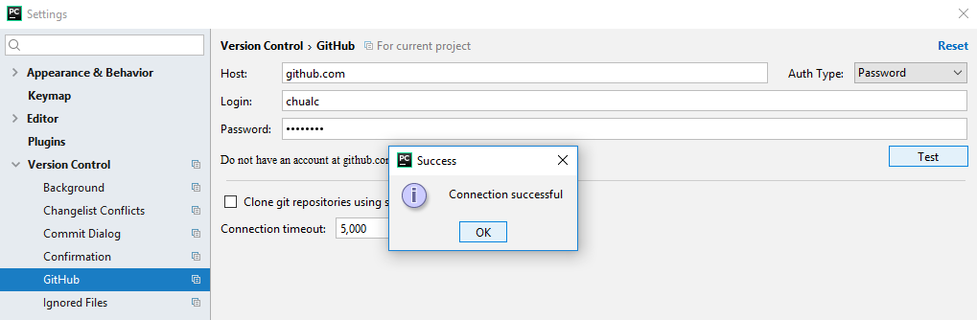

# Upload the flask project from PyCharm to GitHub

1. VCS -> Import into Version Control -> Share Project on GitHub

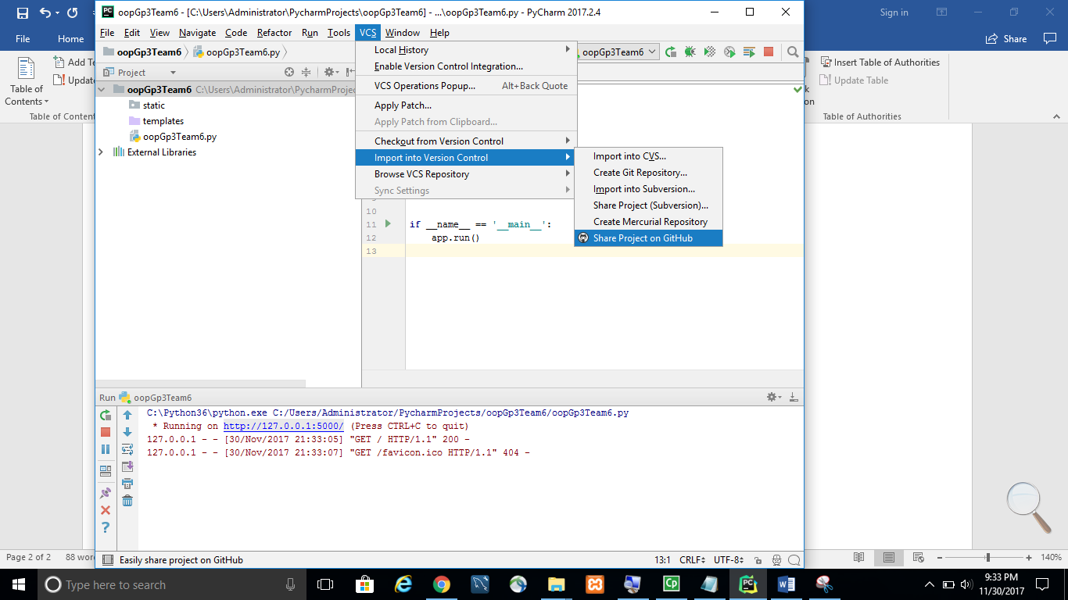

1. Enter your GitHub username and password if prompted. Select ‘**Save credentials**’.

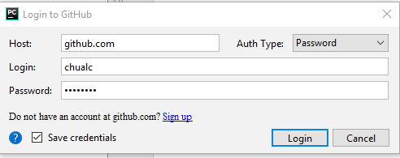

1. Enter repository name and click ‘**Share**’.

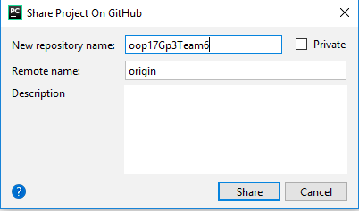

1. Select the files that you want to commit and click ‘**OK**’.

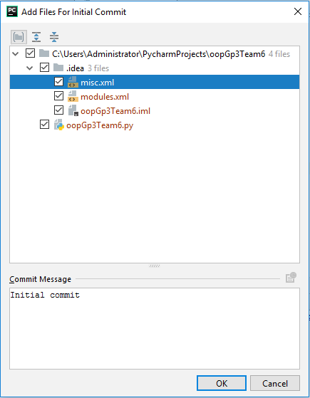

Note: If initial commit is unsuccessful, most probably your username and email setting for GitHub are not set. One way to fix the issue is to check in the file again and you will be prompted to enter the information. Once the correct information is captured, the commit issue should be resolved.

1. Check if your project is available on GitHub.

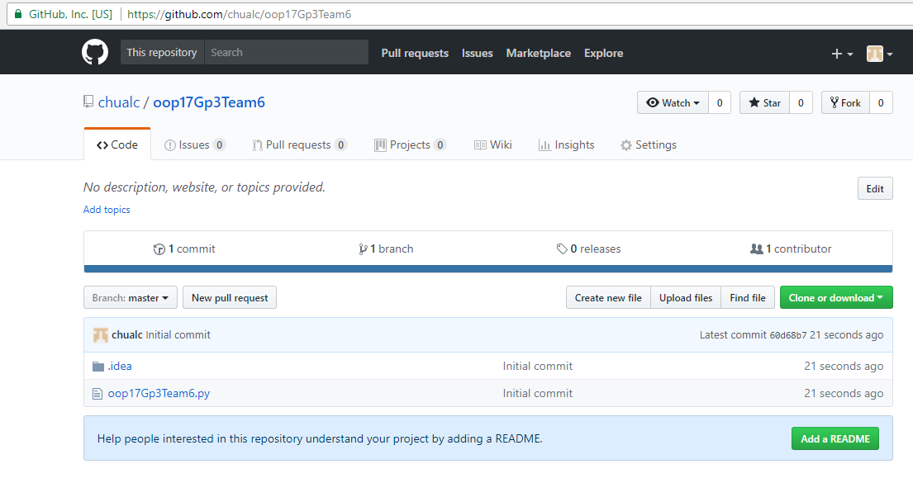

# Push the changes from PyCharm (local on your PC) to GitHub

1. Right click on the file that has been modified. Select **Git -> Commit File**

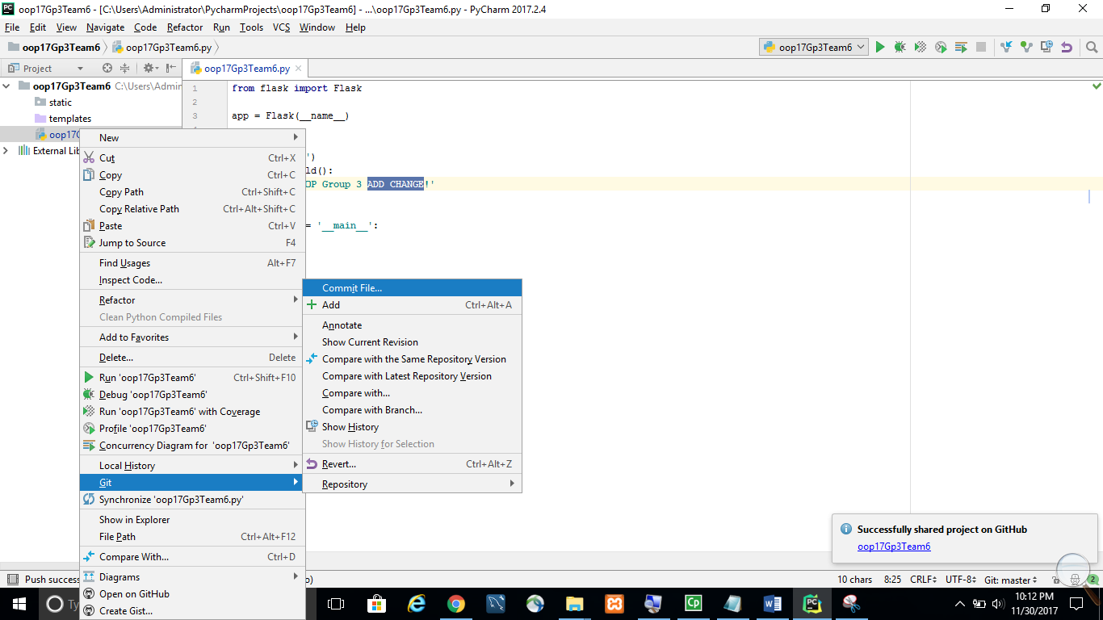

1. Enter the **Commit Message** and then select ‘**Commit and Push**’

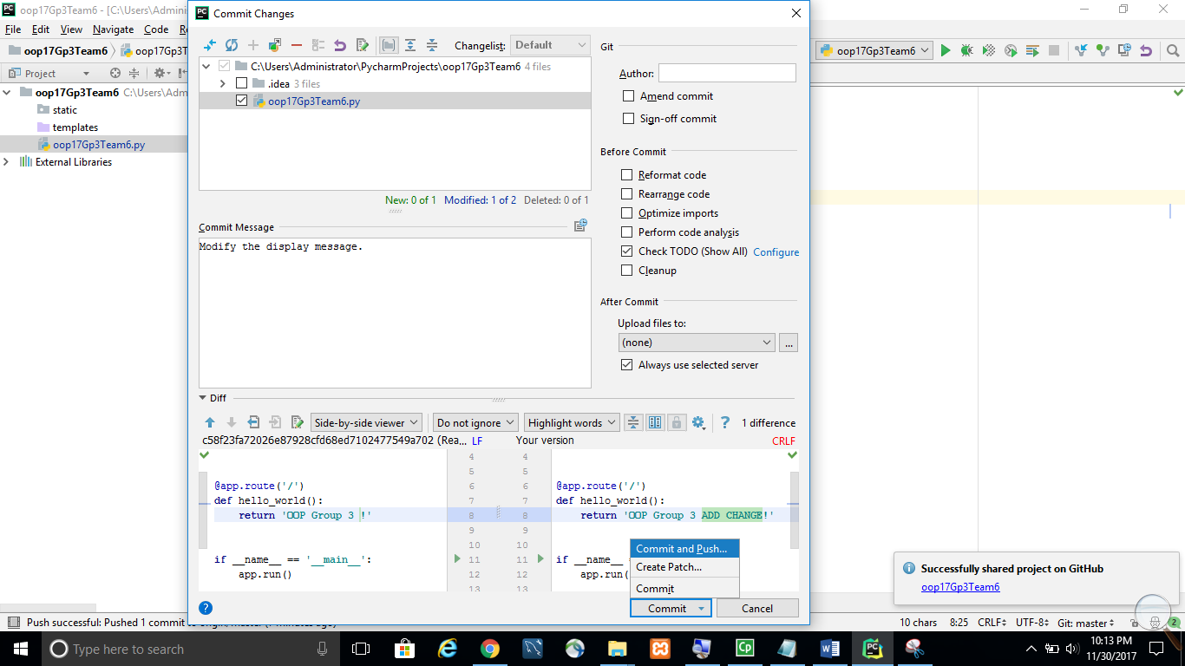

1. Click on the **Push** button.

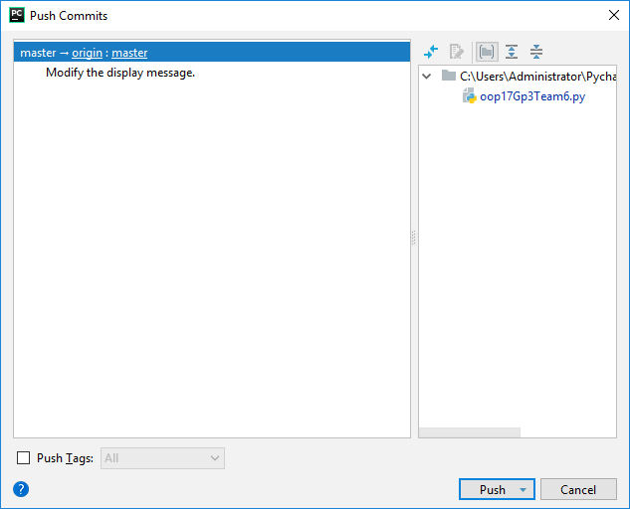

# Download a flask project from GitHub to PyCharm

Note: If you are not the owner of the project on the GitHub, make sure you are added as a collaborator.

1. Select GitHub from one of the methods shown below.

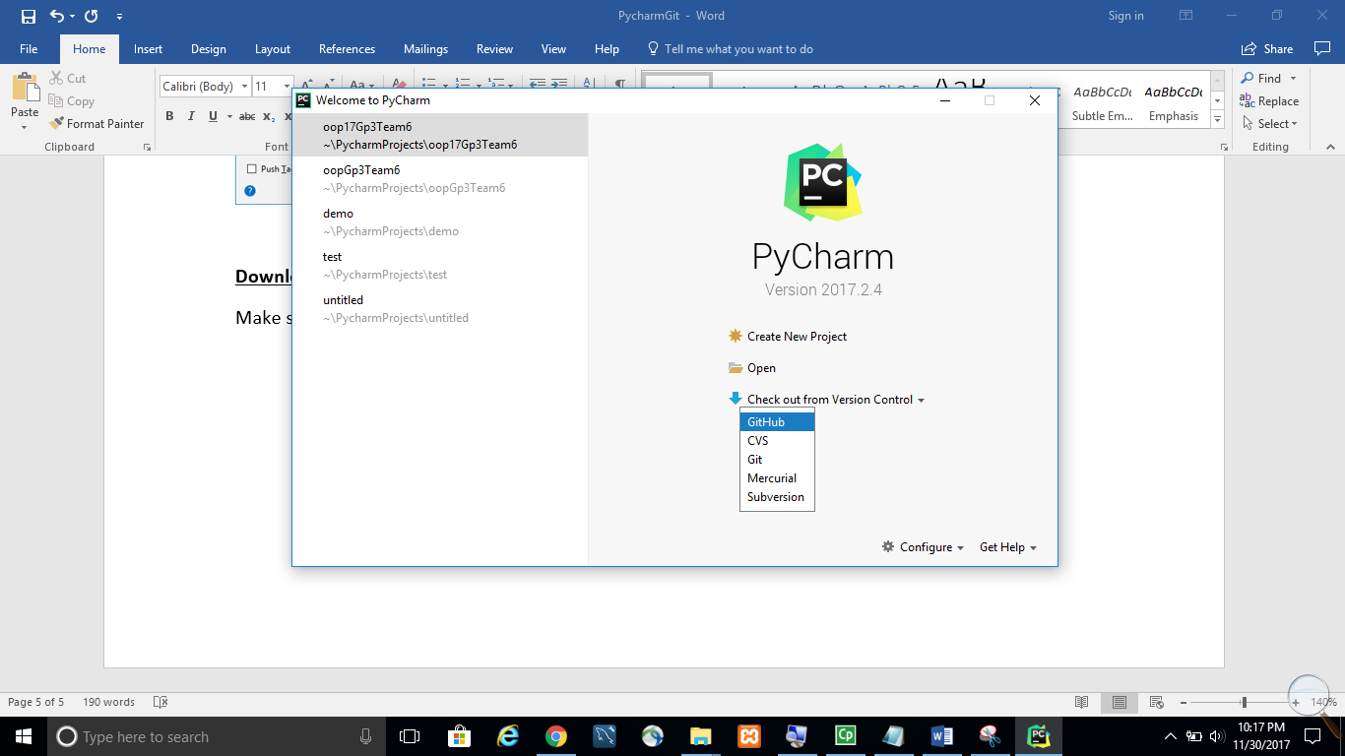 OR 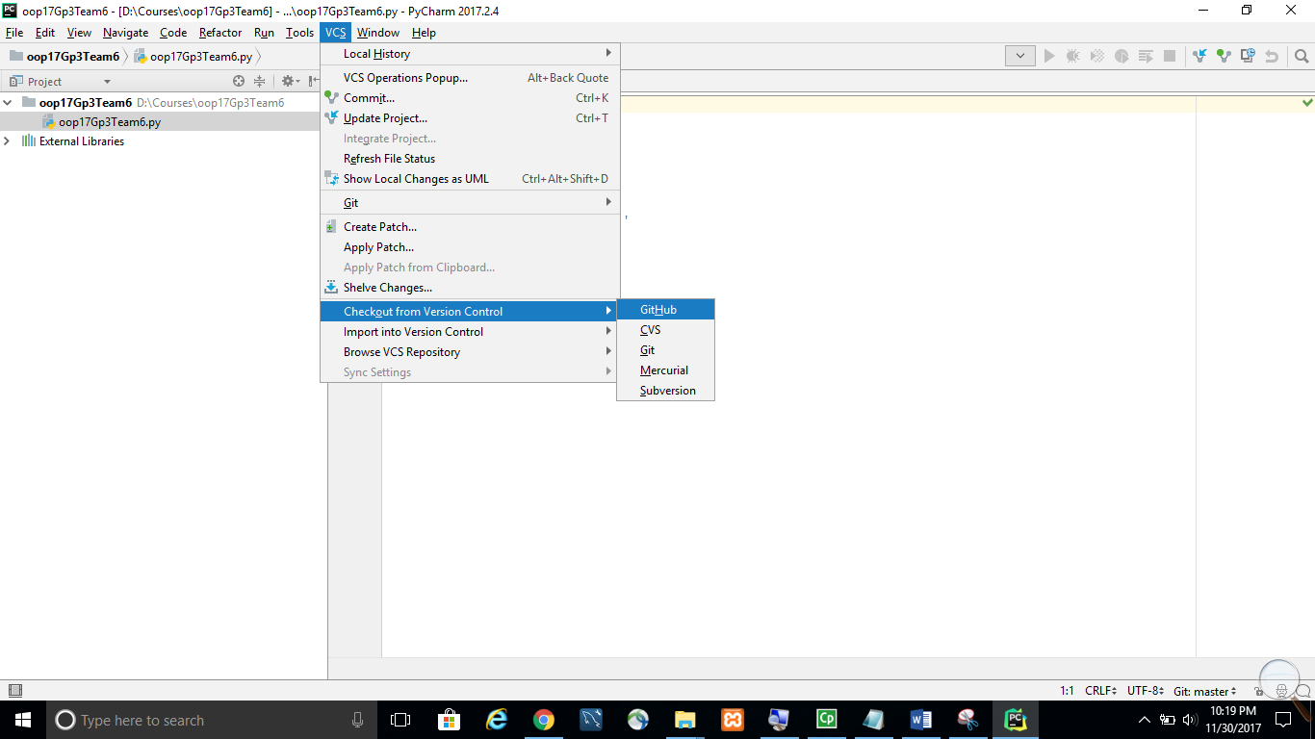.

1. Select the repository and click on the **Clone** button. If successful, a project will be created.

