Code can be downloaded from <https://github.com/chualc/Components>

Follow the steps below:

1. Go to VCS -> Checkout from Version Control

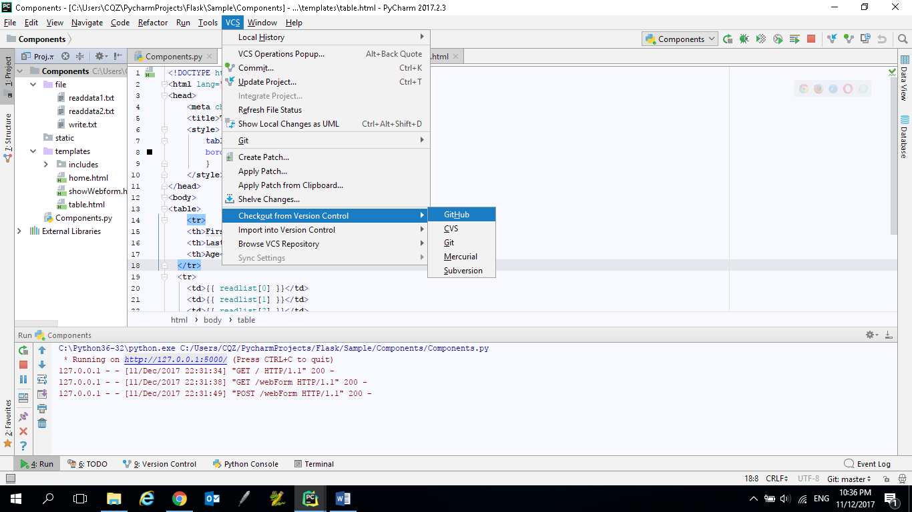

1. Enter <https://github.com/chualc/Components> as **Git Repository URL** and click **Clone**

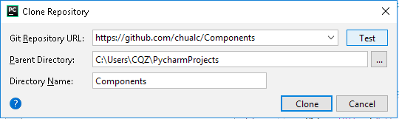

1. Double click on the Components to see the files in the folders

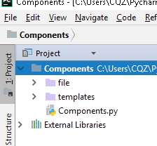

1. Select Run -> Run

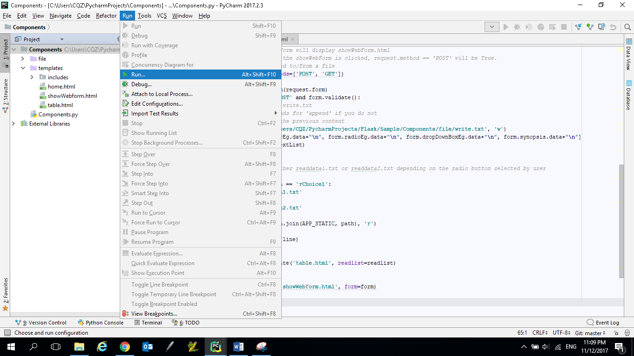

Step 5 to 8 may or may not be needed depending on your pyCharm setting.

1. If you see the window below, select ‘**Edit Configurations**’

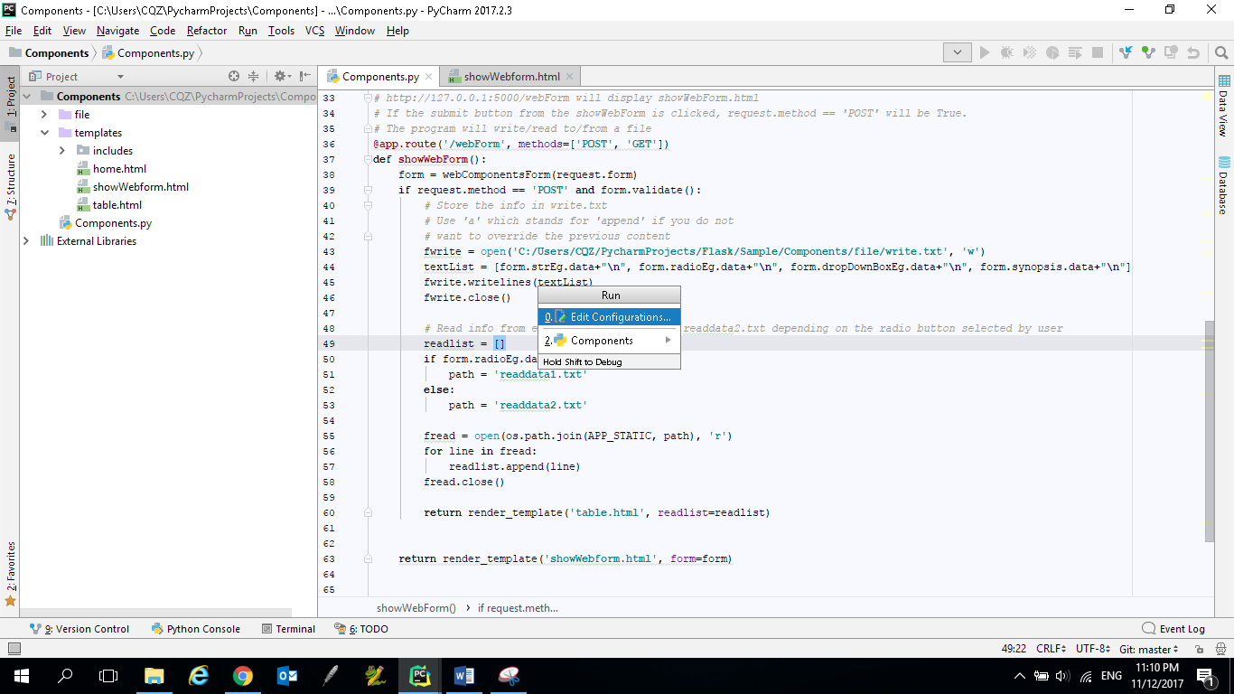

1. Click the + sign and select Python.

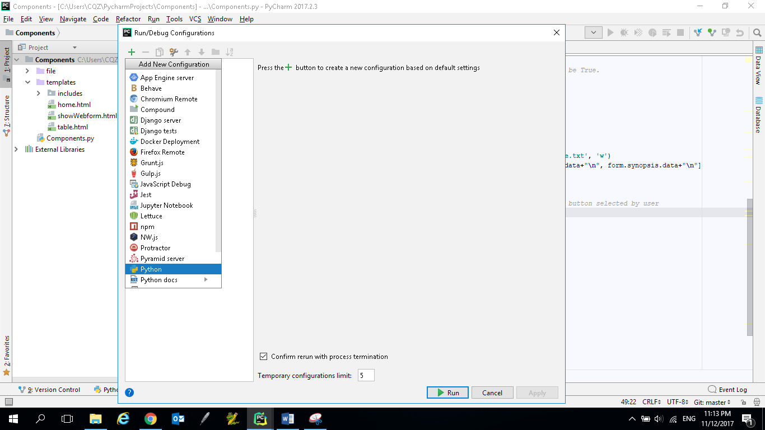

1. Enter the Name as **Components** and set the path of Python interpreter (depends on where your python .exe is located).

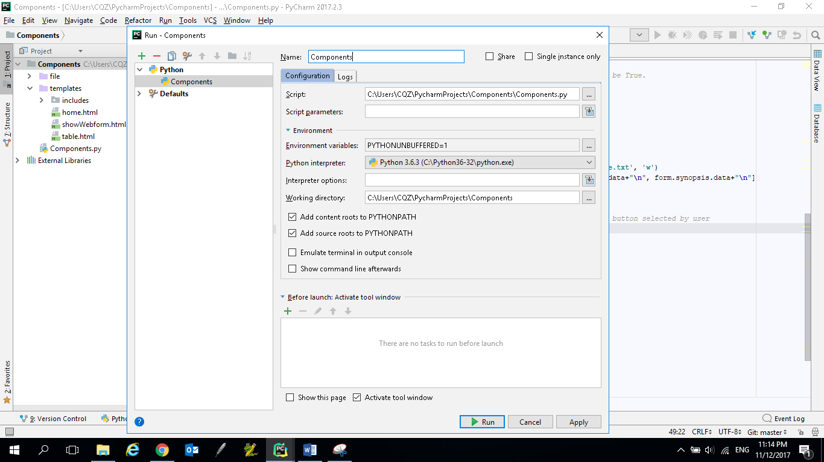

1. Click **Run**

**How it works:**

**File: Components.py**

The webComponentsForm class defines the type of components (e.g. a text box, radio buttons, dropdown box and text field) to be displayed on a webpage.

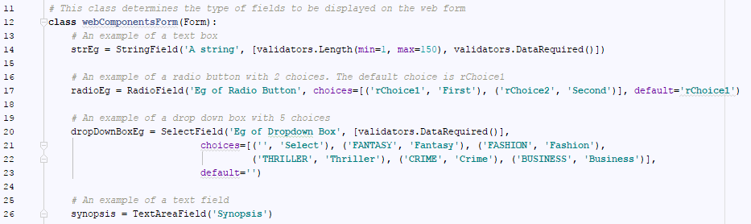

Run the flask project and go to <http://127.0.0.1:5000/webForm>. In this case, the request.method is NOT a POST because the ‘SUBMIT’ button is not clicked (this will be explained later).

Line 38: create an instance of the webComponentsForm, form, and then pass the information to showWebform.html (refer to line 63). Since the request.method is NOT a POST, line 43 to 60 will not be executed.

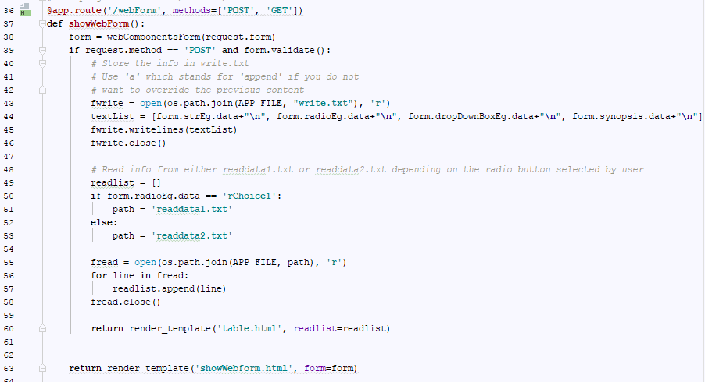

Create an instance of webComponentsForm (which defines the web components) and pass the information to showWebform.html

**File: ShowWebform.html**

ShowWebform.html gets the form data from showWebForm() in Components.py and display the information. The form information can be retrieved using form.radioEg, form.strEg, form.dropDownBoxEg and form.synopsis. The names, radioEg, strEg, dropDownBoxEg and synopsis, are defined in the webComponentsForm class.

<**form** method=**"POST"** action=**""**>  
  
 <**div** class=**"form-group"**>  
 <**div** class=**"form-row"**>  
 {{ render_field(**form.radioEg**, class_="radio-inline") }}  
 </**div**>  
 </**div**>  
 <**div** class=**"form-group"**>  
 {{ render_field(**form.strEg**, class_="form-control") }}  
 </**div**>  
  
 <**div** class=**"form-group"**>  
 <**div** class=**"form-row"**>  
 <**div** class=**"form-group col-md-4"**>  
 {{ render_field(**form.dropDownBoxEg**, class_="form-control") }}  
 </**div**>  
 </**div**>  
 </**div**>  
 <**div** class=**"form-group"**>  
  
 {{ render_field(**form.synopsis**, class_="form-control") }}  
  
  
 </**div**>  
 <**div** class=**"form-group col-md-1"**>  
 <**input** type=**"submit"** value=**"Submit"** class=**"btn btn-info"**/>  
 </**div**>  
  
 </**form**>

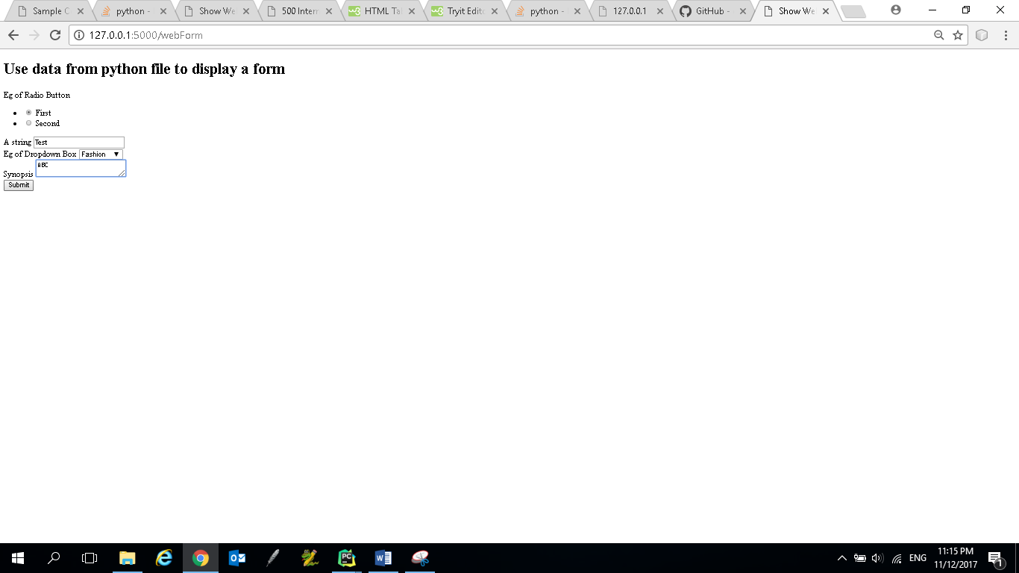

After entering the data and click **Submit** button, the request.method is POST. The information entered by the user will be passed to **Components.py**.

**File: Components.py**

Since the request.method is POST (because the Submit button is clicked), the code in the if statement will be executed. The code shows how information can be stored and read from files.



Pass the readlist to table.html

If user clicks the first radio button, read from readdata1.txt. Otherwise, read from readdata2.txt

Store the data entered by the user in a file

Request.method is POST if the submit button is clicked

**File: table.html**

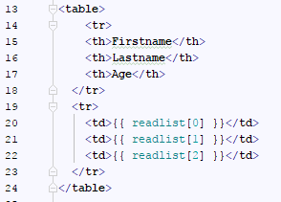

Depending on which radio button is selected, different information will be displayed in the table.

