**Question 1**

**Aim:**

To recreate and visualize the given graph for the Social Network Adds Dataset.

**Work Done:**

The give graph can be achieved only by any one of the classification models. There are many classification models which include Decision tree, Naive Bayes, Kernel SVM, SVM , etc. But this graph was exactly visualizable in the random forest classification.

To do so, the first and foremost step is to import the dataset because only by using the dataset, the further implications can be done. But to import the dataset, the libraries must be imported from their respective places. After importing the dataset, the dataset must be checked for missing values. But in this case there are no missing values. Then the categorical data must either be encoded or ignored. Here the categorical data does not add much value to the output, so the categorical data column is ignored. After the data pre-processing, the data can be directly visualized or trained and tested. Here the data is split into training and test set and also fitting transformation. After all these, the random forest classifier is applied to the training set and then trained to do the same with the test set as well. After the model implication, the plotting is done as required. And finally the required output is received.

**Output:**

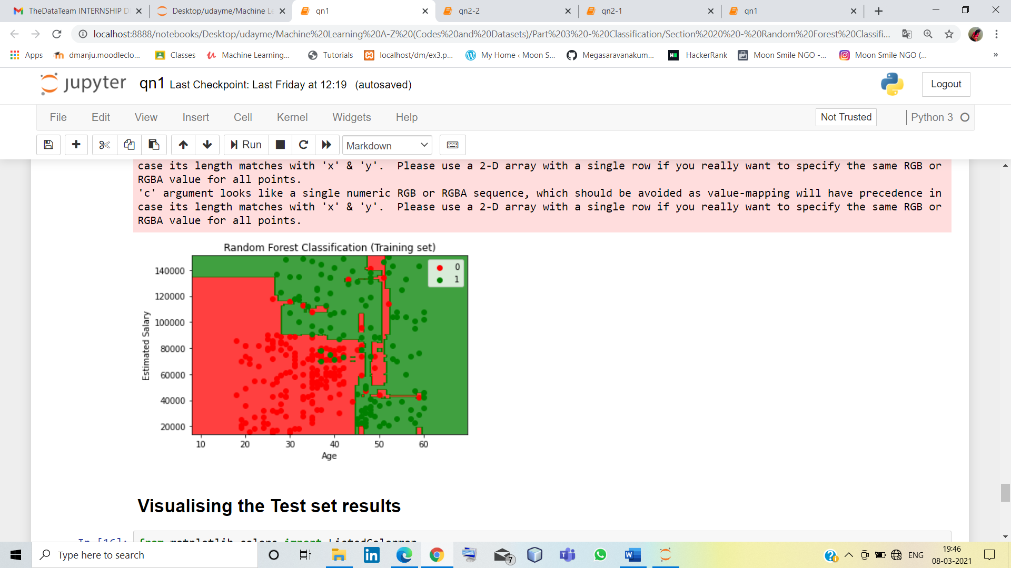

**Question 2**

**Aim:**

To see whether the deaths , cases etc increases every year.

**Work Done:**

Since the dataset is given in three different sets, the first and foremost work is to combine them with the desired attributes. Even after combing, some kind data cleaning might be required. So we first replace the missing values, then encode categorical data by onehutencoding. Then when the data is ready to be processed, we import the dataset and split it into train and test set. And since there are multiple data for single year, average is taken and then the visualization is done so that the interpretation of the result might be easier.

**Output:**

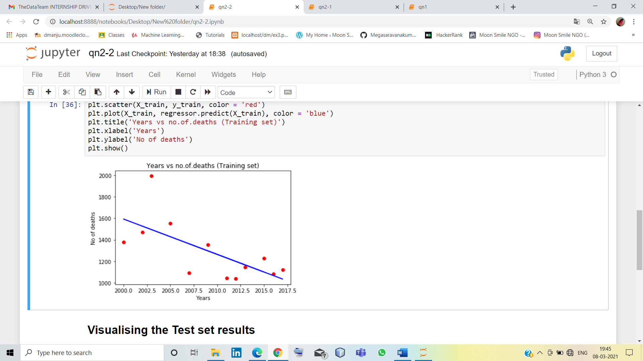

Here in this graph we can clearly see that the no of death rates decreases every year because of medical advancements. Similarly it is done for all parameters.