HELLO GUYS MERGIO IS A PDF AND DOCX MERGER CREATED USING PYTHON LANGUAGE FOR THE PURPOSE OF MERGING TWO PDF OR DOCX FILES

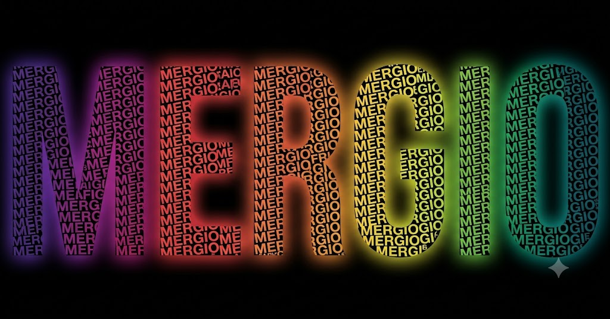

TRY THE MERGIO MERGER FOR FREE AT MEGATRON-GIT23 IN GITHUB
FOR MORE DETAILS ENQUIRY AT LINKEDIN #AJITH PA

