DADIP 2.0
Distributed AI-Driven Disaster Intelligence and Resilient Communication Platform

Technical project report
Prepared for the IEEE ComSoc Student Tech Leadership Conference (STLC) Tunisia 2026 — Projects Showcase
Megavarshan A
B.Tech Artificial Intelligence, SRM Institute of Science and Technology
November 2026 · Version 2.0.0-alpha.1
Source code: github.com/Megavarshan/dadip-2.0

Contents
1. Abstract
2. Introduction
3. From DADIP to DADIP 2.0
4. System architecture
5. AURA intelligence engine
6. Cloud intelligence core
7. Resilient communication engine
8. Edge intelligence network
9. Disaster command centre
10. Experimental evaluation
11. Verification and testing
12. Limitations and future work
13. Conclusion
Appendix A. Running the system
Appendix B. Repository structure

1. Abstract
During disasters, the information that matters most is often the hardest to deliver. Cellular networks congest, power and links fail, citizen reports arrive unverified, and warnings from several agencies conflict. DADIP 2.0 is a cloud–edge platform that addresses this end to end: it assesses incidents with an uncertainty-aware intelligence engine (AURA), places a human approver in front of every high-impact alert, and delivers alerts through a communication engine designed for congestion and outages.
The communication engine combines severity-aware scheduling, a durable PostgreSQL outbox, retries with jittered exponential backoff, a circuit breaker for channel availability, deduplication, message expiry, and delivery and acknowledgement tracking. Field devices run an offline-first edge agent that stores reports locally and synchronises them exactly once over MQTT when connectivity returns.
We evaluated three delivery strategies in a seeded discrete-event simulation (7 network scenarios × 3 strategies × 30 seeds, 630 runs) that calls the same scheduling code as the live dispatcher. The resilient strategy delivered every red alert before expiry in all scenarios, against 0.790 for a first-in-first-out baseline during a 120-second outage and 0.732 under congestion. Under congestion, priority scheduling reduced red-alert 95th-percentile latency from 284.6 s to 0.67 s. Reliability has a cost: alerts that other strategies drop arrive later. All results are simulated and are reported with 95% confidence intervals and their limitations.
Keywords: disaster management, emergency alerting, resilient communication, MQTT, edge computing, uncertainty, decision admissibility, network simulation.

2. Introduction

2.1 The problem
Disaster communication infrastructure becomes unreliable exactly when it is needed. The project addresses the following problems:
- Cellular network congestion and delayed emergency notifications.
- Power and connectivity failures and damaged communication infrastructure.
- Fragmented information from multiple agencies and inaccurate or unverified citizen reports.
- Language barriers in public warnings.
- No intelligent prioritisation of emergency messages.
Existing disaster management systems often focus on incident reporting, dashboards and resource allocation. DADIP 2.0 goes further: it decides what needs immediate attention, how far the assessment can be trusted, and how to get the resulting warning through degraded networks.

2.2 Objectives
- Retain and improve the decision-admissibility architecture of the original DADIP intelligence engine (AURA).
- Build an intelligent emergency communication engine with prioritisation, delivery tracking, retries, deduplication and expiry.
- Introduce asynchronous, event-driven cloud processing with secure authentication, authorisation and auditing.
- Integrate offline-first edge devices over MQTT with store-and-forward synchronisation.
- Provide a unified command centre that shows only real, labelled data.
- Evaluate communication strategies under network degradation with reproducible experiments.

2.3 Research question
Do severity-aware scheduling and resilience mechanisms — a persistent outbox, retries with backoff, a circuit breaker, deduplication and expiry — improve the timely delivery of critical alerts when the channel degrades, and at what cost?

3. From DADIP to DADIP 2.0
DADIP 2.0 was built on a full audit of the original DADIP repository, which remains unchanged as the reference baseline. The original introduced the central idea of decision admissibility: combining a risk estimate with reliability and distribution-shift checks so that low-confidence outputs are deferred to a human. The audit established what was implemented, what was simulated and what was missing.
Table 1. What changed from the original DADIP
Area | Original DADIP | DADIP 2.0
Intelligence | Five hand-weighted engines in the browser, with random inputs | Same engines ported to Python, parity-tested, deterministic, with provenance and uncertainty
Data path | Dashboards read in-browser sample data | All screens read the live backend; demo data labelled
Alert delivery | Button showed success after a timer; nothing was sent | Approval-gated engine with outbox, retries, deduplication, TTL and acknowledgements
Edge | Not present | Offline-first agent over MQTT with exactly-once ingestion
Persistence | Supabase tables created by hand | PostgreSQL with Alembic migrations and constraints
Security | Demo logins in code, permissive row-level policies | Argon2 passwords, JWT, four roles, audit log, rate limits
Evaluation | No experiments in the repository | 630 reproducible simulation runs with confidence intervals
Testing | None | 392 automated tests on real PostgreSQL, Redis and Mosquitto, plus browser tests

4. System architecture
DADIP 2.0 has five subsystems organised as Python packages in one backend service, a Next.js web application, and a set of background workers. Components are separated by operational need rather than split into microservices: one API process, one or more dispatcher workers, an edge gateway, and the edge agents themselves.
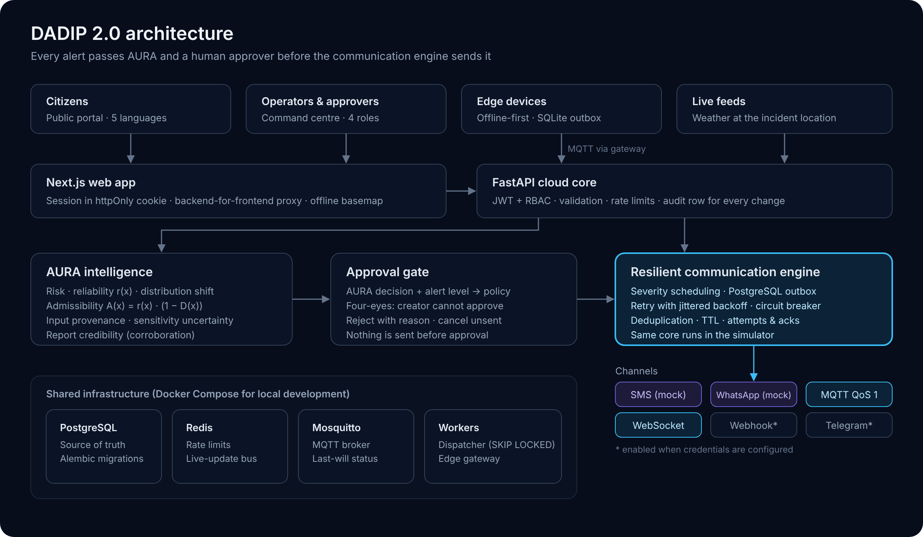
Figure 1. DADIP 2.0 architecture. Every alert passes AURA and a human approver before the communication engine sends it.
Table 2. Subsystems
Subsystem | Responsibility
AURA intelligence engine | Risk estimation, reliability, distribution shift, decision admissibility, uncertainty, report credibility
Cloud intelligence core | REST API, persistence, authentication and roles, auditing, health checks, background processing
Resilient communication engine | Approval workflow, scheduling, delivery, retries, deduplication, expiry, acknowledgements
Edge intelligence network | Local ingestion and inference, offline queue, MQTT synchronisation, device status
Disaster command centre | Operator console and multilingual public portal

Table 3. Technology choices
Layer | Technology | Reason
API | Python 3.12, FastAPI, Pydantic v2 | Same language as AURA and the simulator; typed, documented API
Persistence | PostgreSQL 16, SQLAlchemy 2, Alembic | Durable outbox, constraints, versioned migrations
Background work | Dispatcher worker, Redis 7 | Row-locking outbox; Redis for rate limits and live updates
Messaging | Eclipse Mosquitto (MQTT QoS 1) | Lightweight, acknowledged delivery suited to edge devices
Edge | Python agent, SQLite, paho-mqtt | Runs on low-cost hardware; survives restarts and outages
Web | Next.js 16, React 19, TypeScript, Tailwind CSS, Leaflet | Server-side session handling; responsive console
Quality | pytest, Playwright, Ruff, ESLint, GitHub Actions | Every push is checked automatically

5. AURA intelligence engine
AURA turns an incident and its surrounding conditions into a structured assessment. Its core is the decision-admissibility rule of the original DADIP:
A(x) = r(x) · (1 − D(x))
where r(x) is the reliability of the risk estimate and D(x) the normalised distance of the input from the reference distribution. An assessment is executed if A(x) ≥ 0.55, deferred to a human if A(x) ≥ 0.385, and otherwise abstained.
Table 4. AURA modules
Module | Output | Method
Risk prediction | Flood, cyclone, earthquake and tsunami risk, composite risk, severity | Weighted, normalised features with a sigmoid
Reliability r(x) | Score 0.05–0.99 with interpretation | Prediction entropy, feature coverage and margin
Distribution shift D(x) | Normalised distance, out-of-distribution flag | Diagonal Mahalanobis distance
Decision admissibility | Execute / defer / abstain with reasoning | A(x) = r(x) · (1 − D(x))
Feature deviation | Ranked contributing inputs | Weighted deviation from baselines

5.1 What DADIP 2.0 adds
- Reproducibility. The original filled missing weather and terrain values with random numbers, so the same incident could receive different decisions. Inputs now come from live weather at the incident location or documented constants.
- Input provenance. Every input is labelled observed, estimated or default, and the assessment lists which inputs were defaulted.
- Uncertainty. Each assessment is repeated over 200 perturbations of the inputs with documented measurement noise, reporting the 5–95% range of composite risk and how often the decision stays the same.
- Corrected distribution-shift test. A χ² test on the squared distance (12 degrees of freedom) runs alongside the original flag.
- Report credibility. Citizen and edge reports are scored by corroboration from nearby reports, proximity to known incidents and description detail.

5.2 Verification and findings
The Python engines were checked against the original TypeScript code, executed under Node.js, on 304 pipeline inputs and a 441-point grid of reliability and distance values. Every output field matches.
Finding 1. Global optimisation over all input bounds shows that the original admissibility score never exceeds 0.48, while execution requires 0.55. The original engine can therefore only defer or abstain. DADIP 2.0 reports this rather than lowering the threshold: every alert is routed to a human approver.
Finding 2. The original out-of-distribution threshold (16.92) is the χ² 95th percentile for nine degrees of freedom on the squared scale, but was compared with the unsquared distance over twelve features, so the flag almost never fired.
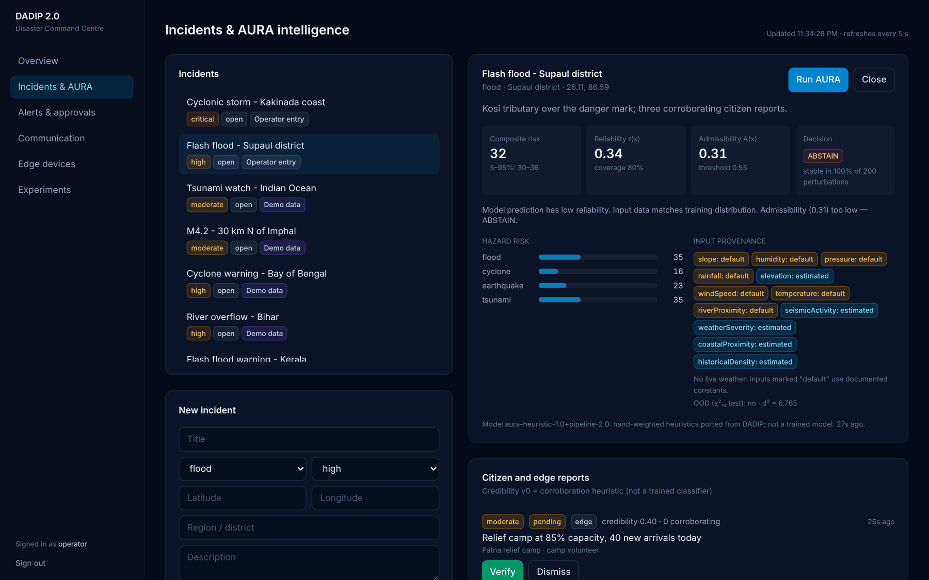
Figure 2. AURA assessment in the command centre: risk, reliability, admissibility, uncertainty and the provenance of every input.

6. Cloud intelligence core
The cloud core is a FastAPI service backed by PostgreSQL. All schema changes go through versioned Alembic migrations; closed value sets, coordinates and probabilities are enforced by database constraints.
Table 5. Main data entities
Entity | Purpose
Users | Accounts with one of four roles: citizen, operator, approver, admin
Incidents | Disaster events with hazard, severity, location and data provenance
Incident reports | Citizen and edge reports with verification status and credibility
AURA assessments | Every assessment with its full inputs, provenance and outputs
Alerts | Operator alerts with approval state, level, channels and expiry
Messages | The outbox: one row per alert, channel and recipient
Message events, delivery attempts | Every state change and every physical send attempt
Edge devices, edge events | Device status and de-duplicated device events
Resources | Shelters, hospitals and response units
Audit events | Every state-changing action, written in the same transaction
Experiment runs | Recorded experiment configurations and metrics

6.1 Security
- Passwords hashed with Argon2id; short-lived signed access tokens.
- Role-based access: citizens report; operators manage incidents and create alerts; approvers approve; administrators manage roles and channels.
- Self-registration always creates a citizen account; elevated roles are granted by an administrator.
- In the web application the session token is held in an httpOnly cookie and never exposed to browser scripts.
- Public reporting is rate-limited per client; contact details are visible only to operators.
- Production refuses to start without its own signing secret; credentials are supplied only through environment variables.

7. Resilient communication engine
Communication is a core subsystem that can be evaluated on its own, not a notification add-on. Its scheduling logic is a pure core with no input/output and an injected clock, so the same functions run in the live dispatcher and in the network simulator.

7.1 Alert lifecycle
- An operator creates an alert for an incident. AURA's latest assessment sets the alert level and determines whether approval is required.
- Alerts that require approval send nothing until an approver signs off. The creator of an alert cannot approve it (four-eyes rule). Approvers can also reject with a reason.
- On approval, one outbox message is created per channel, with a priority, an idempotency key and an expiry time.
- Dispatcher workers claim due messages in priority order using row-level locks, so several workers never send the same message.
- Each attempt is recorded. Transient failures are retried with jittered exponential backoff; permanent failures and expired messages stop.
- Recipients acknowledge over MQTT or through a signed link; acknowledgements are recorded even if they arrive while the send is still in progress.
Table 6. Delivery guarantees
Guarantee | Mechanism
No high-impact alert without a human | Approval policy; messages created only on approval
Four-eyes approval | Creator cannot approve their own alert
No duplicate alerts | Alert-level check plus a unique idempotency key per alert, channel, recipient and content
No double sending | FOR UPDATE SKIP LOCKED claim; verified with four concurrent workers
Bounded retries | Full-jitter exponential backoff, 2 s base, 120 s cap, 6 attempts
No stale warnings | Expiry checked before every attempt and before scheduling a retry
Store and forward | Messages stay in the outbox while a channel is down; circuit breaker probes for recovery

Table 7. Channels
Channel | Status | What "delivered" means
SMS, WhatsApp | Mock | Simulated provider acceptance; labelled MOCK everywhere
MQTT | Real (Mosquitto) | Broker acknowledgement of a QoS 1 publish
WebSocket | Real (Redis) | Published to the live-update bus
Webhook | Real when configured | Receiving service answered with success
Telegram | Real when configured | Accepted by the Telegram Bot API

Alert headers are generated from fixed phrase tables in English, Hindi and Tamil. The operator's instruction text is sent as written: DADIP does not machine-translate emergency instructions.
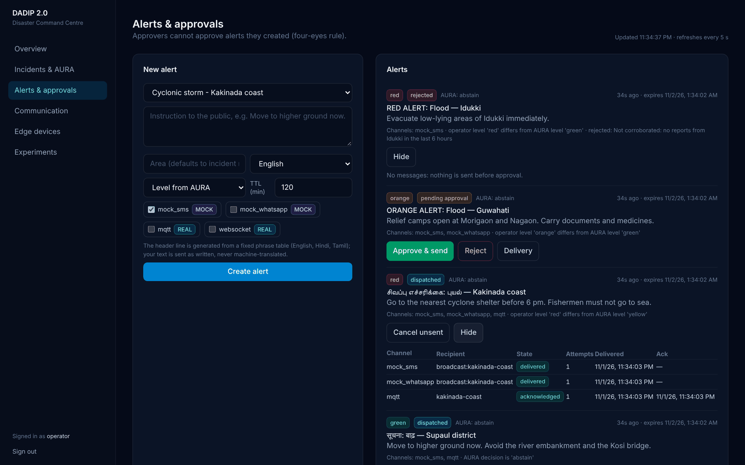
Figure 3. Alerts and approvals: rejected, pending and dispatched alerts with per-channel delivery and acknowledgement.

8. Edge intelligence network
Edge devices — for example at shelters, schools or relief camps — run the DADIP edge agent. It is designed for the case where the network fails first.
- Local persistence. Every report and sensor reading is written to a local SQLite outbox before any network activity.
- Acknowledged upload. Events are published over MQTT with QoS 1 and marked as synchronised only when the broker acknowledges them.
- Exactly-once ingestion. Each event carries a device-generated identifier; the cloud gateway discards re-sent copies. Delivery is at-least-once on the network and exactly-once in the database.
- Local inference. The agent runs the AURA risk engine on local readings and records a local alarm when the level is orange or red, even with no connection.
- Status. Devices publish their status; the broker's last-will message marks a device offline if it disappears.
- Alert reception. Alerts are stored once however often they are redelivered, and acknowledged each time.
These properties were tested against a real MQTT broker with real link outages injected by a TCP fault proxy: events queued during an outage arrived exactly once after restoration, and a 500-event backlog drained after reconnection.
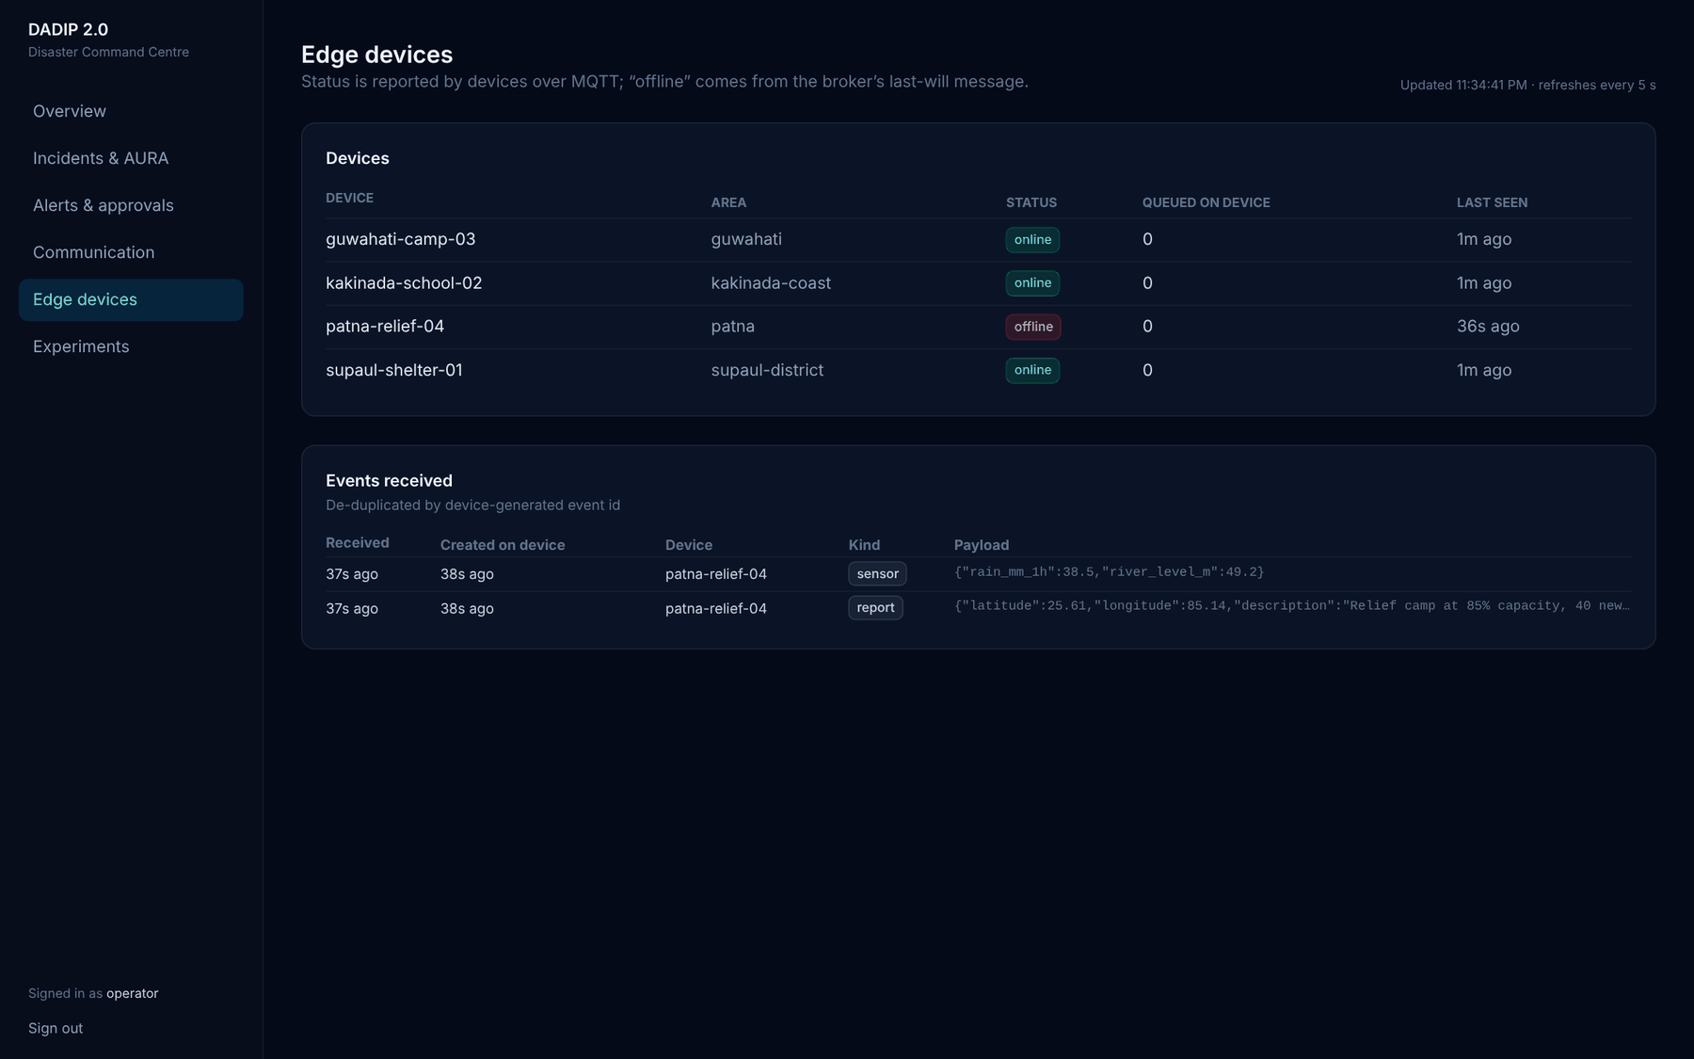
Figure 4. Edge devices: live status over MQTT, offline detection and de-duplicated events.

9. Disaster command centre
The command centre is the operator interface; the public portal serves citizens. Every figure on screen comes from the backend and shows when it was last refreshed. Demo data, mock channels and simulated results are labelled.
Table 8. Screens
Screen | Purpose
Executive overview | Open incidents, alerts awaiting approval, unverified reports, delivery in the last 24 hours, edge devices online, live map
Incidents and AURA | Incident management, AURA assessments, verification of citizen and edge reports
Alerts and approvals | Alert creation, approval or rejection, per-channel delivery and acknowledgement
Communication | Delivery ratio, acknowledgement ratio, latency and attempts per channel; channel switches
Edge devices | Device status, queued events and received events
Experiments | Simulation results with confidence intervals
Audit log | Every state-changing action (administrators)
Public portal | Incident map, help centres and incident reporting in five languages

Maps include an offline base layer of country outlines bundled with the application, so they remain usable when online map tiles cannot be loaded.
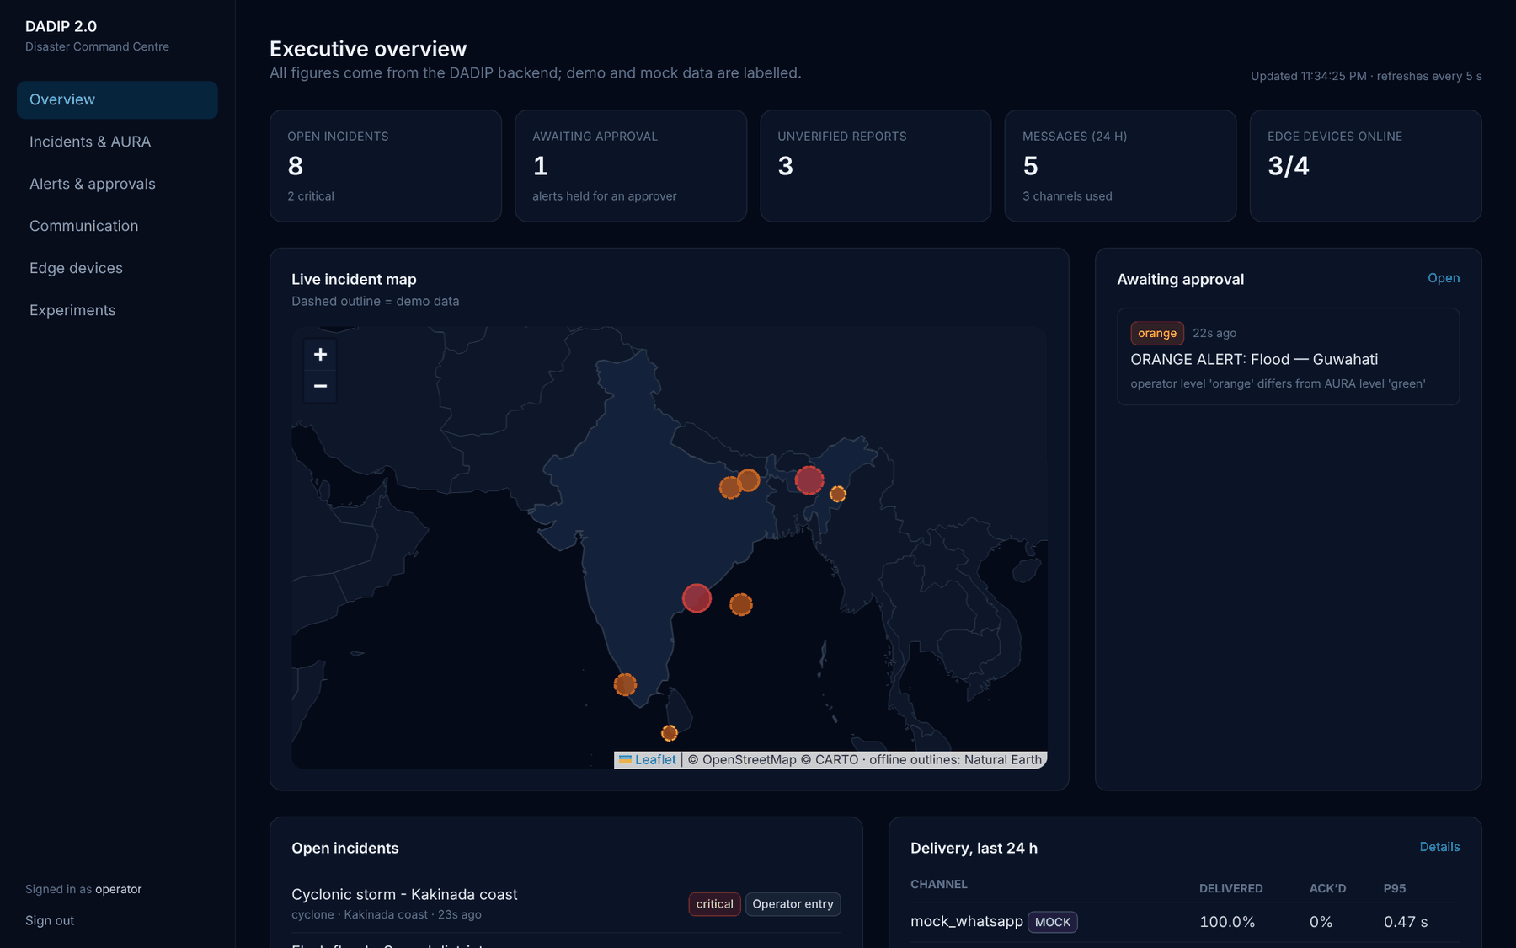
Figure 5. Executive overview of the command centre.
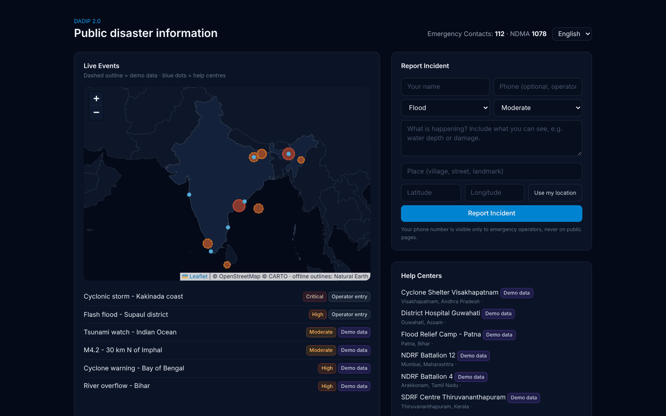
Figure 6. Public portal with the offline base map, help centres and reporting form.

10. Experimental evaluation

10.1 Method
The communication engine was evaluated in a seeded discrete-event simulation of one alert channel with finite capacity, log-normal latency, independent loss in each direction and outage windows. Alerts arrive as a Poisson process with 10% red, 20% orange, 30% yellow and 40% green alerts; 5% of alerts are submitted twice. Expiry times are 5, 10, 15 and 20 minutes by level. Each run lasts 600 seconds of arrivals followed by a drain period. For a given seed every strategy sees identical arrivals and channel randomness. 630 runs were executed (30 seeds per cell); means are reported with bootstrap 95% confidence intervals.
Table 9. Network scenarios
Scenario | Offered load | Capacity | Loss | Outage
Normal | 2/s | 10/s | 1% | —
High latency (2 s) | 2/s | 10/s | 1% | —
Packet loss | 2/s | 10/s | 20% | —
Four-fold load | 8/s | 10/s | 5% | —
Congestion | 8/s | 5/s | 1% | —
Outage | 2/s | 10/s | 1% | 200–320 s
Outage, lossy recovery | 2/s | 10/s | 10% | 200–320 s

Table 10. Strategies compared
Strategy | Order | Retry | Deduplication | Holds during outage | Expiry
Baseline | Arrival (FIFO) | No | No | No | No
Priority | Severity, then arrival | No | No | No | No
Resilient | Severity, then deadline | Yes | Yes | Yes (circuit breaker) | Yes

10.2 Results
Table 11. Red alerts delivered before expiry (mean and 95% confidence interval)
Scenario | Baseline | Priority | Resilient
Normal | 0.990 [0.987, 0.993] | 0.991 [0.988, 0.993] | 1.000 [1.000, 1.000]
High latency (2 s) | 0.990 [0.987, 0.993] | 0.991 [0.988, 0.993] | 1.000 [1.000, 1.000]
Packet loss | 0.822 [0.810, 0.835] | 0.823 [0.810, 0.835] | 1.000 [1.000, 1.000]
Four-fold load | 0.951 [0.946, 0.955] | 0.950 [0.946, 0.954] | 1.000 [1.000, 1.000]
Congestion | 0.732 [0.718, 0.745] | 0.991 [0.990, 0.993] | 1.000 [1.000, 1.000]
Outage | 0.790 [0.777, 0.803] | 0.791 [0.777, 0.804] | 1.000 [1.000, 1.000]
Outage, lossy recovery | 0.722 [0.710, 0.734] | 0.723 [0.710, 0.735] | 1.000 [1.000, 1.000]

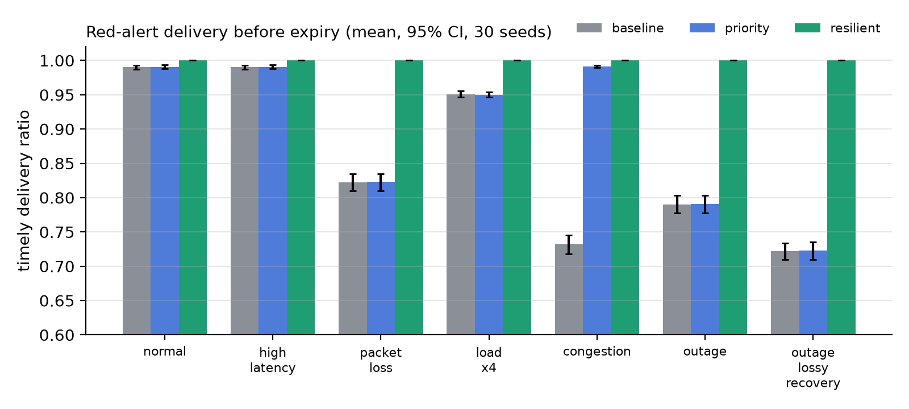
Figure 7. Red-alert delivery before expiry by scenario and strategy (mean, 95% CI, 30 seeds).
Table 12. Red-alert 95th-percentile latency in seconds (delivered alerts only)
Scenario | Baseline | Priority | Resilient
Normal | 0.42 | 0.41 | 0.42
High latency (2 s) | 4.69 | 4.69 | 4.77
Packet loss | 0.43 | 0.42 | 13.89
Four-fold load | 1.13 | 0.45 | 2.55
Congestion | 284.64 | 0.67 | 0.69
Outage | 0.42 | 0.41 | 89.12
Outage, lossy recovery | 0.42 | 0.41 | 93.37

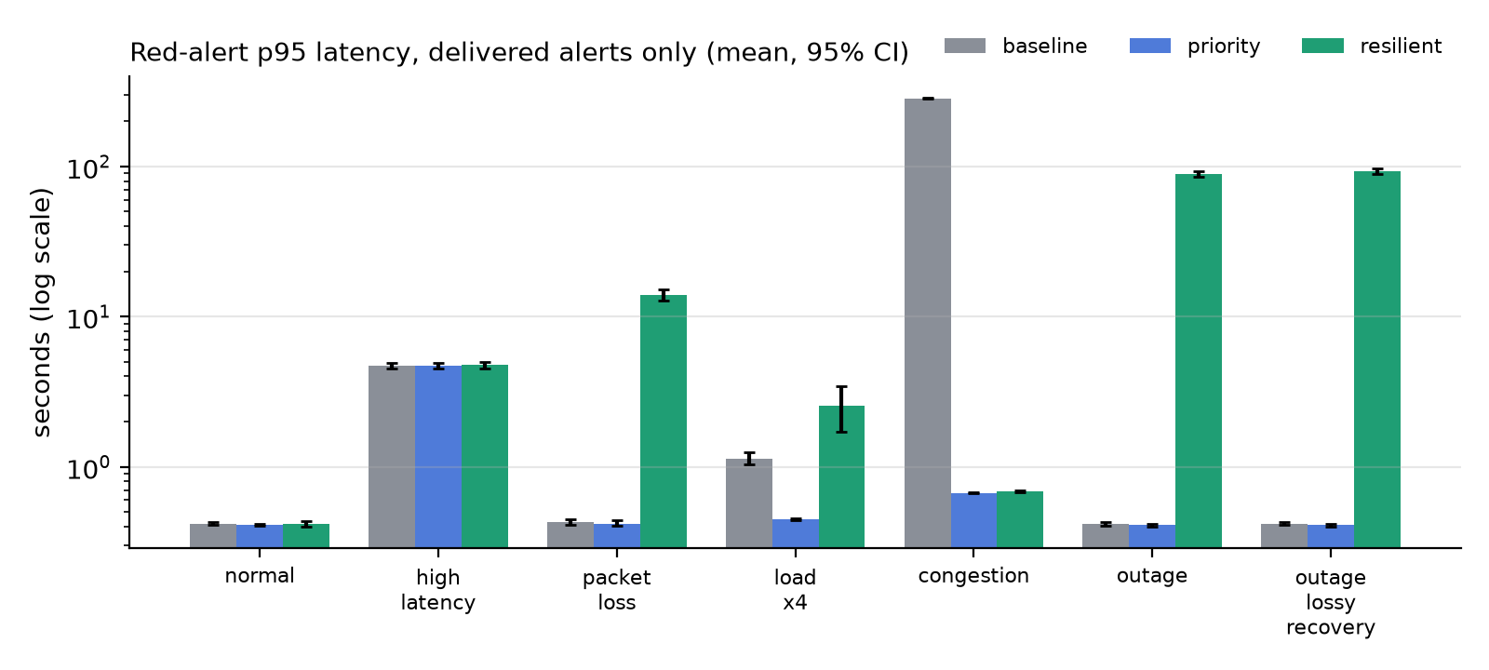
Figure 8. Red-alert 95th-percentile latency, delivered alerts only (log scale).
Table 13. Transmission attempts per delivered alert
Scenario | Baseline | Priority | Resilient
Normal | 1.059 | 1.059 | 1.020
High latency (2 s) | 1.059 | 1.059 | 1.020
Packet loss | 1.298 | 1.298 | 1.556
Four-fold load | 1.102 | 1.102 | 1.107
Congestion | 1.088 | 1.060 | 1.020
Outage | 1.324 | 1.324 | 1.050
Outage, lossy recovery | 1.448 | 1.448 | 1.260

10.3 Discussion
- Reliability. The resilient strategy delivered every red alert before expiry in all seven scenarios. The baseline lost alerts in proportion to the degradation, down to 0.722 with an outage and 10% loss.
- Prioritisation. Ordering matters only when messages queue. Under congestion, priority scheduling cut red-alert p95 latency from 284.6 s to 0.67 s and raised red delivery from 0.732 to 0.991. Without queueing, priority and baseline are indistinguishable.
- Cost in latency. Resilient red-alert p95 latency was 89.1 s during the outage scenario against about 0.4 s for the baseline. The comparison is not like for like: latency is measured over delivered alerts only, and the baseline is fast because it drops every alert it cannot send at once.
- Cost in transmissions. With 20% loss the resilient strategy needed 1.556 attempts per delivered alert against 1.298. During outages it needed fewer (1.050 against 1.324), because the circuit breaker stops attempting on a channel known to be down.
- Duplicates and staleness. Baseline and priority showed users about 0.049 duplicate alerts per alert; the resilient strategy showed none. Under congestion the baseline delivered 129.9 alerts per run after their expiry; the other strategies delivered none.
- Recovery. After the 120-second outage the resilient strategy cleared its backlog in 33.0 s.

10.4 A design defect found by the experiment
The first outage runs showed red alerts doing worse than average under the resilient strategy. While the circuit breaker was open, its probe used the next message in priority order — always a red alert — and each failed probe consumed that alert's retry budget until it was abandoned. Failures while a channel is known to be down now return the message to the outbox without consuming its budget. The fix is shared by the simulator and the live dispatcher and is covered by regression tests.

10.5 Threats to validity
- The channel is a software model: loss is independent per message, latency is log-normal and capacity is a single serial sender. Real networks show bursty, correlated loss.
- Expiry times are generous (5–20 minutes); shorter times would reduce resilient delivery and were not explored.
- A single channel was modelled; multi-channel failover was not evaluated.
- Receiver-side deduplication is assumed for the resilient strategy, matching the DADIP edge agent.
- Retry and circuit-breaker parameters were not tuned.
- Narrow confidence intervals describe simulation noise, not uncertainty about real-world performance.

11. Verification and testing
Table 14. Verification summary (392 backend tests passing)
Test area | What is verified | Count / method
AURA parity | Python engines equal the original TypeScript on every output field | 313 tests (745 cases)
AURA pipeline | Determinism, provenance, uncertainty bounds, corrected shift test, approval policy, credibility | Unit tests
Communication core | Ordering, backoff bounds, transitions, expiry, outage handling, circuit breaker | Unit tests
Communication engine | Approval and four-eyes rule, lifecycle, retries, expiry, deduplication, cancellation, outbox during outages, concurrency | Integration tests on PostgreSQL
MQTT | QoS 1 publishing to a real broker; unreachable broker handled as transient | Integration tests on Mosquitto
Edge | Exactly-once synchronisation after outages, deduplication, alert reception, local inference, 500-event backlog | Real outages via TCP fault proxy
API and security | Roles, validation, privacy of contacts, audit, rate limiting, trusted proxy handling | Integration tests
Simulator | Determinism, sanity cases, regression for the probe defect | Unit tests
Web application | Type checking, linting, production build | tsc, ESLint, next build
End to end | Citizen report → AURA → alert → approval → MQTT delivery → edge acknowledgement | Playwright in Chrome

The backend test suite migrates a fresh database with the real migrations and runs against real PostgreSQL, Redis and Mosquitto. Continuous integration runs the backend tests, linting, type checking and the production web build on every push.
Table 15. Defects found by verification and fixed with regression tests
Defect | How it was found | Fix
Port rounding differed from JavaScript at 0.49999999999999994 | Parity tests against the original | Exact JavaScript rounding semantics
MQTT acknowledgements lost when devices replied very quickly | End-to-end run with real processes | Acknowledgement waits on the dispatcher's row lock
Edge agent froze after reconnecting with a backlog | Outage test; stack dump | Lock ordering with the MQTT client corrected
Red alerts abandoned during long outages | Simulation experiment | Outage failures no longer consume retry budget
Circuit-breaker timing livelock at a floating-point boundary | Simulator test | Tolerance and strictly advancing wake-ups
Unconfigured channels shown as available | Reviewing screenshots | Channels report whether they are configured

12. Limitations and future work

12.1 Limitations
- AURA uses hand-weighted heuristics, not trained models; its risk and credibility scores have not been evaluated against labelled outcomes.
- SMS and WhatsApp are mock channels until a provider is configured.
- Experimental results are simulated and do not measure cellular, satellite or mesh networks.
- The web interface updates by polling every five seconds.
- Alert header translations in Hindi and Tamil need review by native speakers before real use.

12.2 Future work
- Cloud deployment of the API, workers and broker, with production smoke tests.
- Load and security testing.
- Live fault-injected experiments on a real broker, compared with the simulation.
- Bursty (Gilbert–Elliott) loss, expiry-time sweeps and multi-channel failover experiments.
- A trained, calibrated incident classifier and a labelled evaluation of report credibility.
- Physical edge devices (for example Raspberry Pi with LoRa or cellular uplinks).

13. Conclusion
DADIP 2.0 turns the decision-admissibility idea of the original DADIP into a working cloud–edge system. AURA assesses incidents reproducibly and states how far its output can be trusted; a human approves every high-impact alert; and a communication engine delivers alerts by priority, retries through failures, avoids duplicates and stale warnings, and records every attempt and acknowledgement. Edge devices continue to work offline and synchronise exactly once.
In simulation, the resilient strategy delivered every critical alert before expiry across all tested degradations, at the cost of later delivery for alerts that simpler strategies lose. The project also documents what it does not yet show — real-network measurements, trained models and deployed operation — and the experiments needed to show it.

Appendix A. Running the system
Requirements: Python 3.12+, Node.js 22+, PostgreSQL 16, Redis 7 and Mosquitto 2 (or Docker Compose for the services). Credentials and secrets are supplied through environment variables; see the .env.example file in the repository.

Backend
cd backend
python -m venv .venv && source .venv/bin/activate
pip install -e ".[dev]"
alembic upgrade head
python -m dadip.seed --admin-email you@example.com --demo
uvicorn dadip.main:app

Workers and edge device
dadip-dispatcher
dadip-edge-gateway
dadip-edge --device-id shelter-01 --area supaul-district

Web application
cd frontend
npm ci
DADIP_API_URL=http://localhost:8000 npm run dev

Experiments
cd backend
pip install -e ".[research]"
dadip-sim --seeds 30 --out ../simulation-results/latest
python -m dadip.simulation.figures ../simulation-results/latest

Tests
cd backend && ruff check . && pytest
cd frontend && npx tsc --noEmit && npx eslint src && npx next build

Appendix B. Repository structure
dadip-2.0/
backend/
dadip/api/ REST routes, schemas, authentication
dadip/aura/ intelligence engines, assessment pipeline, credibility
dadip/comms/ scheduling core, channel adapters, dispatcher, alerts
dadip/edge/ edge agent, local storage, cloud gateway
dadip/simulation/ simulator, experiments, figures, fault proxy
dadip/db/ data models
migrations/ database migrations
tests/ unit, integration and parity tests
frontend/ command centre and public portal
simulation-results/ experiment outputs
docs/ architecture, research, development guide, status
infrastructure/ broker configuration
legacy/ original DADIP components for reference

