**EARTHQUAKE PREDICTION MODEL – PHASE 4**

Name: MEGAVARSHANAN M  
Register Number: 61772131026.

**SPILITTING AND TESTING:**

Splitting the data in training data, validation data, and testing data.

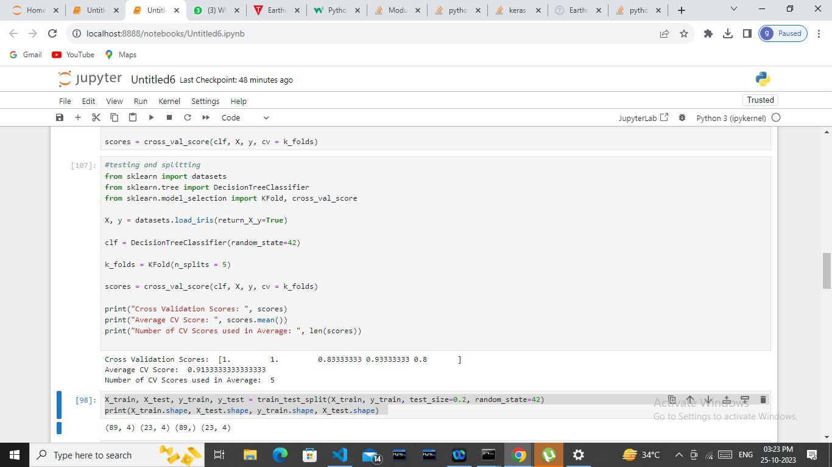

Import dataset and decision classifier to random state and cross Validation score and split the dataset. Then we can print the cross validation score, Average CV score, and number of CV scores used in Average.

**ACCURACY:**

Accuracy contains model ability correctly predict whether earthquake will occur or not. It is typically measured as the ratio of correct prediction.

Accuracy = (Number of correct Predictions) / (Total Number of Predictions) *100.

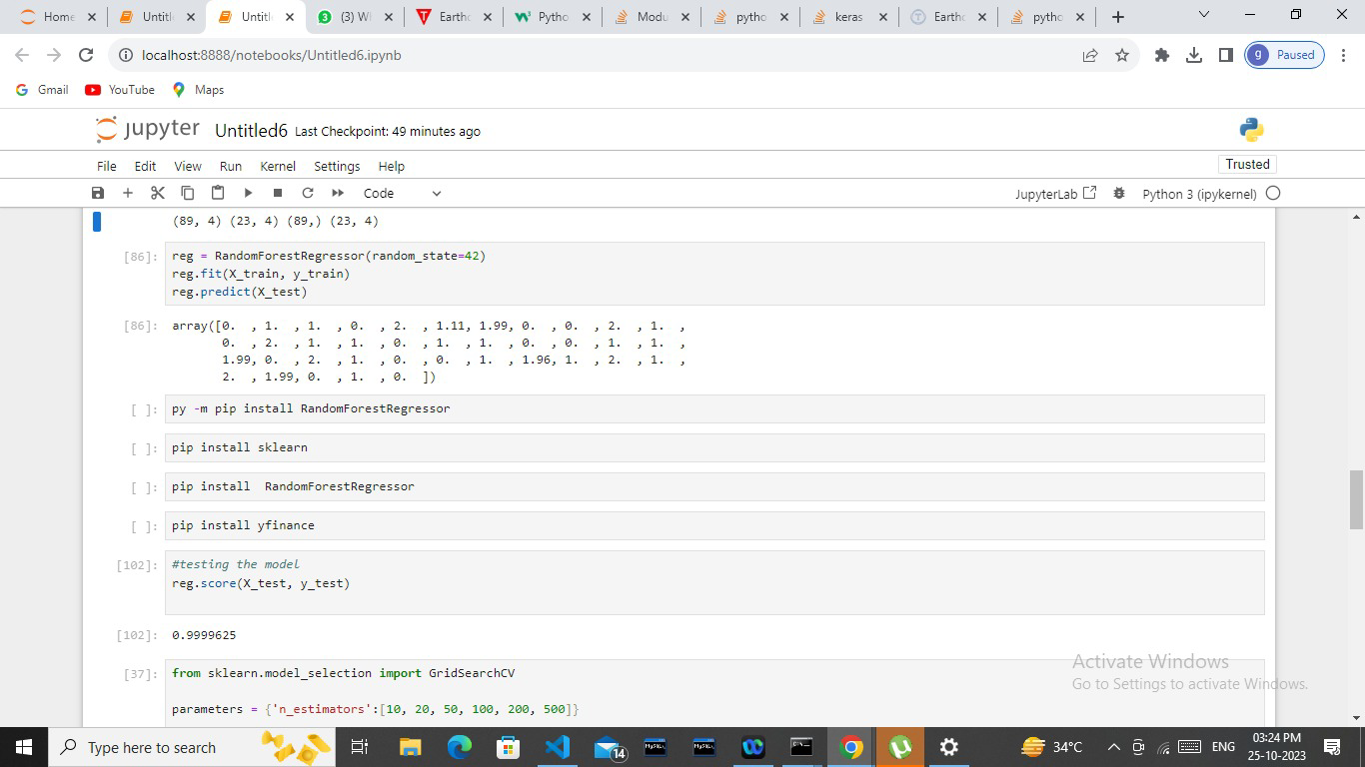

It contains 99% of accuracy is high.

We can regressor the Random Forest Regressor model to predict the earthquake model. Regressor score can be testing.

Next we will see the Shift to Grid search.

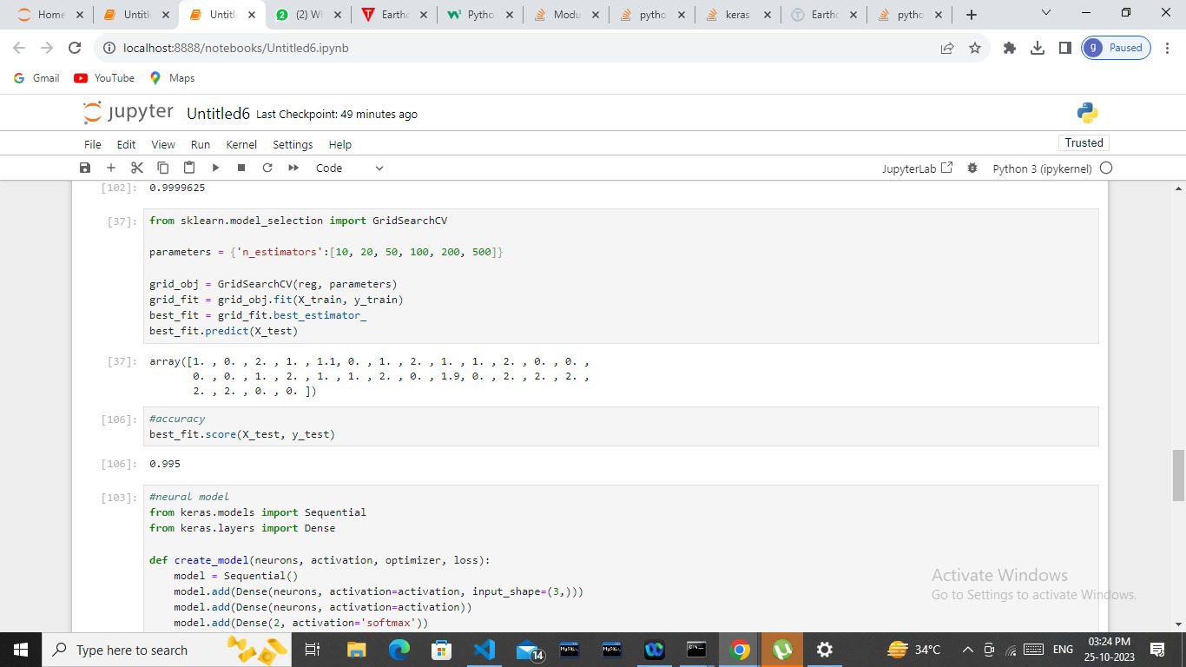

Import the Grid search CV to implement the parameter to grid object and grid fit and to find best- fit to grid fit of best estimater. We got high accuracy number in the earthquake prediction model accuracy.

We can use Neural Networks for predicting the earthquake prediction model.

**NEURAL NETWORK:**

A neural network-based earthquake prediction model is a machine learning system that uses artificial neural networks to analyze seismic data and make predictions about the likelihood of earthquakes occurring. This model typically takes various input features such as historical seismic activity, geological data, and other relevant information, and processes this data through layers of interconnected neurons to learn patterns and relationships that may indicate the potential for an earthquake. Neural networks can be used for earthquake prediction, accurate and reliable earthquake forecasting remains a challenging scientific problem.

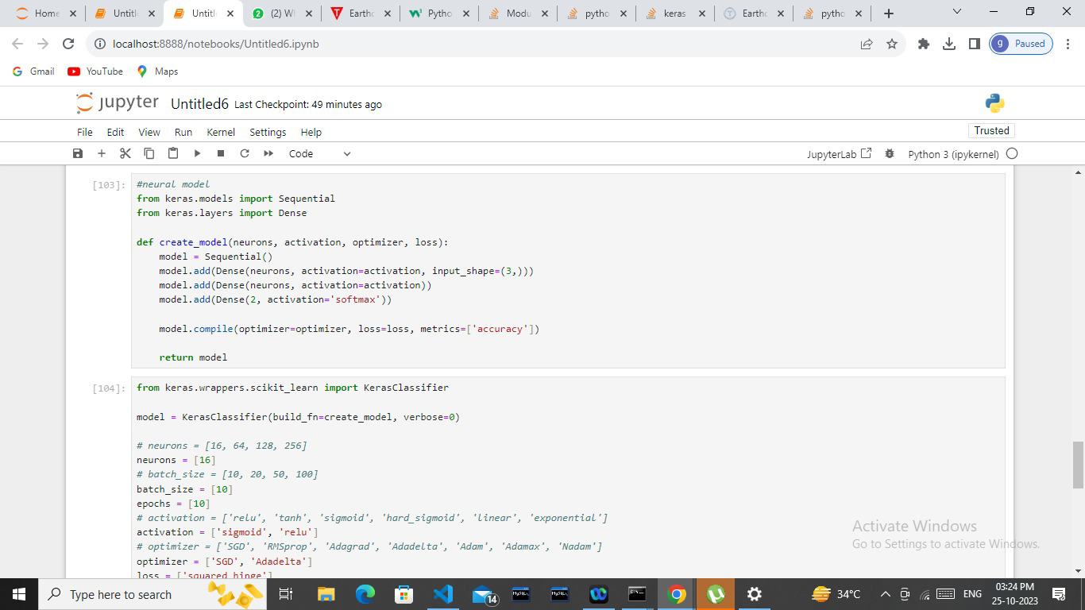

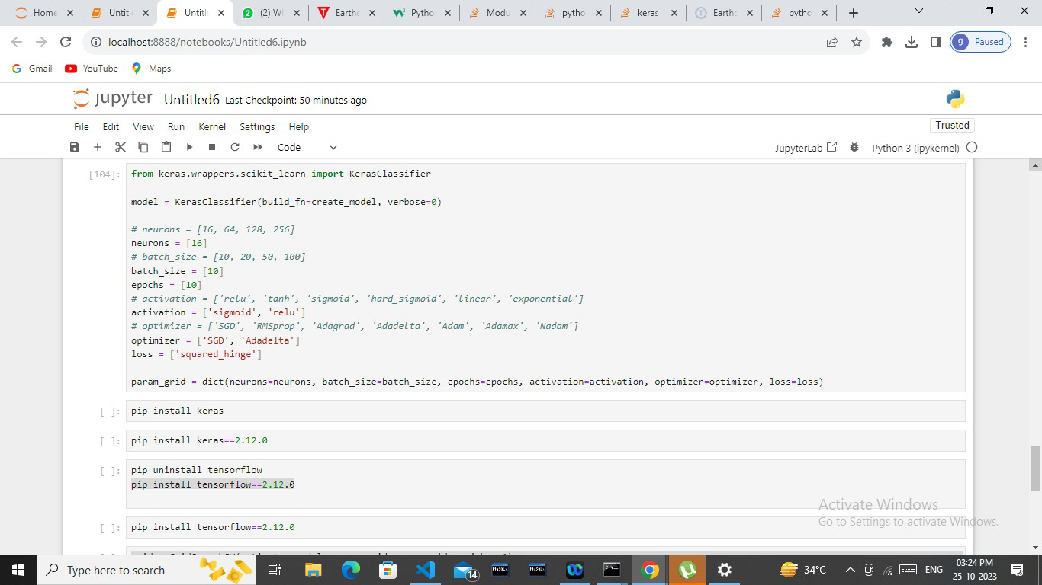 Import the keras classified to build and create a model. To implement the neuron numbers, batch size numbers, multiple activation choices and optimizer. To help the neural network to find the best options in neuron, batch size, activation, and optimization.

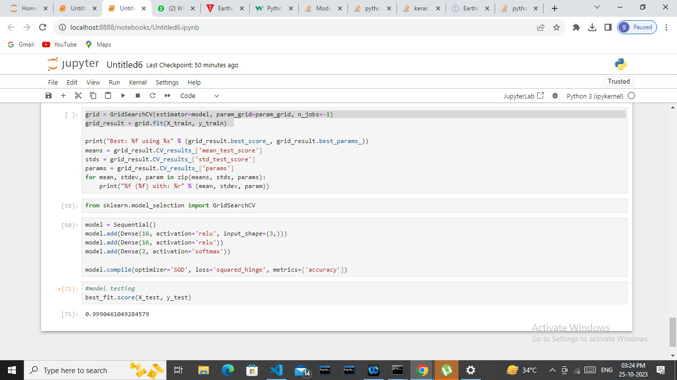

The given model has been tested and the neural network model is to choose the best options to predict the earthquake in future.

Testing in an earthquake prediction model is critical to assess its accuracy and reliability. A well-designed conclusion would depend on the specific details of the testing process and the model's performance.

After an extensive testing process, our earthquake prediction model has shown promising capabilities but also revealed areas that require further improvement. It still faces challenges in accurately forecasting the exact magnitude and location of earthquakes. To enhance its performance, ongoing research and data collection are essential. This model represents a valuable step towards improving earthquake preparedness, but it is important to acknowledge its limitations and continue refining it for more reliable predictions.

FACTOR ANALYSIS IN MACHINE LEARNING:

Factor analysis is a statistical technique used in machine learning and data analysis to identify underlying factors or latent variables that explain the observed correlations among multiple variables. In the context of developing an earthquake prediction model, factor analysis can help identify hidden patterns or common causes that may contribute to seismic activity.

TYPES OF FACTOR ANALYSIS:

Factor analysis is a statistical technique used to uncover underlying structures or latent variables in a dataset.

* Principal Component Analysis (PCA)
* Common Factor Analysis (CFA)

**Principal Component Analysis (PCA):**

- PCA is not strictly factor analysis, but it's often used for dimensionality reduction

- It finds orthogonal (uncorrelated) linear combinations of variables (principal components) that explain the most variance in the data.

- PCA does not identify underlying factors with specific meanings but focuses on capturing as much variance as possible in the original data.

**Common Factor Analysis (CFA):**

- CFA assumes that the observed variables are influenced by both common factors and unique factos (specific to each variable).

- It aims to decompose the variance in the data into common variance (due to shared factors) and unique variance (specific to each variable).

PRINCIPLES OF FACTOR ANALYSIS:

* Dimension Reduction
* Common and unique variance
* Factor identification
* Integration with prediction models.

APPICATION OF FACTOR ANALYSIS:

* Anomaly Detection
* Research and hypothesis
* Multi- variable validation.

BENEFITS OF FACTOR ANALYSIS:

Factor analysis is not a widely used technique in earthquake prediction models due to the complexity and nature of seismic events. However, it can offer some benefits when applied judiciously as a supplementary tool.

* Dimensionality Reduction
* Data Exploration
* Variable Interpretation
* Multicollinearity Mitigation

CONCLUSION:

In conclusion, factor analysis can have some limited utility in the field of earthquake prediction, mainly as a tool for data exploration and dimensionality reduction. However, it is not a primary technique for earthquake prediction models. Factor analysis can be a valuable exploratory tool for understanding data patterns and relationships within earthquake-related datasets. It can aid in feature extraction, variable interpretation, and model calibration. However, it should be part of a broader, multidisciplinary approach to earthquake prediction, which integrates various data sources and methods to enhance prediction accuracy and preparedness for seismic events.