PROGRAM DOCUMENTATION – MAZE
Spis treści
1. Overview 1
2. Features 1

1. Overview
This project is an updated version of a simple maze generator based on the DFS (Depth-First Search) algorithm, expanded into a small maze game. The main goal of the game is to navigate through the generated maze and reach the exit. The player can also collect points while exploring the maze and try to complete each level as quickly as possible. The project combines maze generation with basic game mechanics, creating a simple interactive experience based on procedurally generated mazes.
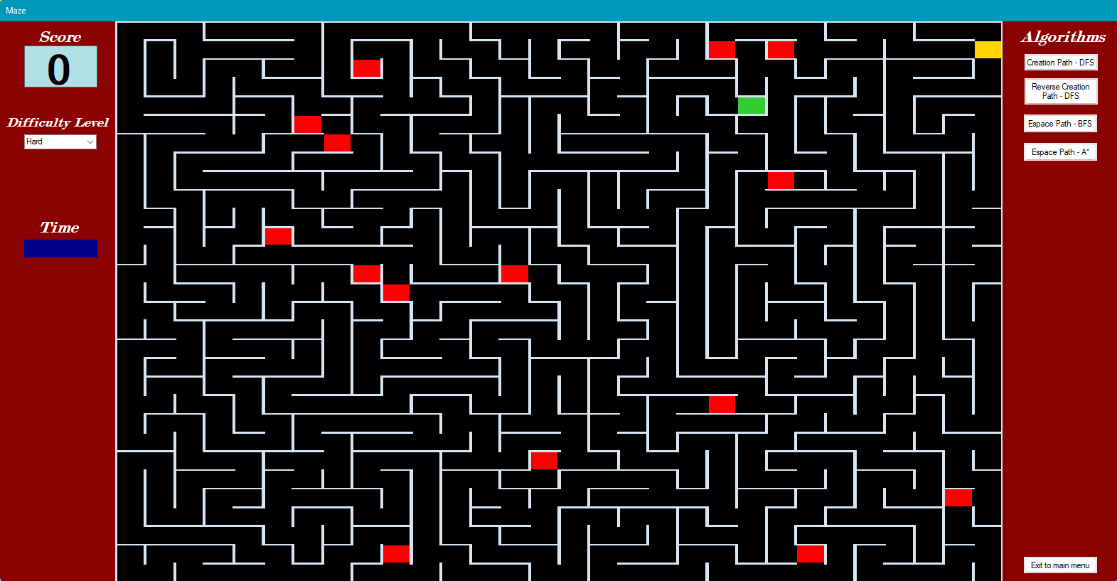
Figure 1. Screenshot from the game

2. Features
Enable features in the game:
- Maze generation using DFS (from start to end and from end to start).
- Player and exit cells.
- Event cells that increase the player's score.
- Locked exit that unlocks only after all event cells have been collected.
- Escape path visualization using BFS (Breadth-First Search) and A* algorithms.
- Path animation reversal.
- Difficulty level selection (changing the difficulty starts a new game and resets the current score).
- Simple graphical user interface.
- In-game background music.
- Random teleport event for each difficulty level.
- Enabled enter player name (without saving in active session).
- Scoreboard section with best times for each difficulty level (now empty without any saved times).

