Create web application with Google Books APIs(https://developers.google.com/books/docs/v1/getting_started).
Example below (This is example, you can provide you own design, use ready-made designs is forbidden):
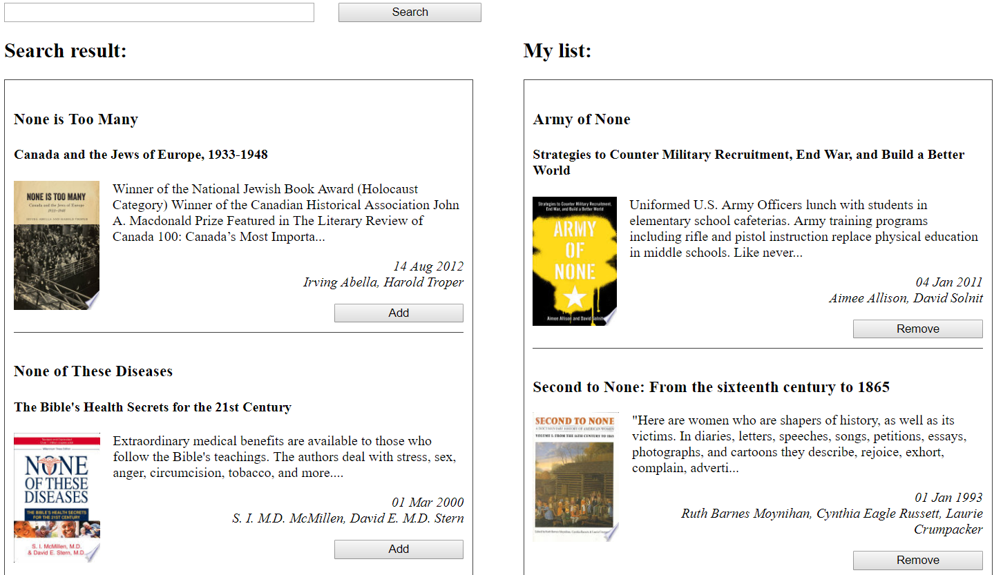
1. Search field (for input search terms).
2. Search button (for send request with search terms).
3. Search result (Title and list with data). Each element contains:
- title (book title);
- subtitle (book subtitle, optional field);
- smallThumbnail (image);
- description (only first 200 symbols, after them “…”);
- publishedDate (date format “DD MM YYYY”);
- authors (list of all authors, separated by “,”);
- button “Add” (For add book to “My list”).
4. My list (Title and list with data). (Title and list with data). Each element contains:
- title (book title);
- subtitle (book subtitle, optional field);
- smallThumbnail (image);
- description (only first 200 symbols, after them “…”);
- publishedDate (date format “DD MM YYYY”);
- authors (list of all authors, separated by “,”);
- button “Remove” (For remove book from “My list”).
You could keep your list data between page-refreshes using local storage (it’s not required, but it could help you to make things clear with mounting behavior).
Take to consideration, that some data could be absent in various books, and you must deal with it in your own way.

Please, DON’T concentrate on design! The task is not about that. It won’t give you any extra points)

