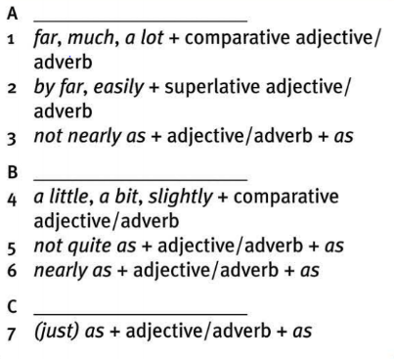28.11.

Your assay was much better than Mark’s one

That was by far the most expensive computer which I have worked with

That film wasn’t nearly as good as book

This exercice can be solved much more easily

I would like to study something easier than MatFyz

Math is just as nice as Physics

1 shape

2 size

3 position

4 space

5 line

6 segment

7 either

7.5 point

8 right

9 straight

10 pressiesly

11 one

12 paralel

13eplenation

Past perfect

Simple => had + PP

Continuous =>

Úkol:

17/3)

One full-length vertical line is joined at the top and at its centre point by two parallel lines, the former slightly longer than the latter, extending to the right horizontally.

Jedna celočíselná svislá čára je spojena nahoře a ve středu dvěma rovnoběžnými

řádky, první o něco delší než druhý, rozkládající se vpravo horizontálně.

A symmetrical, wedge-shaped figure: two straight but oblique lines slanting down to

the base from a common point at the top; these are bisected by a single horizontal line.

Symetrická, klínovitá postava: dvě rovné, ale šikmé linie skloněné dolů

základna ze společného bodu nahoře; tyto jsou rozděleny jednou vodorovnou čárou.

A long vertical line is connected at two points - at the top and halfway down - to a

curved, semi-circular line running to the right. From the centre intersection a sloping line

drops to the baseline at an angle 45 degrees to the perpendicular, again to the right.

Dlouhá svislá čára je spojena ve dvou bodech - v horní a poloviční poloze - na a

zakřivená, polokruhová linie běžící doprava. Z křižovatky středu je šikmá čára

klesá k základní čáře pod úhlem 45 stupňů k kolmici, opět zprava.

17/5)

a) Straight, straight, horizontal, oblique

b) intersect, equedistant, parrarel

38/9)

1) was working in big company, had studied at university

2) when I was 15, had got my first bike

3) I saw that, never had saw it before

4) I won lottery, had never won

5.12.

Before they came to the Prague, they had lived in the USA for 12 years.

They had worked on that effects lots of years, before they finished that film.

On September I came to the mff and from that moment I have been happy

I didn't know nothing about that that time

While I was waiting for you I was reading the book

When I was waiting for you I finished reading that book

Articles

1 více nepočitatelný

a/an some,any some,any

the the the

40/6 sb

The a

The the

- an the

- -

The the

A a the

An -

- -

**determination**

a two-year course

in a friendly way (friendly = adj)