REPORT OF EXPLORATORY DATA ANALYSIS
by Megh Patel

For the first EDA project, I was baffled as there were a lot of datasets available. All of them provided different types of information, and I was not sure which data set to use. From childhood, I treated soccer as nothing but scoring more goals than the opponent, which ensured our victory. So, I decided to use the shooting data/stats available. In this dataset, I was interested in gaining insights into players about their Goals per Shot on Target and Shot on Target percentage.
Analysis 1
In analysis 1, I started by converting the 1st row of the data into a column of the whole dataset, so each column represents what the data means instead of some random column names. I found out that the data type was an object type and converted only the needed columns into a float data type. Then I formed EDA and visualized the data as the figure suggests.
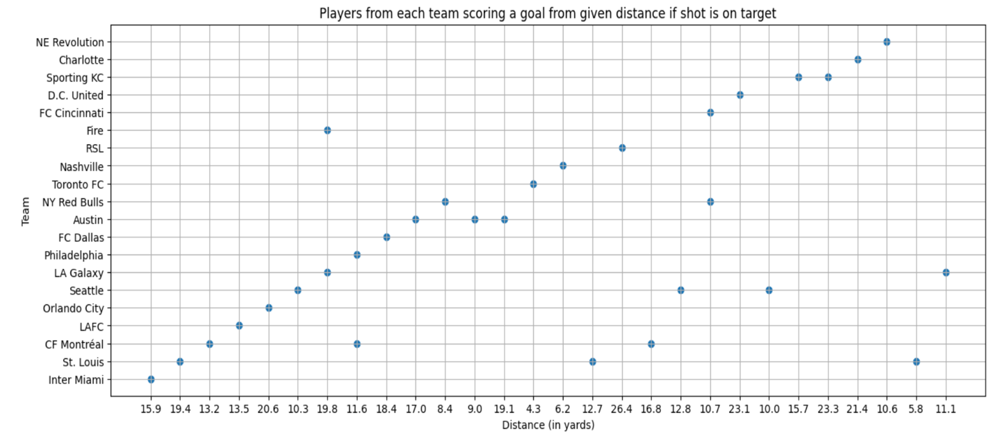

Key-Findings:
This scatterplot gives information on the players in each team who will score a goal if the shot is on target from the average distance of the shot taken, which is depicted on the x-axis. For instance, there are 3 players each in the St. Louis team who will score a goal if the shot is on target from 5.8 yards, 12.7 yards, and 19.4 yards.
Challenges:
I also wanted to depict the name of the player, respectively, to their data on the graph, but since there are so many players, it turned out to be difficult for me.
Analysis 2
I did this analysis because I wanted to depict the names of players and their positions whose Sot% was greater than or equal to 50% and who always scored a goal if the shot was on target.
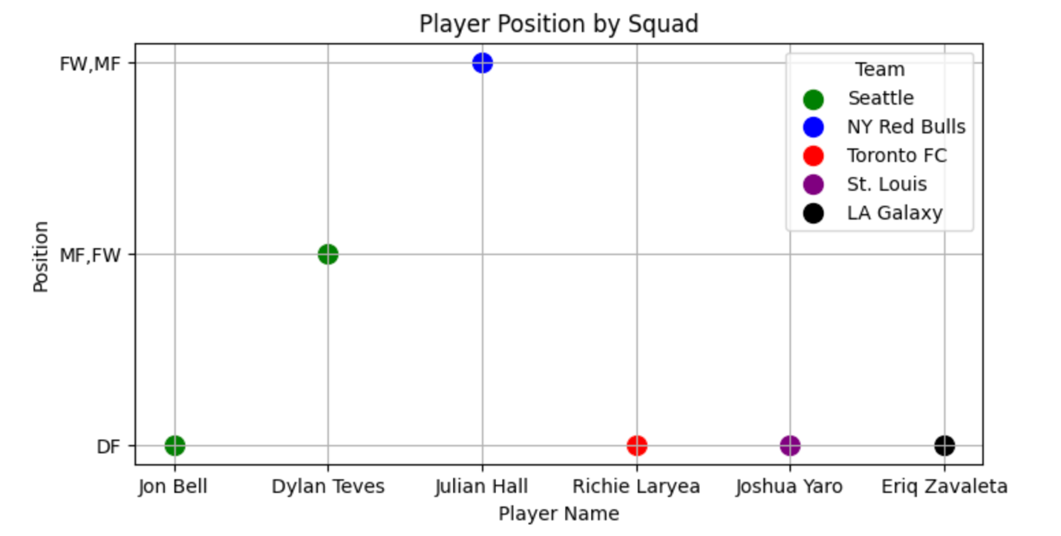
Key-Findings:
This scatterplot shows the names of players, their team, and the position they played, where 1 out of 2 shots they took were on target and also scored a goal. For example, Julian Hall from the NY Red Bulls, who plays FW, MF, has more than a 50 percent chance of scoring a goal if he took a shot.

