**Q1**

**W21**

**(a) What is topology? Explain star topology in brief. 03**

* Network topology is the arrangement of the various components (links, nodes, etc.) of a computer network.
* Types of topologies:
  1. Bus
  2. Ring
  3. Star
  4. Mesh
  5. Tree
  6. Hybrid

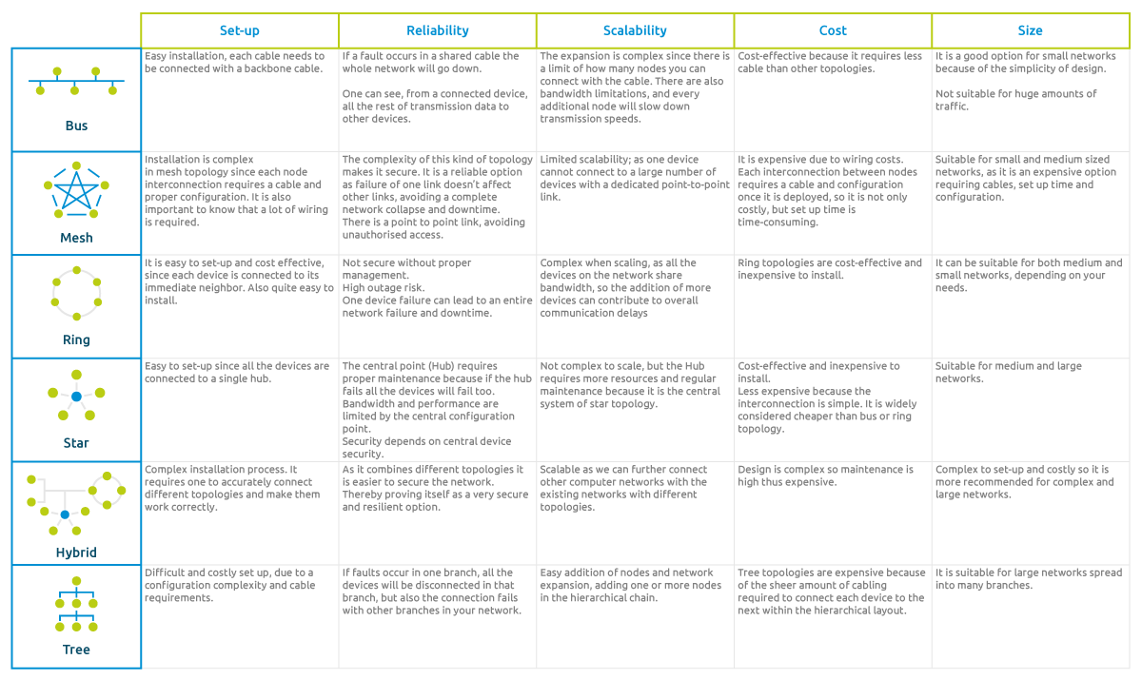

**(b) Explain various delay which are occur in data packet transmission. 04**

* Processing delay (eg. routing packets, error checking errors…)
* Queuing delay (eg. packets are queued in routers for routing calculation...)
* Delay due to distance between source and destination (eg. propagation speed = 200000km/s if destination is 2000 km away from source it will take 10ms...)
* Bandwidth (eg. if bandwidth is 1GHz and size is 10000bits than it will take 10ms…)

**(c ) Explain functionality of Repeater, Hub, Bridge, Switch, Router and Gateway. 07**

* **Repeater**
  + A repeater is a device that receives a signal and retransmits it to extend the range of a network. It regenerates the signal to ensure it maintains strength over long distances.
* **Hub**
  + A hub is a basic networking device that connects multiple Ethernet devices, making them act as a single network segment. It operates at the physical layer.
* **Bridge**
  + A bridge connects two or more network segments and filters traffic between them. It operates at the data link layer.
* **Switch**
  + A switch is a more advanced device than a hub, operating at the data link layer and sometimes at the network layer. It connects devices within a single network and intelligently forwards data packets to the correct destination based on MAC addresses.
* **Router**
  + A router connects different networks and directs data packets between them. It operates at the network layer.
  + Routers use IP addresses to determine the best path for forwarding packets across networks. They can also provide additional functions like NAT.
* **Gateway**
  + It act as translator which allows to communicate through, even if it uses different type of protocols.

**W22**

**(a) Which of the OSI layers handles each of the following:**

**i) Dividing the message into segments.**

**ii) Determining which route through the subnet to use.**

**iii) Dividing the transmitted bit stream into frames. 03**

* Segment - Transport layer
* Subnet - Network layer
* Frames - Data-link layer

**(b) Besides bandwidth and latency, what other parameter(s) is/are needed to give a good characterization of the quality of service offered by network used for**

**(i) Online financial transaction traffic?**

**(ii) Video streaming traffic? 04**

****(i) Online financial transaction traffic?****

* **Reliability : This refers to the ability of the network to consistently deliver data without loss. Reliable connections are essential for financial transactions to ensure that data is not lost during transmission.**
* **Security : Security measures such as encryption and secure protocols (like HTTPS) are vital for protecting sensitive financial data during transmission.**

**(ii) Video streaming traffic?**

* **Buffering and Rebuffering Rate** : This refers to how often video playback is interrupted to load more data. A lower buffering rate leads to a smoother viewing experience.
* **Frame Rate** : Frame rate (measured in frames per second, or FPS) affects how smooth the video appears
* **Video Quality (Resolution and Bitrate)** : The quality of the video stream and the bitrate (the amount of data processed per second) directly affect the viewing experience.

**(c) Discuss the circuit switching versus packet switching approaches for moving data through a network of links and switches. 07**

|  |  |
| --- | --- |
| **Circuit switching** | **Packet switching** |
| Path is decided at the beginning. | Path will be decided for every packet. |
|  |  |
| It is used in making phone calls. | It can be used to tranfer data. |
| Fixed bandwidth. | Dynamic bandwidth. |
| Packets are in order. | Packets arent in order. |
| Packets gets translated as they arrive. | Packet gets translated after the group of it arrives. |
| Huge amout of bandwidth is getting wasted. | It saves bandwidth. |
| Packet follows the same path till the end. | Its less like;y to follow the same path till the end. |

**W23**

**(a) What is protocol? How it is different than standard? 03**

* A **protocol** is a set of rules or conventions that define how data is transmitted and received over a network.
* It specifies the format of messages, the procedures for sending and receiving them, and the actions to take in various situations.
* Protocols ensure that devices on a network can communicate with each other effectively and reliably
* A protocol is a specific set of rules governing how data is transmitted and received. It focuses on the operational aspects of communication.
* A standard is a formal document that establishes uniform criteria, guidelines, or characteristics for a process, product, or service. It provides a framework or baseline for various technologies and practices.

**(b) Explain different networking devices. 04**

* Repeater
* Hub
* Bridge
* Switch
* Router
* Gateway

**(c) Draw and explain different layers of OSI Model. 07**

* 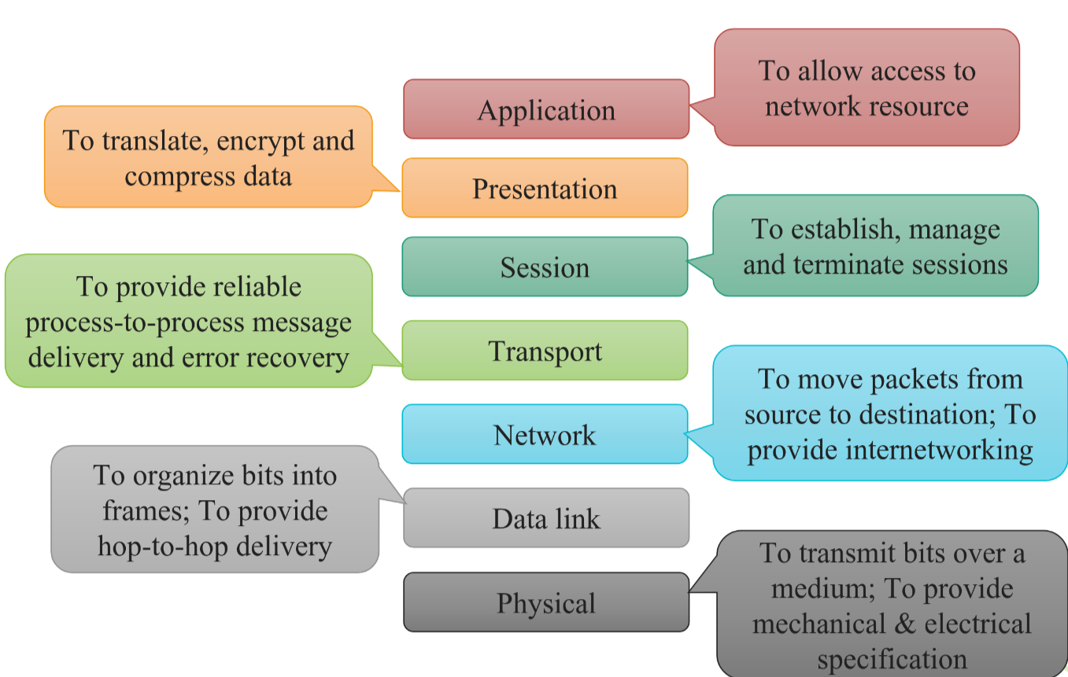**Physical layer :** 
  + Carries the bit stream over a physical media.
  + This layer will get the signal and send it to the Data Link layer
  + Hub, Repeater, Cables are Physical Layer devices
  + It also defines the transmission rate i.e. the number of bits sent per second.
  + The various transmission modes possible are Simplex, half-duplex and full-duplex.
* **Data link layer :** 
  + The data link layer is responsible for moving frames from one node to the next.
  + Switch & Bridge are Data Link Layer devices.
  + This layer allows to link the Logical Link Control layer and the network's physical layer.
  + Framing is a function of the data link layer.
  + The data link layer translates the physical's raw bit stream into packets known as Frames.Attaching special bit patterns to the beginning and end of the frame.
  + The Data link layer adds the header and trailer to the frame.Data link layer adds a header to the frame that contains destination and source addresses.
  + Flow controll is the main functionality of the Data-link layer which manages transmission rate.
  + Adding a calculated value CRC (Cyclic Redundancy Check) that is placed to the Data link layer's trailer.

|  |  |  |
| --- | --- | --- |
| Header (mac add.) | Data | CRC |

* **Network layer:**
  + The network layer is responsible for the delivery of individual packets from the source host to the destination host.
  + It provides a logical connection between different devices.
  + Network layer adds the source and destination IP addresses to the header of the frame.
* **Transport layer:**
  + The transport layer is responsible for the delivery of a message from one process to another.
  + Transport Layer reads the port number from its header and forwards the Data that it has received to the respective application.
  + It also adds Source and Destination port numbers in its header and forwards the segmented data to the Network Layer.
* **Session layer:**
  + If some error occurs in the middle of the transmission of data, then the transmission will take place again from the checkpoint.
  + Session layer acts as a dialog controller that creates a dialog between two processes.
  + In simple words, it allows the communication between two processes which can be either half-duplex or full-duplex.
* **Presentation layer:**
  + The presentation layer is responsible for translation, compression, and encryption.
  + data from the application layer is extracted here and manipulated as per the required format to transmit over the network.
  + It converts the data from sender-dependent format into a common format and changes the common format into receiver-dependent format at the receiving end.
  + Data compression reduces the number of bits that need to be transmitted on the network.
* **Application layer:**
  + The application layer is responsible for providing services to the user.
  + These applications produce the data, which has to be transferred over the network.
  + An application layer allows a user to access the files in a remote computer, to retrieve the files from a computer and to manage the files in a remote computer.

**Q2**

**W21**

**(a) Write short note on Domain Name System (DNS). 03**

* 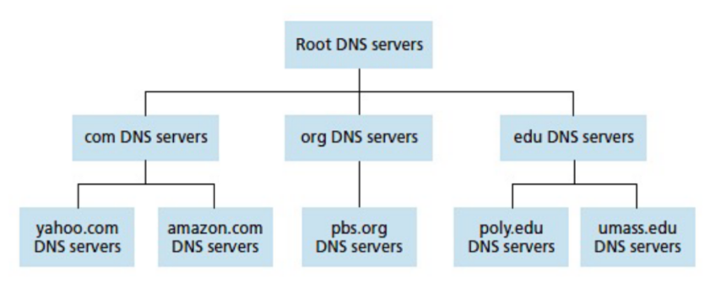It is an internet service that translates domain names into IP addresses.
* A single point of failure: If the DNS server crashes then the entire Internet will not stop.
* It requestes local server to find ip for requested domain.
* If it doesn’t has it than it will ask it to top level DNS which has the ips of where the client can find its domain eg .com .net .edu etc.
* After that client requestes for ip of desired domain to Root domains if request of desiered domain has sub domain eg. aniwatch.co.in than the root domain will be .in than the the root domain server return the ip of co-root domain.
* After receiving co-root domain cient will request to it and fetches the ip of that domain name.

**(b) What is HTTP? Differentiate its persistent and non-persistent types with request-response behavior of HTTP. 04**

* HyperText Transfer Protocol – Application layer protocol
* HTTP defines the structure of these messages and how web client – web server exchange messages.
* It is implemented in two programs.
  + Client Program
  + Server Program
* HTTP is “stateless protocol”, server maintains no information about past client requests.
* **Non-persistent** 
  + 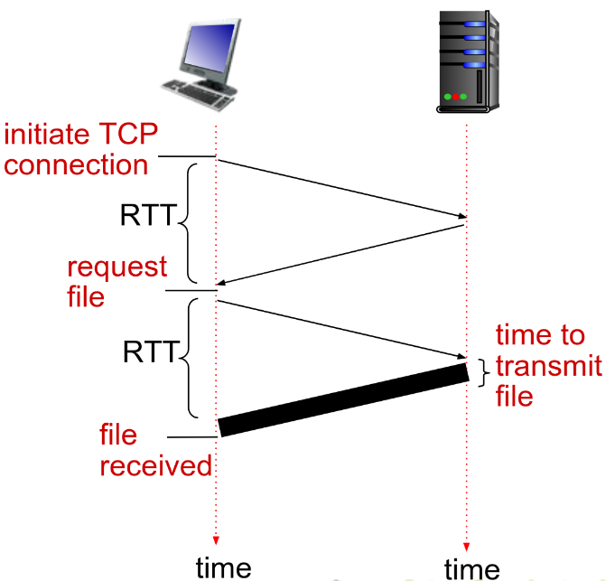A non-persistent connection is closed after the server sends the requested object to the client.
  + For downloading multiple objects, it required multiple connections.
  + Non-persistent connections are the default mode for HTTP/1.0.
  + Diagram:
* **Persistent**
  + Server leaves the TCP connection open after sending responses.
  + Subsequent HTTP messages between same client and server sent over open connection.
  + With persistent connections, the performance is improved by 20%.
  + Persistent connections are the default mode for HTTP/1.1.
  + The server closes the connection only when it is not used for a certain configurable amount of
  + time.

**(c ) Draw the layered architecture of OSI reference model and write at least two services provided by each layer of the model. 07 RE**

**OR(c ) Explain DHCP and Email(SMTP) in detail. 07**

* **Dynamic Host Configuration Protocol (DHCP)**
  + Dynamic Host Configuration Protocol is a protocol for assigning dynamic IP addresses to devices on a network.
* 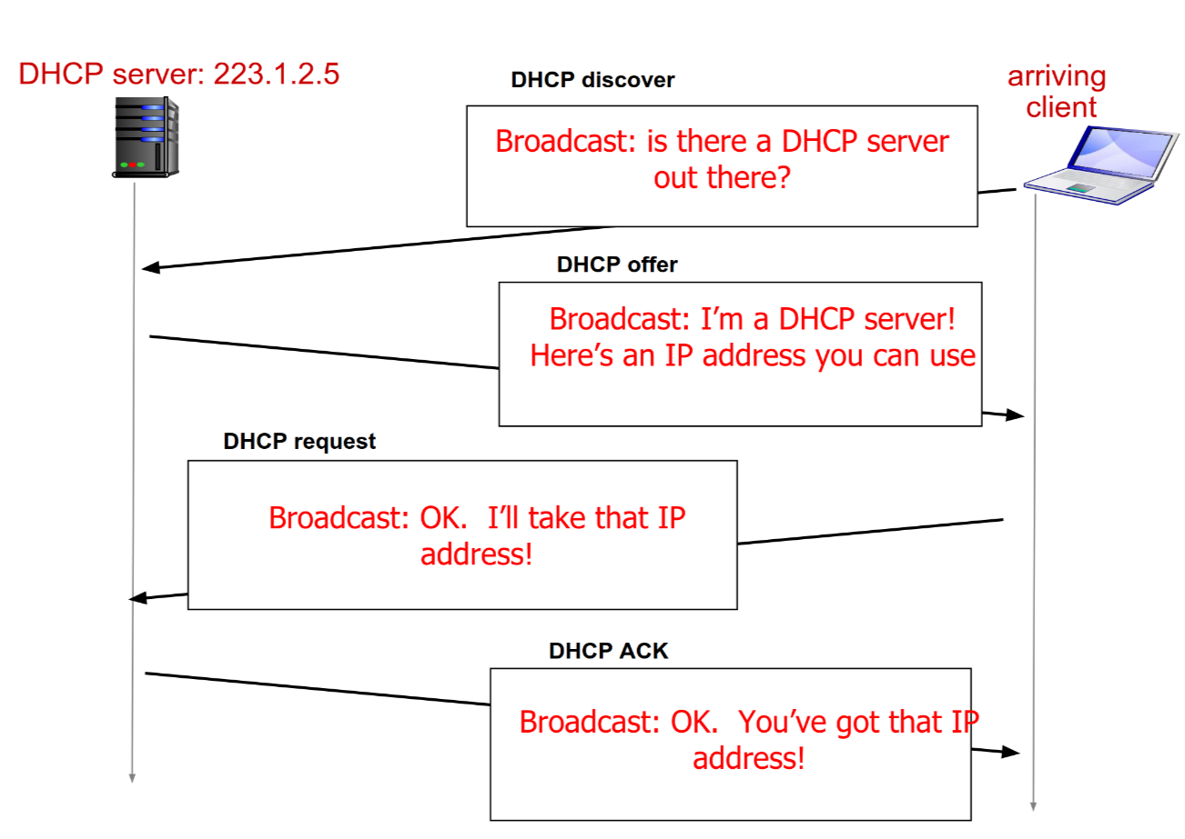**Email**
* Email is an asynchronous communication medium in which people send and read messages as convenient for them.

Give example...

**W22**

**(a) Justify the statement, “HTTP server is stateless”. 03**

**(b) State the port number for the following application layer protocols. i) FTP ii) HTTP iii) SMTP iv) POP3 04**

**(c) Discuss the five layer internet protocol stack along with the functionalities of each layer in detail.**

**07**

**OR(c) Explain User Datagram Protocol (UDP) in detail and discuss how it differs from Transmission Control Protocol (TCP). 07**

**W23**

**(a) Find transmission delay for transmission of 1500 bytes (12000 bits) using a transmission rate of 100Mbps. 03**

* Transmission bits = 1500*8 = 12000 bits

Transmission rate = 100 Mbps = 100*1000 Kbps = 100*1000*1000 bps

hence Transmission delay = Transmission bits / Transmission rate

= 12000/100000 ms

= 0.12 ms

**(b) Differentiate between connection oriented and connection less service. 04**

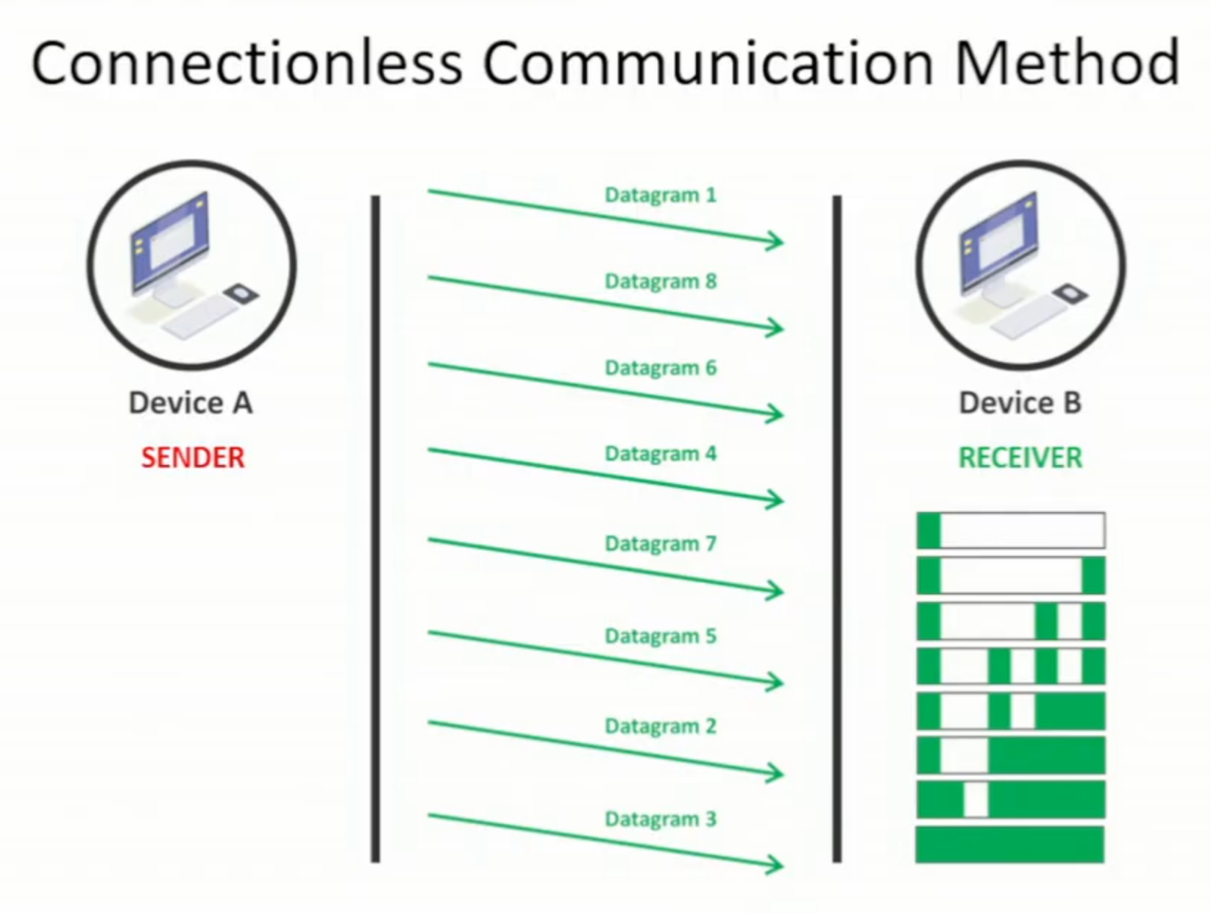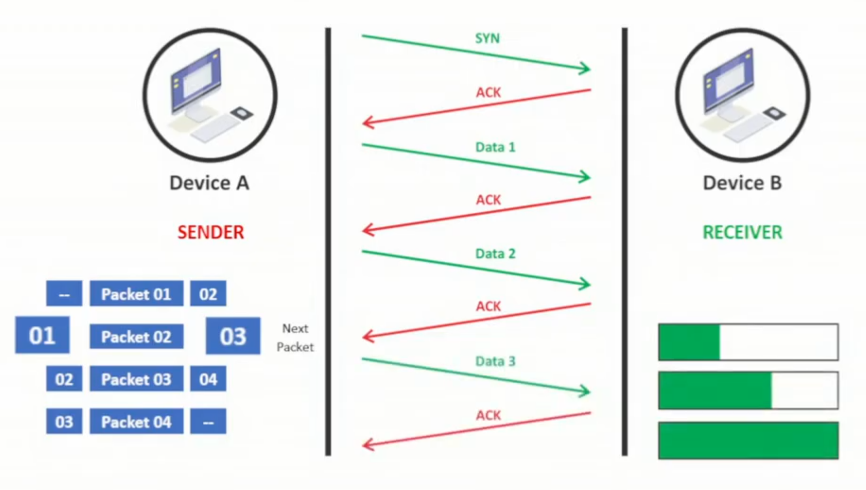Points: In Order (no, yes), acknoladment(no , yes) , secure(no , yes), reliable (no , yes), time (less , more), what if package lost(re – send all , send whichever is lost)

**(c) Explain different types of CSMA with suitable example. 07**

* **1 Persistante**
  + Systems will check whether medium is busy or not if it is than it will continuosly check till it gets free than it will send data.
  + In this the chances of collisions is significuntly high.
  + Worst case: Wait till the medium is free, than all waiting systems to use bus will send it simultaniously.
* **0 Persistante**
  + Systems will check whether medium is busy or not if it is than it will check after random about of time till it gets free than it will send data.
  + In this the chances of collisions is low.
  + Worst case: If medium is busy and system need to use medium than it will wait for random time during this time eventhough medium gets free, the system will wait for that randomly generated period of time.
* **P Persistante**
  + Systems will check whether medium is busy or not if it is than it will continuosly check till it gets free than after that based on randomly generated Probability P it will send data.
  + In this the chances of collisions is significuntly low.
  + Worst case: If medium is busy and system need to use medium than it will wait till it gets free after that if two system with high probability P if they sent the data it will cause.

**OR(c) Explain HTTP and DNS in detail. 07 RE**

**Q3**

**W21**

**(a) Explain Physical Address, IP address, Port Address in brief. 03**

**(b) Compare IPv4 and IPv6. 04**

**(c ) Explain Distance Vector Routing Algorithm. 07**

**OR(a) Discuss the principles of Reliable Data Transfer. 03**

**OR(b) Give difference between connection oriented and connectionless services. 04**

**OR(c ) What do you mean by congestion and overflow? Explain the slow-start component of the TCP congestion-control algorithm. 07**

**W22**

**Q.3 (a) For the below mentioned internet applications protocol, mention the underlying transport protocol (TCP or UDP). i) Telnet ii) FTP iii) HTTP 03**

**(b) Discuss the count-to-infinity problem in distance vector routing algorithm with example. 04**

**(c) Explain the class-full sub-netting with example. 07**

**OR(a) Define the term unicasting, multicasting, and broadcasting. 03**

**OR(b) What is the significance of the following flags in TCP segment? i) URG ii) SYN iii) FIN iv) PSH 04**

**OR(c) Explain TCP Congestion mechanism in detail. 07**

**W23**

**(a) Explain the term piggybacking and congestion. 03**

**(b) Compare Datagram and virtual circuit. 04**

**(c) What is IP address? Explain different classes of IP address. 07**

**OR(a) What is the functionality of Router, Bridge and Gateway? 03 RE**

**OR(b) What is subnet? What are the benefits of creating subnets? 04**

**OR(c) Generate CRC code for message 1101010101. Given generator polynomial is x4+x2+1. 07**

**Q4**

**W21**

**(a) Explain packet fragmentation with example. 03**

**(b) Write a short note on broadcast and multicast routing. 04**

**(c ) What is IP address? Explain sub netting with example. 07**

**OR(a) Give differences between TCP and UDP. 03**

**OR(b) What is socket? Explain its importance at transport layer protocols. 04**

**OR(c ) Discuss transport layer multiplexing and demultiplexing concepts. 07**

**W22**

**(a) Explain the UDP checksum mechanism for error detection with example. 03**

**(b) What is the relevance of Type of Service (ToS) and Time to Live (TTL) field in IPV4 packet? 04**

**(c) Explain Link State Routing algorithm in detail. 07**

**OR(a) What are the three most important network-layer functions in a virtual-circuit network? 03**

**OR(b) Explain Route Summarization or Route Aggregation in network layer. 04**

**OR(c) Demonstrate the various error detection techniques at data link layer with example. 07**

**W23**

**(a) What is store and forward packet switching? 03**

**(b) What are the services provided to transport layer by the network layer? 04**

**(c) Explain distance vector routing with suitable example. 07 RE**

**OR(a) Explain the problem of Count-to-infinity with example. 03**

**OR(b) Discuss optimality principle with example. 04**

**OR(c) Explain Link state routing with suitable example. 07**

**Q5**

**W21**

**(a) Discuss CSMA/CD Protocol. 03**

**(b) Explain CRC code generation with example. 04**

**(c ) Describe Go Back N and Selective Repeat protocol. 07**

**OR(a) Discuss parity check for error detection in data transfer. 03**

**OR(b) What do you mean by random access protocols? Explain slotted ALOHA in brief. 04**

**OR(c ) Draw and explain Ethernet Frame Structure. 07**

**W22**

**(a) What is the purpose of Address Resolution Protocol (ARP) and Network Address Translation (NAT)? 03**

**(b) Explain the following static channel allocations mechanisms: i) TDMA ii) FDMA 04**

**(c) Explain p-persistent CSMA protocol in detail. 07**

**OR(a) Data link protocols almost always put CRC in a trailer rather than in a header. Why? 03**

**OR(b) State the difference between bit rate and baud rate. 04**

**OR(c) Discuss the working of slotted aloha along with its efficiency in terms of channel utilization. 07**

**W23**

**(a) Explain LRC with suitable example. 03**

**(b) Compare IPV4 and IPV6. 04 RE**

**(c) Explain the hierarchical DNS system. 07 RE**

**OR(a) Explain flow and error control in TCP. 03**

**OR(b) Compare TCP and UDP. 04 RE**

**OR(c) Write note on: 802.3 Ethernet. 07**