***Q.1***

**W23**

**(a) Explain HTTP Request and Response. 03**

* HTTP stands for Hypertext Transfer Protocol.
* HTTP is based on the client-server architecture model.
* TCP protocols are used to open a channel between sever and client.
* An HTTP "client" is a program (Web browser) that establishes a connection to a server for the

purpose of sending one or more HTTP request messages.

* An HTTP "server" is a program (generally a web server like Apache Web Server) that accepts

connections in order to serve HTTP requests by sending HTTP response messages.

* **HTTP Request**
* The HTTP request message consist of following,
  + A request line (e.g. GET /index.php HTTP1.1)
  + Request header fields (e.g. Accept-Language: en)
  + An empty line
  + An optional message body
* A request line contains the method of request followed by the resource we want and at the end

protocol version used.

* HTTP Request Methods: GET, POST, PUT, DELETE etc…
* **HTTP Response**
* After receiving and interpreting a HTTP request message, a server responds with an HTTP

response message.

* The HTTP response message consist of following,
  + Status-Line (format= HTTP-Version SP Status-Code)
  + An empty line
  + An optional message body
* Status-Line consist of
  + HTTP-Version, which can be HTTP/1.1
* Status-Code is a 3 digit code which is in below format
  + 1xx: Informational - Request received, continuing process
  + 2xx: Success - The action was successfully received, understood, and accepted
  + 3xx: Redirection - Further action must be taken in order to complete the request
  + 4xx: Client Error - The request contains bad syntax or cannot be fulfilled
  + 5xx: Server Error - The server failed to fulfill an apparently valid request

**(b) What is Web security? Explain in details. 04**

* It basically means protecting a website or web application by detecting, preventing and responding to cyber threats
* protection of websites, web applications, and web services security is vital.
* Any website or application that is secure is surely backed by different types of checkpoints and techniques for keeping it safe.
* There are different types of technologies available for preventing threats.
  + **Stolen Data:** Cyber-criminals frequently hacks visitor’s data that is stored on a website like email addresses, payment information, and a few other details.
  + **Phishing schemes:** This is not just related to email, but through phishing, hackers design a layout that looks exactly like the website to trick the user by compelling them to give their sensitive details.
  + **Session hijacking:** Certain cyber attackers can take over a user’s session and compel them to take undesired actions on a site.
* Web security is extremely important, especially for websites or web applications that deal

with confidential, private, or protected information.

* Security methods are evolving to match the different types of vulnerabilities that come into

existence.

**(c) Explain how basic and nested tables are created using HTML. 07**

* **Basic table**

<table border=1>

<tr>

<th>Heading1</th>

<th>Heading2</th>

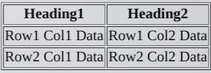</tr>

<tr>

<td>Row1 Col1 Data</td>

<td>Row1 Col2 Data</td>

</tr>

<tr>

<td>Row2 Col1 Data</td>

<td>Row2 Col2 Data</td>

</tr>

</table>

* **Nested tables**

<table border=1>

<tr>

<table>

<tr>

<th>Heading1T1</th>

<th>Heading2T1</th>

</tr>

<tr>

<td>Row1 Col1 Data</td>

<td>Row1 Col2 Data</td>

</tr>

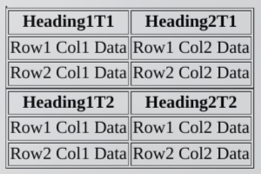<tr>

<td>Row2 Col1 Data</td>

<td>Row2 Col2 Data</td>

</tr>

</table>

</tr>

<tr>

<table>

<tr>

<th>Heading1T2</th>

<th>Heading2T2</th>

</tr>

<tr>

<td>Row1 Col1 Data</td>

<td>Row1 Col2 Data</td>

</tr>

<tr>

<td>Row2 Col1 Data</td>

<td>Row2 Col2 Data</td>

</tr>

</table>

</tr>

</table>

**W22**

**(a) Define term : WWW 03**

* WWW is stands for World Wide Web.
* It is a collection of websites or web pages stored in web servers and connected to local

computers through the internet.

* These websites contain text pages, digital images, audios, videos, etc.
* Users can access the content of these sites from any part of the world over the internet using their devices.
* The World Wide Web is a global information medium which users can read and write via computer connected to the internet.
* A web is given an online address called a URL.
* World Wide Web is like a huge book whose pages are stored on multiple servers across the world
* Small websites store all of their WebPages on a single server, but big websites or organizations place their WebPages on different servers in different countries so that when users of a country search their site they could get the information quickly from the nearest server.

**(b) Explain the Architecture of Web Browser. 04**

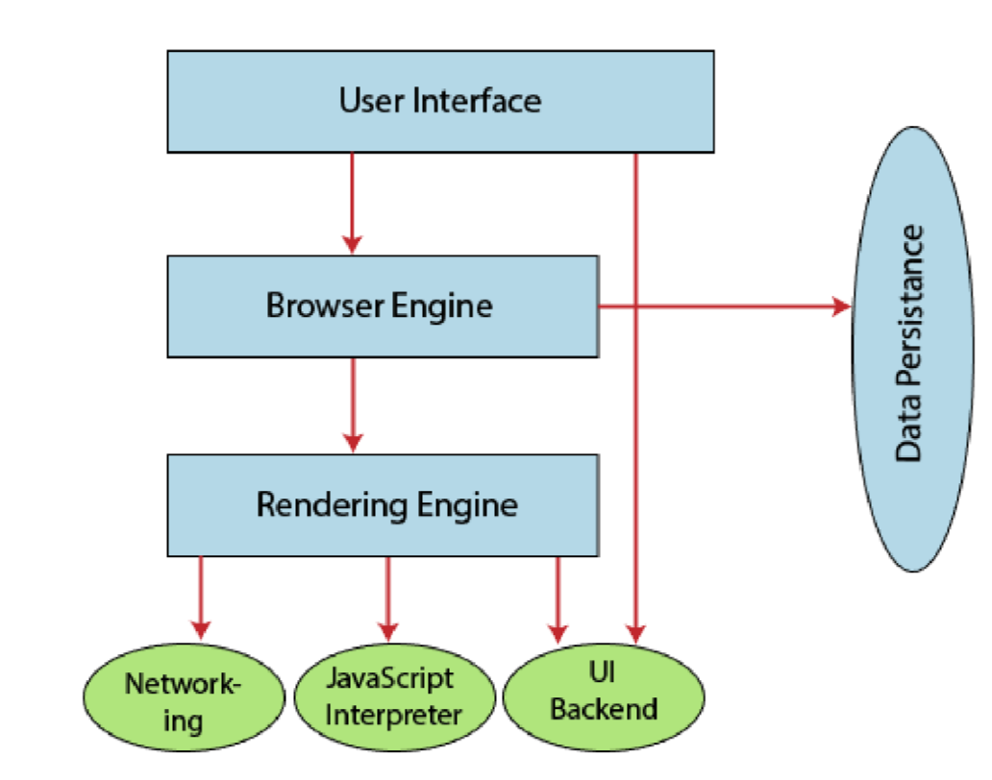

* **User Interface:** The user interface is an area where the user can use several options like address bar, back and forward button, menu, bookmarking, and many other options to interact with the browser.
* **Browser Engine:** It connects the UI (User Interface) and the rendering engine as a bridge.
  + It queries and manipulates the rendering engine based on inputs from several user interfaces.
* **Rendering Engine:** It is responsible for displaying the requested content on the browser screen.
  + It translates the HTML, XML files, and images, which are formatted by using the CSS.
  + It generates the layout of the content and displays it on the browser screen.
* **Networking:** It retrieves the URLs by using internet protocols like HTTP or FTP.
  + It is responsible for maintaining all aspects of Internet communication and security.
  + Furthermore, it may be used to cache a retrieved document to reduce network traffic.
* **JavaScript Interpreter:** translates and executes the JavaScript code, which is included in a website.
  + The translated results are sent to the rendering engine to display results on the device screen.
* **UI Backend:** It is used to draw basic combo boxes and Windows (widgets).
  + It specifies a generic interface, which is not platform-specific.
* **Data Storage:** The data storage is a persistence layer that is used by the browser to store all sorts of information locally, like cookies.
  + A browser also supports different storage mechanisms such as IndexedDB, WebSQL, localStorage, and FileSystem.
  + It is a database stored on the local drive of your computer where the browser is installed. It handles user data like cache, bookmarks, cookies, and preferences.

**(c) Elaborate HTTP Protocol Header, HTTP Request and HTTP. Response 07 RE**

**W21**

**(a) Define term : WWW 03 RE**

**(b) List out any four HTML Tag and describe their functionality. 04**

* H1-H6
* Table, tr, td, th
* p
* ul, ol, li

explain it by your self

**(c) Elaborate HTTP Protocol Header, HTTP Request and HTTP Response 07 RE**

***Q.2***

**W23**

**(a) Explain types of CSS. 03**

* **1. Inline Style**
  + Inline CSS has the highest priority out of external, internal, and inline CSS.
  + If you want to add a style inside an HTML element all you have to do is specify the desired CSS properties with the style HTML attribute.
  + <p style="background: blue; color: white;"> My Inline CSS </p>
* **2. Internal/Embedded Style sheet**
  + This type of CSS is only for Single Web Page.
  + When using internal CSS, we must add a new tag, <style>, inside the <head> tag.
  + <html>

<head>

<style type="text/css">

p{ color: red;}

</style>

</head>

<body>

<p>Your page's content!</p>

</body>

</html>

* **3. External Style Sheet**
  + When using CSS it is preferable to keep the CSS separate from your HTML.
  + External CSS is a file that contains only CSS code and is saved with a ".css" file extension.
  + **TEST.html**
  + <html>

<head>

<link rel="stylesheet" href="xyz.css">

</head>

<body>

<p>Your page's content!</p>

</body>

</html>

* + **xyz.css**
  + p

{

color:"red";

text-align: center;

}

**(b) Write short note on CSS variables. 04**

* The var() function is used to insert the value of a CSS variable.
* you can create variables with local or global scope, change the variables with JavaScript, and change the variables based on media queries.
* var(--name, value).

|  |  |
| --- | --- |
| name | Required. The variable name (must start with two dashes) |
| value | Optional. The fallback value (used if the variable is not found) |

* The name in var is case sensitive
* **xyz.css**

:root

{

--blue = #0000ff;

--red = #ff0000;

}

p

{

color:var(--red,#ff0000);

text-align: center;

}

li

{

color:var(--blue);

}

**(c) Create HTML form (Font Color: Blue, set image as background) using CSS. 07**

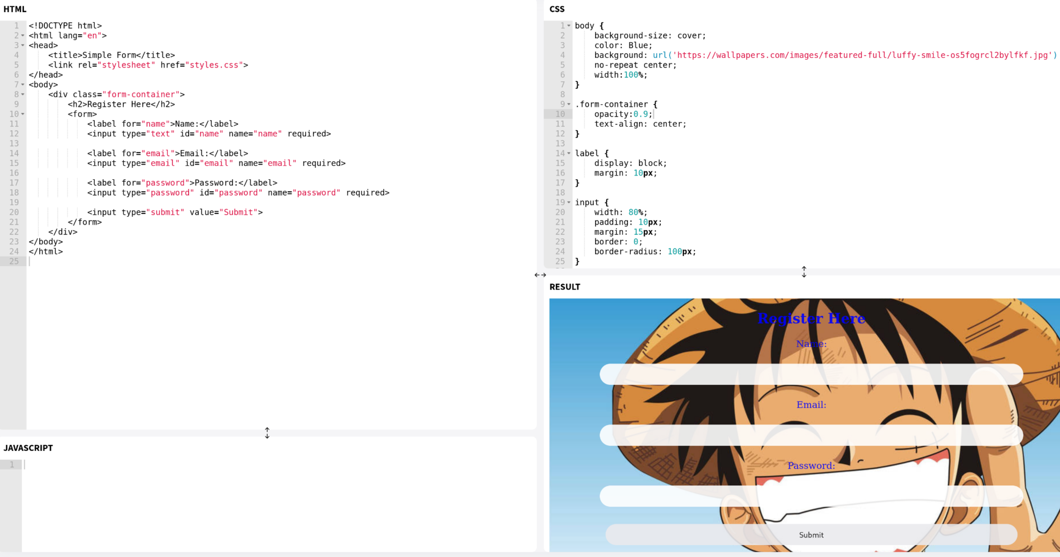

**OR(c) Create Time Table in HTML form using Table Tag. 07**

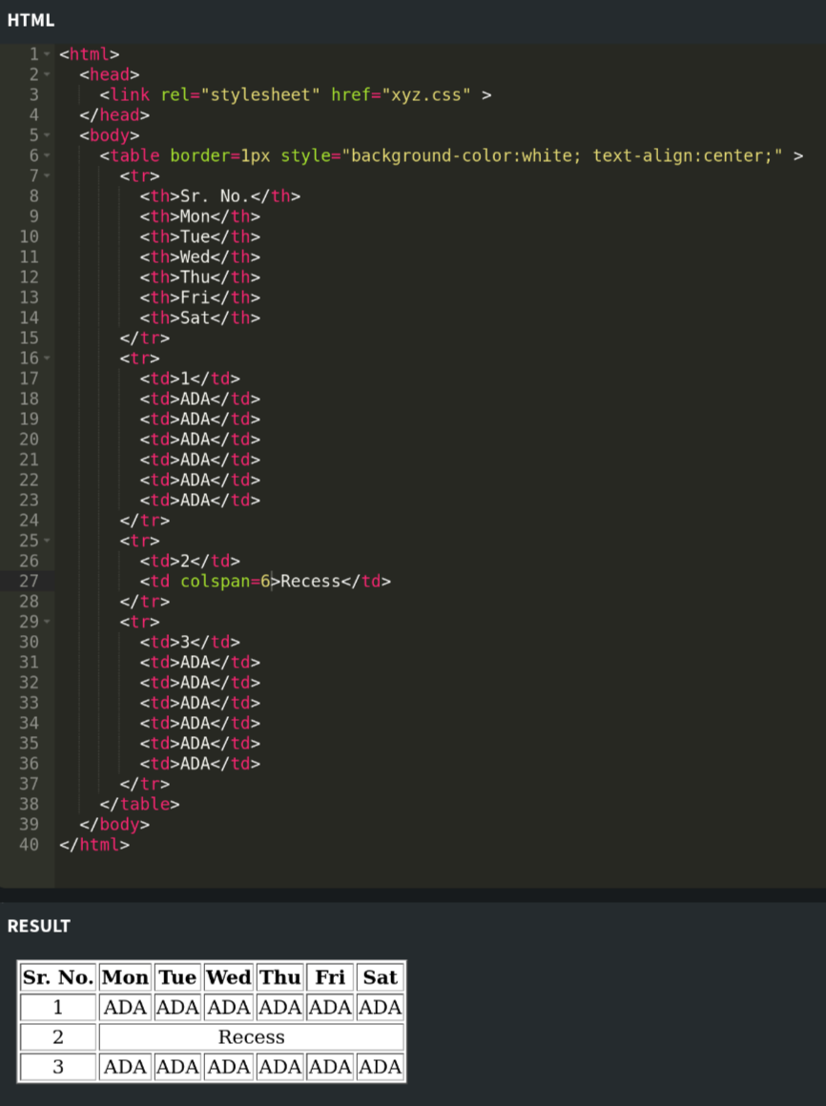

**W22**

**(a) Define term: SEO 03**

* SEO stands for Search Engine Optimization.
* It improves website visibility in search engine results pages.
* The goal of SEO is to increase organic (non-paid) traffic to a website.
* SEO involves keyword research to identify search terms users commonly use.
* Content optimization ensures relevance and quality for targeted keywords.
* SEO focuses on optimizing website elements like titles and meta tags.
* SEO includes activities like building backlinks from other sites.
* SEO ensures the website is fast, mobile-friendly, and error-free.
* Tools like Google Analytics and Search Console help monitor SEO performance.
* SEO is an ongoing process to adapt to search engine algorithm updates.

**(b) Explain ordered and unordered list with example. 04**

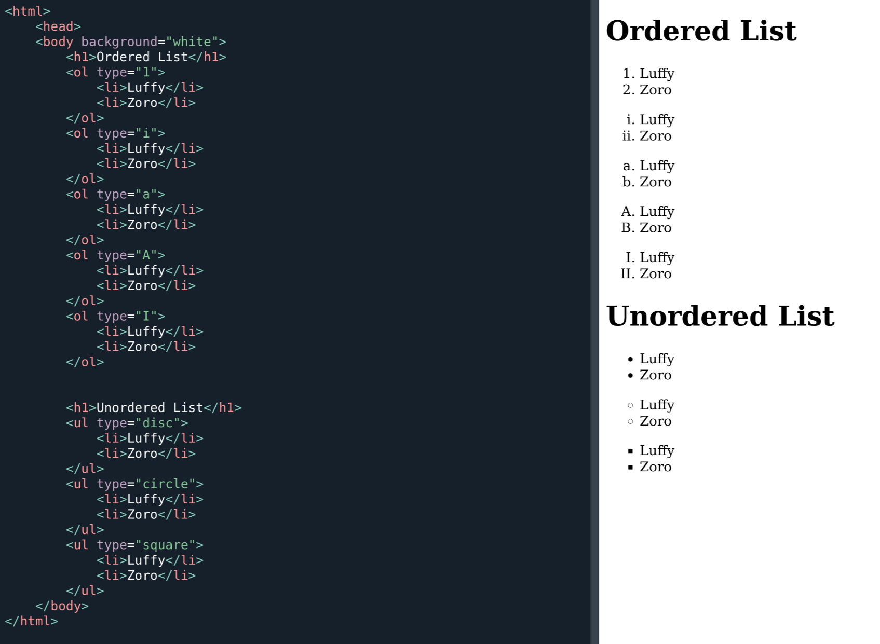

**(c) Give the difference between Client side Scripting and Server Side Scripting. 07**

| Client-side scripting | Server-side scripting |
| --- | --- |
| Source code is visible to the user. | Source code is not visible to the user because its output of server-sideside is an HTML page. |
| Its main function is to provide the requested output to the end user. | Its primary function is to provide access to the respective database as per the request. |
| It usually depends on the browser and its version. | In this any server-side technology can be used and it does not depend on the client. |
| It runs on the user’s computer. | It runs on the webserver. |
| There are many advantages linked with this like faster. | The primary advantage is its ability to highly customize, response. |
| It does not provide security for data. | It provides more security for data. |
| It is a technique used in web development in which scripts run on the client’s browser. | Its a technique that uses scripts on the webserver to produce a unique response for each client’s request. |
| HTML, CSS, and javascript are used. | PHP, Python, Java, Ruby are used. |
| No need of interaction with the server. | It is all about interacting with the servers. |
| It reduces load on processing unit of the server. | It surge the processing load on the server. |

**OR(c) What is selector class ? Explain the pseudo class selector in CSS with example. 07**

* The selector can be HTML element, id or class
* **“id” selector**
  + The id selector is used to specify a style for a single, unique element.
  + The id selector uses the id attribute of the HTML element, and is defined with a “#” in css.
  + The style rule below will be applied to the element with id="para1":
  + HTML

<h1 id=“para1”>Hello Friends</h1>

<h1>How are you</h1>

* + CSS

#para1{

color: blue;

}

* **“class” selector**
  + The class selector is used to specify a style for a group of elements.
  + The class selector uses the HTML class attribute, and is defined with a “.” in css.
  + HTML

<h1 class=“myClass”>Hello Friends</h1>

<h1 class=“myClass”>How are you</h1>

* + CSS

.myClass{

color: blue;

}

* **pseudo class selector**
* <html>

<head>

<style>

/* unvisited link */

a:link {

color: red;

}

/* visited link */

a:visited {

color: green;

}

/* mouse over link */

a:hover {

color: yellow;

}

/* selected link */

a:active {

color: blue;

}

</style>

</head>

<body>

<a href="default.asp">This is a link</a>

</body>

</html>

**W21**

**(a) Define term: SEO 03 RE**

**(b) Write full form of CSS. Describe types and advantages of CSS. 04**

* CSS - Cascading Style Sheets
* There are three types of css
  + Inline style
  + Internal style
  + External style
* Advantages
* CSS saves time
* Pages load faster
* Easy maintenance
* Superior styles to HTML
* Multiple Device Compatibility
* Global web standards
* Increases readablility of code

**(c) Create HTML Form for 1st Year Student registration which asks all personal details. 07 RE**

**OR(c) Explain term: Class, ID, Wild card selectors, Media Queries for CSS. 07**

* **Class selector:**
  + A class selector is used to apply specific styles to multiple elements that share the same class.
  + Can be used by . and class name eg. .classxyz{…} in css
  + In html to access created class use class="classname"

eg. <p class="Yamamoto">Bankai Zankano tachi</p>

* **ID selector**
  + An ID selector is used to apply styles to a unique element on the page.
  + Can be used by # and id name eg. #idName{…} in css
  + In html to access created id use id="idName"

eg. <p id="Nika">Gomu Gomu no Bajarang gunn!!</p>

* **Wild card selector**
  + The wildcard selector (*) is used to select all elements on a page.
  + Can be used by * and id name eg. *{…} in css
  + It automatically gets applied to every tags in html
* **Media Queries**
  + They make a website responsive and adaptable to different devices.
  + Media queries are used to apply styles based on the device's characteristics, such as screen size, resolution, or orientation.

body {

background-color: white;

}

@media (max-width: 768px) {

body {

background-color: lightgray;

}

}

@media (max-width: 480px) {

body {

background-color: lightblue;

}

}

***Q.3***

**W23**

**(a) What is Bootstrap? Why we use it. 03**

* Bootstrap is an open-source **CSS framework** used for designing responsive and mobile-first websites.
* It provides pre-designed components and utilities such as navigation bars, buttons, forms, grids, and typography.
* Reasons to Bootstrap
  + Responsive Design
  + Time-Saving
  + Consistency
  + Customizability
  + Cross-Browser Compatibility
  + Ease of Use

**(b) Explain types of JavaScript. 04**

* **Client-side js**
* **Server-side js**
* **Embedded js**
  + Embedded JavaScript refers to JavaScript integrated directly within other languages or frameworks, such as HTML or templating engines.
  + It enhances functionality by allowing to embed scripts for tasks like dynamic content.
* **Core js**
  + Core JavaScript refers to the base language without additional libraries or frameworks.
  + It provides the fundamental building blocks such as data types, functions, loops, and objects.
  + It is essential for understanding JavaScript’s principles and is the foundation for creating custom features, frameworks, or tools tailored to specific applications.

**(c) Write the code of JavaScript to make Pop up box. 07**

* <html>

<head>

<title>JavaScript Popup Box</title>

</head>

<body>

<h1>JavaScript Popup Box Example</h1>

<button onclick="showPopup()">Click Me!</button>

<script>

function showPopup() {

alert("This is a JavaScript Popup Box!");

}

</script>

</body>

</html>

**OR(a) Explain Callbacks in JavaScript. 03**

* A callback is a function passed as an argument to another function.
* This technique allows a function to call another function.
* A callback function can run after another function has finished.
* eg.

function div(a,b){return a/b}

function mul(a,b){return a*b}

function add(a,b){return a+b}

function writeit(a,b,fun){alert(""+a+b+fun(a,b))}

writeit(10,15,mul)

**OR(b) Differentiate between the 'BITWISE AND' and the 'LOGICAL AND'operators in PHP. 04**

| ****Aspect**** | ****Bitwise AND (&)**** | | ****Logical AND (&&)**** | |
| --- | --- | --- | --- | --- |
| **Operation Type** | | Works at the **bit level**. Compares individual bits of operands. | Works at the **logical level**. Compares boolean expressions. | |
| **Input Values** | Operands are treated as integers (binary representation). | | Operands are treated as boolean values (true/false). | |
| **Usage** | Used for bit manipulation tasks like masking or setting flags. | | Used in conditional statements for logical operations. | |
| **Example** | 5 & 3 → (0101 & 0011) = 0001 → Result: 1. | | (5 > 3) && (3 > 1) → Result: true. | |
| **Result** | Outputs a number resulting from bit-level operation. | | | Outputs true or false based on the condition. |

Eg.

$a=6;

$b=9;

echo ($a&$b);

if ($a>3 && $b>$a){

echo “Gomu Gomu no Bajarang gunn”

}

**OR(c) Write a PHP script to sort the elements of an array. 07**

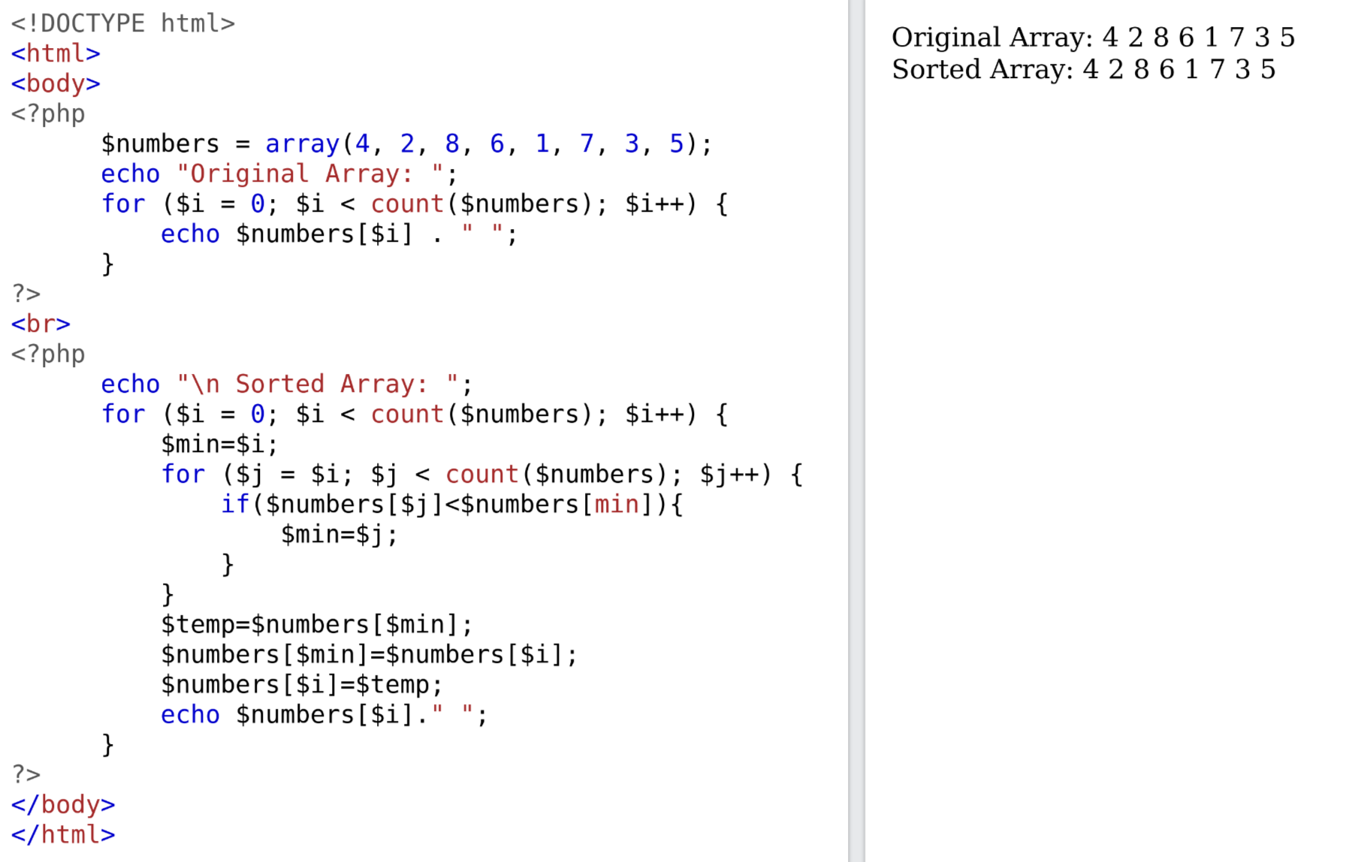

**W22**

**(a) What is meta tag? How it is useful by search engine? 03**

* **Meta Tag**
* A meta tag is an HTML element that provides metadata about the webpage, such as description, keywords, author, and other relevant information.
* These tags are placed inside the <head> section of the HTML document and are not visible to the user on the webpage itself.
* Meta tags play a crucial role in search engine optimization (SEO). They help search engines understand the content and purpose of a webpage, making it easier for them to index and rank the page appropriately.
* The <meta name="description"> tag provides a brief summary of the page’s content. Search engines use it to display a snippet of the page in search results, which can influence click-through rates.
* The <meta name="keywords"> tag lists relevant keywords for the page. Although this tag is less influential today, some search engines may still use it to understand the page’s focus.
* In essence, meta tags help search engines gather and understand essential information about a webpage, impacting its visibility and ranking in search engine results<!DOCTYPE html>

<head>

<meta name="description" content="A blank page with meta tags for SEO.">

<meta name="keywords" content="HTML, Meta Tags, SEO, Blank Page">

<meta name="author" content="Oda">

</head>

**(b) What is CSS? Compare inline, embedded and external style sheet with example 04 RE**

**(c) Define Frameset, Frame Tag. Divide the web page into four equal parts each individual part displays different web page.07**

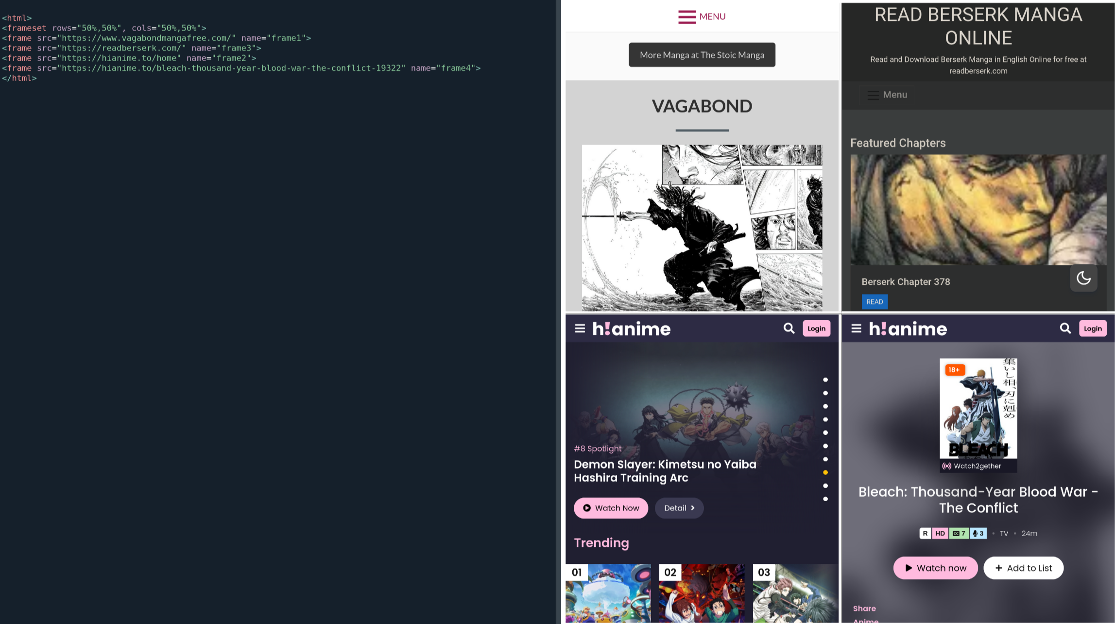

**OR(a) Write CSS code for the following:**

**i) set the background color for the hover and active link states to "yellow".RE**

**ii) Set the list style for unordered lists to "square".RE**

**iii) Set "paper.gif" as the background image of the page. RE 03**

**OR(b) Explain Wildcard Selectors (*, ^ and $) in CSS. 04**

* **Contains Selector (**\*=**)**

<style>

[class*="str"] {

background: green; color: white;

}

</style>

<body>

<div class="firststr">This matches because it ends with "str".</div>

<div class="secondstrhere">This matches because it ends with "str".</div>

<div class="strtihrd">This does not match because it does not end with "str".</div>

</body>

* **Starts With Selector (**^=**)**

<style>

[class^="str"] {

background: green; color: white;

}

</style>

<body>

<div class="firststr">This matches because it ends with "str".</div>

<div class="secondstrhere">This matches because it ends with "str".</div>

<div class="strtihrd">This does not match because it does not end with "str".</div>

</body>

* **Ends With Selector (**$=**)**

<style>

[class$="str"] {

background: green; color: white;

}

</style>

<body>

<div class="firststr">This matches because it ends with "str".</div>

<div class="secondstrhere">This matches because it ends with "str".</div>

<div class="strtihrd">This does not match because it does not end with "str".</div>

</body>

**OR(c) Write an HTML and JavaScript program which accepts N as input and print first N odd numbers. 07**

<html>

<body>

<form1>

<script>

function pr(){

var inputValue = document.getElementById("number").value;

var i=0;

while(i<=inputValue){

document.write(" "+i);

i=i+2;

}

}

</script>

<label>Number</label>

<input type="text" id="number">

<input type="submit" onclick="pr()" value="submit">

</form>

</body>

</html>

**W21**

**(a) Define term: Boot Strap for CSS 03 RE**

**(b) Write java script function to find maximum value among three different value entered by user.**

**04**

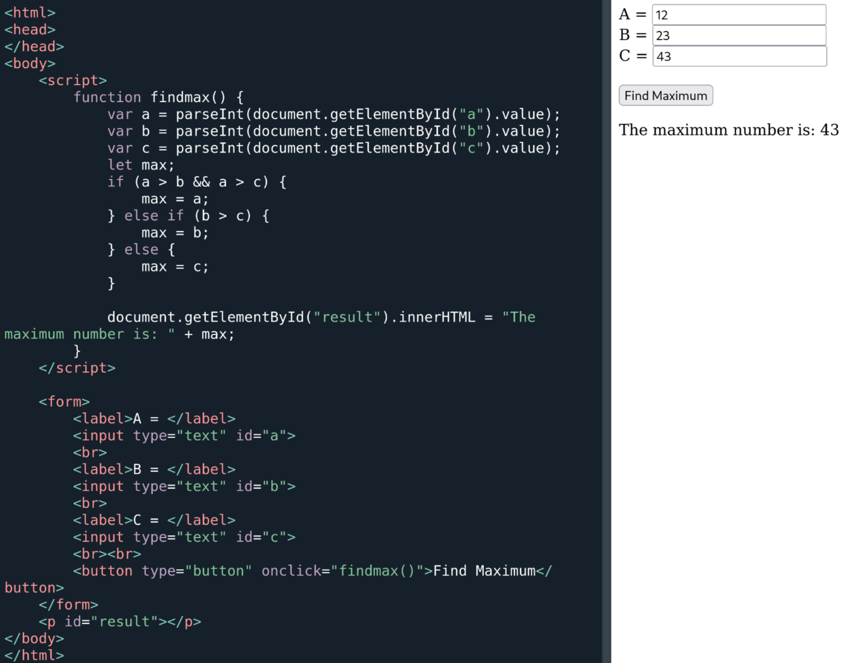

**(c) Develop a PHP Code which read stock code and display stock information when user submit page. 07**

* **home.php**

<!DOCTYPE html>

<html>

<body>

<form method="POST" action="path/to/another.php">

<label name="code">Enter Stock Code <label>

<input type="text" id="code" name="code">

<input type="submit">

</form>

</body>

</html>

* **another.php**

<?php

$code=$_POST["code"];

if($code=="Toei"){

echo "Name:Zoro <br>";

echo "Price:111100000<br>";

echo "Discription: Onigiri <br>";

}

else{

echo "Name: Ichigo<br>";

echo "Price: 368";

echo "Discription: GOAT<br>";

}

?>

**OR(a) Define term: JSON 03**

* JSON is a data storing formate which is made to make data simple enough to be readed by human
* JSON is popular form of storing data since it requires less memory because of how optimised it is.
* Some modern languages has datatypes which supports JSON natively such as js,python.
* JSON is also being used in APIs
* Examlpe

data = {

"anime":[

"one piece",

"attack on titan",

"bleach",

],

"type":"anime",

};

* To access element whithin it use data.anime[0] , data.type …

**OR(b) Describe any four php array function. 04**

* rsort()

$arr=array(3,54,23,62,69);

rsort($arr);

foreach ($arr as $value) {

echo $value . " ";

}

* shuffle()

$arr=array(3,54,23,62,69);

shuffle($arr);

foreach ($arr as $value) {

echo $value . " ";

}

* sizeof()

$arr=array(3,54,23,62,69);

echo sizeof($arr);

* sort()

$arr=array(3,54,23,62,69);

sort($arr);

foreach ($arr as $value) {

echo $value . " ";

}

**OR(c) Develop a PHP Code which read employee code, year and month. On submit button press, it generates salary slip for that month-year for that employee. 07**

* **In home.html**

<!Doctype html>

<html>

<body>

<form method="POST" action="otaku.php">

<label name="code">Code</label>

<input type="code" id="code" name="code">

<label name="month">Month</label>

<input type="month" id="month" name="month">

<label name="year">Year</label>

<input type="year" id="year" name="year">

</form>

</body>

</html>

* **In otaku.php**

<!Doctype html>

<html>

<body>

<?php

echo "<div border=1>";

$year = $_POST["year"];

$code = $_POST["code"];

$month = $_POST["month"];

echo "<p id='year'>Year: $year</p>";

echo "<p id='month'>Month: $month</p>";

echo "<p id='code'>Code: $code</p>";

if ($year == "2006" && $month == "2" && code=="666")

{

$name="Mahesh dalal";

$salary="70000";

echo "<p id='name'>Name: $name</p>";

echo "<p id='salary'>Salary: $salary</p>";

}

else

{

$name="Zoro the navigator";

$salary="111100000";

echo "<p id='name'>Name: $name</p>";

echo "<p id='salary'>Salary: $salary</p>";

}

echo "</div>";

?>

</body>

</html>

***Q.4***

**W23**

**(a) What is session Management? 03**

* The server and client are aware of each other only when the current request after that client and server forgot about each other, so that browser cannot get information between different request across the web pages.
* Hnece the syncronisation between different pages gets difficult to manage and requires resources a lot.
* To make server remembe about the client’s existance we use sessions.
* Sessions gets stred in server side.
* Because of that Sessions are much more secure compare to cookies.
* Session is size independent to store as many data the user wants
* Eg. to perform login-logout we use sessions

**(b) Differentiate between for and foreach statements in PHP. 04**

for

<?php

$arr=[3,23,54,62,69];

for ($x=0;$x<5;$x++){

echo $a." ";

}

?>

for each

<?php

$arr=[3,23,54,62,69];

foreach ($arr as $a){

echo $a>" ";

}

?>

**(c) What is DOM? Explain with example. 07**

* The Document Object Model is a platform and language neutral interface that will allow programs and scripts to dynamically access and update the content
* When we write :

document.write(“Hello World”);

* We are actually writing :

window.document.write(“Hello World”);

* The window is just there by default
* All the client side objects are connected to the window object.
* getElementById()
* getElementsByName()

html : <form name=“myForm”>...

js: var a = document.forms[“myForm”];

var u = a.uname.value;

var p = a.pword.value;

**OR(a) Difference between Server side programming & Client side programming 03 RE**

**OR(b) Describe in details: Cookie and Session 04**

* A **cookie** in PHP is a small file with a maximum size of 4KB
* The web server stores cookies on the client computer.
* They are typically used to keep track of information such as a username that the site can retrieve to personalize the page when the user visits the website next time.
* A cookie can only be read from the domain that it has been issued from.
* Cookies are usually set in an HTTP header but JavaScript can also set a cookie directly on a browser.
* Cookies aren’t as secure as sessions.

**OR(c) What is the use of a constructor function in JavaScript? Explain with suitable example. 07**

* A constructor function in JavaScript is used to create and initialize objects of a specific type.
* It acts like a blueprint for creating multiple objects with the same structure and behavior.
* The function's name is usually capitalized (e.g., Person) to distinguish it from regular functions.
* The this keyword is used to refer to the newly created object.
* Constructor functions are called using the new keyword.

function Person(name, age, city) {

this.name = name;

this.age = age;

this.city = city;

this.introduce = function() {

return "Hi, I'm ${this.name}, ${this.age} years old from ${this.city}.";

};

}

const crew1 = new Person("Zoro", 21, "East blue");

const crew2 = new Person("Sanji", 21, "North blue");

alert(crew1.name);

alert(crew2.introduce());

**W22**

**(a) Define term : JSON 03 RE**

**(b) Write a java script code to find whether given number is prime or not. 04 RE**

**(c) Explain pop-up boxes in javascript with example. 07**

* person = prompt("Please enter your name", "Harry Potter");
* if (confirm("Press a button!")) {echo "Baaankaaiiiiii"}
* alert("I am an alert box!");

**OR(a) Interpret PHP Function: Implode and Explode 03**

* Implode is used to convert array as string with any character or string as differentiator.
* Explode is used to split string into array by differentiator.

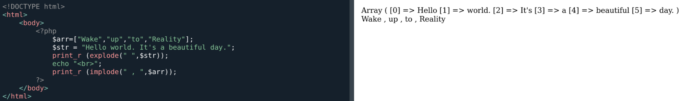

**OR(b) Differentiate GET and POST methods. 04**

| eature | GET Method | POST Method |
| --- | --- | --- |

|  |  |  |
| --- | --- | --- |
| **Data Visibility** | Appends data to the URL, visible to users. | Data is sent in the request body, hidden. |

|  |  |  |
| --- | --- | --- |
| **Data Size** | Limited to URL length (around 2000 characters). | No limit on data size. |

|  |  |  |
| --- | --- | --- |
| **Use Case** | Ideal for fetching data (e.g., search queries). | Suitable for sending sensitive data (e.g., login forms). |

|  |  |  |
| --- | --- | --- |
| **Security** | Less secure, as data is visible in URL. | More secure, as data is not exposed in URL. |

|  |  |  |
| --- | --- | --- |
| **Caching** | Cached by browsers, bookmarks possible. | Not cached or bookmarked. |

|  |  |  |
| --- | --- | --- |
| **Performance** | Faster, as data is sent in URL. | Slightly slower, as data is sent in the body. |

**OR(c) Prepare a java script solution to validate registration form including email address entered by user. 07**

**W21**

**(a) Interpret PHP Function: Implode and Explode 03RE**

**(b) Differentiate GET and POST methods. 04RE**

**(c) Prepare a java script solution to validate registration form including email address entered by user. 07RE**

**OR(a) Discuss Java script alert, prompt, confirm with example. 03 RE**

**OR(b) Demonstrate functionality of following java script methods: substring, Slice, getDate, charAt 04**

**OR(c) Prepare a java script to find whether entered number by user is Prime or Not. 07**

***Q.5***

**W23**

**(a) Write the benefits of JQuery. 03**

**(b) Write the limitations of AJAX. 04**

**(c) Write a program to connect database using PHP. And write query for insert and delete data. 07**

**OR(a) What are the advantages of AJAX. 03**

**OR(b) What are the protocols used by AJAX? 04**

**OR(c) Using JQuery write program to create image slider. 07**

**W22**

**(a) Define term: JQUERY 03**

**(b) Prepare a PHP Code to read and write content from File. 04**

**(c) Prepare a PHP Code to manage online shopping cart using session. 07**

**OR(a) Define term: AJAX 03**

**OR(b) Differentiate Cookie and Session. 04 RE**

**OR(c) Develop a web page which contains two list box. First list ask to select State and according to state selection second list box loads name of city. Develop it using AJAX. 07**

**W21**

**(a) Define term: AJAX 03 RE**

**(b) Differentiate Cookie and Session. 04 RE**

**(c) Develop a web page which contains two list box. First list ask to select State and according to state selection second list box loads name of city. Develop it using AJAX. 07 RE**

**OR(a) Define term: JQUERY 03 RE**

**OR(b) Prepare a PHP Code to read and write content from File. 04 RE**

**OR(c) Prepare a PHP Code to manage online shopping cart using session. 07 RE**