TECHNICAL PROJECT REPORT

# **Voice Controlled Toy Car:**

# **Team Members / Inventors:**

|  |  |  |  |  |  |
| --- | --- | --- | --- | --- | --- |
| **S.No.** | **Name** | **Department** | **Designation** | **Mobile** | **E-Mail** |
| 1. | Megha Thakur | Cse Ai&ml | Student | 7464909321 | megha181999@gmail.com |
| 2. | Yuvraj Koundal | Cse Ai&ml | Student | 9988442055 | crownyuvraaj[@gmail.com](mailto:Saurabh12478@gmail.com) |
| 4. | Khushal Thakur | ECE | Mentor | 9646030764 | khushal.thakur@cumail.in |
| 5. | Anshul Sharma | ECE | Mentor | 9478697475 | anshulsharma.ece@cumail.in |
| 6. | Kiran Jot Singh | ECE | Mentor | 9463909689 | kiranjotsingh.ece@cumal.in |
| 7. | Divneet Singh Kapoor | ECE | Mentor | 9878422653 | divneet.ece@cumail.in |

Section – 1 (IPR Related)

# **Brief Abstract (500 words):**

Our project comprises of some basic low level computer programmable gadgets such as Arduino, Bluetooth, motor driver.

The functioning of our project is depended on an external voice command which is provided through a speaker. The voice command is given via a speaker and is provided to the Arduino with the help of a Bluetooth module.

As soon as the voice command reaches the Arduino it fires up the circuit and locomotion is attained with the help of a mechanism of motors.

To conclude, our project is a technically passive device which is partially dependent on an external source for its functioning.

# **Existing state-of-the-art and Drawbacks in existing state-of-the-art**

(*Brief background of the existing knowledge*)

|  |  |  |
| --- | --- | --- |
| **S. No.** | **Existing state of art** | **Drawbacks in existing state of art** |
| 1 | Toys like simple car that needs force to move | It is very fragile. |
| 2 | Source of entertainment | Can not be used by mute |

# **Novel/Additional modifications that you can propose to improve upon drawbacks**

*(List down the features)*

* Its infrastructure can be improvised.
* It can also work as transporting light weight stuff .
* Basic use of this device can be a toy, where kids can make there own way for the car to follow.

# **Advantages**

(*List down the advantages, if each feature is incorporated)*

* delivers a great customer experience while improving self-service system’s containment rate
* encourages natural, human-like conversations that create more satisfying [self-service](http://www.sestek.com/2014/10/the-advantages-of-customer-services-automation-solutions/) interactions with customers.
* automates what touchtone cannot by collecting dynamic data such as names and addresses
* enables organizations save agents for more important tasks

# **Block Diagram**

(*Functional diagram depicting the flow of information in your system. Do not define exact components, only use generic terms. Must include modifications as well.)*

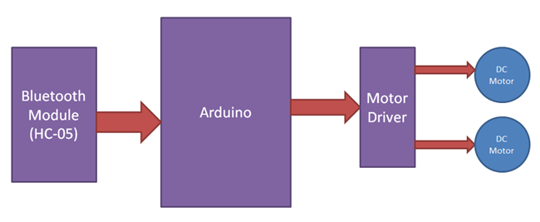

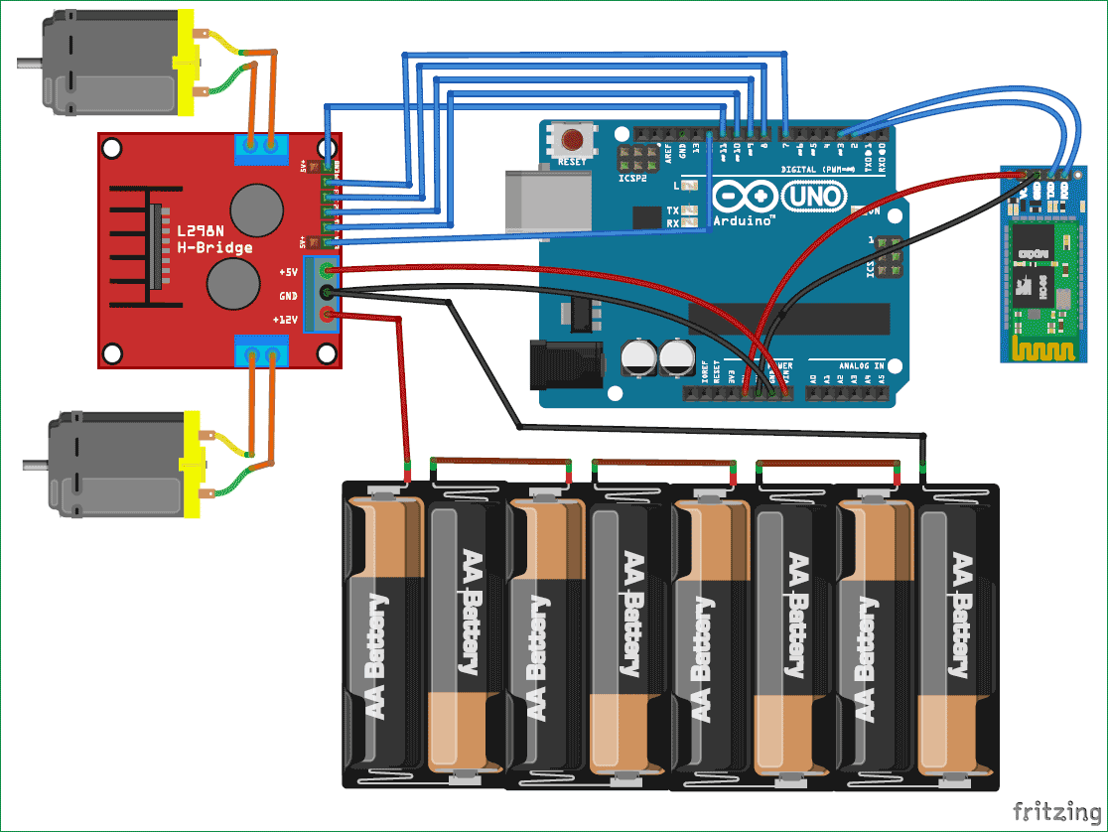

Section – 2 (Real Project)

# **Materials**

(*List down the Components, Equipment, etc. actually used in the project*)

s.no Articles Quantity Cost

1. Arduino Nano 1Pcs 390
2. Bluetooth module 1Pcs 180
3. Car Chassis 1 Pcs 200
4. L298N Motor Driver Modules 1 Pcs 320
5. 12v 300 RPM DC Geared Motors 4 Pcs 480
6. 7x2 cm Wheels 4 Pcs 200

# **Circuit Diagram🡪**

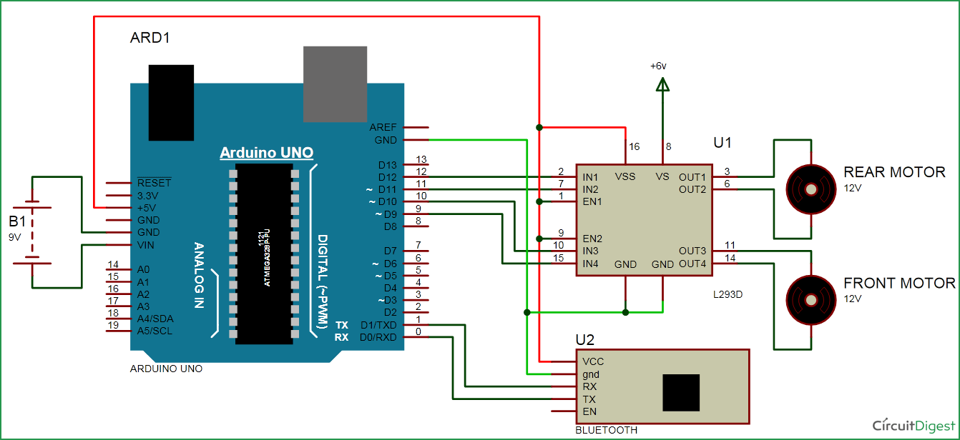

# **Steps of Circuit Completion**

(*Bifurcate the circuit completion in steps, specify with photographs, leading to final project*)

**Controller (Arduino UNO)**: Arduino UNO is the main controller in the project. The data from the module (Bluetooth) will be given to Arduino and it gives corresponding signals to the Motor Driver IC.

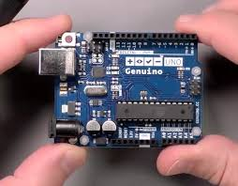

**Motor Driver** : Motor Driver IC is used in this project to drive the motors of the robot. It receives signals from Arduino based on the information from the Bluetooth. 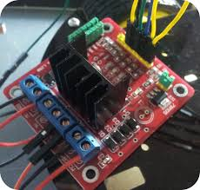

**Motors (Geared Motors)**: We have used four geared motors at the rear and the posterior of the line follower robot. These motors provide more torque than normal motors and can be used for carrying some load as well.

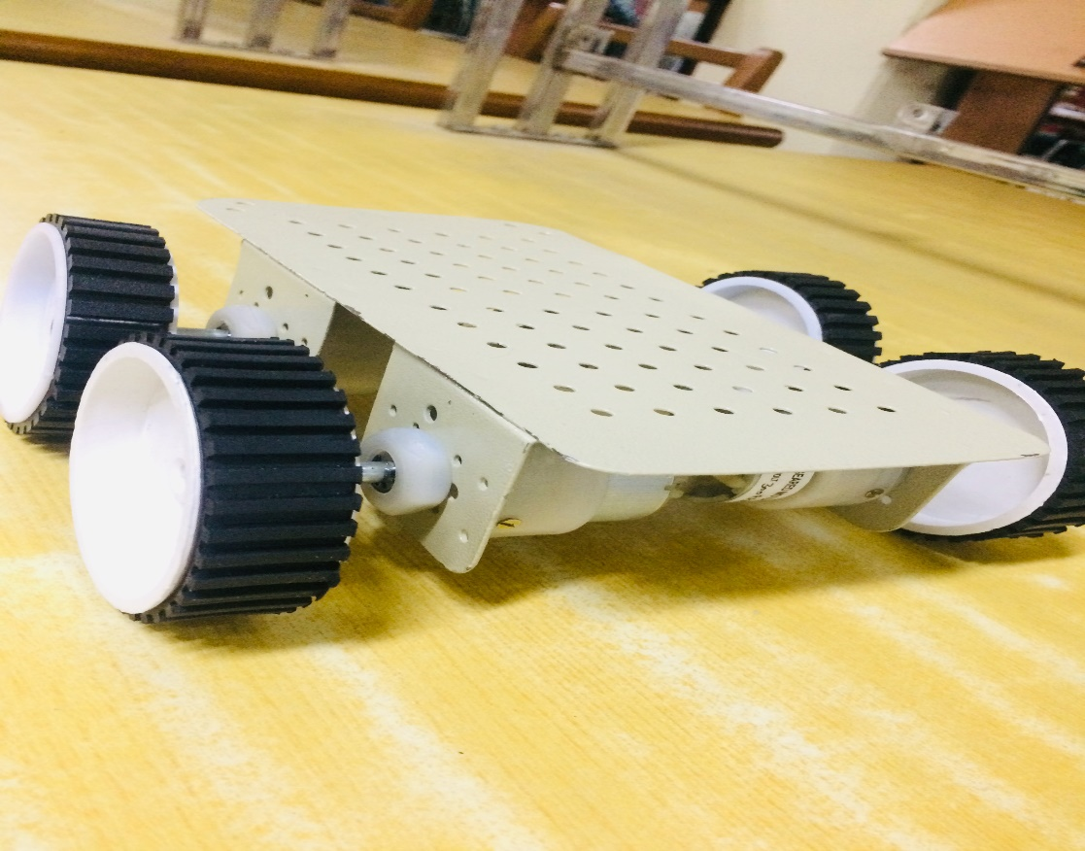

Using the same principle, we will setup the Bluetooth such that the four motors are on the either side of the floor.

Arduino UNO detects this change and sends signal to motor driver accordingly. In order to turn in multi directions.

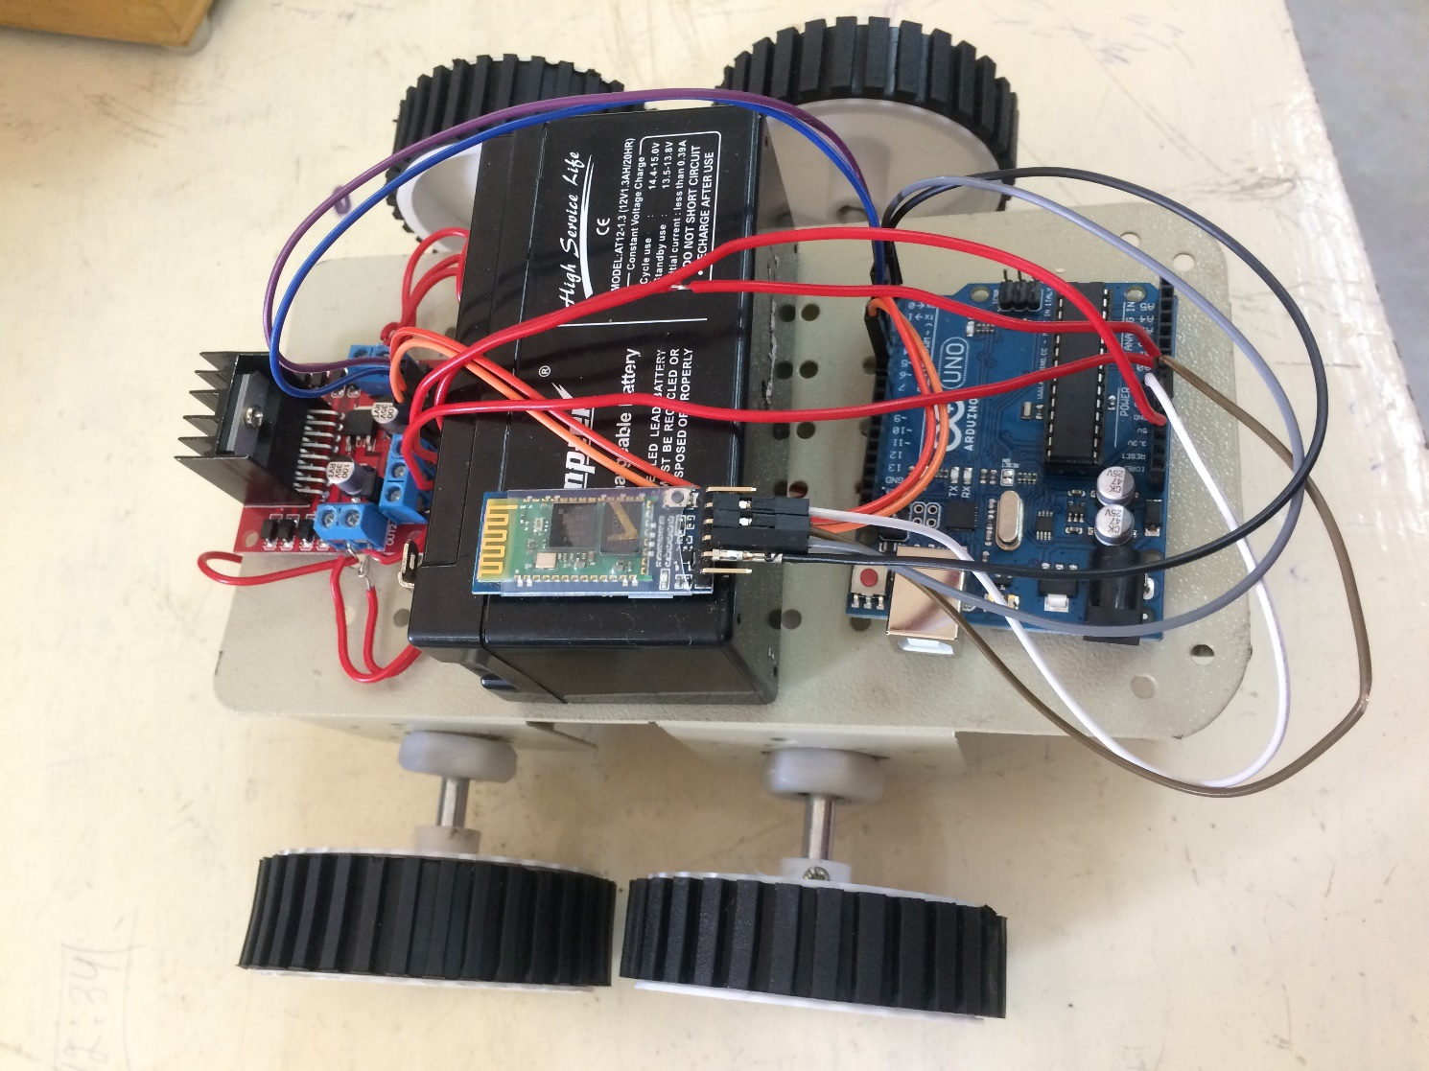

# **Program Code**

(*Link of your GitHub project*)

<https://github.com/AIpranjaliml/line-following-robot/blob/master/beee_project.ino>

}