**EXPERIMENT**

**AIM :** To design a hand held magical heart that blinks 60 times a minute with red colour if it is held from any one side and 120 times a minute with green colour if held from both sides.

**APPARATUS :** Arduino, LDR, Resistor(10K, 220), Breadboard, Ultrasonic sensor.

**Circuit Diagram** :

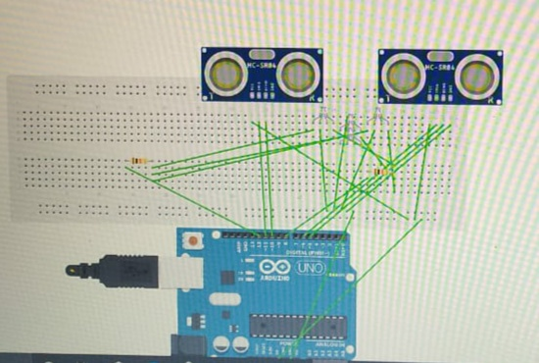

**Program :**

const int led1=12;

const int led2=8;

const int trigpin1=11;

const int echopin1=10;

const int echopin2=5;

const int trigpin2=6;

int duration1;

int duration2;

int distance1;

int distance2;

void setup()

{Serial.begin(9600);

pinMode(led1, OUTPUT);

pinMode(trigpin2,OUTPUT);

pinMode(echopin1,INPUT);

pinMode(echopin2,INPUT);

pinMode(trigpin1,OUTPUT);

pinMode(led2, OUTPUT);

}

void loop()

{

digitalWrite(trigpin1,LOW);

digitalWrite(trigpin2,LOW);

delayMicroseconds(1);

digitalWrite(trigpin1,HIGH);

digitalWrite(trigpin2,HIGH);

delayMicroseconds(5);

digitalWrite(trigpin1,LOW);

digitalWrite(trigpin2,LOW);

duration1=pulseIn(echopin1,HIGH);

duration2=pulseIn(echopin2,HIGH);

distance1=duration1*0.34/2;

distance2=duration2*0.34/2;

if(distance1<10&&distance2<10)

{digitalWrite(led2,HIGH);

delay(100);

digitalWrite(led2,LOW);}

if(distance1<10 && distance2>10)

{digitalWrite(led1,HIGH);}

if(distance2<10 && distance1>10)

{digitalWrite(led1,HIGH);}

}

**Result :** The functioning of hand held magical heart that blinks 60 times a minute with red colour if it is held from any one side and 120 times a minute with green colour if held from both sides is verified after uploading the program.