**MASTERING DATA VISUALIZATION in power bi**

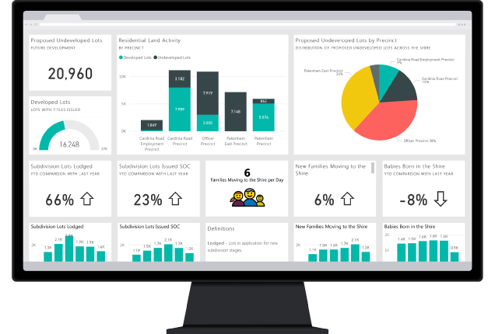

**Submitted by**

**Megha Bisht**

**Data analyst intern**

**INTRODUCTION**

* Presenting the visual information in today’s data-driven world is very important and creative too.
* Various data visualization tools were used one of which is Power BI, It is a very useful easy-to-use analytics tool, which helps in transforming the raw data into creative and visually appealing reports and Dashboards.
* For creating good and creative visualizations we should have a deep and good understanding of different functions so that the visualizations could become more interactive and easy to understand by everyone.

**Audience Understanding**

* Understanding the audience and their needs are very essential if you want to go into the world of data visualization.
* Firstly understand about the audience, if they are the data analyst who requires different information or insights in the form of data visualization to find solution of various problem statements in their dataset or they are some executives who want to know deep about different high-level insights.
* Showcasing all your visualizations so that they can meet all the needs of the audience which will help your reports to resonate with them.

**Right visualization choices**

* A wide range of visualization options are offered by Power BI such as line graphs, column charts, bar charts, scatter plots etc.
* You can choose visualizations which will best fit and perfect for the data you want to visualize like for trend analysis we can use line graphs to visualize it and for visualizing the categorical data we can use bar charts.

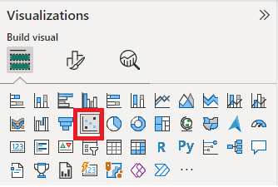

**Focusing on quality content**

* Person while doing data visualization does a common mistake that is they just overcrowd their dashboard.
* Person should focus on visualizing short, concise and exact information about the insights.
* Elements which do not provide any values in the visualizations should be removed from the dashboard.

**Colour selection**

* Colour choice and colour combinations also play a vital role in data visualization and it helps in the differentiation of different data points, graphs and also helps in highlighting important points and information.
* Do not use too much colors it can be a little problematic or distracting.
* Try to prepare your dashboard by using some consistent colour in entire dashboard.

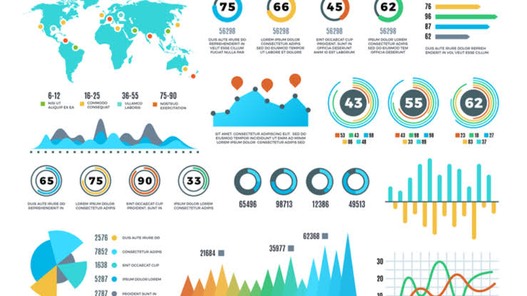

**Story telling through your data**

* For telling the whole story of your data to your users you should use good, creative and effective data visualization.
* Prepare it in such a way that it should be easily accessible and understandable by everyone.
* For explaining about your data and visualizations use title, different captions, annotations and also explain the significance of the given data.
* For engaging your audience or clients you can frame your visualizations in the form of a narration and can easily explain it to them and also ensure that you delivered the message effectively to your audience.

**Interactivity**

* Power BI provides interactive dashboard features which help the user to easily access the data deeply.
* Use these features more such as adding slicers, filters etc. which can help the users to interact with the visualizations.
* This will help in enhancing the experience and help the users to detect valuable insights.

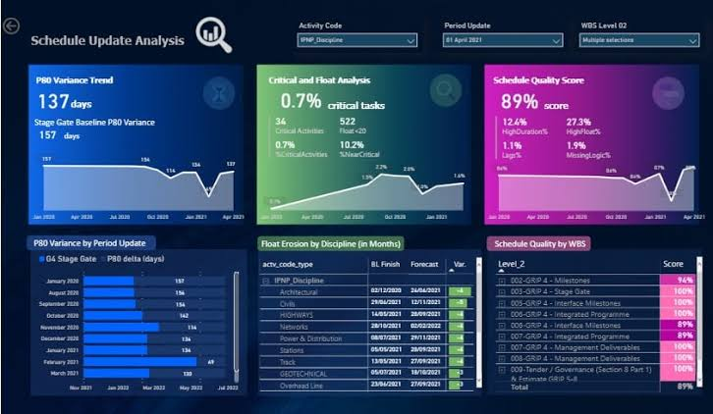

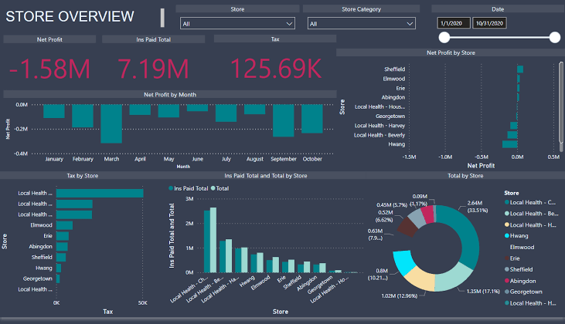

**CONCLUSION**

* Preparing interactive and creative dashboards and data visualization is an art.
* Visually appealing dashboards and reports were created that provide various meaningful insights.