**Download:**

<https://www.anaconda.com/products/individual>

<https://www.jetbrains.com/pycharm/download/#section=windows> (Download community version)

<https://git-scm.com/downloads>

**Udemy Trainings:**

<https://www.udemy.com/course/robot-framework-level-1/>

<https://www.udemy.com/course/robot-framework-2/>

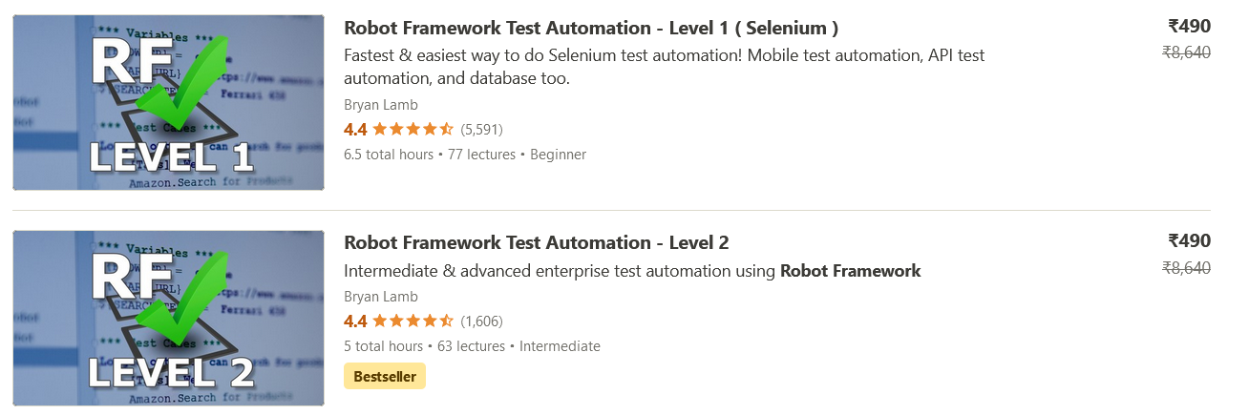

Steps for setup:

1. Create a separate python environment as shown below:

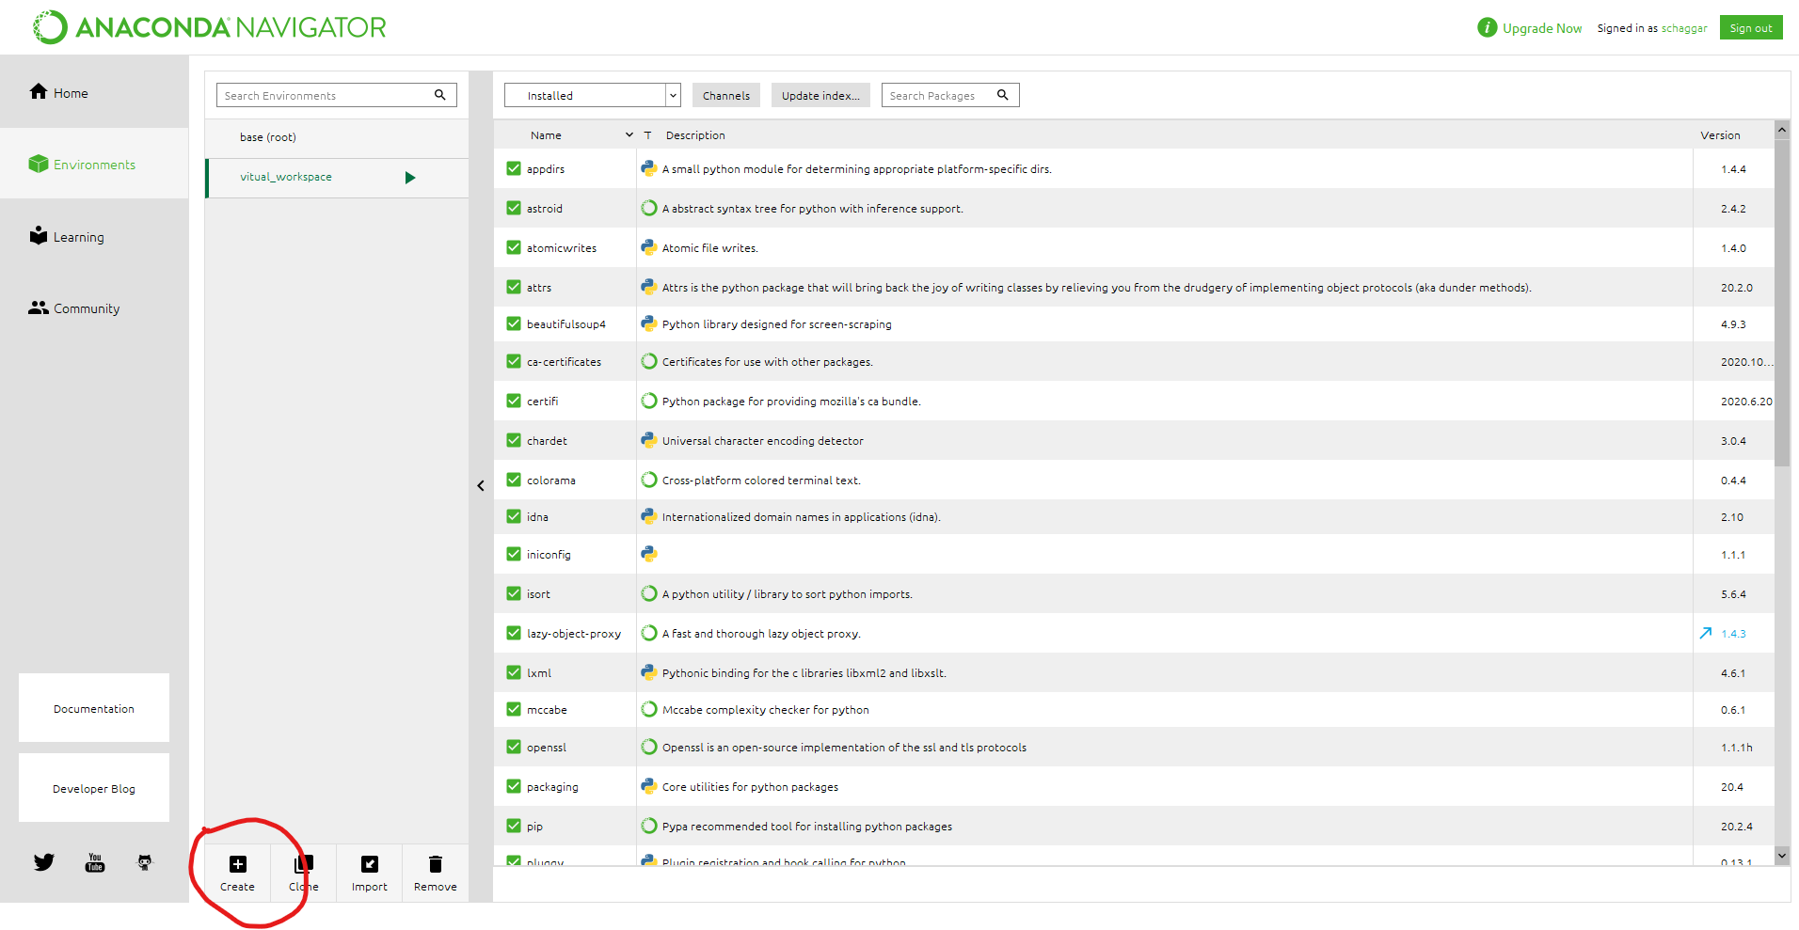

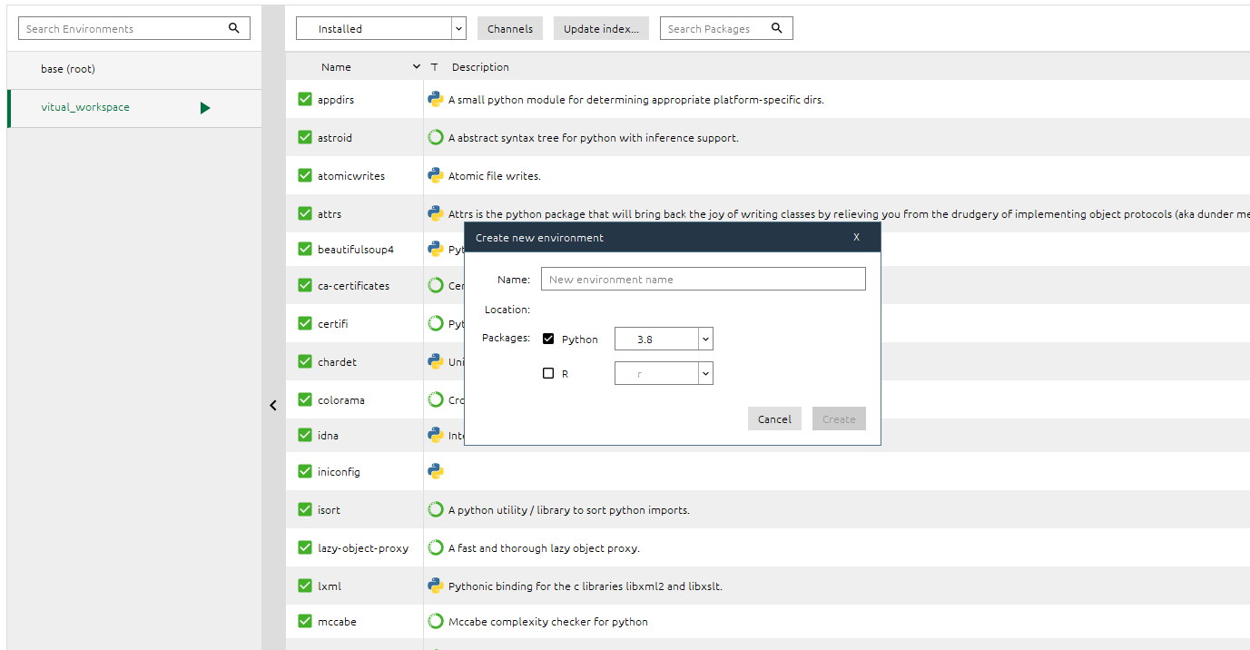

It will take some time.

1. Once environment setup is complete you can see a separate environment as shown above (virtual_workspace is the name of my virtual environment you can use anyname)
2. Click open terminal as shown below:

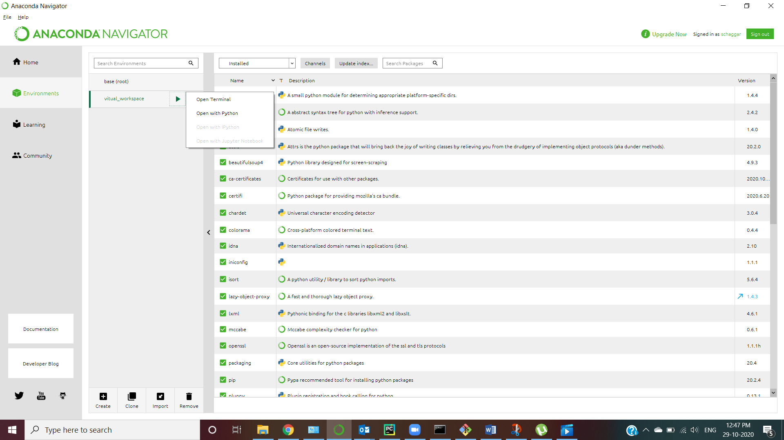

Run the commands

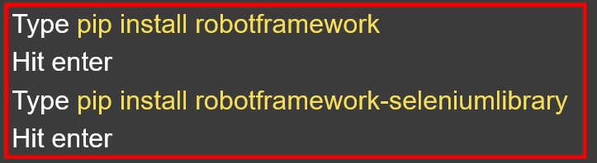

1. Restart anaconda navigator and connect to the environment and launch pycharm from anaconda navigator, it will take the default python interpreter.

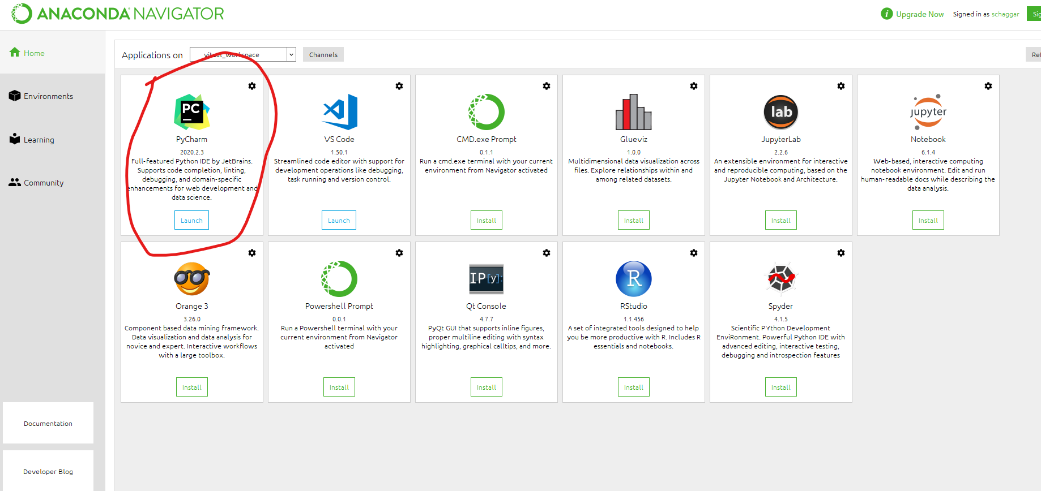

1. Open Pycharm then goto File -> Settings -> Project

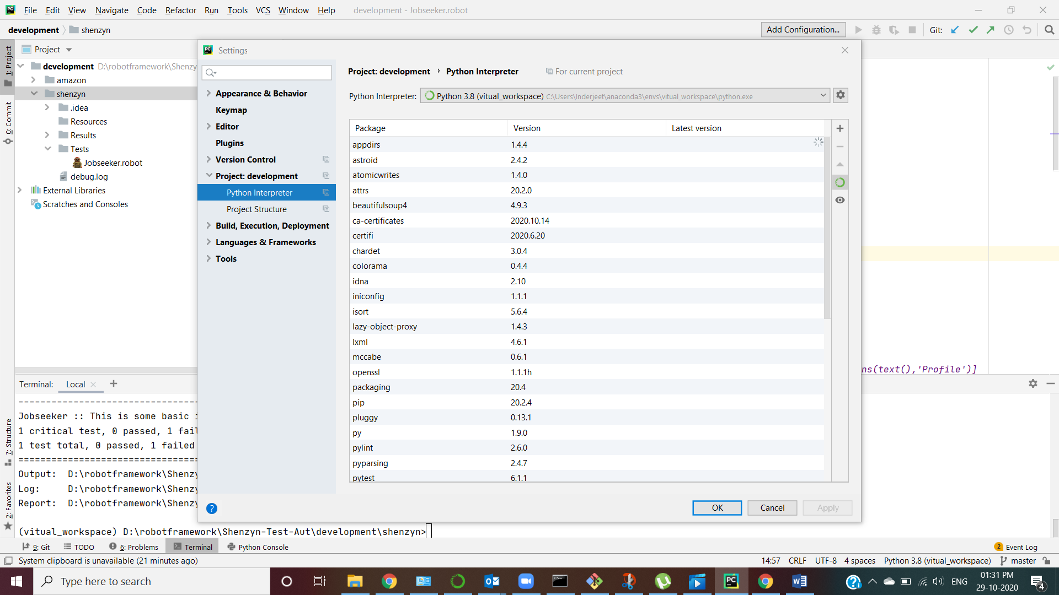

And select your environment:

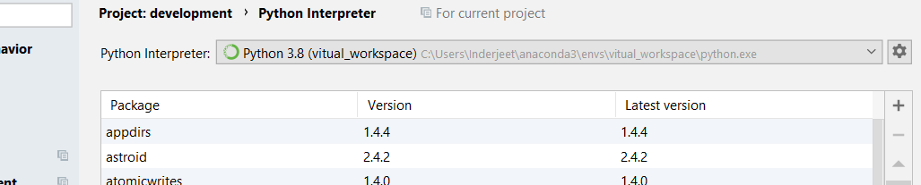

1. Install intellibot got to file -> settings-> plugins and select the jar file from Shenzyn-Test-Aut\intellibot\intellibot.jar

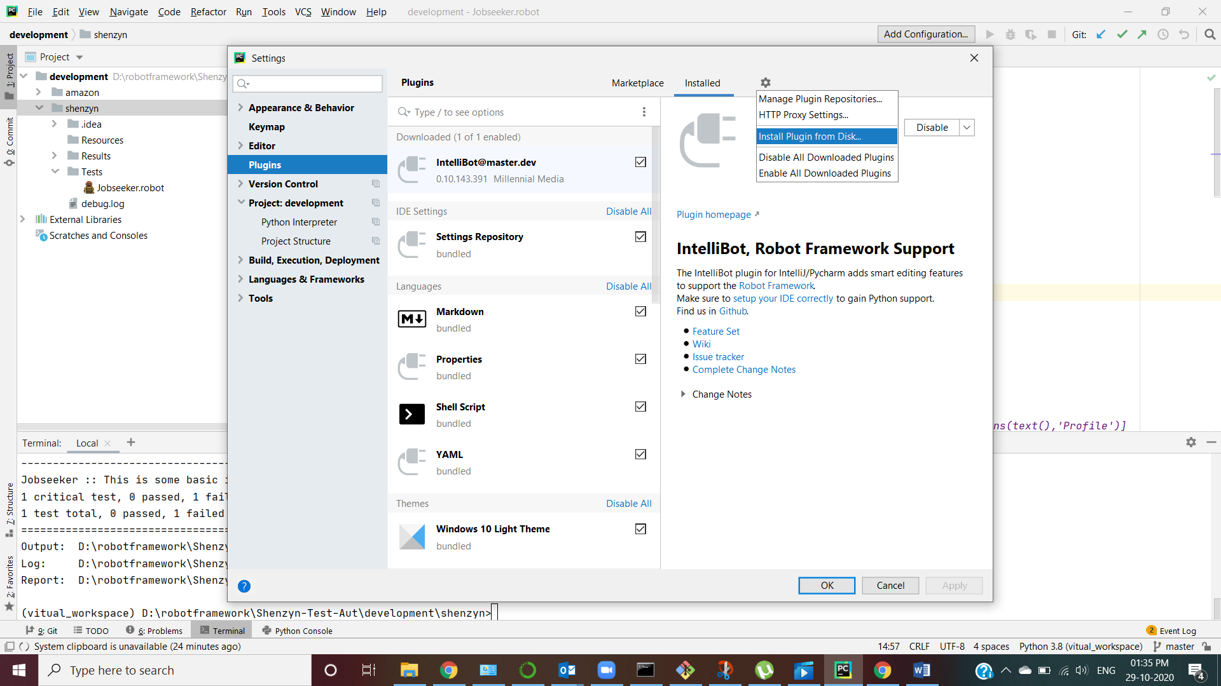

1. Set the environment variable on your local machine for web drivers –

D:\robotframework\Shenzyn-Test-Aut\bin

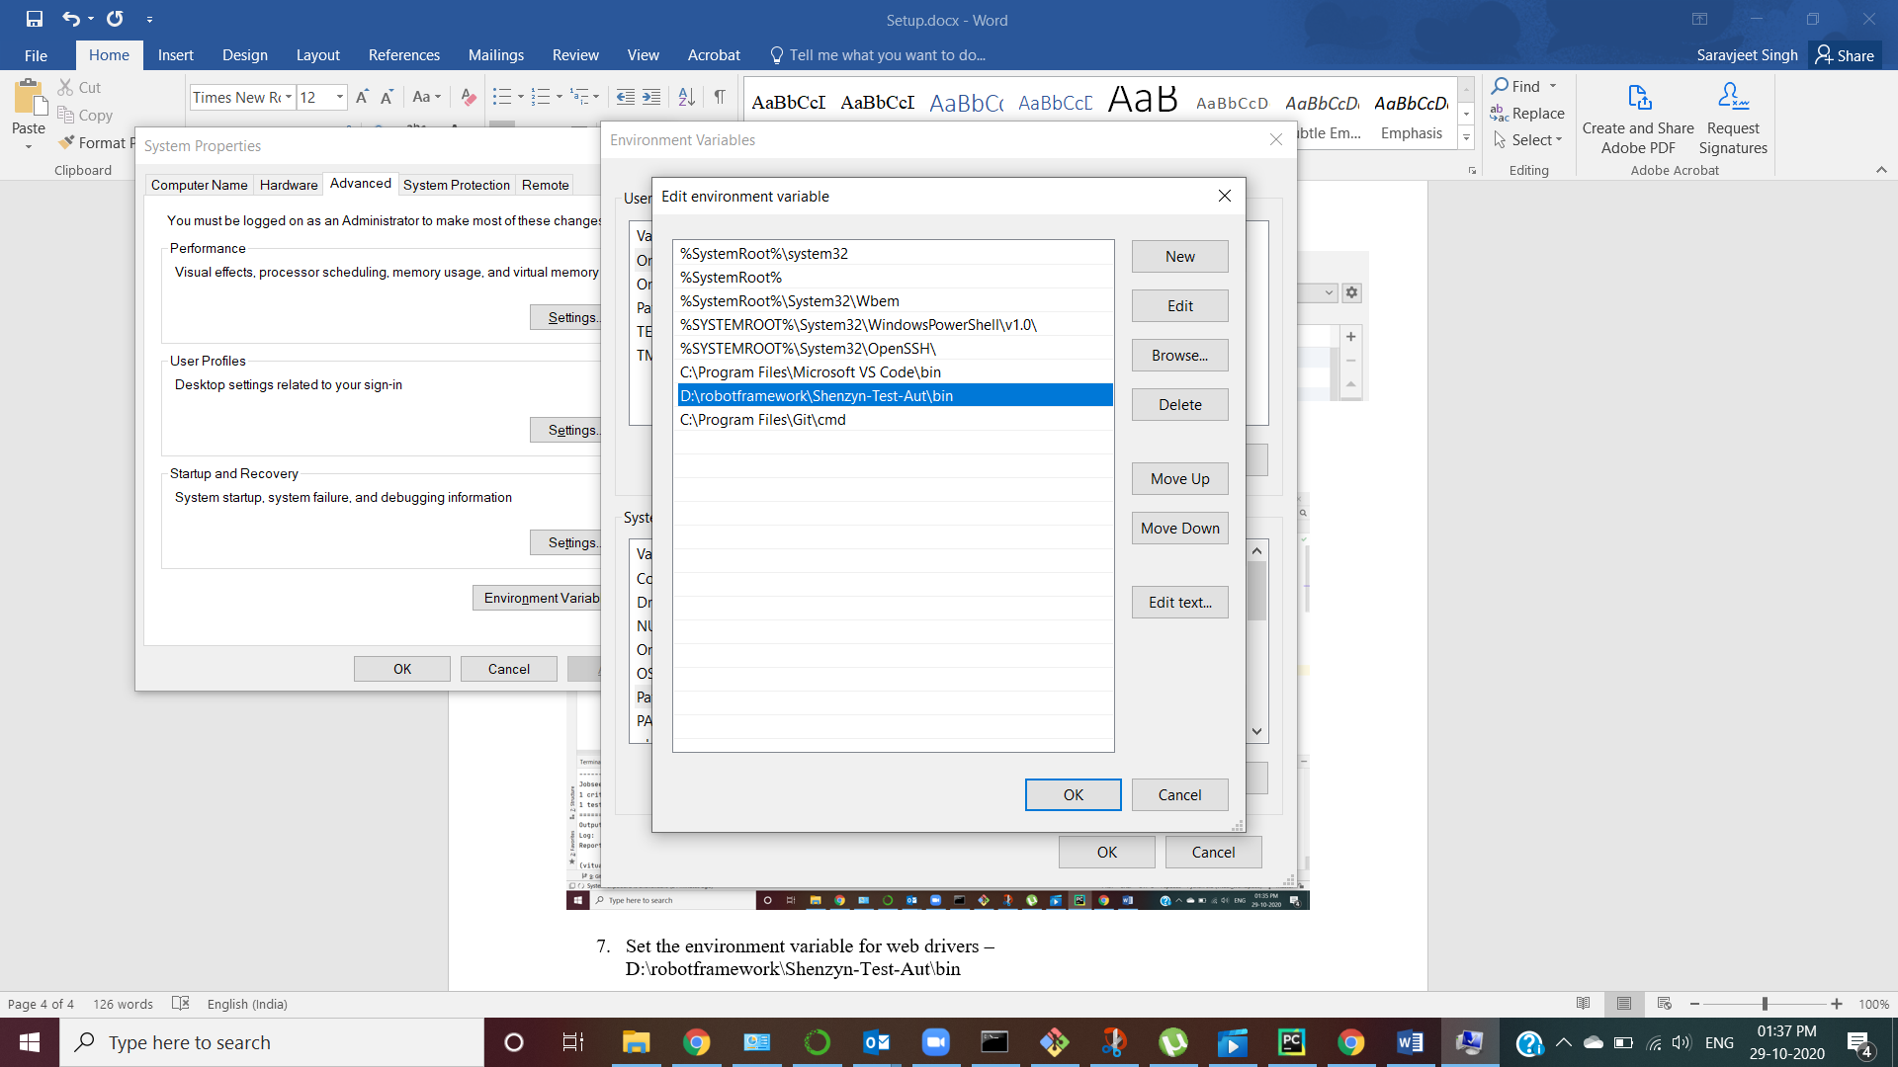

I think, that’s all. Let me know if you still face any issues, we will sort it out.

Open the project and run the below command from pycharm terminal

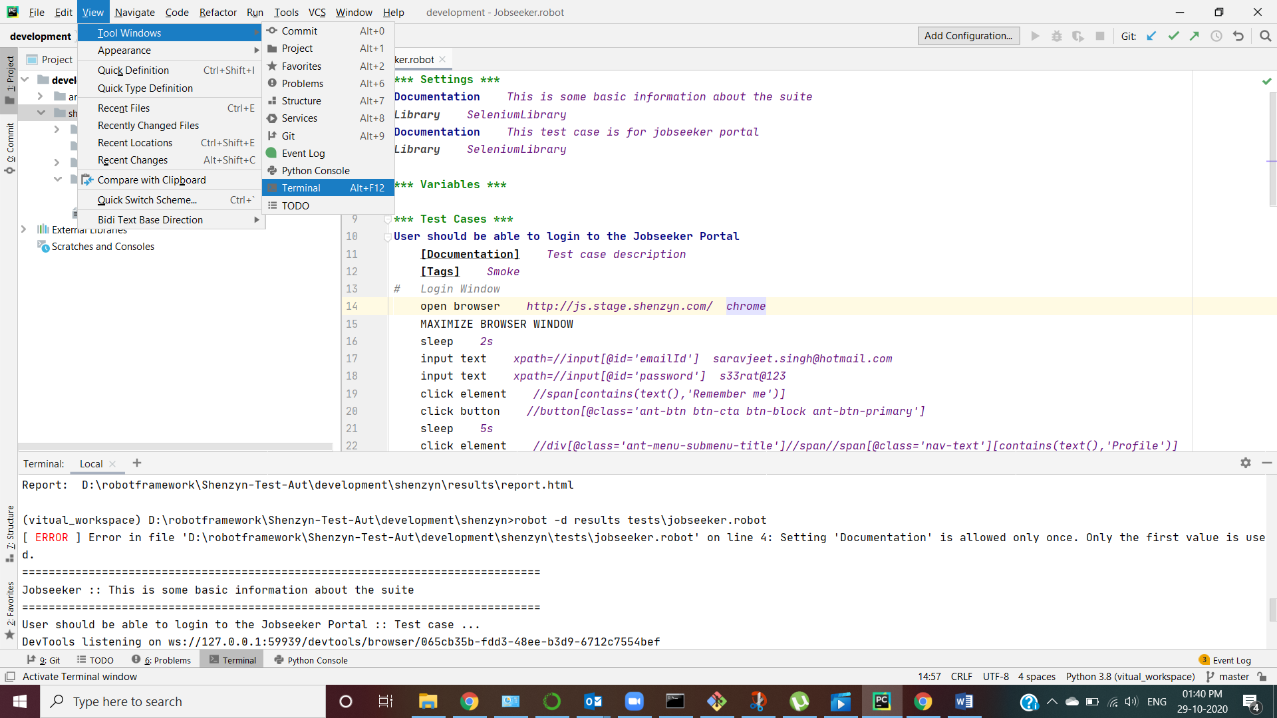

D:\robotframework\Shenzyn-Test-Aut\development\shenzyn>robot -d results tests\jobseeker.robot

If it runs then this means your setup is all good. Do not touch or change my code replicate the folder and start working on your own 😊