|  |  |
| --- | --- |
| STUDENT NAME | STUDENT ID |
| ABIN BENNY | 500210729 |
| LINIYA SHEEN | 500211496 |
| MEGHA ANN MATHEW | 500211185 |

Linear Regression

**AISC2013 - Deployment of AI Solutions**

# **Step 1: Create a Python applica5on for a machine learning task, where the user will have the following features: Upload data or specify a data file or enter the data**

## **Python program**

## **Importing Library**

* pandas: Used for data manipulation and analysis.
* train_test_split: From scikit-learn, used to split the data into training and testing sets.
* LinearRegression: Also from scikit-learn, used to create a linear regression model.
* mean_squared_error: Used to calculate the Mean Squared Error.
* matplotlib.pyplot: Used for data visualization, specifically to plot the scatter plot.

* This function prompts the user to either upload a CSV file or manually enter data.
* If the user chooses to upload a CSV file, it reads the file using pd. read_csv.
* If the user chooses manual entry, it collects X and y values interactively.

## **Linear Regression**

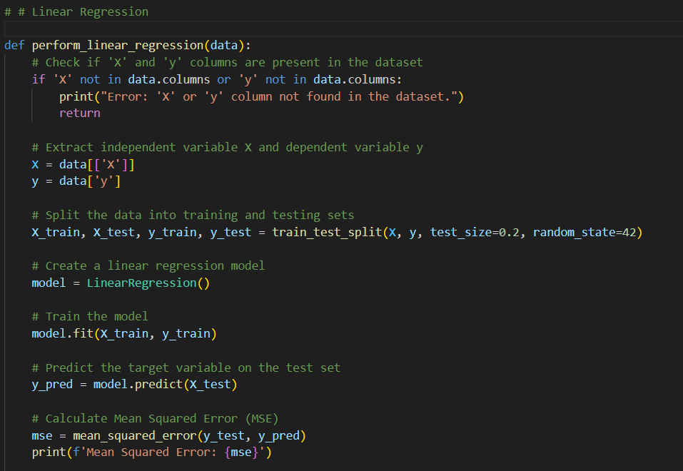

* This function performs linear regression analysis on the given data.
* It checks if 'X' and 'y' columns are present in the dataset.
* It splits the data into training and testing sets.
* It creates a linear regression model, trains it, and makes predictions on the test set.
* It calculates the Mean Squared Error (MSE) and displays the scatter plot of actual vs. predicted values.

## **Performing linear regression**

* The main part of the script where it welcomes the user, uploads data, and performs linear regression.

# **Step 2: See the results of analysis**

# **Step 3: Upload your application’s code on GitHub**

# **Step 4: After implementing the application, create a Docker container with it and run Push the image to the Docker Hub public repository.**

**

## **Build the Docker Image**

* C:\Users\abinb\Desktop\docker> docker build -t my-python-app .  
    
  Docker build: This command builds a Docker image from the Dockerfile in the current directory.
* -t my-python-app: This option assigns a name (or tag) to the image, in this case, "my-python-app."

## **Running the python file in the docker**

C:\Users\abinb\Desktop\docker> docker run -it --rm --name my-running-app my-python-app

* docker run: This command creates and starts a new container from a specified image.
* -it: These options enable interactive mode and connect the terminal to the container.
* --rm: This option removes the container automatically when it exits.
* --name my-running-app: This assigns a name to the running container, making it easier to refer to or manage.

**Docker login and tagging**  
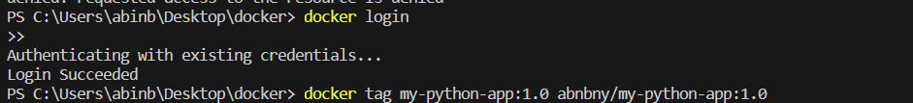

docker login

docker tag my-python-app:1.0 abnbny/my-python-app:1.0

* This command tags the previously built image with a version identifier (1.0), creating an alias for the image.

# **Step 5: Run the app using the image from the public repository**

* This is the docker website where we pushed the image to docker

## **Docker push**

C:\Users\abinb\Desktop\docker> docker push abnbny/my-python-app:1.0

* This command pushes the tagged Docker image to Docker Hub, making it available for others to pull and use.

## **Docker pull**

PS C:\Users\abinb\Desktop\docker> docker pull abnbny/my-python-app:1.0

* This command pulls the Docker image from Docker Hub to the local machine.

## **Running the program in docker container**

* This command runs a Docker container from the pulled image interactively.