**Project Report on**

**Airline Route & Fare Analysis Using Hadoop and Hive**

**Group Members:**

**Vishala Vemuri - vxv230006**

**Megha Chandrasekharan Nair​ - mxc220113**

**Mallikarjun Gudumagatte Nagaraja - mxg220123**

**Business Question1:**

**What are the top 10 most revenue-generating routes?**

***Query***

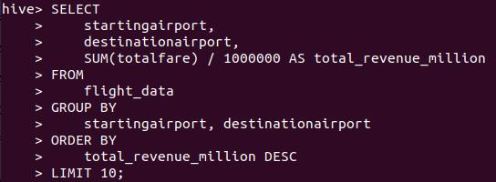

***Output:***

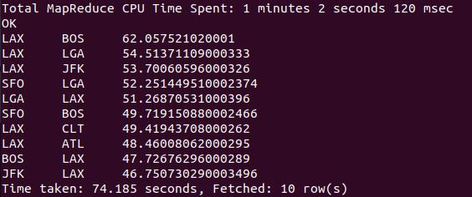

**Interpretation:**

* The most revenue-generating route is LAX-BOS, with a revenue of 62 million dollars, followed by LAX-LGA with 54.5 million dollars and LAX-JFK with 53.7 million dollars.
* LAX appears in 8 out of the top 10 routes, making it a major revenue center. This indicates that both inbound and outbound traffic from LAX is commercially significant.
* Many of the top routes are cross-country (e.g., LAX–BOS, LAX–JFK), showing the importance of coast-to-coast travel.
* Cities like New York (JFK/LGA), LA (LAX), San Francisco (SFO), and Boston (BOS) are both tourism magnets and business hubs.
* These insights highlight how route-level revenue analysis can drive better operational planning, customer experience, and profitability.

**This result can be helpful in:**

* Capacity Planning: Add more flights, and use larger aircraft.
* Customer Experience: Introduce non-stop options, and improve check-in.
* Revenue Strategy: Apply dynamic pricing to top routes.
* Growth Strategy: Explore new routes from LAX and other key hubs.

**Business Question 2:**

**Which routes have the highest number of flights departing from DFW?**

***Query***

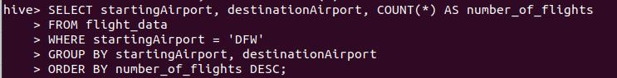

***Output***

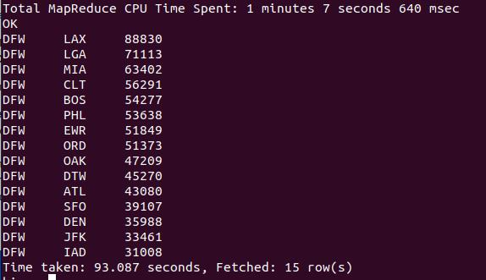

**Interpretation:**

* The most frequent flight destination from DFW: The LAX (Los Angeles) route has the highest number of flights from Dallas/Fort Worth, totaling 88,830 flights.
* Other significant routes from DFW: After LAX, the following most frequent routes are to LGA (New York - LaGuardia) with 71,113 flights and MIA (Miami) with 63,402 flights. These routes seem to be the most popular ones.
* Least frequent route: The least frequent destination on this list is IAD (Washington D.C. - Dulles), with 31,008 flights.
* Key insights:
  + Popular destinations like LAX, LGA, and MIA see a high volume of flights, indicating strong demand for travel to these cities.
  + Routes such as IAD or JFK have fewer flights, which could suggest lower demand or less frequency on those specific routes.

**This result can be helpful in:**

1. Airlines: Identifying the busiest routes to plan for more frequent flights or larger planes.
2. Travel Agencies: Understanding where most travelers are flying to/from DFW to target these destinations more aggressively.
3. Airport Operations: Forecasting and managing airport traffic, resources, and security needs.

**Business Question 3:**

**How do flight prices vary over time based on weekday vs. weekend?**

***Query***

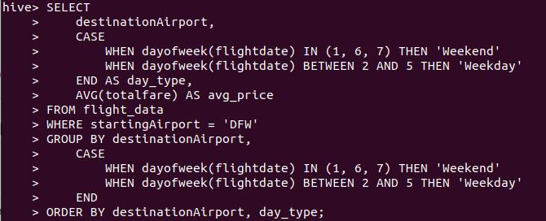

***Output***

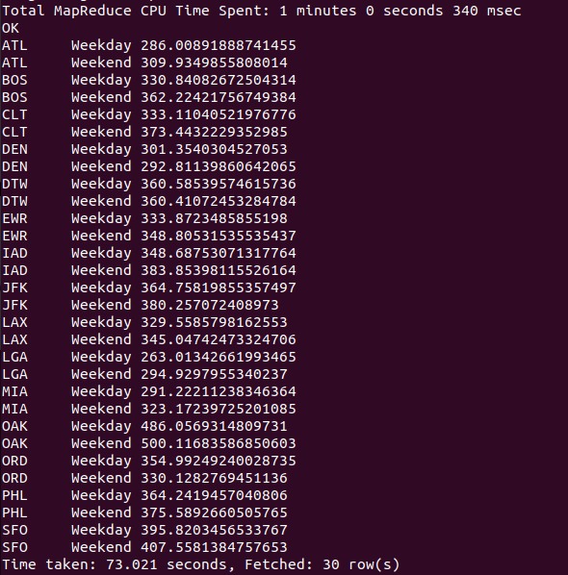

**Interpretation:**

* Weekend Prices Are Higher on Most Routes
  + For most of the destinations (e.g., BOS, JFK, DTW, CLT, EWR), weekend prices are more than weekday prices.
* Some Routes Show Minor Differences
  + Routes like DEN or LAX have smaller price differences, suggesting more stable pricing.
  + This can be due to business-heavy traffic where the demand is strong throughout the week.

**This result is helpful in:**

* Revenue Optimization: Shows when ticket prices can be increased (e.g., weekends) to maximize profit. Helps in applying dynamic pricing based on demand patterns.
* Flight Scheduling & Capacity Planning: Identify weekend peak travel routes so that airlines can add extra flights or increase the capacity.
* Targeted Marketing & Promotions: Design weekday travel promotions to fill low-demand periods.