Detailed Software Technical Design (DSTD)
For
<VYNTRA MART>

Table of Contents

1 Introduction 5
1.1 Purpose 5
1.2 Scope 5
1.3 Definitions, Acronyms and Abbreviations 5
1.4 References 5
2 Assumptions 6
3 PROJECT OVERVIEW AND USECASE DIAGRAMS 6
4 Detailed Design for Module: <<Module Name>> 7
4.1 Detailed Design for Feature: <<Feature Name>> 7
4.1.1 User Profile 7
4.1.2 Navigation Map 7
4.1.3 UI Screen Design 7
4.1.3.1 Screen Layout 7
4.1.3.2 Validations 8
4.1.4 Object Model/Data Flow Design 8
4.1.4.1 Interface Description 8
4.1.4.2 Class Design 8
4.1.4.2.1 Algorithmic/Business Logic Description (Optional) 8
4.1.4.2.2 Local Data Structure (Optional) 8
4.1.4.3 Data Transfer/Value objects 8
4.1.4.4 Related Database Tables 9
4.1.4.5 Dependencies with Other Sub-systems/Components 9
4.2 Detailed Design for Feature: <<Feature Name>> 9
5 Detailed Design for Module: <<Module Name>> 10
6 Database Design 11
6.1 Entity Relationship Diagrams 11
7 Packaging/Folder Structure and System Artifacts 12
7.1 System Artifacts 12
8 Core Technical Services Design 13
8.1 Persistence 13
8.2 Inter-process Communication 13
8.3 Authentication and Authorization 13
8.4 Error Handling 13
8.5 Logging 13
8.6 Transaction Management 13
8.7 Other Applicable Technical Services 13
9 Non Functional Requirements 14
Appendix 14
1. Design Metrics to be Used 14
2. Supplementary Information 14
3. DQI – Design Quality Index Checklist 14

Document Revisions

Date | Version | Description | Author | Reviewer | Approver

Information Handling

These documents are strictly for Virtusa/Client use only. They shall not be shared with an external party other than the client concerned. These documents should always be kept securely and employees shall use reasonable care protecting these documents from unauthorized use or disclosure to a third party. This category also covers client intellectual property where Virtusa has a non-disclosure agreement with the client.

Introduction

Purpose

This document provides the detailed technical design for the Vyntra mart the online shopping system.
The purpose of this application is the process of purchasing, selling and exchanging of goods and services from people and merchants who sell on the internet which results in increase in sales and customers, open and available all time, instant processing of transactions and increased business reach.
The Virtusa team will use this design as a blueprint when coding and testing the system.

Scope

- The companies that sell Trendy clothes have their most of the sales comes through ecommerce applications that has very high search engine rankings.

- This application is planned to re-engineer the ecommerce website since it is currently experiencing some serious scalability issues.

- Our top priority in this re-engineering effort is the performance and user experience.

- We are planning to launch a new e-commerce mobile app as part of this re-engineering effort. In addition to this, we need to add a good recommendation engine to both web and mobile apps to improve the sales through online shopping

Definitions, Acronyms and Abbreviations

References
https://www.w3schools.com/
https://www.greengeeks.com/
www.amazon.com
www.flipkart.com
www.myntra.com

Assumptions

- A database server is needed to store the details of the products and the customer information.

- The user must have knowledge about how to use the application or basic computer knowledge.

- The application should be able to handle the massive customers use at a time and complex situations and respond within time.

PROJECT OVERVIEW AND USECASE DIAGRAMS

- VYNTRA MART is an e-commerce application for clothing.

- This application consists of an E-cart to view, research about the products and purchase it.

- The online payment for the purchased product is done through different payment gateways including PAYPAL support.

- The ordered products are then managed and the status of the product has been tracked.

- The admin interface used for user and product management.

- The secured mechanisms are used for authentication of user accounts either by users Facebook account or the account of the application itself.

- We enable the users to track and buy products from sellers nearer to their location for faster delivery by reduced shipping time and low cost.

- Share the products in the social media through the website.

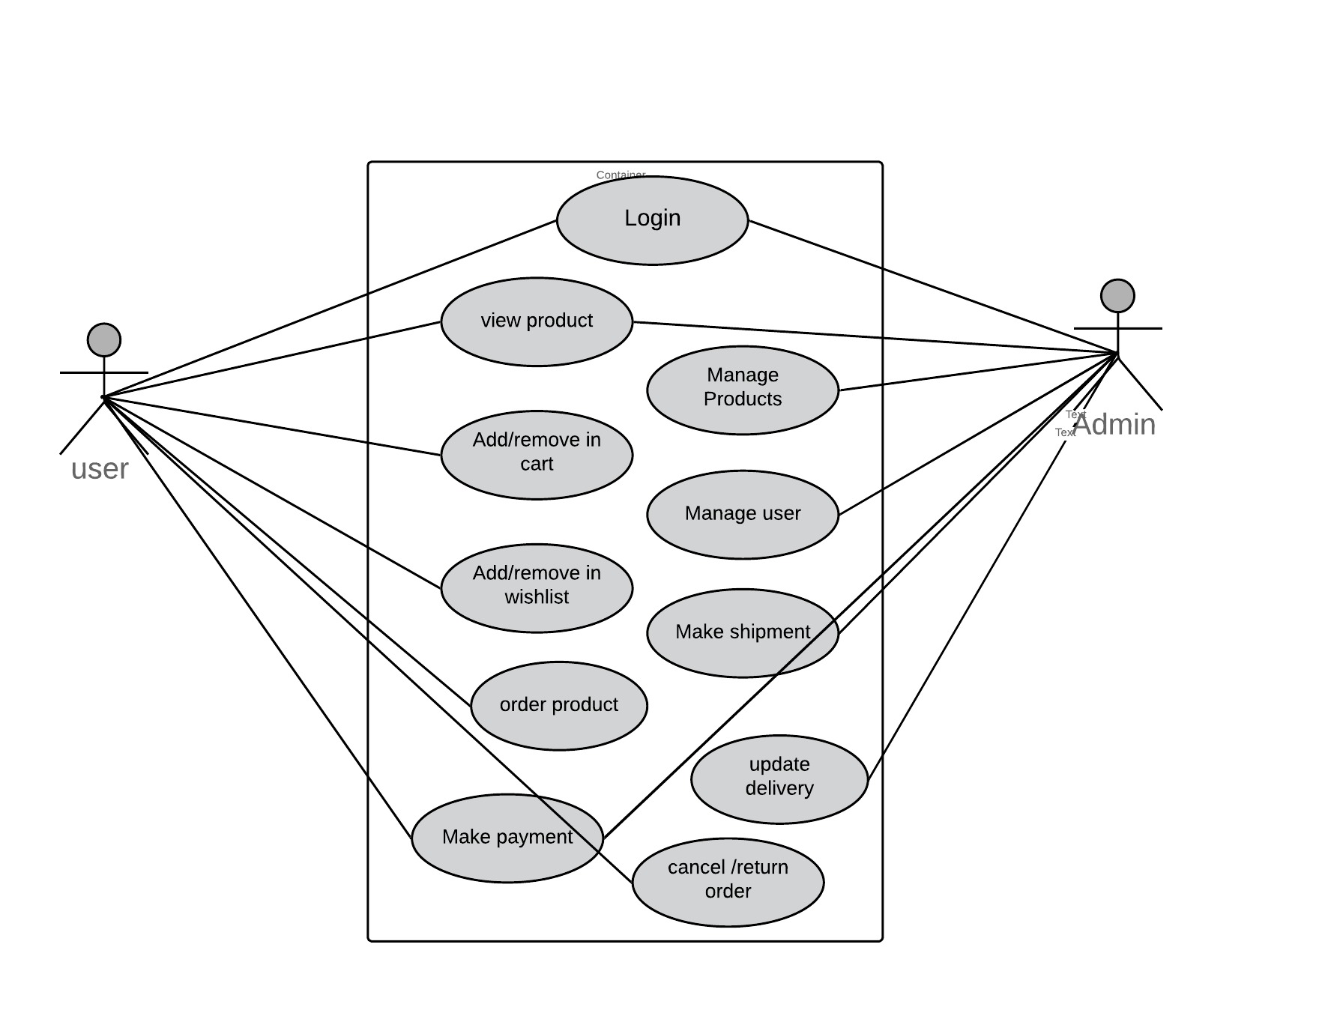

Detailed Design for Module:

This section describes the detailed design for the following modules.
- E-Cart
- Order Management & Status tracking
- Admin Interface
- Payment Gateway
- Secured authentication mechanism
- Tax Calculations

Detailed Design for Feature:
[This section describes the detailed design for the feature including the user interface design.]

User Profile

[Describe the different user types with the security profiles and specify the roles that can access these screens.]

Navigation Map

[Describe the navigation map along with use case traceability of all screens for this feature.]

UI Screen Design

Page Summary
Name | Search for Customer File
Description | The user retrieves the customer information based on the search criteria such as File ID, last name, first name, middle name, business name, SSN/TIN, address, city, state and/or zip.
Use Case Number | UC-002

Screen Layout

[Include a screen shot and describe each element/button in the following table.]

Validations

Error Trigger | Action | Description
If the user group is not selected. | Displays the message “Please select a User Group from the list”. | Prompts the user to select an entry from the User Group list.
User enters an invalid date | Displays the message “Enter a valid date. The date must be in <mm-dd-yyyy> format”. | Displays invalid date message.

Object Model/Data Flow Design

[This sub-section describes the detailed design for the system pertaining to the <<Feature Name>> feature. Interaction diagrams showing the details of the component structure, behavior, or information/control flow may be included in the sub-section devoted to that particular component.]

Interface Description

[Describe the interfaces including component interfaces and interfaces to other systems, products, or networks.]

Class Design

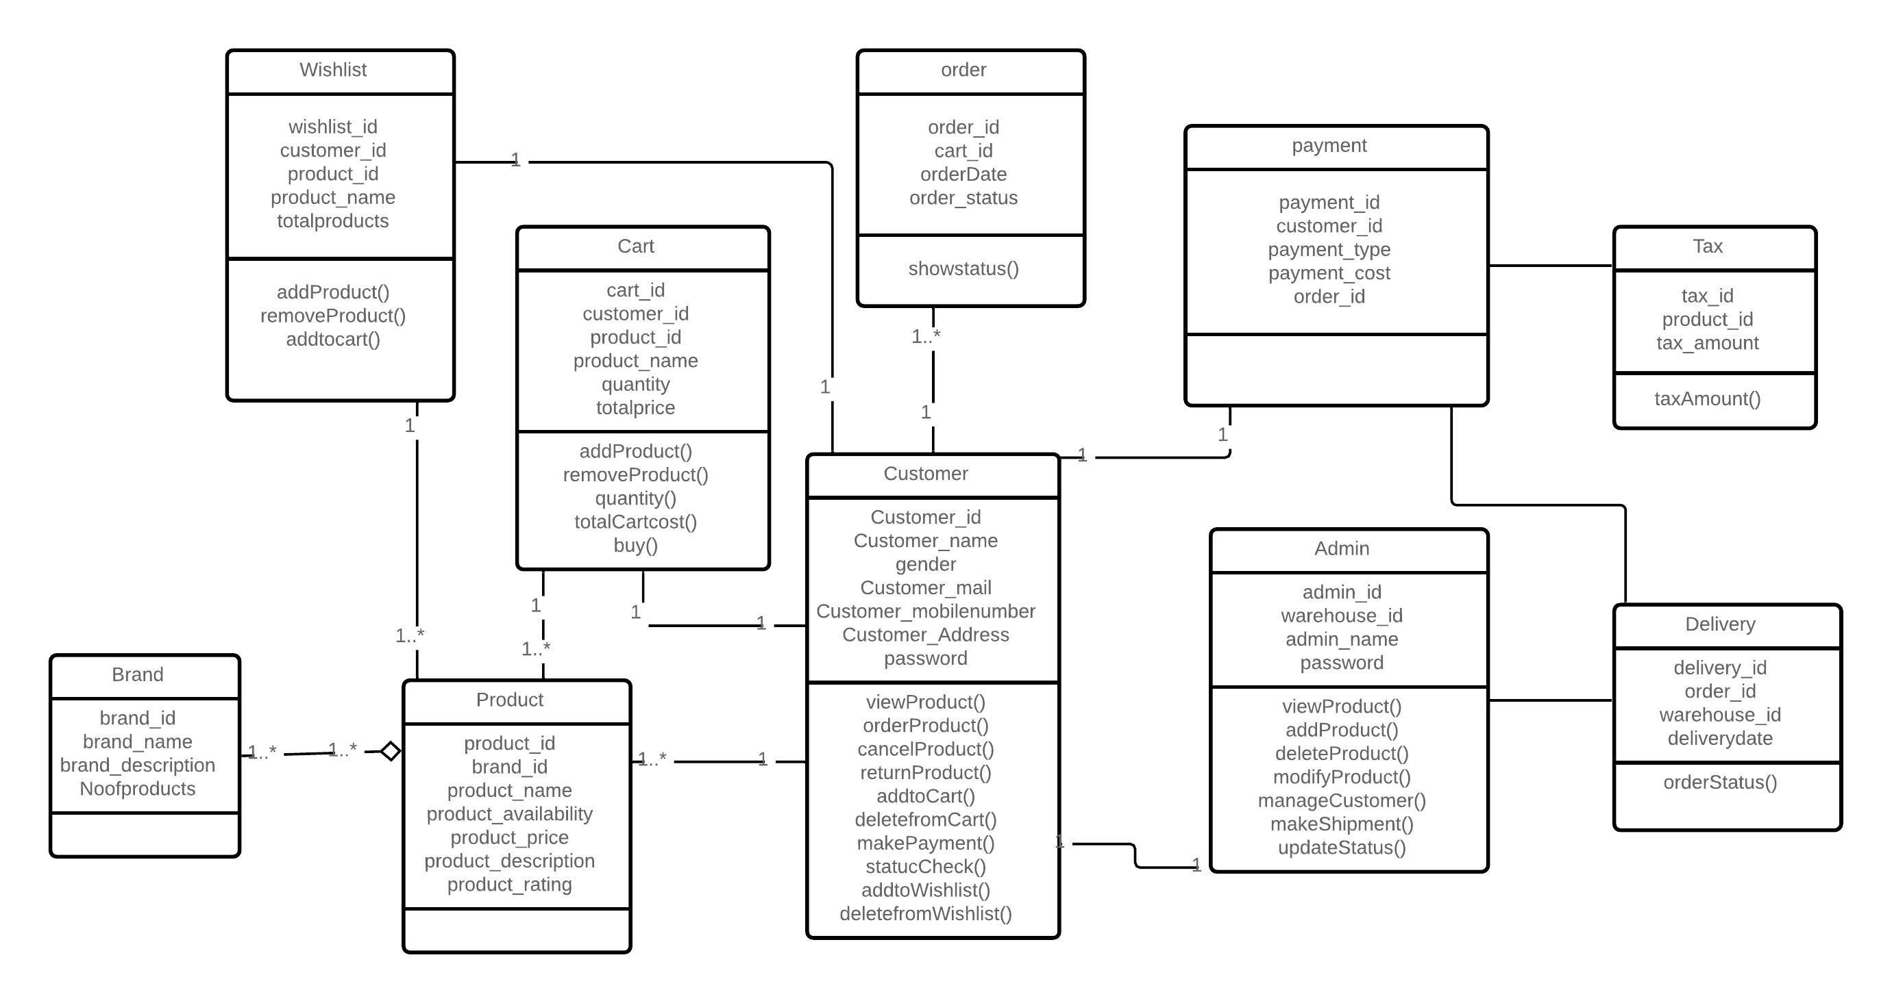

Algorithmic/Business Logic Description (Optional)

[Describe complex algorithms used in the class (if any).]

Local Data Structure (Optional)

[Describe key data structure algorithms used (if any).]

Data Transfer/Value objects

[Based on the design pattern being used, identify and describe the value/transfer objects.]

Related Database Tables

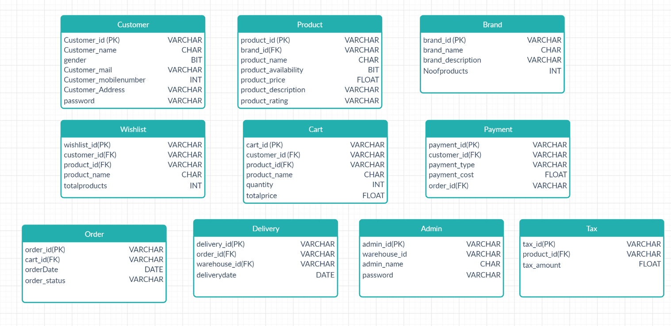

Dependencies with Other Sub-systems/Components

[Describe the dependencies with other sub-system/components, if any.]

Detailed Design for Feature: <<Feature Name>>

Repeat all sub-sections given in 3.1 for this feature.

Detailed Design for Module:

.

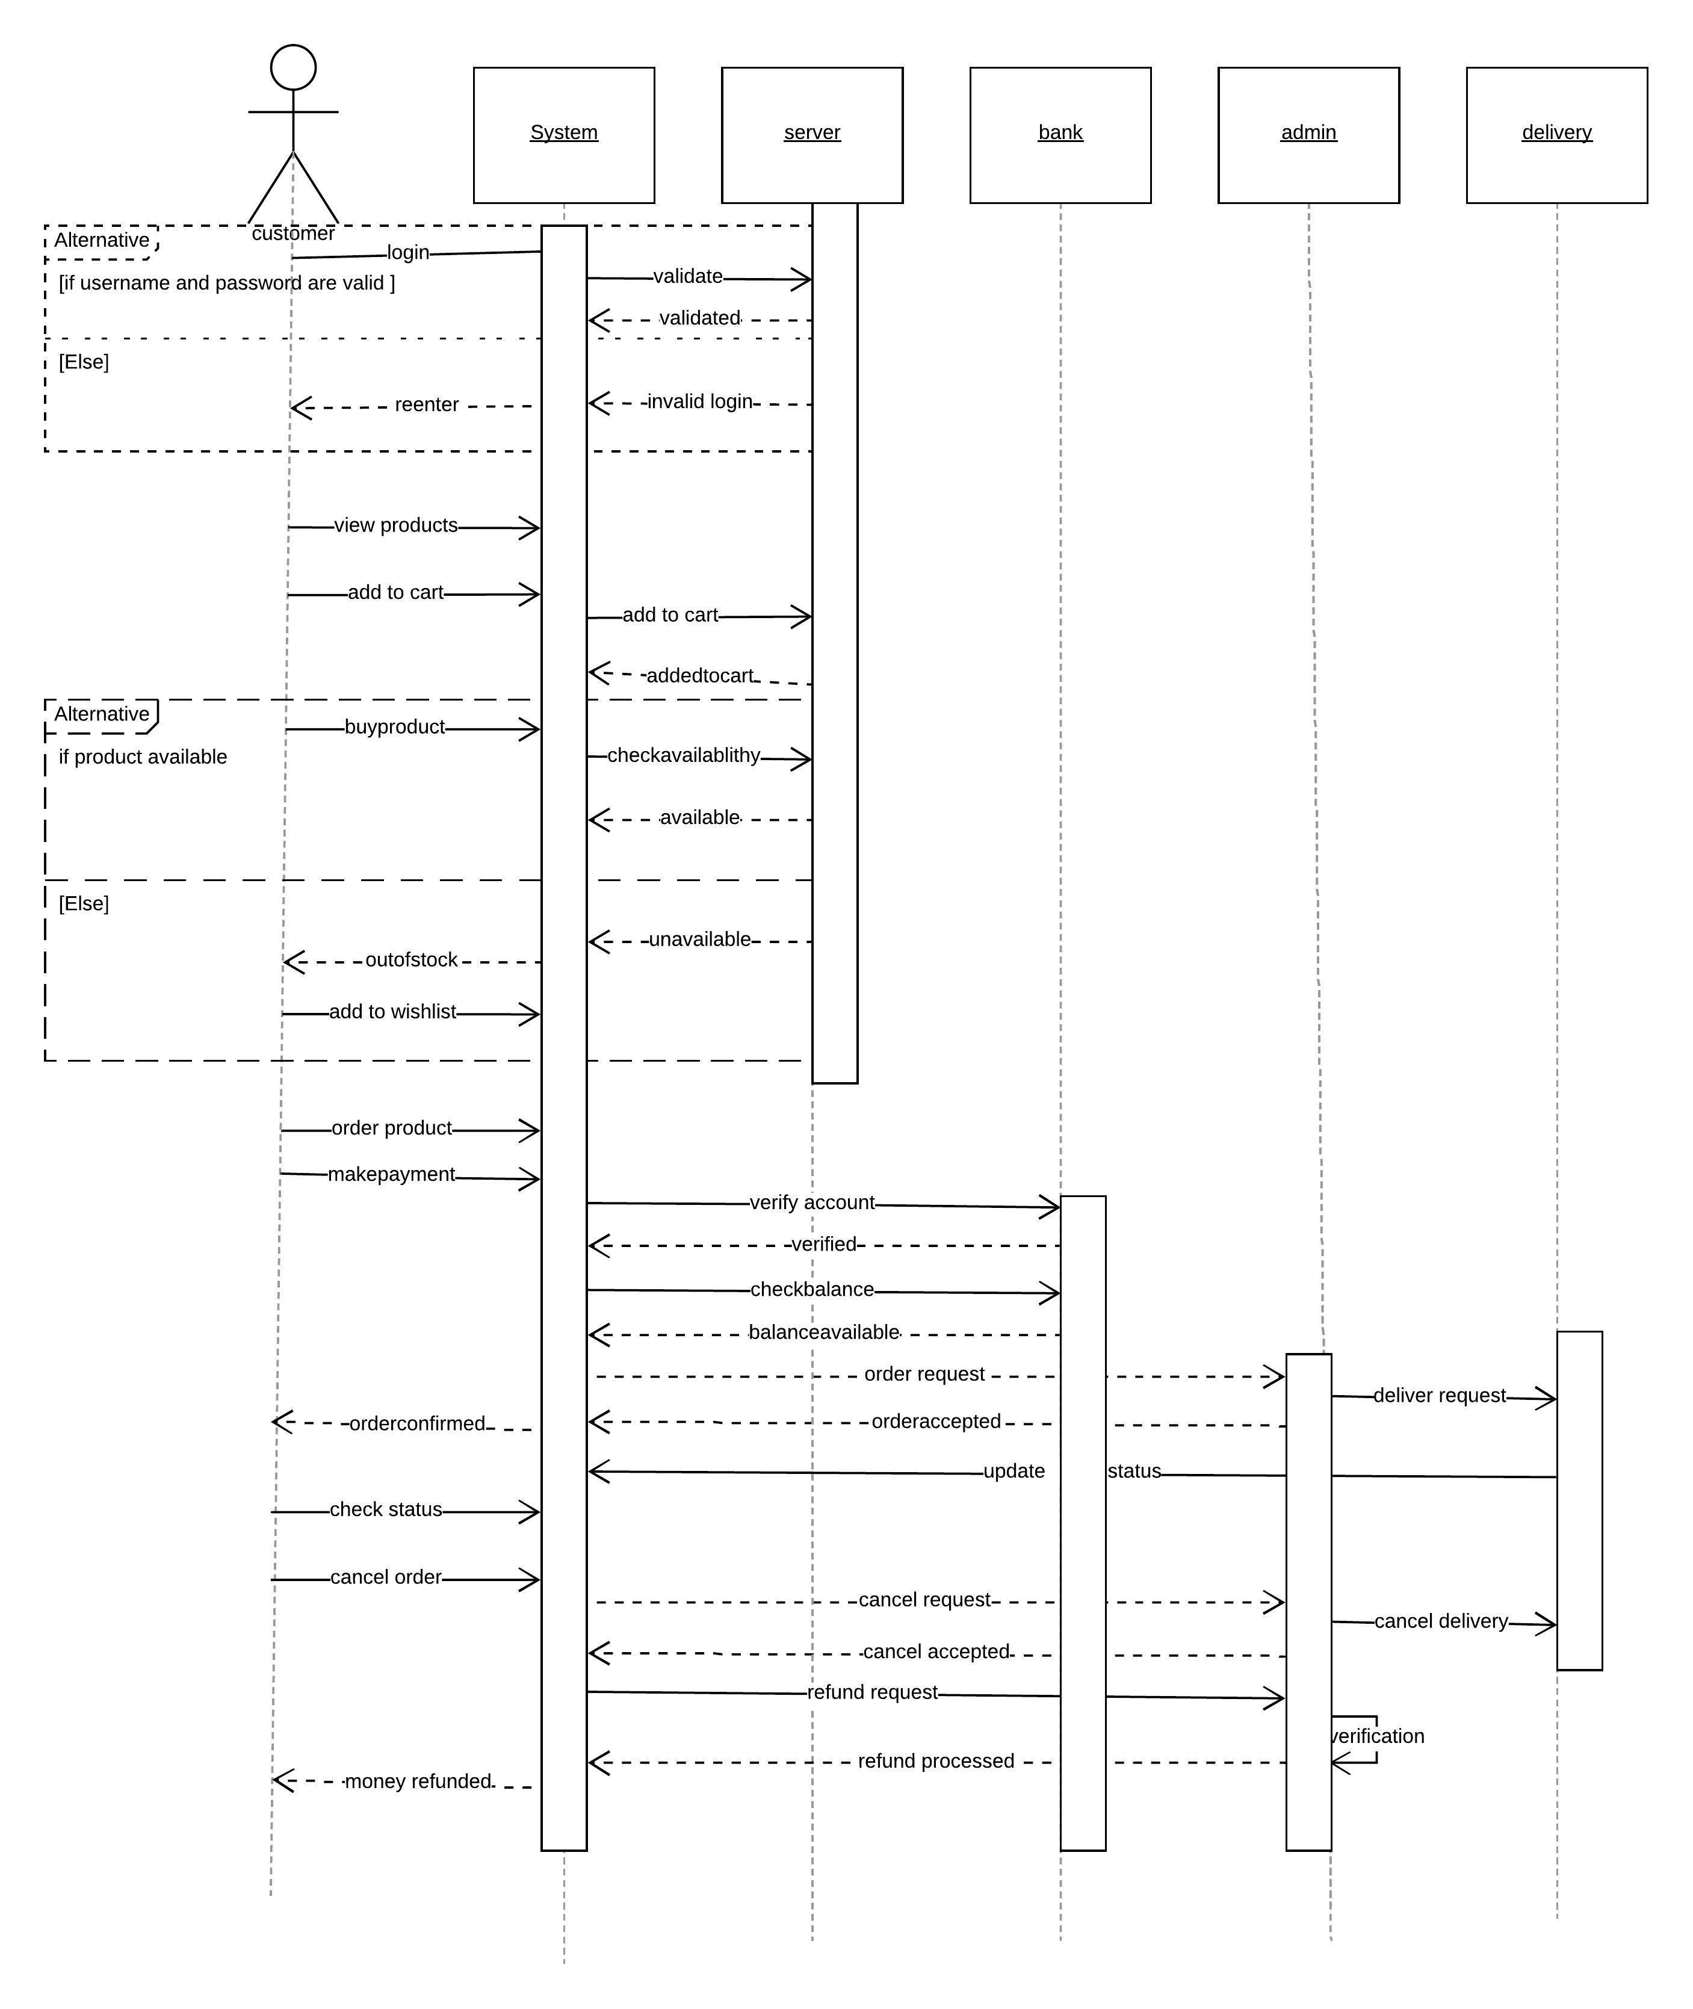

Database Design
Models | Tools
Database Entity Relationship Diagrams | Lucid chart
Object Models | Lucid chart

Entity Relationship Diagrams

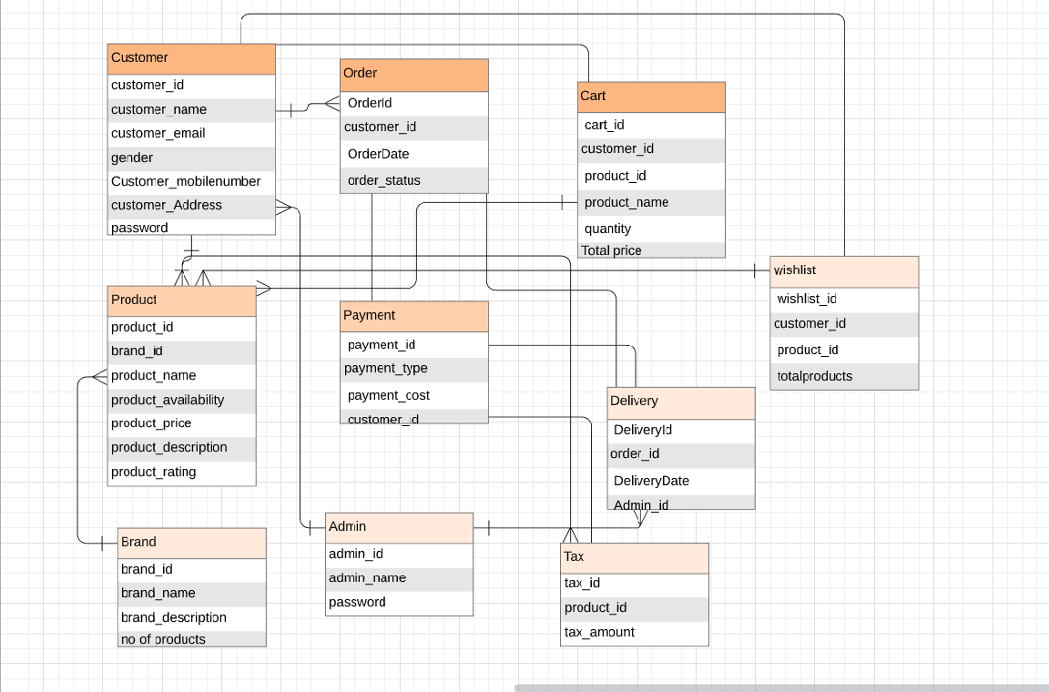

Packaging/Folder Structure and System Artifacts

[This section describes the file structure for the Vyntra mart project, which will indicate where the code, unit tests, executables, libraries, etc. are to be placed during implementation. Optionally the file structure can be described in a separate GA chapter and a reference given here.]

[Sample structure

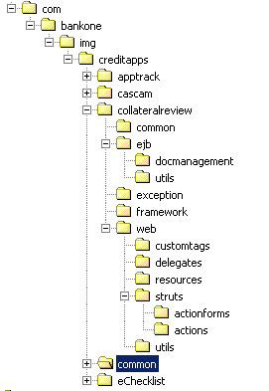
End Sample Structure]

System Artifacts

[Provide information on the Registry structure, INI files, property files, configuration files, etc.]

Core Technical Services Design

[This section describes the detailed design and usage pattern for the core technical services of the system.]

Persistence

[This sub-section captures the detailed design and usage patterns of the persistence service for the application.]

Inter-process Communication

[This sub-section captures the detailed design and usage patterns of the inter-process communication framework for the application.]

Authentication and Authorization

[This sub-section captures the detailed design and usage patterns of the security services for the application.]

Error Handling

This sub-section captures the detailed design and usage patterns of the error handling services for the application.]

Logging

[This sub-section captures the detailed design and usage patterns of the logging framework for the application.]

Transaction Management

[This sub-section captures the detailed design and usage patterns of the Transaction Management service for the application.]

Other Applicable Technical Services

[This sub-section captures the detailed design and usage patterns of the other core technical services to be handled by the system such as the installation mechanism, failure prevention, fault tolerance, caching design, internationalization, validation framework, client and server initialization, error handling, etc.]

9 Non Functional Requirements

Appendix

Nonfunctional requirements describe how a system must behave and establish constraints of its functionality. This type of requirements is also known as the system’s quality attributes.

Design Metrics to be Used

- Usability
- Efficiency of use
- Intuitiveness
- Low perceived workload
- Security
- Reliability
- Availability
- Performance
- Scalability

Supplementary Information

[Provide as required.]

DQI – Design Quality Index Checklist
This checklist shall be used to perform self-review as a reference while preparing software design.


