**ASSIGNMENT 1**

**GIT COMMANDS**

SUBMIT VIA SCREENSHOT OF YOUR CMD

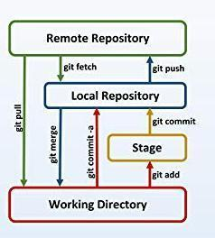

Create a local git repository

Commit the initial code

Update the code on the remote server . Also perform some changes on remote n reflect the same on local.

Raise a pull request on remote and merge without conflicts.

Use git commands to

o Get the updated files

o Perform reset

o List the changes

o Create branches b1,b2,b3 and update them as well.

o List the changes

Demonstrate diff between branches

Perform merging operation and after that delete the unnecessary ones locally as well as remote

Perform fork operations on your repository as well.