Megha N

PE05

In the code checked in git hub I have removed Mongodb url as it might cause security breaches.

Screenshots of UI and DB is below

1. Landing page.

1. Add a new Recipe

1. View the added recipe in the list

1. When clicked on the recipe it displays it, we have option to edit or delete the recipe

1. When clicked on edit it takes to again the same page, the params passed and we can edit any recipe.

1. Edited recipe is displayed.

1. A new recipe is added.

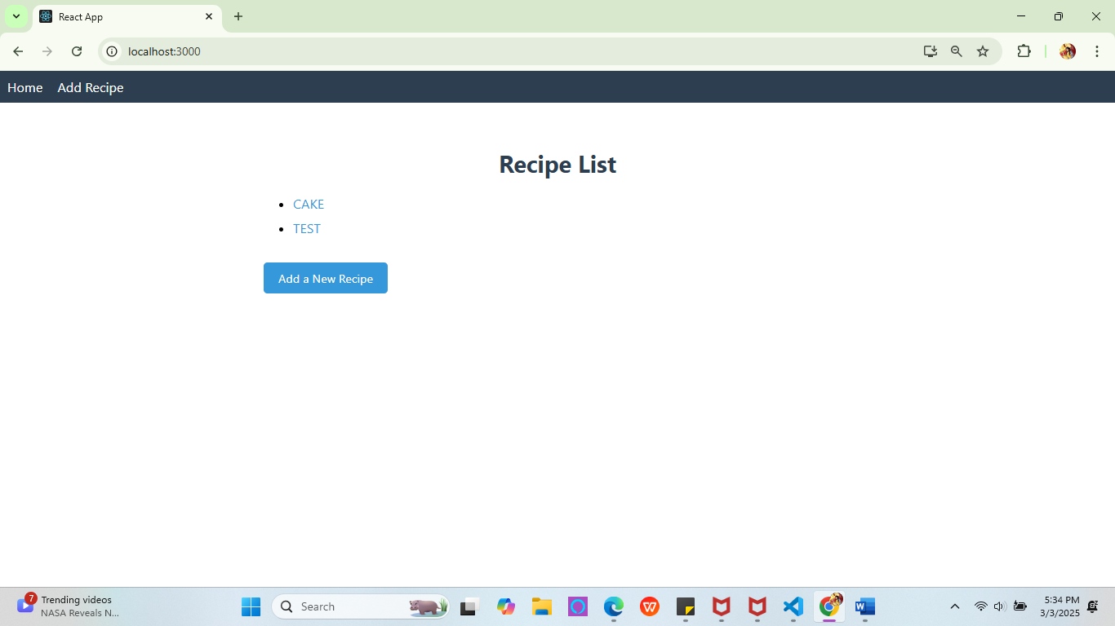

1. The new recipe is deleted

1. The snapshot of DB with recipes.

