Q-SHIELD AGENT
AI-Powered Post-Quantum Cryptography Security Assessment
Technical Project Documentation
PREPARED BY
Megha Narendra Simha
Sai Shruthi Sridhar
Poorrnima Palanisamy Vetrivelan
Team 1 · Secure AI Hackathon · Security Reasoning Agent Track

Table of Contents
(Right-click below and choose “Update Field,” or press F9, to populate this table — Word does this automatically for most users on open.)

1. Executive Summary
Q-Shield Agent is an AI-assisted security engineering pipeline that automates post-quantum cryptography (PQC) readiness assessment. It combines a Cryptography Bill of Materials (CBOM) scan, static-analysis findings from SonarQube, and a NIST-grounded retrieval-augmented generation (RAG) knowledge base to produce an evidence-backed security report, narrated by a large language model (Mistral) and checked by three purpose-built guardrails before it reaches a pull request.
The system runs automatically inside GitHub Actions on every pull request and branch push. It is designed around one governing principle: deterministic code decides what the findings are; the AI is used only to explain them in readable language, and its output is checked against the underlying evidence before it is trusted.
Core Design Principle
The AI narrates findings that a deterministic rule engine has already produced. It is never the source of truth for a security finding — that role belongs to the CBOM parser and the PQC rule engine, both of which run without any language model involved.

2. Problem Statement

2.1 Quantum computers will break widely used cryptography
Shor's algorithm, once run on a sufficiently capable quantum computer, defeats RSA, ECDSA, and Diffie-Hellman — the algorithms most software still relies on for encryption and digital signatures. “Harvest now, decrypt later” attacks are already a live concern: data encrypted today with classical algorithms can be captured and stored by an adversary now, then decrypted retroactively once quantum hardware matures.

2.2 Most organizations have no visibility into their exposure
Engineering teams typically cannot state with confidence which cryptographic algorithms are embedded in their codebase, their dependencies, or their infrastructure configuration. Manual cryptographic audits are slow, inconsistent between reviewers, and go stale the moment code changes — which, in an actively developed codebase, is continuous.

2.3 Migration guidance exists but is hard to operationalize
NIST has published finalized post-quantum standards — FIPS 203 (ML-KEM, key encapsulation) and FIPS 204 (ML-DSA, digital signatures) — along with migration guidance such as SP 1800-38B. Translating that guidance into a prioritized, per-asset engineering plan still requires specialist judgment applied one finding at a time, which does not scale across a large codebase or a large organization.

3. Solution Overview
Q-Shield Agent addresses this gap with an automated, evidence-first pipeline: it scans, evaluates, retrieves relevant NIST guidance, drafts a report, and validates that report — all inside continuous integration, on every pull request.
Stage | What it does
Scan | Inventories cryptographic assets from the CBOM and SonarQube's static-analysis output.
Detect | Flags quantum-vulnerable algorithms (RSA, SHA-1, MD5, and other deprecated primitives) using a deterministic rule engine.
Retrieve | Pulls grounded context from a NIST knowledge base (FIPS 203, FIPS 204, SP 1800-38B) via retrieval-augmented generation.
Assess | The AI agent (Mistral) drafts a security assessment narrative, grounded in the findings and retrieved evidence.
Validate | Three guardrails check the input going into the model and the report coming out of it before anything is saved or published.
Deliver | The report, guardrail results, and supporting artifacts are posted to the pull request and uploaded as a CI artifact.

4. System Architecture
The diagram below reflects the actual implementation: a GitHub Actions CI/CD pipeline orchestrates a security analysis pipeline (CBOM + SonarQube parsing), a PQC intelligence engine (rule evaluation + remediation planning), a RAG knowledge base built from NIST documents, and an AI security agent that draws on all three to produce the final report and outputs.
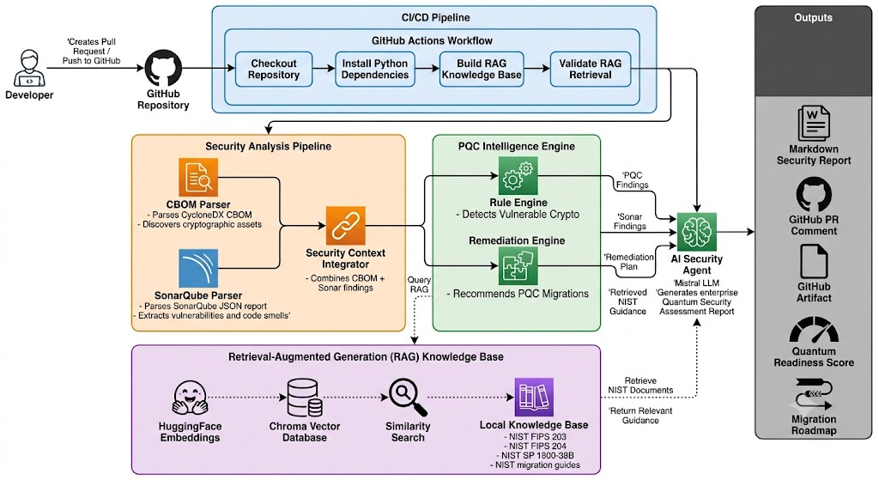
Architecture diagram as implemented in the fea_guardrail_1 branch.

4.1 Architectural flow
- A developer creates a pull request or pushes to the repository, which triggers the GitHub Actions workflow.
- The CI/CD pipeline checks out the repository, installs dependencies, builds the RAG knowledge base, and validates RAG retrieval.
- The Security Analysis Pipeline runs the CBOM Parser and SonarQube Parser in parallel, then combines their output in the Security Context Integrator.
- The PQC Intelligence Engine's Rule Engine evaluates each cryptographic asset against the PQC risk rules; the Remediation Engine builds a migration plan for anything flagged.
- The AI Security Agent (Mistral LLM) retrieves relevant NIST guidance from the RAG knowledge base and drafts the Quantum Security Assessment Report, grounded in the rule engine's findings and the remediation plan.
- The report and guardrail results are published as a Markdown report, a GitHub PR comment, a CI artifact, a quantum readiness score, and a migration roadmap.

5. Repository Structure
Path | Purpose
.github/workflows/pqc-security-scan.yml | CI pipeline — runs on every pull request to main and every push
ai-security-copilot/agent.py | Orchestrates report generation and invokes the guardrails
ai-security-copilot/guardrails.py | The three AI guardrails (injection, hallucination, output validation)
ai-security-copilot/cbom_parser.py | Extracts cryptographic assets from the CBOM JSON
ai-security-copilot/rule_engine.py | Evaluates each asset against the PQC risk rules
ai-security-copilot/remediation_engine.py | Builds the per-asset migration plan
ai-security-copilot/sonarqube_parser.py | Parses SonarQube vulnerability and hotspot reports
ai-security-copilot/sonar_integration.py | Merges CBOM and SonarQube findings into one context
ai-security-copilot/ingest_documents.py | Indexes NIST PDFs into the Chroma vector store
ai-security-copilot/rag_retriever.py | Similarity search over the NIST knowledge base
ai-security-copilot/security_gate.py | Computes a security score and a merge pass/fail gate
ai-security-copilot/pqc_rules.json | PQC risk rules mapped to NIST references
ai-security-copilot/knowledge_base/nist/ | NIST FIPS 203 and FIPS 204 source PDFs
ai-security-copilot/knowledge_base/migration/ | NIST SP 1800-38B migration guidance PDF
cbomkit-theia/ | Go-based CBOM tooling and scanner components
wrongsecrets/ | Intentionally vulnerable reference application for testing

6. Pipeline Walkthrough

6.1 CBOM parsing and rule evaluation
The rule engine loads the PQC risk rules and the CBOM, normalizes algorithm names so naming variants line up consistently (for example, “SHA-1”, “SHA_1”, and “SHA 1” all normalize to the same key), and evaluates each cryptographic-asset component. For every match, it records the asset, its risk level, category, priority, recommended replacement algorithm, migration wave, estimated engineering effort, owning team, and the specific NIST reference that justifies the finding, along with up to five code-evidence occurrences pulled from the CBOM.

6.2 SonarQube integration
SonarQube's vulnerability, hotspot, and general findings are parsed separately and then merged with the CBOM-derived findings in the Security Context Integrator, giving the downstream engines a single unified view of both cryptographic risk and general code-quality findings.

6.3 Remediation planning
The remediation engine maps each flagged algorithm to a concrete migration checklist. For example, RSA-OAEP usage is mapped to a hybrid-cryptography path (RSA-OAEP plus ML-KEM-768) with a plan to move to pure ML-KEM once supported; MD5 usage is mapped to a straightforward replacement with SHA-256 or SHA3-256.

6.4 RAG knowledge base
NIST source documents are embedded using a HuggingFace sentence-transformer model and indexed into a Chroma vector database. At report-generation time, the retriever runs a similarity search per finding (asset name plus category plus “NIST migration guidance post quantum cryptography”) and returns the top matching passages as grounding evidence for the AI agent.

6.5 AI report generation
The agent assembles the findings, the remediation plan, and the retrieved NIST evidence into a single prompt and sends it to Mistral. The response is the draft security report — before it is treated as final, it passes through the guardrails described in the next section.

7. AI Guardrails
Three guardrails validate the pipeline at two points: before the LLM is called (pre-generation) and after it responds (post-generation). All three are implemented in guardrails.py and orchestrated by a single GuardrailRunner class.

7.1 Prompt Injection Guardrail (pre-generation)
Before any RAG document, SonarQube field, or CBOM value is included in the prompt, it is scanned against a pattern library covering five categories of injection attempt:
- Direct instruction overrides — e.g. “ignore previous instructions,” “you are now a...”
- Role manipulation — e.g. “pretend you are,” “jailbreak,” “DAN mode”
- Output manipulation — e.g. attempts to reveal the system prompt
- Data exfiltration — e.g. embedded URLs, curl/wget commands
- Delimiter attacks — e.g. fake system/assistant code fences, chat-template tokens
If a threat is detected, the guardrail can produce a sanitized version of the evidence with matched spans replaced by a “[REDACTED-INJECTION]” marker, so a compromised RAG chunk or SonarQube field cannot silently steer the model.

7.2 Hallucination Guardrail (post-generation)
After the model responds, this guardrail checks four things against the actual source data: whether every algorithm named in the report exists in the CBOM findings or a known-algorithm allowlist; whether every NIST reference (FIPS/SP number) cited in the report is a reference the system actually has evidence for; whether every file-and-line reference in the report exists in the SonarQube findings; and whether the risk level stated for each asset in the report matches the risk level the rule engine actually assigned it.

7.3 Output Validation Guardrail (post-generation)
This guardrail checks the report's structure and integrity independently of its factual grounding: that all required sections are present (Quantum Readiness Score, Executive Summary, Findings, NIST Guidance, Migration Roadmap, Limitations); that cited NIST references aren't fabricated document numbers; that the model hasn't broken character with a refusal or meta-commentary; that every non-Low-risk finding is actually addressed somewhere in the report; and that a readiness score is present and falls within a valid 0–100 range. It also computes a completeness percentage based on how many required sections were found.
Current behavior of the guardrails
In the current implementation (fea_guardrail_1 branch), all three guardrails run and their results are logged to the console and written to output/guardrail_results.json, and a summary is included in the PR comment. Guardrail failures are surfaced for a human reviewer to see, but they do not currently stop the report from being written to disk or posted to the pull request — see Section 10 for a full account of this gap.

8. CI/CD Integration
The workflow (.github/workflows/pqc-security-scan.yml) is triggered on pull requests targeting main and on pushes to any branch. Its permissions block is deliberately narrow:
Permission | Scope granted
contents | read — the job can check out the repository but not push to it
pull-requests | write — required to post the summary comment
issues | write — used by the PR-comment step's GitHub API call
The job runs the full pipeline in sequence — checkout, dependency install, CBOM analysis, SonarQube parsing, context integration, rule engine, remediation planning, NIST ingestion, AI report generation with guardrails — then uploads the report as a CI artifact and, on pull request events only, posts the report plus a guardrail summary table as a PR comment via actions/github-script, authenticated with the default GITHUB_TOKEN rather than a broader personal token.
The only external secret required is MISTRAL_API_KEY, scoped to the report-generation step.

9. Outputs
Output | Description
quantum_security_report.md | The full, human-readable security assessment
guardrail_results.json | Pre- and post-generation guardrail results, per check
security_findings.json | Raw PQC findings from the rule engine
remediation_plan.json | The generated per-asset migration plan
GitHub PR comment | Report summary plus guardrail status table, posted automatically
Quantum Readiness Score | A single 0–100 score computed by security_gate.py

10. Current Implementation Status and Known Gaps
This section states plainly what is fully wired end-to-end versus what exists in the codebase but is not yet connected, so the system's real behavior is not overstated.

10.1 Fully implemented and wired in
- CBOM parsing, rule evaluation, and remediation planning — deterministic, no LLM involved, run in every CI job.
- SonarQube parsing and context integration.
- RAG ingestion and retrieval over the NIST knowledge base.
- All three guardrails execute on every run and their results are saved and surfaced in the PR comment.
- CI permissions are scoped to the minimum needed (contents: read; pull-requests and issues: write).

10.2 Implemented but not yet enforced
Security gate does not currently block anything. security_gate.py computes a readiness score and is designed to exit with a non-zero status — failing the CI job — when the score falls below the configured threshold (60%). However, this script is not currently invoked as a step in pqc-security-scan.yml. As written today, the workflow will post a report and complete successfully regardless of how low the readiness score is.
Guardrail failures do not block report publication. agent.py runs both guardrail passes and prints/logs their results, but the report is written to disk and posted to the PR unconditionally — there is no branch in the code that halts execution or withholds the report when a guardrail reports hallucinated content, a failed injection check, or missing required sections. The guardrails currently function as a visible audit trail and a signal to the human reviewer, not as an automatic gate.

10.3 Recommended next step
The most direct way to close this gap is to add a step to pqc-security-scan.yml that runs security_gate.py after report generation and fails the job on a non-zero exit code, and to add an equivalent check in agent.py that skips writing/posting the report when post_result["passed"] is false for the hallucination or output-validation guardrails. Both changes are small relative to the guardrail logic already in place — the detection work is done; what remains is wiring the pass/fail signal to an actual stop.

11. Key Technologies
Layer | Technology
LLM | Mistral, via the mistralai SDK
RAG | LangChain + ChromaDB + HuggingFace embeddings (all-MiniLM-L6-v2)
Knowledge base | NIST FIPS 203, FIPS 204, SP 1800-38B
Code analysis | SonarQube findings integration
Cryptographic inventory | CBOM (Cryptography Bill of Materials), CycloneDX format
CBOM tooling | cbomkit-theia (Go-based scanner)
CI/CD | GitHub Actions, with PR comment integration via actions/github-script

12. Limitations
- CBOM completeness sets the ceiling — the agent only sees cryptographic assets present in the CBOM input; a scanner gap means a missed dependency, silently.
- LLM accuracy — guardrails catch structural and evidence-mismatch issues, not every subtle semantic imprecision in the model's language.
- External API dependency — report generation requires Mistral API access; an outage or rate limit fails that pipeline step.
- No auto-remediation — the system recommends fixes but does not apply code changes; engineers migrate manually.
- Static analysis scope — cryptographic usage is detected at build/config time only; runtime-negotiated algorithms (TLS handshakes, dynamic key selection) are not covered.
- Knowledge base currency — RAG is limited to the NIST PDFs checked into the repository; new NIST publications require manual re-ingestion.
- Guardrails are currently advisory, not enforcing — see Section 10.2.

13. Team
Megha Narendra Simha · Sai Shruthi Sridhar · Poorrnima Palanisamy Vetrivelan
Team 1 — Secure AI Hackathon — Security Reasoning Agent track.

