**Color-> colour**

[**0265-2635648**](tel:0265-2635648)**-> +91 9426647142**

Add phone in contact page

**=>91 9426647142**

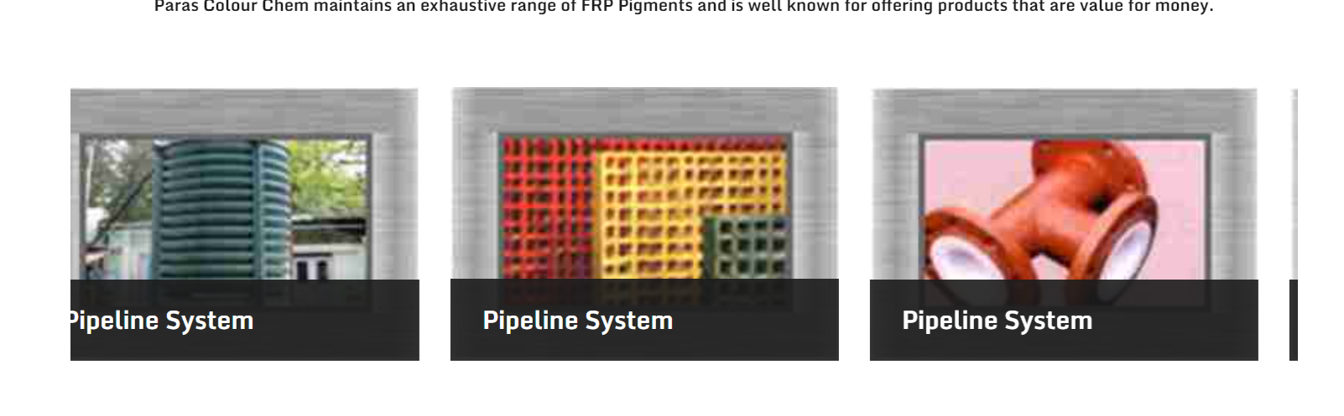 remove our product and replace with shade card , only keep Download option

* In FRP pigment add ShadeCard options

frp pigment manufacturers -> EPOXY pigment manufacturers,   
  
add these sco by adding and replacing FRp with Epoxy